
Remuneration bands for
executives employed in
public service bodies
)
(
Victoria
Determination 01/2020


Front cover image:
© Mark Farrelly Photography

DETERMINATION | [2020] DVPS 01
Victorian Independent Remuneration Tribunal and Improving Parliamentary Standards Act 2019 (Vic)
Part 3—Determination of the remuneration bands for executives employed in public service bodies.

Remuneration bands for executives employed in public service bodies (Victoria) Determination 01/2020

Table of contents
Part 1 – Legal matters and definitions
- Title
- Effective date
- Definitions
- Coverage and application
Part 2 – Remuneration bands for subordinate executives
- Subordinate executives employed in public service bodies
Part 3 – Remuneration bands for public service body Heads
- Administrative Office Heads
- Department Heads and the Victorian Public Sector Commissioner
Statement of Reasons

Part 1 – Legal matters and definitions
- Title: This Determination is the Remuneration Bands for Executives Employed in Public Service Bodies (Victoria) Determination No. 01/2020 and is made under Part 3 of the Victorian Independent Remuneration Tribunal and Improving Parliamentary Standards Act 2019 (Vic) by the Victorian Independent Remuneration Tribunal.
- Effective date: This Determination takes effect on 20 September 2019.
- Definitions
  - Terms not defined in this Determination have the same meaning as in the Public Administration Act 2004 (Vic), unless the contrary intention appears.
  - In this Determination, unless the contrary intention appears:
FTE means Full Time Equivalent;
Public service body Head means:
- a Department Head;
- an Administrative Office Head;
- the Victorian Public Sector Commissioner;
Subordinate executive means an executive other than a public service body Head;
TRP means total remuneration package, and is the sum of:
- base salary;
- superannuation contributions;
- employment benefits (i.e. non-salary) specified in the executive’s contract of employment; and
- the annual cost to the employer of providing the non-monetary benefits, including any fringe benefits tax payable;
VPS Executive Classification Framework means the Victorian Public Service Executive Classification Framework in relation to Senior Executive Service classifications issued by the Victorian Public Sector Commission and available on its website, as amended from time to time.
- Coverage and application
4.1 This Determination sets the values of the remuneration bands for executives employed in public service bodies.

Part 2 – Remuneration bands for subordinate executives
- Subordinate executives employed in public service bodies
  - The values of the remuneration bands for subordinate executives employed in public service bodies are:
- from 20 September 2019 until 30 June 2020, the values set out in
table 1;
- from 1 July 2020, the values set out in table 2.
  - The relevant remuneration band for each executive corresponds to:
- if the classification of the executive’s position has not been determined using the VPS Executive Classification Framework, the Executive Officer classification specified in their contract of employment;
- if the classification of the executive’s position has been determined using the VPS Executive Classification Framework, the Senior Executive Service classification of that position determined under that framework.
Table 1: values of remuneration bands for subordinate executives from 20 September 2019 until 30 June 2020
Classification | Base of band TRP  $ per annum | Top of band TRP  $ per annum
Senior Executive Service-3 / Executive Officer-1 | 312,274 | 457,081
Senior Executive Service-2 / Executive Officer-2 | 214,883 | 343,938
Senior Executive Service-1 / Executive Officer-3 | 185,711 | 240,789
Note: the above values are for executives employed on a 1.0 FTE basis, and apply pro rata to executives employed on a part-time basis.
Table 2: values of remuneration bands for subordinate executives from 1 July 2020
Classification | Base of band TRP  $ per annum | Top of band TRP  $ per annum
Senior Executive Service-3 / Executive Officer-1 | 360,001 | 479,900
Senior Executive Service-2 / Executive Officer-2 | 249,701 | 360,000
Senior Executive Service-1 / Executive Officer-3 | 192,800 | 249,700
Note: the above values are for executives employed on a 1.0 FTE basis, and apply pro rata to executives employed on a part-time basis.

Part 3 – Remuneration bands for public service body Heads
- Administrative Office Heads
  - The values of the remuneration bands for Administrative Office Heads are:
- from 20 September 2019 until 30 June 2020, the values set out in
table 3;
- from 1 July 2020, the values set out in table 4.
  - This clause applies to an Administrative Office Head if the classification of their position has not been determined using the VPS Executive Classification Framework. The relevant remuneration band for that Administrative Office Head is:
- if their TRP (based on 1.0 FTE) immediately prior to the making of this Determination was $360,001 per annum or greater, Administrative Office Head-3;
- if their TRP (based on 1.0 FTE) immediately prior to the making of this Determination was between $249,701 and $360,000 (inclusive) per annum, Administrative Office Head-2;
- if their TRP (based on 1.0 FTE) immediately prior to the making of this Determination was $249,700 per annum or less, Administrative Office Head-1.
  - This clause applies to an Administrative Office Head if the classification of their position has been determined using the VPS Executive Classification Framework. The relevant remuneration band for that Administrative Office Head corresponds to the Administrative Office Head classification of that position determined under that framework.
Table 3: values of remuneration bands for Administrative Office Heads from
20 September 2019 until 30 June 2020
Classification | Base of band TRP  $ per annum | Top of band TRP  $ per annum
Administrative Office Head-3 | 360,001 | 479,900
Administrative Office Head-2 | 249,701 | 360,000
Administrative Office Head-1 | 192,800 | 249,700
Note: the above values are for executives employed on a 1.0 FTE basis, and apply pro rata to executives employed on a part-time basis.
Table 4: values of remuneration bands for Administrative Office Heads from
1 July 2020
Classification | Base of band TRP  $ per annum | Top of band TRP  $ per annum
Administrative Office Head-3 | 360,001 | 479,900
Administrative Office Head-2 | 249,701 | 360,000
Administrative Office Head-1 | 192,800 | 249,700
Note: the above values are for executives employed on a 1.0 FTE basis, and apply pro rata to executives employed on a part-time basis.
- Department Heads and the Victorian Public Sector Commissioner
  - The values of the remuneration band for Department Heads and the Victorian Public Sector Commissioner are:
- from 20 September 2019 until 30 June 2020, the values set out in
table 5;
- from 1 July 2020, the values set out in table 6.
  - For the purposes of section 47(6A) of the Public Administration Act 2004 (Vic), the relevant remuneration band for an Acting Victorian Public Sector Commissioner is the same as the remuneration band that applies at that time to the Victorian Public Sector Commissioner.
Table 5: values of remuneration band for Department Heads and the Victorian Public
Sector Commissioner from 20 September 2019 until 30 June 2020
Classification | Base of band TRP  $ per annum | Top of band TRP  $ per annum
Department Head / Victorian Public Sector Commissioner | 457,082 | 650,000
Note: the above values are for executives employed on a 1.0 FTE basis, and apply pro rata to executives employed on a part-time basis.
Table 6: values of remuneration band for Department Heads and the Victorian Public Sector Commissioner from 1 July 2020
Classification | Base of band TRP  $ per annum | Top of band TRP  $ per annum
Department Head / Victorian Public Sector Commissioner | 520,000 | 701,800
Note: the above values are for executives employed on a 1.0 FTE basis, and apply pro rata to executives employed on a part-time basis.

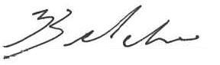
Warren McCann | The Honourable Jennifer Acton | Barbara Belcher AM
Chair | Member | Member
Victorian Independent Remuneration Tribunal | Victorian Independent Remuneration Tribunal | Victorian Independent Remuneration Tribunal
Date: 14/05/2020



Remuneration bands for
executives employed in
public service bodies
(Victoria)

Determination 01/2020

Statement of Reasons



Contents

Glossary 11
Introduction 13
1 Role of the Tribunal 15
1.1 Functions of the Tribunal 16
1.2 Scope of the Determination 17
1.3 Consultation 19
1.4 Data 20
1.5 Other executive workforce reforms 21
2 Roles of executives 25
2.1 Victorian context 25
2.2 Roles of public service body Heads 30
2.3 Roles of subordinate executives 40
2.4 Changing nature of the role of executives 41
3 Existing employment and remuneration framework 45
3.1 Employment policy 45
3.2 Remuneration policy 47
3.3 Trends in executive remuneration 52
4 Characteristics of the VPS executive labour market 59
4.1 The ‘market’ for VPS executives 60
5 Economic factors 67
5.1 Current and projected economic conditions and trends 67
5.2 Financial position and fiscal strategy of the State of Victoria 69
5.3 Victorian Government’s Wages Policy 70
6 Tribunal’s considerations 73
6.1 Existing executive remuneration framework 74
6.2 Structure of remuneration bands 75
6.3 Value of the remuneration bands 82
6.4 The new executive remuneration framework 95
6.5 Conclusion 98
Reference list 101
Appendix A – consultation 105

Glossary
Term or abbreviation | Definition
AO | Administrative Office – a type of Victorian public service body established by the Governor in Council under section 11 of the PAA.
ABS | Australian Bureau of Statistics.
APS | Australian Public Service.
AWOTE | Average Weekly Ordinary Time Earnings.
Board | Victorian Secretaries’ Board.
CPI (Victoria) | Consumer Price Index Victoria.
Department | A type of Victorian public service body established by the Governor in Council under section 10 of the PAA.
Headcount | The number of people employed in an organisation, whether employed full-time, part-time or casual.
GDP | Gross Domestic Product.
GSP | Gross State Product.
p.a. | Per annum.
PAA | Public Administration Act 2004 (Vic).
Public service bodies | As defined in Part 1 of the PAA, public service bodies are:  - Departments  - AOs  - the VPSC.
Public service body Head | As defined in Part 1 of the PAA, a public service body Head means:  - in relation to a Department – the Head of that Department  - in relation to an AO – the Head of that AO  - in relation to the VPSC – the Victorian Public Sector Commissioner.
Subordinate executive | A term used in this Statement of Reasons to refer to executives who are not public service body Heads.
TRP | Total Remuneration Package.
VIRTIPS Act | Victorian Independent Remuneration Tribunal and Improving Parliamentary Standards Act 2019 (Vic).
VPSC | Victorian Public Sector Commission.
VPS | Victorian Public Service.
WPI (Victoria) | Wage Price Index Victoria.

Introduction

In March 2019, the Victorian Parliament passed the Victorian Independent Remuneration Tribunal and Improving Parliamentary Standards Act 2019 (Vic) (VIRTIPS Act) establishing the Victorian Independent Remuneration Tribunal (Tribunal). Tribunal Members were appointed in June 2019.
The Tribunal was established to inquire into and make Determinations in relation to the salaries and allowances of Members of the Parliament of Victoria and to inquire into and make Determinations in relation to remuneration bands for executives in the Victorian public sector.
The Tribunal is required to include in a Determination, a Statement of Reasons for the making of the Determination. This Statement of Reasons relates to the Tribunal’s first Determination dealing with remuneration bands for executives employed in public service bodies.
The structure of the Statement of Reasons reflects the requirements of the VIRTIPS Act. Chapter 1 sets out the Tribunal’s establishment and functions, along with the scope of the Determination. Chapters 2 to 4 provide contextual information about the roles and responsibilities of executives, trends in Victorian Public Service (VPS) executive remuneration and the employment and remuneration framework in place prior to the Determination. Chapter 5 details the economic considerations relevant to the Determination. Chapter 6 details the Tribunal’s considerations in determining the structure and values of the remuneration bands.

1 Role of the Tribunal
The Victorian Independent Remuneration Tribunal and Improving Parliamentary Standards Act 2019 (Vic) (VIRTIPS Act) establishes the Tribunal. The VIRTIPS Act requires the Tribunal to inquire into and make Determinations in relation to:
- basic salary and allowances for Members of the Parliament (MPs) of Victoria, including additional salary and allowances for Ministers and other parliamentary officeholders
- remuneration bands for executives employed in public service bodies
- remuneration bands for executives employed in prescribed public entities.
The Tribunal was established to:
- support transparent, accountable and evidence-based decision-making in relation to the remuneration of MPs and public sector executives
- bring Victoria into line with other Australian jurisdictions that already have independent tribunals to review and determine remuneration for MPs and public sector executives.
The legislative framework for the Tribunal is informed by the principles of independent and impartial decision-making, transparency and fairness.
There are three part-time Tribunal Members:
- Mr Warren McCann, Chair
- the Honourable Jennifer Acton
- Ms Barbara Belcher AM.
All Tribunal Members have specialist skills and extensive expertise across a range of subject matters and areas relevant to the work of the Tribunal, including Government, economics, industrial relations, law and public administration.
  - Functions of the Tribunal
In relation to the remuneration of executives employed in public service bodies, the Tribunal has the following functions and powers under the VIRTIPS Act:
- inquire into and determine the remuneration bands for executives employed in public service bodies (s6(1)(g))
- issue guidelines with respect to the placement of public service body Heads and other executives within the relevant remuneration bands (s6(1)(h))
- provide advice about requests to approve remuneration for public service body Heads and other executives which is above the relevant remuneration band (s6(1)(i)).
The VIRTIPS Act provides the Tribunal with the power to do all things necessary or convenient to be done in connection with the performance of its functions. The Tribunal:
- may inform itself in any manner it decides is appropriate (s13(a))
- may seek and receive written or oral statements (s13(b))
- is not required to conduct proceedings in a formal manner (s13(c))
- is not bound by the rules of evidence (s13(d)).
Under the VIRTIPS Act, before making a Determination, the Tribunal must:
- publish notice of its intention to make a Determination (s24(1)(a))
- include details about the proposed Determination in the public notice (s24(1)(b))
- give any affected person or class of persons a reasonable opportunity to make a submission in relation to the proposed Determination (s24(1)(c)).
In performing its functions, the Tribunal must also act independently and impartially and is not subject to the control or direction of any person, including the Minister (s5(2)).

Legislative requirements when making a Determination
The VIRTIPS Act also specifies the matters the Tribunal is required to take into account in making its Determination:
- the roles of executives employed in public service bodies and the existing remuneration provided to executives (s21(1)(a))
- any statement or policy issued by the Government of Victoria which is in force with respect to its Wages Policy (or equivalent) and the remuneration and allowances of any specified occupational group (s24(2)(a))
- the financial position and fiscal strategy of the State of Victoria (s24(2)(b))
- current and projected economic conditions and trends (s24(2)(c))
- submissions received in relation to the proposed Determination (s24(2)(d)).
  - Scope of the Determination
The Tribunal’s legislation requires that it make a Determination setting the values of remuneration bands for executives employed in public service bodies. The Determination must also provide for any other matter the Tribunal considers relevant. Public service bodies are defined under section 4(1) of the Public Administration Act 2004 (Vic) (PAA) as:
- departments
- Administrative Offices (AOs)
- the Victorian Public Sector Commission (VPSC).
The Determination applies to executives, including public service body Heads, employed in these bodies under Part 3 of the PAA.
Section 25(4) of the PAA provides that the remuneration paid to an executive under a contract of employment must be within the relevant remuneration band in a Determination made by the Tribunal.
The Tribunal’s Determination sets the parameters for an executive’s remuneration based on their relevant band. Employers of executives retain the power to set an individual executive’s remuneration within the relevant band. However, employers proposing to pay an executive above the maximum of the relevant band must apply for and consider advice from the Tribunal (s25(4)(b) of the PAA and s37(1)(b) of the VIRTIPS Act).
As discussed under section 1.1 above, the Tribunal may make guidelines with respect to the placement of executives within the remuneration bands set by the Tribunal (s36(6) of the VIRTIPS Act).
For ease of reference, the Statement of Reasons distinguishes between two groups of VPS executives:
- public service body Heads
- subordinate executives, who are employed by a public service body Head.

Departments
Departments are the primary policy advisers and program administrators for Ministers of the Crown and the Victorian Government. Each department is headed by a Secretary, employed by the Premier of Victoria.
At 30 June 2019, the VPS was structured into eight departments and several agencies. The departments were:
- Department of Education and Training (DET)
- Department of Environment, Land, Water and Planning (DELWP)
- Department of Health and Human Services (DHHS)
- Department of Jobs, Precincts and Regions (DJPR)
- Department of Justice and Community Safety (DJCS)
- Department of Premier and Cabinet (DPC)
- Department of Transport (DoT)
- Department of Treasury and Finance (DTF).
As at 30 June 2019, departments employed around 36,500 staff, including approximately 800 executives.

Victorian Public Sector Commission
The VPSC is a statutory body, whose objectives are to:
- strengthen the efficiency, effectiveness and capability of the public sector in order to meet existing and emerging needs and deliver high quality services
- maintain, and advocate for, public sector professionalism and integrity.
The VPSC is led by a Commissioner, who is appointed by the Governor in Council on the recommendation of the Special Minister of State.
As at 30 June 2019, the VPSC employed six executives, including the Commissioner.

Administrative Offices
AOs are created in relation to a department, typically the department with the core policy function. For example, the Major Transport Infrastructure Authority is an AO established in relation to the Department of Transport.
Each AO is led by an AO Head, employed by the Premier of Victoria. The responsibilities of an AO Head, in relation to the AO, are established in legislation under the PAA.
As at 30 June 2019, there were 13 AOs, employing around 220 executives.

1.3 Consultation
Pursuant to section 24(1) of the VIRTIPS Act, and before making the Determination, the Tribunal:
- published a notice of its intention to make a Determination on its website, including details about the proposed Determination
- gave any affected person or a class of affected persons a reasonable opportunity to make a submission in relation to the proposed Determination.
The Tribunal invited approximately 1,000 executives employed in public service bodies to make a submission via an online questionnaire. The questionnaire helped the Tribunal understand the nature of executive roles, the motivations of executives moving into executive employment and how current remuneration arrangements could be improved. The Tribunal received 242 responses to the questionnaire, approximately 25 per cent of all executives within the scope of the Determination. A summary of the responses to the executive questionnaire is at Appendix A.
The Tribunal also invited AO Heads, Secretaries of departments and the Commissioner, to make submissions.
Further, the Tribunal published two documents on its website to assist interested parties in making a submission:
- a summary of the matters being considered by the Tribunal, including responses to the executive questionnaire
- a discussion paper of the options available to the Tribunal in relation to public service body Heads.
Following the outbreak of COVID-19 in early 2020 and its impact on the Victorian economy, the Tribunal called for a second round of submissions from interested parties on whether the Determination should be limited to:
- maintaining the existing structure and values of the remuneration bands for subordinate executives
- establishing new, non-overlapping (contiguous) remuneration bands for AO Heads, based on the existing values of the subordinate bands
- establishing a single remuneration band for Department Heads (based on the existing remuneration of Department Heads) and the Victorian Public Sector Commissioner, based on the remuneration of recent Commissioners.
The Tribunal expresses its appreciation to all those who made submissions and assisted the Tribunal in the performance of its functions, including VPS and external human resource groups involved in recruiting VPS executives.
Submissions cited by the Tribunal in this Statement of Reasons have not been corrected for publication.

1.4 Data
The Tribunal’s Determination and Statement of Reasons draws extensively on the VPSC’s public service workforce data collection processes. To enable consistent analysis and conclusions to be made, the Determination and Statement of Reasons generally rely on workforce data collected as at 30 June 2019.

1.5 Other executive workforce reforms
The Tribunal’s Determination sits within the broader VPS executive workforce reforms recommended in the VPSC’s 2016 Review of Victoria’s Executive Officer Employment and Remuneration Framework.
The review noted that the employment and remuneration frameworks then in place did not support a high performing executive workforce, lacked transparency and accountability and did not provide for fairness and rigour in the classification and remuneration of executives.
The review also found that a lack of clarity around the classification of executives was contributing to unintended remuneration outcomes. These included some executive roles being over-classified so as to offer higher remuneration to a prospective executive, either as a new appointee or for retention purposes. Table 1.1 summarises the recommendations of the review that have been taken into account throughout the Statement of Reasons.
Table 1.1: 2016 VPSC review recommendations relevant to the Determination
VPSC recommendation
The base of the executive remuneration range be increased from $152,560 to $175,000 per annum.
A remuneration differential of nine per cent be maintained between the top of the VPS-6 remuneration band and the base of the lowest executive remuneration band.
VPS and executive annual adjustments be aligned to avoid salary overlap.
Bonus provisions be removed from executive contracts.
A new framework be developed for classifying and remunerating VPS executives, which should:
- have three clearly distinct bands
- support remuneration outside the band when required.
Secretary remuneration be increased to reflect the size and complexity of the role and to better align with comparable jurisdictions.
Establish a public sector executive remuneration panel secretariat.
Express the executive offer as salary and any other benefits plus superannuation (rather than a TRP).
Source: VPSC, Review of Victoria’s Executive Officer Employment and Remuneration Framework: summary report, (State Government of Victoria: Melbourne, Victoria: March 2016).

Classification framework for subordinate executives
A key recommendation of the review was to revise the existing classification framework for VPS executives.
In 2019, the VPSC released a revised VPS executive classification framework. The aim of the framework is to provide clarity on the expectations of executives by assessing executive roles against a tailored work value assessment methodology.
The VPSC’s revised executive classification framework maintains a three-band structure, with the bands renamed and reordered. The bands classify subordinate executives within a Senior Executive Service (SES) level 1, 2 or 3. The classification band to which an executive role is assigned is determined by a work value score for that role. Work value scores are calculated by assessing each executive role against eight competencies, with the methodology providing for a score of 1, 3, 5 or 7 against each competency. The final tally is the work value score (table 1.2).
Table 1.2: revised executive classification framework and work value scores
Existing band | Title | Revised band | Revised band score
EO-3 | Director | SES 1 | 21 to 35
EO-2 | Executive Director | SES 2 | 36 to 47
EO-1 | Deputy Secretary | SES 3 | 48 to 56
Source: VPSC revised executive classification framework, 2019.
At the time of the making of the Determination, the revised classification framework was being rolled out across the VPS.

Bonus removal and buyout offers
Another key recommendation of the VPSC’s review was the removal of bonus opportunities from VPS executive contracts. This policy was implemented for new contracts from late 2016. Existing executives were provided the option to ‘buy-out’ the bonus opportunity, at a rate of four per cent. As part of the policy change, the top and bottom of each of the executive remuneration bands were lifted by four per cent.
The bonus buyout offer for existing executives was not mandatory. As such, a small number of existing VPS executives might retain a bonus opportunity until the expiry of their contract.

Summary
The Tribunal’s Determination applies to VPS executives employed in departments, AOs and the VPSC. The Tribunal’s Determination sets the parameters for an executive’s remuneration based on their relevant band. Employers of executives retain the power to set an individual executive’s remuneration within the relevant band. Employers proposing to pay an executive above the maximum of the relevant band must apply for and consider advice from the Tribunal.
The Tribunal’s Determination takes into account recent executive workforce reforms, in particular, the revised subordinate executive classification framework.

2 Roles of executives
In making its Determination, the Tribunal is required to consider the roles of executives employed in public service bodies (s21(1)(a) of the Victorian Independent Remuneration Tribunal and Improving Parliamentary Standards Act 2019 (Vic) (VIRTIPS Act)).
Victorian Public Service (VPS) executives are senior leaders responsible for delivering the government’s objectives for their organisation. Generally speaking, the remuneration paid for a given role reflects factors such as the knowledge and skills required for the role and the span of its responsibilities.
This chapter discusses the roles and responsibilities of public service body Heads and their subordinate executives, drawing on the Tribunal’s consultations and research.

2.1 Victorian context
Victoria has experienced the largest population growth of all the States and Territories in Australia over the last four years. This growth is reflected in increases in government expenditure on service delivery and infrastructure. The Victorian Secretaries’ Board (Board) submission noted that:
Government infrastructure investment is expected to average $13.4 billion over the budget and forward estimates, nearly triple the average of $4.9 billion per year from 2005-06 to 2014-15.
The size and structure of the public service has also evolved to deliver the government’s agenda. From June 2015 to June 2019, the size of the VPS grew from 37,942 employees (headcount) to 50,416 employees (headcount), or around 30 per cent. These trends have in turn impacted the number and nature of executive roles. From June 2015 to June 2019, the executive workforce grew by around 55 per cent. Again, to cite the Board’s submission:
Executives operate in an increasingly complex and changeable environment and are often responsible for the administration of billions of dollars of state assets, management of substantial budgets, oversight of large workforces, delivery of critical policies and services, and the management of considerable risk.
The outbreak of COVID-19 has had a substantial impact on the VPS, and the broader Victorian public sector.
The Government has established eight ‘missions’ and two programs of work which are designed to ensure critical services will continue during the pandemic and position Victoria to recover following the easing of restrictions. Existing staff across the VPS are supporting these new missions and programs of work.
The VPS has also been re-oriented to deal with the health, economic and social effects of COVID-19, with some VPS staff expected to be re-deployed into areas of the public service with high demand. In late March 2020, significant portions of the VPS shifted to remote working, and these arrangements are likely to remain in place for some time. Prior to the COVID-19 crisis, only around 10 per cent of the Victorian public sector worked remotely.

Department structures
Departments are established by the Governor in Council under section 10 of the Public Administration Act 2004 (PAA). The key functions of departments include:
- providing policy and administrative support to Ministers
- service delivery functions such as child protection, advice on public health and consumer issues, land management and managing the delivery of school education
- funding and coordinating the delivery of services such as public health care services, public transport, water and sewage supply and cultural assets.
The functions of departments are set out in the Administrative Arrangements Orders. Such Orders may be adjusted by the Governor when a new Ministry is appointed or to reflect changes in the government’s priorities. Typically, Orders follow an election to reflect Machinery-of-Government changes.
At 30 June 2019, there were eight VPS departments:
- Department of Education and Training (DET)
- Department of Environment, Land, Water and Planning (DELWP)
- Department of Health and Human Services (DHHS)
- Department of Jobs, Precincts and Regions (DJPR)
- Department of Justice and Community Safety (DJCS)
- Department of Premier and Cabinet (DPC)
- Department of Transport (DoT)
- Department of Treasury and Finance (DTF).
Departments vary significantly in size and budget. For example, as at 30 June 2019, DPC had approximately 1,000 employees (headcount) and a budget of approximately $760 million, while DHHS had over 11,000 employees (headcount) and a budget of approximately $27 billion. As at 30 June 2019, around 80 per cent of VPS executives were employed within a department. The highest number of executives were employed by DHHS (184 headcount), DELWP (117 headcount) and DJPR (108 headcount) (figure 2.1).
Figure 2.1: number of executives (headcount) by department, June 2019.
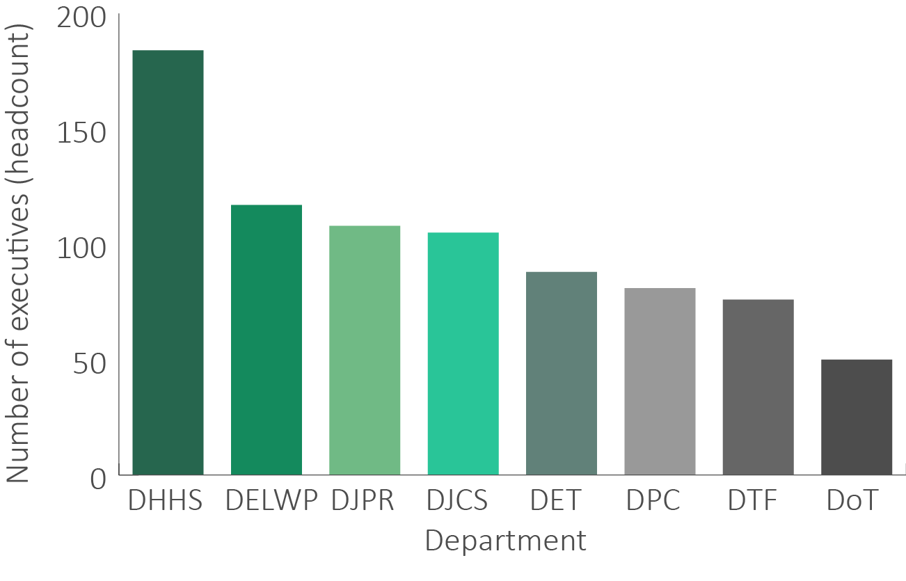
Sources: departmental annual reports 2018-19.

Administrative Offices
AOs are public service bodies established by the Governor in Council under section 11 of the PAA to undertake specific tasks. Under the PAA, AOs are established in relation to a department, are not incorporated and do not have a separate legal identity.
At 30 June 2019, there were 13 AOs (table 2.1 overleaf) compared to 10 in 2015.
Table 2.1: VPS Administrative Offices, June 2019
AO | Purpose
Family Safety Victoria | Deliver family violence reform and drive action to end family violence.
Latrobe Valley Authority | Bring together local people, councils, industry, education providers and governments to secure the future of the Latrobe Valley.
Local Government Inspectorate | Dedicated integrity agency for local government.
Major Transport Infrastructure Authority | Oversee planning and construction for major transport projects.
Office of Projects Victoria | Provide quality advice to the Government on developing and building major infrastructure projects.
Office of the Chief Parliamentary Counsel | Transform policy into legislation and advise the Government on its legislative program.
Office of the Governor | Provide support to the Governor and their partner in carrying out all aspects of their official duties for the benefit of the community.
Office of the Victorian Government Architect | Provide leadership and independent advice to the Government about architecture and urban design and promote awareness about how good design can make great places for people.
Public Record Office Victoria | Maintain the archives of the Government and manage these for use by the Government and people of Victoria.
Safer Care Victoria | Work with patients, families, clinicians and health services to monitor and improve the quality and safety of care delivered across our public health system.
Service Victoria | The Government’s dedicated customer service delivery agency.
Victorian Agency for Health Information | Analyse and share information across Victoria’s healthcare system, to help build an accurate picture of public and private hospital and health service performance.
Victorian Government Solicitor’s Office | Provide legal advice and services to the Government and its entities.
Note: Three new AOs have been established since June 2019: Suburban Rail Loop Authority, Bushfire Recovery Victoria and Mental Health Reform Victoria.

The Board’s submission cited above noted that there has been an increase in the number of AOs established to support the Government’s delivery of projects and reforms.
AOs have been a major contributor to the growth in VPS staff numbers.
The number of AO staff has risen from around 850 in June 2015 to over 2,600 in June 2019 (figure 2.2). This reflects the establishment of bodies such as the Major Transport Infrastructure Authority (MTIA), which employed 1,617 staff (headcount), and Family Safety Victoria, which employed 310 staff (headcount), as at June 2019.
Figure 2.2: number of employees (headcount) in AOs, June 2015 and June 2019
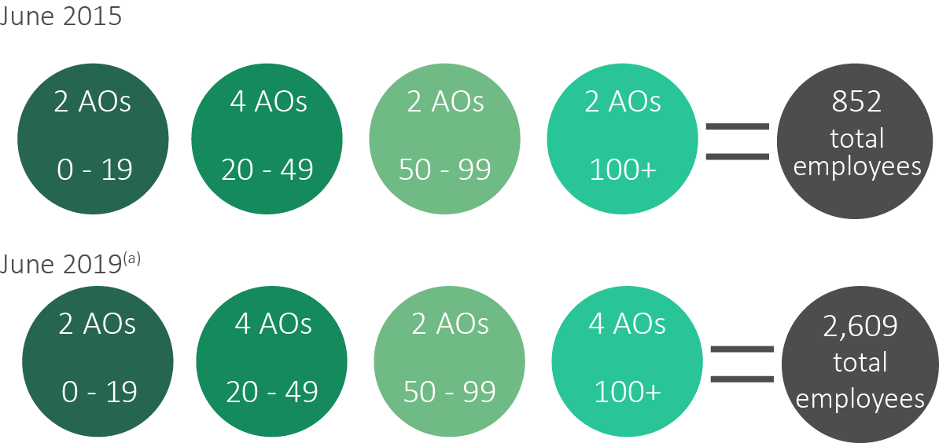
Note: (a) Employee numbers not available for Office of Projects Victoria in 2019.
Sources: VPSC, The State of the Public Sector in Victoria 2014-15; departmental annual reports 2018-19.
At 30 June 2019, the MTIA employed around 150 executives (figure 2.3 overleaf), accounting for:
- 17 per cent of the total VPS executive workforce
- nearly half of the growth in the VPS executive workforce since 2015.
Figure 2.3: number of executives (headcount) employed in AOs focused on infrastructure delivery, June 2015 – June 2019
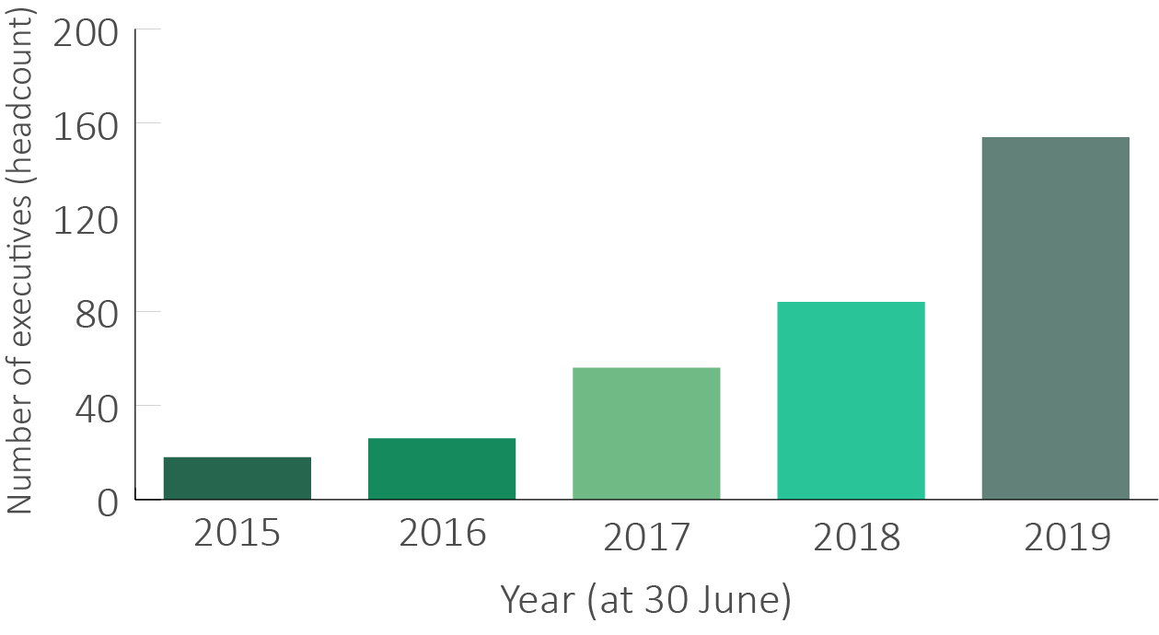
Notes: Includes executives employed in the following administrative offices: MTIA, established on 1 January 2019; the Level Crossing Removal Authority, Major Road Projects Authority, North East Link Authority, Rail Projects Victoria, West Gate Tunnel Authority which were merged into the MTIA on 1 January 2019; Regional Rail Link Authority, abolished on 2 June 2016.
Source: VPSC executive workforce data collection 2014-15 to 2018-19 (VPSC).

2.2 Roles of public service body Heads
Each public service body has a public service body Head:
- departments are headed by Secretaries
- AOs are headed by AO Heads
- the Victorian Public Sector Commission (VPSC) is headed by the Commissioner.
Public service body Heads assume the stewardship, leadership and direction of, and accountability for, the effective operation of their agencies. They have widespread responsibilities as leaders, employers and office holders with legislated duties and powers. They play a key leadership role within the Victorian public sector and nationally on matters relevant to their areas of responsibility and are expected to develop strategic relationships both within government and externally.
The following section outlines the roles undertaken by the different types of public service body Heads.

Secretaries of departments
Each department is headed by a Secretary, who is employed by the Premier of Victoria, generally on the same standard terms and conditions as other executives employed in the VPS.
In broad terms, the role of a Secretary encompasses:
- administering a department, including associated statutory responsibilities
- providing leadership within their department and across the broader public sector
- advising on, and assisting, public entities within their portfolio.
Secretaries have been given additional roles and responsibilities in the wake of the COVID-19 outbreak. As well as their usual departmental responsibilities, Secretaries have been commissioned to lead one of the eight new missions established to respond to the social, health and economic impacts of the pandemic. Secretaries are being supported to undertake these new responsibilities through the creation of an ‘Associate Secretary’ position in most departments. The functions and responsibilities of these roles are negotiated between the Secretary and Associate Secretary and may vary across departments.
Role as department Head
A department Secretary is responsible to a Minister or Ministers for the general conduct and the effective, efficient and economical management of the functions and activities of their department.
Some Secretaries have statutory policy and program responsibilities conferred on them under various Acts. For example, the Secretary of the DHHS has a legal responsibility to promote the prevention of child abuse and neglect and to assist children who have suffered abuse and neglect.

Oversight of ‘super-departments’
Traditionally in Australia, a single Secretary was responsible to a single Minister. However, the rise of the ‘super-department’ in Victoria and other jurisdictions, where several related portfolio areas are brought under one departmental structure, means that a single Secretary is responsible for supporting several Ministers.
In Victoria, former Premier Jeff Kennett reduced the number of departments from 20 to eight between 1992-1999. The number of Victorian departments has since remained at around eight to ten, while the number of Ministers has stayed at around 22.
As at 30 June 2019, the Secretary of DPC supported seven Ministers whereas the Secretaries of DTF and DET supported two Ministers each (figure 2.4).
Figure 2.4: number of Victorian Ministers by government department, June 2019
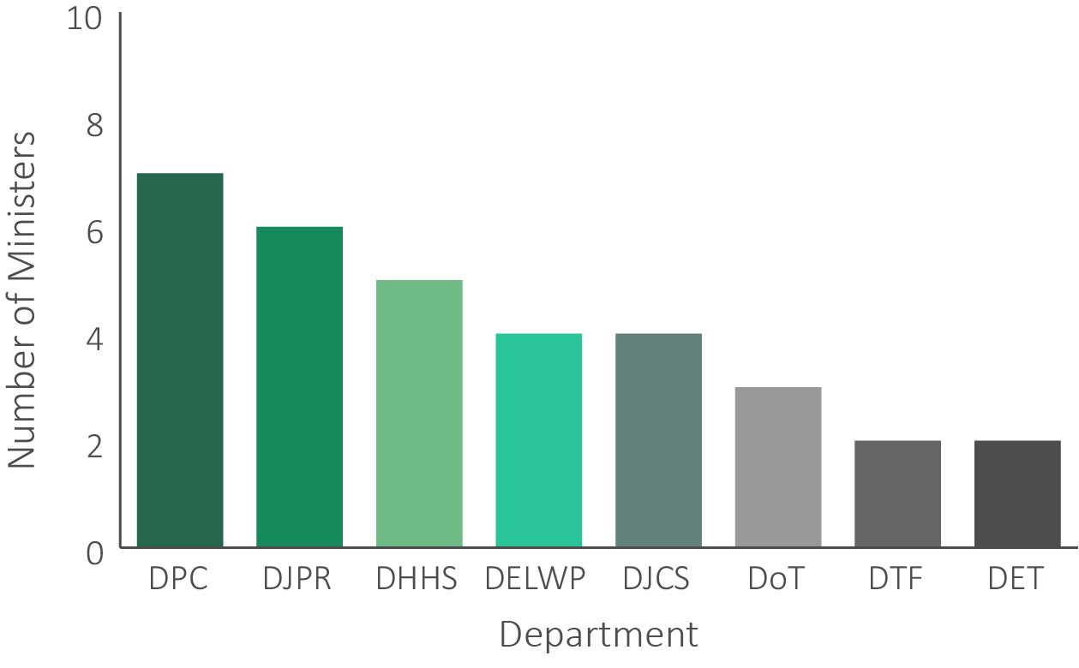
Sources: department annual reports 2018-19.
The creation of ‘super-departments’ aims to better facilitate cross-portfolio policy development and allow a more holistic approach to implementing the government’s priorities. For example, in 2015, the sports, medical research, health and human services portfolios were brought together under the Department of Health and Human Services as these areas were identified as key drivers of wellbeing for Victorians. Bringing these areas into a ‘single department’ was also aimed at assisting the government to respond to some difficult areas of public policy, such as socio-economic participation.
’Super-departments’ may also:
- bring together diverse areas to identify priorities for collaboration and relationship building
- provide a single point of accountability to allow the Minister or Parliament to more easily assess the performance of a department or policy initiative.
One of the consequences of moving to a ‘super-department’ construct is that it has significantly increased the complexity of the role of Secretaries, requiring Secretaries to understand and have detailed knowledge of several diverse and multifaceted portfolios, sectors and policy initiatives. They must account to their Ministers and the Parliament for the performance of their departments across broad spans of public policy and program and project delivery.
Beyond these functional responsibilities, Secretaries have a duty of leadership. It is to the Secretary of the department that employees look to establish and articulate a vision, strategic direction and set of values for the department ‍– values they must constantly demonstrate through their own day-to-day behaviours in the workplace. Secretaries must also ensure that all the necessary workplace policies, practices and systems required to support the achievement of a high-performing public service are adopted and observed.
Role as whole-of-government leaders
All department Secretaries, along with the Chief Commissioner of Victoria Police and the Commissioner of the VPSC, are members of the Victorian Secretaries’ Board. The Board coordinates policy initiatives across the public sector and promotes leadership and information exchange in the public service.
In a 2015 speech, DPC Secretary Chris Eccles outlined his view of the role of the Board and its purpose:
… departmental secretaries together with the Chief Commissioner of Police and the Victorian Public Sector Commissioner… collectively provide coordination, leadership and stewardship of the public sector… Our shared vision is to drive high quality public policy, public administration and public sector performance for the benefit of all Victorians.
The DPC Secretary noted that this requires the members of the Board to:
- share information and ideas
- form a coherent view on issues of strategic importance
- promote collaboration across departments and agencies, consistent with individual roles and responsibilities
- uphold the highest standards of public administration, professionalism and integrity.
In response to COVID-19, some of the functions of the Board relating to the day-to-day administration of the public sector has been transferred to the new Public Sector Administration Committee (PSAC). PSAC has also absorbed the Integrity and Corporate Reform Sub-Committee of the Board.
Role as Mission Leads
The Premier has commissioned the Secretaries of each department as ‘Mission Leads’ who are responsible for short-, medium- and long-term planning for the missions established to respond to the social, health and economic impacts of the pandemic. The DPC Secretary leads the Missions Coordination Committee which includes all of the Mission Leads and some DPC Deputy Secretaries.
The missions have been designed to respond to and fix emerging issues during COVID-19 and may cut across traditional portfolio areas. Mission Leads also coordinate advice relating to their mission to support the Premier in National Cabinet and are responsible for ensuring that relevant Coordinating Minister/Portfolio Minister positions are taken into account.
Role in relation to portfolio entities and AOs
In addition to their departmental responsibilities, Secretaries also have a number of obligations under the PAA in relation to any public entities and AOs relevant to the department.
The Victorian public sector is established on a devolved governance framework. This framework allows non-departmental bodies with public functions (such as hospitals and health services, waste management authorities and emergency service providers) to conduct their day-to-day operations at ‘arms-length’ from government.
In large departments, portfolios can span very diverse sectors. For example, the Secretary of DJPR has responsibility for public entities which encompass the sports, arts and forestry sectors.
For public entities, the Secretary is required to:
- provide advice to the Minister on matters relating to the public entity, including the discharge by the entity of its responsibilities
- work with, and provide guidance to, public entities to assist the entity on matters related to public administration and governance.
Secretaries also have specific legislative obligations in relation to AOs. For AOs, Secretaries are responsible for reporting to the Minister on the effective, efficient and economical management of the functions and activities of any AOs established in relation to the department.
The Secretary is also responsible for:
- providing advice and support to the department’s portfolio agencies in relation to financial management, performance and sustainability
- supporting Ministers in the oversight of portfolio agencies and their portfolio as a whole, including providing information on agencies’ financial management, performance and sustainability
- providing information to DTF to support the Government’s delivery of sound financial management.
Overview of span of existing Secretaries’ responsibilities
Table 2.2 sets out for each existing Secretary:
- the number of Ministers serviced
- departmental staffing structures
- departmental budget allocation.
The Secretary of DHHS oversees the highest number of staff and has the largest budget. The Secretary of DPC services the most Ministers. The Secretary of DTF has the lowest number of staff and the smallest budget.
In addition, as explained above, Secretaries may have responsibilities in relation to a large number of portfolio entities. For example, the Secretary of DELWP is responsible for providing advice on over 1,000 entities (the majority of which are Committees of Management).
The data in the table serve to illustrate the range of some of the key metrics that define the various departments that make up the Victorian system. They should not be taken as suggesting a hierarchy of individual Secretary roles. Various factors, other than the size of the budget and the number of employees need to be taken into account in determining the ultimate work value attaching to each role. For example, the central agencies have significant whole-of-government co-ordination and leadership responsibilities that are not present to the same degree in the line agencies.
Table 2.2: summary of existing Secretaries span of responsibilities, June 2019
Department | No. of Ministers | Headcount (non-executive) | Headcount (executive) | Budget 2018-19  $b actual^{(a)} | No. of direct reports^{(b)}
DET | 2 | 4,096 | 88 | 15.2 | 12
DELWP | 4 | 4,084 | 117 | 2.8 | 8
DHHS | 5 | 11,057 | 184 | 27 | 13
DJPR | 6 | 2,658 | 108 | 1.6 | 10
DJCS | 4 | 10,023 | 105 | 7.5 | 11
DPC | 7 | 1,008 | 82 | 0.7 | 8
DoT | 3 | 635 | 50 | 9.4 | 10
DTF | 2 | 619 | 76 | 0.6 | 6
Notes: (a) Income from transactions for 2018-19 as reported in departmental annual reports; (b) based on organisation charts for each department.
Sources: departmental annual reports 2018-2019.

Commissioner of the Victorian Public Sector Commission
The VPSC is responsible for strengthening the efficiency, effectiveness and capability of the Victorian public sector. It is also responsible for maintaining and advocating for public sector professionalism and integrity.
The Commissioner also provides authoritative policy advice and briefings to Ministers and to the Government, including on the delivery of Commission-led programs and services.
As with other public service body Heads, the Commissioner is expected to build and maintain relationships within and across the Victorian public sector, the private sector and the broader Victorian community to deliver VPSC programs and services.
Sections 39 and 40 of the PAA outline the responsibilities of the VPSC in relation to the Victorian public sector (box 2.1).
Box 2.1: summary of VPSC functions under the PAA
Source: PAA, ss 39, 40.
Section 39: public sector efficiency, effectiveness and capability
- to assess and provide advice and support on issues relevant to public sector administration, governance, service delivery and workforce management and development;
- to conduct research and disseminate best practice in relation to public sector administration, governance, service delivery and workforce management and development;
- to collect and report on whole-of-government data;
- to conduct inquiries as directed by the Premier.
The VPSC must perform any work falling within its functions under s39 as requested by the Premier and may perform any work as requested by a Minister or a public sector body.
Section 40: public sector professionalism and integrity
- to advocate for an apolitical and professional public sector;
- to issue and apply codes of conduct and standards;
- to monitor and report to public sector body Heads on compliance with the public sector values, codes of conduct, and public sector employment principles and standards;
- to review employment related actions and make recommendations following those reviews
- to maintain a register of lobbyists and a register of instruments.
In performing a function specified in s40 a) to d), the Commission is not subject to Ministerial direction or control.

Administrative Office Heads
Each AO is led by an AO Head, who is employed by the Premier generally on the same standard terms and conditions as other executives employed in the VPS.
AO Heads employ their own staff under the PAA and perform activities under the direction and control of Ministers. The PAA confers on the AO Head the same functions as a Secretary in relation to a department.
The governance arrangements for AOs can be complex and require an AO Head to have a sound understanding of the different reporting arrangements in place (figure 2.4 overleaf). For example, AO Heads report to the:
- Premier on matters of their own employment and remuneration
- relevant department Secretary on the management of the AO
- relevant portfolio Minister on the performance and activities of the AO.
To assist the Secretary to perform their functions in relation to the AO (e.g. financial reporting), the AO Head is required to report to the Secretary on the general conduct and efficient, economical and effective management of the AO. However, the AO Head does not report to the Secretary of the department on functions which have been conferred on the AO Head by any other Act (e.g. Family Violence Prevention Act 2008 (Vic)).
Some AOs are responsible for the delivery of significant government projects or priorities, such as the MTIA or Family Safety Victoria. Other AOs, such as the Office of the Chief Parliamentary Counsel, provide an “arms-length” service to the VPS.
The size and complexity of AOs varies. For example, at 30 June 2019, the MTIA employed 1,463 (headcount) non-executive employees, 154 (headcount) executives and administered a project budget of $70 billion, while the Office of the Chief Parliamentary Counsel employed four (headcount) executives and 39 (headcount) non-executive employees.

Figure 2.4: typical governance and reporting arrangements for Administrative Offices in Victoria
Premier
Minister
Secretary
AO Head
AO
AO is established as a public service body
AO Head may report directly to Ministers on the performance of the AO functions
Secretary reports to Ministers on the conduct and management of the AO
AO Head reports to Secretary on the conduct and management of the AO
Premier employs Secretary and AO Head directly
Source: Tribunal’s analysis.

2.3 Roles of subordinate executives
Public service body Heads employ subordinate executives to deliver the government’s objectives for their organisations.
There is no single role description for a subordinate executive. The particular duties of each executive will vary depending on their role and employer. The VPSC’s revised subordinate executive classification framework notes that VPS executive roles may include responsibility for one or more of the following:
- large scale service delivery
- the direction of program or project-based delivery functions
- development or implementation of public policy
- development and implementation of compliance and enforcement programs
- the provision of expertise which ensures the integrity of decision-making and planning processes of government.
In undertaking their roles, VPS executives may be expected to represent their department or agency on high-level inter-agency committees, multi-disciplinary teams and special task forces.
Executives must also uphold and demonstrate the values of the VPS Code of Conduct and support all VPS staff to achieve high performance across the VPS.
While executive roles differ, there are some common components, including:
- setting the strategic direction for their area of responsibility
- contributing to the leadership and continuous improvement of their unit by making decisions about the way goals are achieved and priorities are set
- providing authoritative advice and support to their agency Head, Ministers and the broader public sector
- managing and maintaining close liaison and effective relationships with stakeholders including both government and non-government bodies
- ensuring compliance with legislation, directives, policies, regulations and processes.

The revised classification framework notes that executive roles generally require eight core competencies (table 2.3).
Table 2.3: summary of core competencies of VPS executives
Competency | Definition
knowledge | level of required knowledge; skills and expertise; proficiency in a specialised discipline; level of authority; depth of understanding of the work environment.
relationships | requirement to influence and negotiate; interact with internal and external stakeholders; level of sensitivity and complexity of issues and interactions.
judgement and risk | level of required judgement and degree of ambiguity inherent in the role; degree to which role must consider alternative courses of action; level of risk to be mitigated.
independence | requirement to make decisions without support; authority and freedom to plan objectives; requirement to contribute to or lead whole of entity strategic direction.
strategic change | extent of responsibility for significant strategic change management or reform agenda; contribution to business improvement; impact and complexity of change.
impact | scope of role’s impact within an organisation, into the sector, across state, national or international impact.
breadth | diversity of activities; geographical breadth of responsibility; variety of products and services to be managed by the role.
resource management | number of staff and size of resources and budget.
Source: VPSC revised executive classification framework, 2019.

2.4 Changing nature of the role of executives
The Tribunal invited approximately 1,000 VPS executives to make a submission via an online questionnaire in order to understand the roles and responsibilities of executives, the motivations of executives and how current arrangements could be improved. The questionnaire also asked executives to provide comment on any trends or significant changes over the last five years that have affected their role.
Executives reported that the expectations and demands placed on them and their role over the last five years has grown “dramatically”. For example, one executive stated:
[there is an] increased pressure to support Ministers, respond to 24 [hour] media cycle, very low risk tolerance, on call around the clock.
And another responded:
EO roles in the VPS are far more complex and nuanced than they were five years ago. The span of responsibility is far broader and there are increasing difficulties in recruiting and retaining the right capability underneath at the VPS level.
Executives commented on the need to navigate a more uncertain political environment. For example, one respondent mentioned:
… having to navigate the complexities of a less certain political environment and one in which Ministers (and the public) are fairly demanding in their expectations of what can be done.
Increasingly interconnected and complex policy problems require executives to be able to recognise and build relationships with key partners across government, business, community and not-for-profit sectors. One executive noted the growing need for executives:
… to work collaboratively with other government agencies from a Place Based perspective to deliver appropriate services to not just clients that are vulnerable, but the entire population within geographical local government areas.
As discussed in relation to the role of Secretaries, executives in departments are also facing complex challenges as a result of the ‘super-department’ structure. Secretaries rely on their executive leadership team to provide the necessary expertise and advice required by Ministers. In 2015, the then Secretary of the Department of Economic Development, Jobs, Transport and Resources noted:
… [Ministers] would be foolish to rely on me, when on every subject or even most subjects there’d be people in the department who know more than me…
The Tribunal’s consultations revealed that in many instances, the role of a Deputy Secretary has become more like that of a ‘mini-Secretary’. In the past, the Secretary would have been the primary, and sometimes only, contact point for a Minister or Minister’s Office in a department. However, due to the breadth and scale of departmental responsibilities, it is now more common for a Deputy Secretary, and occasionally an Executive Director, to have a deep relationship with the Minister’s Office and the Minister themselves. One executive noted:
[there is] increasing face to face time with ministers, which is a positive development.
Finally, the Tribunal was informed that executives are spending more time undertaking technical tasks related to a project rather than providing a high-level strategic overview to the project, a marked difference from the expectation on the role of an executive in previous years. For example, one executive commented that:
In recent years there appears… to be a depletion of funded FTE to support an orthodox executive structure. This has resulted in a significant uptick of executives doing so-called 'non-executive work', such as developing and drafting policy advice, having a deep role in the preparation of business cases, preparing Cabinet submissions and the routine documents of government. This has come on top of, and sometimes at the expense of, the executives' regular strategic and organisational workload.

Current and future challenges
VPS executives are being challenged to deliver the increased scale of investment in public infrastructure to support the needs of a growing population and changing demographic. They are also increasingly expected to co-ordinate across government to respond to complex policy issues that are often multifaceted and require responses from a range of stakeholders.
The outbreak of COVID-19 has further demonstrated the need for executives to have the skills to work in highly complex and rapidly changing environments. The demands on executives have also increased, with many executives required to develop, implement and communicate difficult and complex policies to deal with an unforeseen global crisis. At the same time, executives have had to transition themselves and their teams to remote work.

Further challenges for VPS executives arise from advances in technology, for example:
- changes in the way Victorians communicate and conduct business, and the increasing expectation that government services should adapt to citizens’ changing preferences via technological solutions
- the increased use and integration of technology to deliver government services increases cyber security and privacy protection requirements
- the fastest growth in demand for technology workers is expected to be in the health care sector, an area traditionally the domain of the public sector.
The rate of introduction of new technologies and the rapidly growing part played by these increasingly complex systems in the delivery of government priorities means that responsibility for the operation and integrity of these systems can no longer be left to information technology specialists. Given the personal and agency reputational damage that flow from the failure of these systems, a high level of technological literacy increasingly forms part of the core competency of every executive role.

Summary
Public service body Heads and subordinate executives are critical to the successful delivery of policy and programs to the Victorian community.
Public service body Heads assume the stewardship, leadership and direction of, and accountability for the effective operation of their agency. They also have widespread responsibilities as leaders, employers and office holders with legislated duties and powers.
Subordinate executives are expected to set the strategic direction for their area of responsibility, provide authoritative advice and support to their agency Head, Ministers and the broader public sector. They also manage and maintain close liaison and effective relationships with government and non-government stakeholders. As the public sector evolves to deliver the priorities of government, the demands on VPS executives are increasing. Executives require a broader skillset and knowledge to respond to increased government and community expectations, advances in technology and complex policy issues.

3 Existing employment and remuneration framework
Prior to the Determination, the remuneration framework for executives employed in the Victorian Public Service (VPS) was in operation for approximately 25 years. While adjustments have been made, the remuneration framework has not been comprehensively reviewed by an independent body since its creation.
Section 21(1)(a) of the Victorian Independent Remuneration Tribunal and Improving Parliamentary Standards Act 2019 (Vic) (VIRTIPS Act) requires the Tribunal to consider the existing remuneration provided to executives employed in public service bodies under the Public Administration Act 2004 (Vic) (PAA).
This chapter outlines the existing employment and remuneration policies applicable to VPS executives, and identifies movements and trends in remuneration arrangements over the last ten years.

3.1 Employment policy
The Victorian Public Sector Commission (VPSC) publishes and maintains the VPS Executive Employment Handbook and the Standard VPS Executive Contract (standard contract), which are approved by the Premier.
Prior to the Determination, the Handbook and standard contract, together with the PAA, governed how VPS executives, including public service body Heads, were employed and paid. This contrasts with non-executive VPS employees, who are covered by the VPS Enterprise Agreement 2016 (Enterprise Agreement).
The contract sets out employment details, including the remuneration package, performance standards and other employment conditions. The PAA requires all VPS executives to be employed on a contract of no more than five years, in contrast with non-executive VPS employees who are typically employed on an ongoing basis. The standard contract is mandated for the employment of all VPS executives. All VPS executive contracts have common conditions (table 3.1).
Table 3.1: summary of key employment conditions for VPS executives
Provision | Conditions
Contract term | Maximum contract term is five years.  Contracts cannot be extended but may be renewed.
Performance management | All executives must have a written performance plan that must be reviewed by the employer at least once a year.
Reimbursement | Reimbursements may be available for:  - necessary and reasonable relocation expenses  - travelling and personal expenses  - telephone expenses, if the executive is required to make official calls or be available by phone outside normal working hours  - living away from home expenses if the executive lives away from their usual place of residence for a short-term assignment.
Paid leave | - 20 days annual leave per year  - 15 days of personal leave per year  - Parental leave (14 weeks primary caregiver, 4 weeks secondary caregiver)  - 3 days of compassionate leave (per event)  - 20 days of family violence leave per year  - Up to 52 weeks of leave as a result of a work-related injury  - For every 10 years continuous service, 3 months of long service leave.
Termination | - An employer can terminate a contract at any time (‘at will’), without showing cause, with four months’ notice or pay in lieu of notice  - If the executive has significantly failed to fulfil the required duties and obligations of their role, an employer can terminate the contract subject to four weeks’ notice or pay in lieu of notice  - An employer may terminate an executive’s employment with immediate effect without notice if the executive commits any act of serious misconduct.
Right of return | In cases where an executive’s contract is terminated for reasons other than misconduct, the executive is entitled to be employed as a Senior Technical Specialist (STS), provided the executive has been continuously employed as an executive and was a non-executive VPS employee immediately prior to becoming an executive.
Sources: PAA; VPS Executive Handbook; VPS standard contract.

3.2 Remuneration policy
The Handbook and standard contract set out the components of an executive’s total remuneration package (TRP), defined as the sum of:
- base salary
- superannuation contributions
- employment benefits (i.e. non-salary) specified in the executive’s contract of employment
- the annual cost to the employer of providing the non-monetary benefits, including any fringe benefits tax payable.

Remuneration structure for public service body Heads
Prior to the Determination, there was no formal remuneration structure to cover all public service body Heads.
When the existing executive remuneration band framework was created in 1995, Secretaries of departments were classified as Executive Officer Level 1 (EO-1) and remunerated within the EO-1 band. Changes in the use of the framework over time have meant that Secretaries now sit outside of the remuneration band framework and TRPs for Secretaries are determined on a case-by-case basis by the Premier.
Since 2018, an informal ‘grouping’ of Secretaries has arisen. Consistent with all other Australian jurisdictions, the Secretaries of the Department of Premier and Cabinet (DPC) and the Department of Treasury and Finance (DTF) receive higher TRPs than other Secretaries. The Secretary of the Department of Health and Human Services receives the next highest remuneration. The remaining Secretaries have the same TRP and the Commissioner of the VPSC receives a TRP that is slightly lower, but higher than nearly all Administrative Office (AO) Heads.
As at 30 June 2019, Secretaries and the Commissioner were paid within a range of $530,000 to $650,000 per annum (p.a.).
The Tribunal mapped the remuneration for AO Heads against the existing subordinate executive remuneration bands. At 30 June 2019, almost all existing AO Heads were paid within the existing subordinate executive remuneration bands:
- six were paid within the EO-2 band
- five were paid within the EO-1 band
- two were paid outside of the EO-1 band.

Remuneration structure for subordinate executives
Public service body Heads are the employers of subordinate executives. Subordinate executive roles are classified into three work value levels that are tied to remuneration ranges. Prior to the Determination, the Premier was responsible for setting the values of each of the remuneration bands (table 3.2).
Table 3.2: VPS executive remuneration bands, July 2019
Band | Description | Minimum TRP ($ p.a.) | Maximum TRP ($ p.a.)
EO-3 | Program, policy and service delivery managers, regional and area managers in some departments and agency heads of smaller agencies. | 185,711 | 240,789
EO-2 | Deputy Secretary and agency heads of major agencies, divisions or significant programs. | 214,883 | 343,938
EO-1 | Head of a substantial public authority, the most senior program managers and Deputy Secretaries in the VPS. | 312,274 | 457,081
Source: VPSC Handbook.
As at 30 June 2019, public service bodies employed around 1,000 subordinate executives, comprising:
- 53 EO-1s, with an average TRP of approximately $391,000 p.a.
- 430 EO-2s, average TRP of approximately $283,000 p.a.
- 529 EO-3s, average TRP of approximately $204,000 p.a.
Prior to the Determination, the remuneration bands for subordinate VPS executives overlapped due to adjustments being made to the top but not the base of the bands. In total, approximately 290 executives were paid within the overlapping portions of the bands as at 30 June 2019, with around 149 EO-3s and 58 EO-2s having a TRP that fell within the overlap between the EO-3 and EO-2 bands (figure 3.1 overleaf).
Figure 3.1: executives with a TRP that fell within the overlapping portion of the bands, June 2019
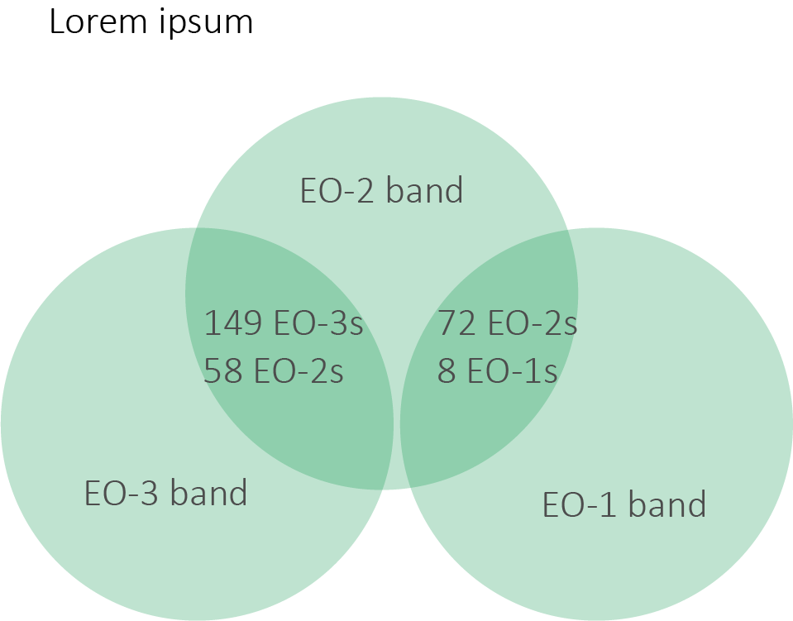
Source: VPSC executive workforce data collection 2019.
Eight EO-3s, 33 EO-2s and six EO-1s were paid above their relevant remuneration band as at 30 June 2019. The Major Transport Infrastructure Authority employed around 77 per cent of the executives paid above their relevant remuneration band.
Figure 3.2 illustrates the structure and distribution of the VPS executive remuneration framework prior to the Determination. There was:
- a five per cent gap between the top of the remuneration band for the highest non-executive grade, VPS-6, and the bottom of the EO-3 band
- an overlap of around $26,000 between the top of the EO-3 band and the base of the EO-2 band
- an overlap of around $32,000 between the top of the EO-2 band and the base of the EO-1 band
- a 16 per cent gap between the top of the EO-1 level and the lowest paid individual in the Secretary/Commissioner group.

Figure 3.2: overview of VPS executive remuneration arrangements,^{(a)} July 2019
Secretaries/VPSC Commissioner
VPS-6
EO-3
EO-1
Base EO-3
$185,711
Base EO-2
$214,883
Top EO-3
$240,789
Top EO-2
$343,938
Top EO-1
$457,081
Base EO-1
$312,274
Overlap between top EO-3 and base EO-2: $25,659
Overlap between top EO-2 and base EO-1: $31,664
Top VPS-6^{(b)}
$176,854
Base of range
$530,000
Top of range
$650,000
5% gap
16% gap
EO-2
6 AO Heads

5 AO Heads

1 AO Head

1 AO Head
Notes: (a) Not to scale; (b) includes a notional employer superannuation contribution of 9.5%.
Sources: VPSC executive workforce data collection 2019; Victorian Public Service Enterprise Agreement 2016 [AG2016/2919].

Opportunities for adjustments to remuneration
The standard contract provides for the annual review of an executive’s remuneration. The Handbook requires employers to assess the performance of an executive when adjusting remuneration.
An executive’s remuneration may be adjusted annually by their employer up to a maximum rate set by the Premier. This is known as the ‘guideline rate’. In 2019-20 the guideline rate was set at 2 per cent. The Handbook also provides for an employer to agree to undertake an ad hoc review of an executive’s remuneration at any time in recognition of changes in responsibility, accountability or for retention purposes.
Unlike eligible VPS staff covered by the Enterprise Agreement, there is no formal process for executives who meet their performance criteria to progress through their relevant remuneration band.

Non-salary benefits
Under the Handbook, executives are able to include non-salary beneﬁts as part of their TRP, including:
- a motor vehicle obtained through the Executive Vehicle Scheme
- a motor vehicle obtained through a novated leasing arrangement
- the VPS health insurance scheme
- salary sacrificed superannuation contributions.
Executive Vehicle Scheme
Executives can access a motor vehicle under a salary sacrifice arrangement where the executive contributes to the cost of the vehicle. Executives who chose to include a motor vehicle in their TRP are responsible for:
- two thirds of the approved costs of the vehicle and any accessories agreed with the employer through a salary sacrifice plan
- paying all e-tags and tolls
- paying the associated fringe benefits tax
- ensuring the vehicle is available for business use during business hours, if required.
Employers are responsible for:
- meeting one third of the approved costs of the vehicle
- arranging provision of fuel cards
- providing car parking at work sites
- maintenance, insurance and servicing of the vehicle, and arranging accident management services and manufacturer’s roadside assistance.
As at November 2019, the average cost to an executive who chose to include a motor vehicle in their remuneration package was approximately $17,000 p.a.
Other benefits
The Tribunal’s consultations also revealed other benefits to executives of working in the VPS, such as:
- flexible work arrangements, for example, the ability to negotiate part-time work arrangements and opportunities to work from home
- professional development opportunities, including those offered through the Victorian Leadership Academy
- the nature of the work done by the public service, for example, the opportunity to give back to the community
- the opportunity to work on a variety of projects, due to the breadth of work carried out by the VPS.

3.3 Trends in executive remuneration
Over the last ten years, subordinate executive remuneration bands have generally been adjusted in line with movements in wages and prices in the Victorian economy.
From 2009 to 2015, adjustments were in the order of 2.5 to 3.0 per cent p.a. and from 2017 to 2019 adjustments were limited to 2.0 per cent p.a. Small adjustments to the top of the bands were also made due to increases in the Commonwealth’s superannuation guarantee rate (table 3.3 overleaf).

Table 3.3: movements in VPS executive remuneration bands, 2009 – 2019
Year | Changes to remuneration bands
2009 | Bands increased by 2.5% based on Premier’s guideline rate.
2010 | Bands increased by 3% based on Premier’s guideline rate.
2011, 2012 | Bands increased by 2.5% based on Premier’s guideline rate.
2013, 2014 | - Bands increased by 2.5% based on Premier’s guideline rate.  - Top of bands increased further by 0.23% due to increase in the Commonwealth’s superannuation guarantee rate.
2015 | Bands increased by 2.5% based on Premier’s guideline rate.
2016 | - Bands increased by 2.5% based on Premier’s guideline rate.  - Bands increased by 4% to match bonus buy-out rate offered to executives.  - The base of the EO-3 band increased to $175,000 p.a.
2017, 2018, 2019 | Bands increased by 2% based on Premier’s guideline rate.
Sources: DPC; VPSC The State of the Public Sector in Victoria reports 2009 – 2019.

2016 changes to remuneration bands
Significant changes were made to the remuneration bands in 2016 in response to the recommendations of the VPSC’s Review of Victoria’s Executive Officer Employment and Remuneration Framework.
Removal of bonus opportunities
The review recommended that bonus opportunities be removed from executive contracts as they did not drive performance for VPS executives, in part because of their small size relative to TRPs. While executives were eligible for a bonus opportunity of up to 17 per cent, the average bonus paid across all executives was only five per cent.
In 2016, bonus opportunities were removed from new contracts, while existing VPS executives were given the option of ‘buying-out’ their bonus opportunity, in return for a four per cent increase to their TRP. The top and bottom of each of the executive remuneration bands were also lifted by four per cent.

Increase in the base of the EO-3 band
The review found the remuneration for VPS-6 staff at the top of the band, taking into account employer superannuation contributions, had overtaken the base of the EO-3 band ($155,458 p.a. for VPS-6 staff compared with $152,560 p.a. for EO-3 staff). As a result, the base of the EO-3 remuneration band was increased to $175,000 p.a. from 1 July 2016. This created a gap of around nine per cent ($19,500) between the top of the VPS-6 band and the base of the EO-3 band when comparing TRPs.

Other trends
The Tribunal observed some other trends in the movement of executive TRPs between 2009 and 2019. These included:
- generally higher remuneration adjustments for non-executive staff compared with executives
- variation in the growth of Secretary TRPs, with greater growth for the lower-paid Secretary roles
- a greater proportion of executives classified at the EO-3 level being paid towards the bottom of the EO-3 band
- an increase in the average TRP for executives classified at the EO-2 and EO-1 levels.
Adjustments in VPS executive and non-executive remuneration
Between 2009 and 2019, executive remuneration (based on the guideline rates) rose by around 27 per cent in nominal terms, while non-executive remuneration rose by around 35 per cent in nominal terms. This comparison excludes the impact of progression payments for eligible non-executive VPS staff, and any adjustments for individual executives beyond the guideline rate.
The lower annual growth in the executive remuneration bands has resulted in the gap between the top of the non-executive VPS-6 remuneration band and the base of the EO-3 band contracting. In TRP terms, the gap has narrowed from nine per cent to five per cent. This is due to lower average annual increases to the EO-3 remuneration band (2.0 per cent p.a.) relative to enterprise agreement outcomes for non-executive staff (3.25 per cent p.a.) between 2016-17 and 2019-20 (table 3.4 overleaf).
Table 3.4: annual adjustments for executives and non-executives, July 2009 - July 2019
Year | VPS non-executive salary increases (%) | Executive TRP increases (%)
2009 | 2.00 | 2.50
2010 | 4.50 | 3.00
2011 | 0.00 | 2.50
2012 | 3.25 | 2.50
2013 | 2.75 | 2.50
2014 | 3.25 | 2.50
2015 | 3.25 | 2.50
2016 | 3.25 | 2.50
2017 | 3.25 | 2.00
2018 | 3.25 | 2.00
2019 | 3.25 | 2.00
Sources: DPC; VPSC, The State of the Public Sector in Victoria reports 2009 – 2019; Victorian Public Service Agreement 2006 [AG847284 varied by PR987723], Victorian Public Service Workplace Determination 2012 [AG895510], Victorian Public Service Enterprise Agreement 2016 [AG2016/2919].
Changes in actual TRPs
Between 2009 and 2019, the TRP of the DPC Secretary generally grew in line with the top of the EO-1 band, increasing by 30 per cent in nominal terms. The TRP of the DTF Secretary increased by 40 per cent, while the average TRP of other Secretaries increased by 46 per cent in nominal terms (figure 3.3).
Figure 3.3: Secretary TRPs (actual), June 2009 — June 2019
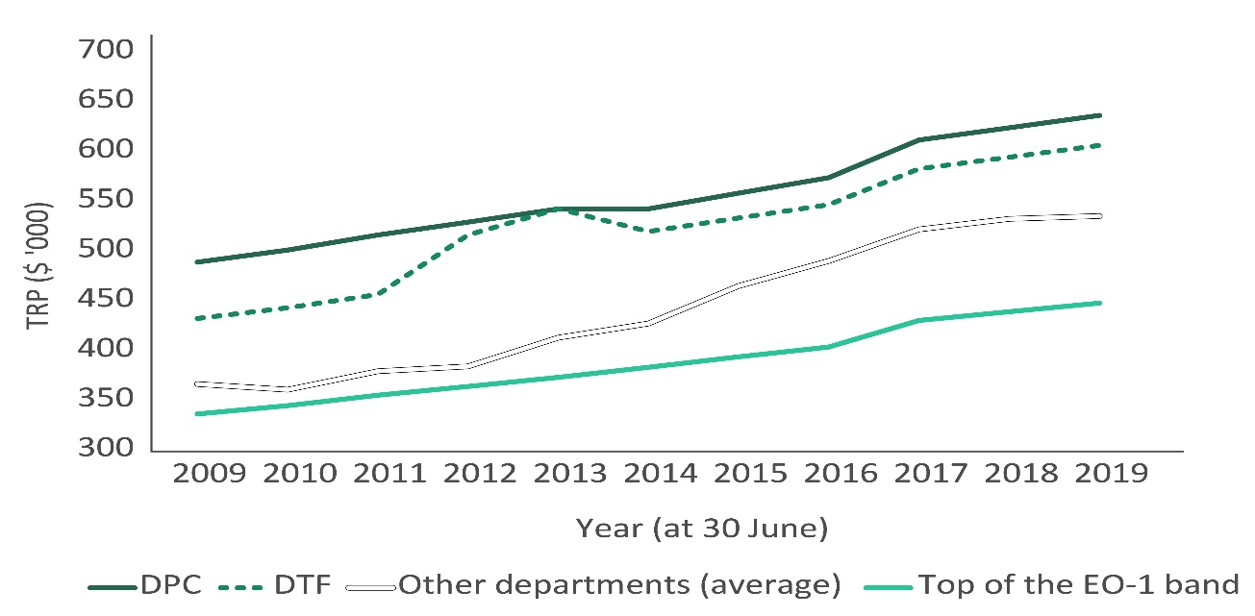
Sources: VPSC, The State of the Public Sector in Victoria reports 2009 – 2019; VPSC executive workforce data collections 2009 – 2019.
Between 2009 and 2019, the average TRP of subordinate VPS executives increased by approximately 41 per cent in nominal terms. EO-2 TRPs experienced the greatest growth (42 per cent overall), followed by EO-1 TRPs (38 per cent) and EO-3 TRPs (35 per cent) (figure 3.4).
Figure 3.4: annual change in average TRP of subordinate executives,^{(a), (b)}
June 2009 —June 2019
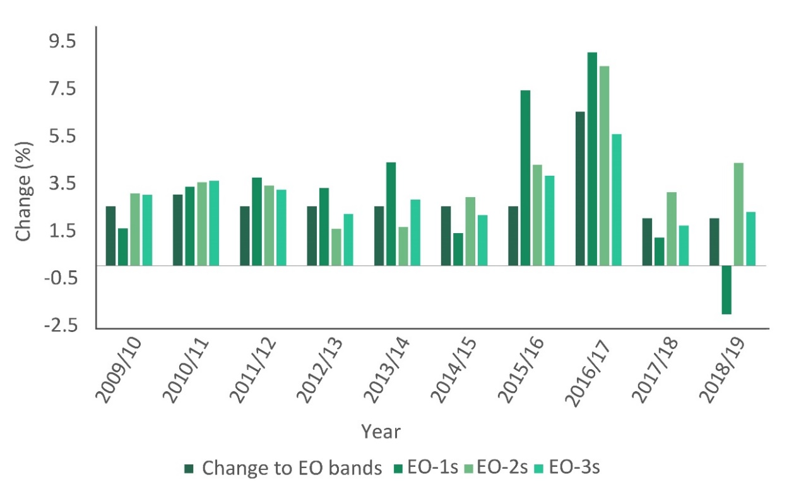
Notes: (a) change to EO-3 band excludes increase of the base of EO-3 band to $175,000 in 2016; (b) changes to EO bands and average TRPs in the 2016-17 financial year include increases to buy-outs of bonus opportunities.
Sources: DPC; VPSC, The State of the Public Sector in Victoria reports 2009 – 2019; VPSC executive workforce data collections 2009 - 2019.
Over the same period, subordinate executives employed in AOs experienced greater average TRP growth (79 per cent) than subordinate executives employed in other public service bodies (34 per cent). Changes in average TRPs should be treated with caution, as they include the four per cent TRP increases of executives who accepted the bonus buy-out offer. Those executives may not have received an overall increase in their annual take home pay despite an uplift in TRP. Some variation in TRPs over time is also to be expected given the movement of executives into and out of the VPS.
Changes in the distribution of subordinate executives within their bands
Prior to the Determination, there was a cluster of executives at the bottom of the EO-3 remuneration band (approximately 200 executives were paid below the 4th segment of the remuneration band). This appeared to be associated with the increase in the base of the EO-3 band from $152,000 to $175,000 p.a. When this change occurred, the TRPs of executives paid below the new base of the EO-3 band were automatically increased to $175,000 p.a. As a result, the average TRP of EO-3s moved from the middle of the band in 2009 towards the bottom third of the band in 2019 (figure 3.5).
Figure 3.5: distribution of EO-3 TRPs - 2009, 2014 and 2019
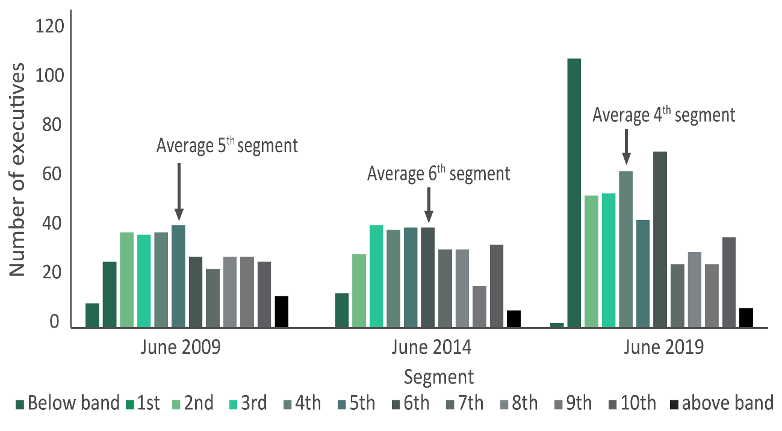
Source: VPSC executive workforce data collections 2009 – 2019.
From 2009 to 2019, the average TRP of executives classified as EO-2 or EO-1 increased from the 5th to 6th segment. There has also been an increase in executives at these levels being paid above the relevant band (figures 3.6 and 3.7).
Figure 3.6: distribution of EO-2 TRPs - 2009, 2014 and 2019
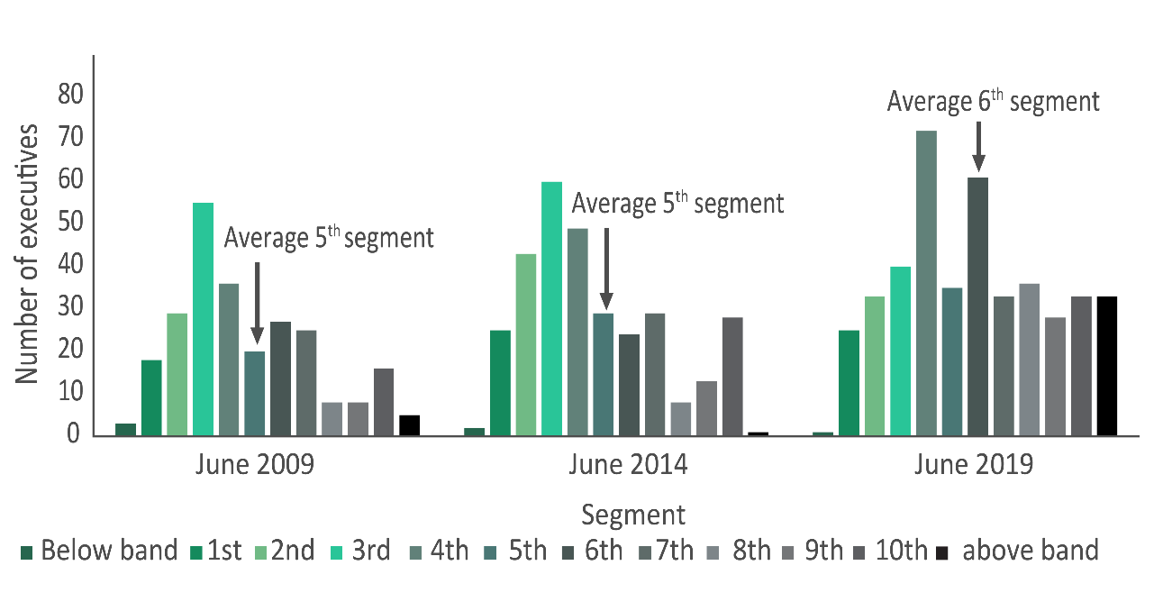
Source: VPSC executive workforce data collections 2009 – 2019.
Figure 3.7: distribution of EO-1 TRPs - 2009, 2014 and 2019
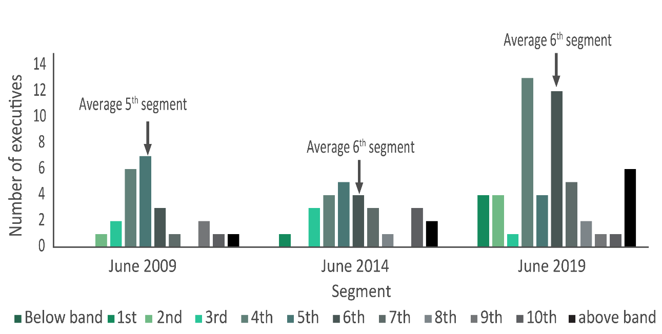
Source: VPSC executive workforce data collections 2009 – 2019.

Summary
Prior to the Determination, the remuneration framework provided for three overlapping remuneration bands for subordinate executives. Over the last ten years, bands were generally adjusted annually to account for changes in wages and prices in the broader community. An exception was in 2016, where bands were significantly adjusted in response to the VPSC’s recommendations to remove bonus opportunities from executive contracts and increase the remuneration at the base of the lowest executive band. The increase in base executive remuneration has resulted in a clustering of executives at the bottom of the EO-3 band.

4 Characteristics of the VPS executive labour market
Section 21(1)(a) of the Victorian Independent Remuneration Tribunal and Improving Parliamentary Standards Act 2019 (Vic) (VIRTIPS Act) requires the Tribunal to consider the existing remuneration provided to executives employed in public service bodies under the Public Administration Act 2004 (Vic) (PAA).
Chapter 3 outlined the existing executive employment and remuneration framework. The Tribunal also sought to understand the key characteristics of the Victorian Public Service (VPS) executive labour market that influence remuneration outcomes.
This chapter sets out the Tribunal’s analysis of the ‘market’ for VPS executives, by examining available data about:
- the number of applicants for each advertised VPS executive role
- the sources of VPS executives
- the motivations of executives in applying for their current roles
- career intentions of existing executives
- historical separation rates for executives.
The Tribunal noted that while its analysis is useful for considering the overall ‘market’ for VPS executives, it is limited by the absence of empirical evidence regarding the quality of candidates entering the VPS executive workforce and inconsistent data regarding the movement of executives both in and out of the VPS and between VPS bodies.

The Tribunal also noted that there has not been comprehensive analysis of:
- the performance of the VPS executive workforce in delivering the government’s agenda
- a preference for training and upskilling the existing workforce as opposed to sourcing external candidates
- whether to meet the government’s expectations, employers of executives need to attract more candidates from outside the VPS, and whether remuneration arrangements will require restructuring to facilitate this.
Further research on these matters, including by the Victorian Public Sector Commission (VPSC) and other central agencies, will be of significant value to the Tribunal in the course of making its future Determinations.

4.1 The ‘market’ for VPS executives
Executive remuneration in both the private and public sectors has often been the object of intense scrutiny and discussion. However, unlike for private sector executive remuneration, there has been little analysis of the labour market principles and factors that underpin decisions about public sector remuneration.
In general, labour markets function to match the supply of workers with demand from employers. In the VPS context, the executive labour market reflects:
- the supply of people who want to become an executive or take up a higher executive role in the VPS
- the demand from the government for executives.
Factors that influence the supply of executives include the costs of accumulating the skills, education and experience required for an executive job, potential remuneration in other positions, the nature of the job such as the risks and efforts it demands, and any non-monetary benefits.

The demand for executives may be influenced by factors such as the policy agenda of the government of the day, the government’s ideas about the role of the public sector, and/or broader economic conditions. At any given time, some types of executive roles may be more in demand than others, for example, information technology roles.
Consistent with other executive labour markets, the Tribunal has assumed that the government will be prepared to pay up to the value of an executive’s perceived potential contribution, and that executives will want to be paid their ‘supply price’, which is influenced by the attractiveness of the overall employment offer relative to other opportunities they may have.
In the VPS, the government’s ‘willingness to pay’ for subordinate executives has historically been given expression through the remuneration bands, along with the flexibility employers have to pay outside the bands for specialist skills and experience.

Trends in the ratio of supply to demand
In recent years, demand for VPS executives has increased. The number of executives employed in public service bodies rose from approximately 670 in June 2015 to over 1,000 in June 2019, or around 55 per cent.
The Tribunal obtained data from the VPSC about the number of people who applied for advertised VPS executive roles over the last four years. From this information, the Tribunal was able to approximate the supply of executive candidates to the demand from the government.
In 2018-19, 270 executive roles were advertised, with a median of 20 applications received per role. By comparison, in 2015-16, 229 executive roles were advertised, with a median of 10 applications received per role.
The Tribunal is also aware that employers have experienced different supply and demand pressures. For example:
- the Department of Premier and Cabinet advertised 28 executive roles in the 2018-19 financial year, with a median of 30 applications received
- in the major transport area, a total of 41 roles were advertised during that period with a median of 14 applications per role.
These figures should be treated with caution, as information is not available on the proportion of applicants that was shortlisted or considered suitable for a role. For example, an employer might attract only a small number of applicants to a role, all of whom could be found suitable for the role.
The Department of Health and Human Services’ submission also noted:
In recent times we have experienced difficulty in attracting executive officers with unique and specialist skills, particularly in the construction and medical industries where individuals can earn significantly more in the private sector.

Sources of VPS executives
In broad terms, executives may be sourced internally — via promotion or lateral movement — or externally, for example, from other Commonwealth or state public services, local government, the private sector or the not-for-profit sector.
The Tribunal was informed by departmental human resource units that most VPS executives were recruited from within the Victorian public sector itself. This included executives being promoted from a non-executive position, executives moving into new or higher roles and individuals working in the broader public sector coming into the VPS.
This evidence was supported by responses to the Tribunal’s executive questionnaire. Of those who responded to the questionnaire, 32 per cent were executives in the VPS immediately prior to their current role, while 26 per cent were non-executive VPS staff and another 10 per cent worked (at both executive and non-executive levels) in the broader Victorian public sector immediately prior to their current role. Only about 16 per cent of respondents reported moving from the private sector into the VPS executive workforce.
To further understand the sources of senior VPS leaders, the Tribunal looked at the prior roles of executives that were first appointed to an Executive Officer (EO) Level 1 position between 1 July 2014 and 30 June 2019:
- 62 per cent were a VPS executive at a lower classification (i.e. EO-2 or EO-3)
- 15 per cent of EO-1s came from a not-for-profit or private sector role
- 12 per cent came from a role within the broader Victorian public sector or local government
- 11 per cent came from a public sector role outside Victoria.
The Tribunal also examined the immediate prior roles of all departmental Secretaries in Victoria since 2015. Around 80 per cent of this group were VPS executives immediately prior to their first Secretary appointment, 13 per cent came from a public service role in another Australian jurisdiction, and 7 per cent came from a private sector role.
Establishment of the Jobs and Skills Exchange
The sourcing of executives may be impacted by the establishment of the Victorian Government’s Jobs and Skills Exchange (JSE). The JSE platform is an internal resource for VPS staff, where VPS employees have initial exclusive visibility of job vacancies from across the VPS.
As of 1 October 2019, all VPS vacancies must be first advertised on the JSE platform for a period of at least 10 business days. If a suitable candidate is not found, the hiring manager may seek approval from a senior executive (Deputy Secretary or Secretary) to advertise the position externally in parallel with a re-advertisement on the JSE platform.
It is too early for the Tribunal to assess the impacts of the JSE on the supply of executives and, by extension, remuneration outcomes.

Motivations for applying for an executive role
The Tribunal’s questionnaire asked executives to identify their motivation for applying for their current role.
Some 35 per cent of respondents cited the nature of the work as a key motivating factor for applying for an executive role. In this regard, respondents referred to the challenges and complexity of the work, the opportunity to provide specialist advice, and the opportunity to work at the centre of government. For example, one executive stated:
Diversity of the role in my specialise area that looked both challenging and delivering social value. the role also managed a large branch and served multiple sectors giving me greater opportunity to apply my skills in different areas.

The ability to drive change and increase value for the community were cited as key motivations by around 19 per cent of respondents. A respondent noted that:
The opportunity to improve justice outcomes and develop a whole of system approach with supporting capabilities and tools; the opportunity to transform the department; and to coach, support and develop the next suite of justice public service leaders
Career progression was also identified as a motivating factor for around 16 per cent of respondents, while around five per cent of respondents were either asked or encouraged to move into their new role. Several executives noted that they had opportunities to act in higher roles before taking on permanent promotions.
Some 11 per cent of respondents reported leadership opportunities as a key motivating factor. Respondents cited the opportunity to establish and lead a new organisation, to develop a strategy, and the desire to lead a team as relevant examples of this motivation. Three per cent of executives reported that remuneration was a motivating factor.

Career intentions
The Tribunal’s executive questionnaire also asked executives about their career intentions in the next five years.
Some 66 per cent of respondents stated that they were likely to remain in the VPS or other Victorian public sector organisation. Eight per cent indicated they would likely move to an executive role in another Australian public sector.
Around 17 per cent of respondents indicated an intention to take on an executive role in the private sector. Five per cent identified ‘other’ career intentions (for example, seeking a non-executive role in another market or in the non-government sector such as in academia).
Compared to executives who came from the VPS, executives who came from the private sector were more likely to intend to leave for a private sector executive role. Of the respondents who were a private sector executive immediately prior to their current role, 30 per cent intended to return to the private sector within the next five years.

Separation rates
From 2015-16 to 2018-19, the annual separation rate for VPS executives ranged from 12 to 16 per cent.
As part of its annual survey of the Victorian public sector in 2018, the VPSC collected data on what was motivating employees who intended to leave their role. Of executives employed in departments who intended to leave in the next two years, around 17 per cent listed ‘better remuneration’ as a major factor.

Summary
The remuneration outcomes for VPS executives reflect demand and supply factors. Demand for VPS executives increased by around 55 per cent from June 2015 to June 2019. While the supply of applicants for executive roles appears to have grown faster than demand, there is no data about the suitability of applicants.
The majority of executive positions in public service bodies are filled by existing VPS staff. Some executive roles are filled by external candidates sourced from the private sector, the wider Victorian public sector and other Australian public sectors. Most existing executives expect to remain in executive roles within the VPS or in another Victorian public sector organisation over the next five years.
Further research is needed to better understand the characteristics of the VPS executive labour market, including the performance of the executive workforce, and the influence of remuneration on attracting and retaining internal and external talent.

5 Economic factors
In accordance with the Victorian Independent Remuneration Tribunal and Improving Parliamentary Standards Act 2019 (Vic) (VIRTIPS Act), the Tribunal is required to consider the economic and fiscal conditions of the State of Victoria.
In particular, the VIRTIPS Act requires the Tribunal to give consideration to:
- current and projected economic conditions and trends (s24(2)(c))
- the financial position and fiscal strategy of the State of Victoria (s24(2)(b))
- any statement or policy issued by the Government of Victoria which is in force with respect to its Wages Policy (or equivalent),
- the remuneration and allowances of any specified occupational group (s24(2)(a)).

5.1 Current and projected economic conditions and trends
Section 24(2)(c) of the VIRTIPS Act requires the Tribunal to consider current and projected economic conditions and trends. The Tribunal has considered both Australian and Victorian economic conditions.

Australian economic conditions
The Reserve Bank of Australia’s (RBA) Statement on Monetary Policy – May 2020 noted that combating the spread of COVID-19 has required severe restrictions on economic activity in many countries.
The RBA’s Statement noted that Australia’s Gross Domestic Product (GDP) is expected to fall by around 10 per cent from peak to trough as a result of the COVID-19 pandemic. In the RBA’s baseline scenario, GDP will be stronger over 2021 as business and dwelling investment gradually recover. The unemployment rate is forecast to peak at around 10 per cent per in June 2020 and be at 7.5 per cent at the end of 2021. Underlying inflation is expected to remain below 2.0 per cent and wages growth is expected to fall.

Victorian economic conditions
Prior to the outbreak of COVID-19 in Victoria, the Victorian Budget 19/20: 2019/20 Budget Update (Budget Update) released in December 2019, reported the following economic outlook for Victoria:
- real (inflation-adjusted) Gross State Product (GSP) growth is forecast to moderate to the trend rate of 2.5 per cent in 2019-20, slightly below trend, following 18 months of weak residential property market conditions
- employment growth is forecast to slow to 2.0 per cent in 2019-20 and 1.75 per cent over the next four years
- the unemployment rate is expected to be slightly higher in 2019-20 at 5.0 per cent, up from the 4.75 per cent forecast in the Victorian Budget 19/20.
The impact of COVID-19 is expected to significantly change Victorian economic and fiscal conditions. In April 2020, the Victorian Department of Treasury and Finance (DTF) released modelling estimating the potential effects of COVID-19 on economic activity, employment and the property market. The modelling showed that Victoria’s GSP could be around 14 per cent lower in the June and September quarters relative to forecasts underlying the Victorian Budget 19/20. In addition, the modelling suggests the unemployment rate could increase to around 11 per cent and property prices could fall by nine per cent by the end of 2020.
The DTF modelling also suggests that the magnitude of the economic impact of COVID-19 makes it likely that Victoria will record negative economic growth in 2019-20 and 2020-21.

Movements in wages and prices
The Tribunal has compared changes in the executive remuneration bands (based on the Premier’s guideline rate) over the last 10 years against movements in consumer prices and employee wages in Victoria.
The measure used by the Tribunal to consider changes in prices is the Melbourne Consumer Price Index (CPI). Between June 2009 and June 2019, the Premier’s guideline rate for executive TRP increases has averaged 2.5 per cent, compared to average annual CPI growth of 2.2 per cent.
For movements in wages, the Tribunal has compared changes in the Premier’s guideline rate to two variables:
- Victorian Wage Price Index (WPI) — measures changes in wages paid for a given unit of labour, where the quality and quantity of that unit of labour are held constant
- Victorian Average Weekly Ordinary Time Earnings (AWOTE) — provides an estimate of average ordinary time wages per week in the community.
Between June 2009 and June 2019, executive total remuneration packages (TRPs) have risen by a total of 27.4 per cent in nominal terms while WPI increased by 31.8 per cent in nominal terms. Over the same period, AWOTE increased by 37.9 per cent in nominal terms.

5.2 Financial position and fiscal strategy of the State of Victoria
Section 24(2)(b) of the VIRTIPS Act requires the Tribunal to consider Victoria’s financial position and fiscal strategy. As such, the Tribunal has considered the Victorian Auditor-General Office’s financial report on Victoria’s finances, the Victorian Budget 19/20 and the impact of COVID-19.

Victorian Auditor-General Office’s financial report
Prior to the outbreak of COVID-19 in Victoria, the Victorian Auditor-General’s financial report on the State of Victoria, released in November 2019, noted that ‘the state continues to operate sustainably and is well positioned financially’.

Victorian Budget
Pre-COVID 19, the Budget Update reported that the operating surplus was expected to be $618 million in 2019-20, and to average $3.3 billion per year over the forward estimates. Revenue growth was forecast to average 4.4 per cent over the Budget and forward estimates, exceeding expense growth of 3.3 per cent. Net debt was forecast to be 8.5 per cent of GSP at June 2020 and to increase to 10.5 per cent by June 2023. However, as noted above, the impact of COVID-19 is expected to significantly change these numbers.
In response to COVID-19, the Victorian Government is expected to borrow around $24 billion in emergency funding over 2019-20 and 2020-21 to support community and businesses and to rebuild the economy following the easing of COVID-19 restrictions. This also includes $8 billion in funding for projects underway in 2020-21. This will add to Victoria’s net debt, which was forecast in the 2019/20 Budget to be around 8.5 per cent at the end of June 2020.
This funding is in addition to the $3.5 billion the Victorian Government has previously committed, which includes a $1.7 billion economic survival and jobs package offering payroll tax refunds for eligible businesses, business support grants and help to workers who have lost their jobs to find new opportunities.
The Government has also delayed the State Budget for 2020-21 until October 2020, which means the full impact of COVID-19 on the Victorian economy and the Budget over the forward estimates will not be known for some time.
In early April 2020, Standard and Poor’s (S&P) revised its credit-rating outlook for Victoria to ‘negative’ (implying that Victoria’s AAA credit rating from S&P could be revised down in the future) because of an expected rise in public debt due to COVID-19.

5.3 Victorian Government’s Wages Policy
Section 24(2)(a) of the VIRTIPS Act requires the Tribunal to consider any statement or policy issued by the Government of Victoria which is in force with respect to its Wages Policy (or equivalent) and the remuneration and allowances of any specified occupational group, the latter of which has been dealt with in chapter 3.
Box 5.1 re-produces the Victorian Government Wages Policy and Enterprise Bargaining Framework (Wages Policy) which applies to departments and agencies in the Victorian public sector.
Box 5.1: Victorian Government Wages Policy and Enterprise Bargaining Framework
Source: Industrial Relations Victoria, ‘Victorian Government Wages Policy,’ Wages Policy and the Enterprise Bargaining Framework, (State Government of Victoria: Melbourne, Victoria, 2019).
The Victorian Government Wages Policy and Enterprise Bargaining Framework has three pillars:
- Pillar 1: Wages — increases in wages and conditions will be capped at a rate of growth of 2 per cent per annum over the life of the agreement. In practice this means employee wages and conditions will be allowed to grow at this rate.
- Pillar 2: Best Practice Employment Commitment — all public sector agencies will be required to make a Best Practice Employment Commitment which will outline measures to operationalise elements of the Government’s Public Sector Priorities that reflect good practice within Government and can be implemented operationally or without significant costs.
- Pillar 3: Additional strategic changes — additional changes to allowances and other conditions (not general wages) will only be allowed if the Government agrees that the changes will address key operational or strategic priorities for the agency, and/or one or more of the Public Sector Priorities.
A ‘Secondary Pathway’ is also available for public sector agencies whose current enterprise agreement reaches its nominal expiry date on or before 30 June 2020 which permits one annual wage and allowance increase capped at 2.5 per cent (instead of at 2 per cent).
Caution should be taken when comparing the Tribunal’s Determinations with the changes in the growth of wages and conditions under an enterprise bargaining agreement (EBA), as the period to which a Determination from the Tribunal applies is generally different from an EBA. An EBA is typically set is for a period of four years, and annual wage adjustments are agreed at the time the EBA is signed. In comparison, under section 21 of the VIRTIPS Act, the Tribunal must make a comprehensive Determination of executive remuneration bands for VPS executives. While the Tribunal may elect to phase in changes to bands over time, it is also required to consider making annual adjustments to the bands, noting that it cannot make an annual adjustment if a Determination has been made in the preceding nine months (s22 of the VIRTIPS Act).

6 Tribunal’s considerations
The Tribunal now turns to the determining of the structure and values of the remuneration bands for executives employed in Victorian Public Service (VPS) bodies. These elements form the Tribunal’s Determination of the new remuneration framework for executives employed in public service bodies.
In making its Determination, the Tribunal considered the legislative requirements set out in the Victorian Independent Remuneration Tribunal and Improving Parliamentary Standards Act 2019 (Vic) (VIRTIPS Act). As earlier indicated, these are:
- the role of executives and existing remuneration provided to executives (s21(1)(a))
- any statement or policy issued by the Government of Victoria which is in force with respect to its Wages Policy (or equivalent) and the remuneration and allowances of any specified occupational group (s24(2)(a))
- the financial position and fiscal strategy of the State of Victoria (s24(2)(b))
- current and projected economic conditions and trends (s24(2)(c))
- submissions received in relation to the proposed Determination (s24(2)(d)).
The role of executives, including public service body Heads, and the existing remuneration provided to executives is set out in chapters 2 and 3 of the Statement of Reasons. Chapter 4 describes the characteristics of the executive labour market in the VPS. Economic, financial and fiscal matters, including the Government’s Wages Policy, are set out in chapter 5. Submissions received by the Tribunal, including responses to the Tribunal’s executive questionnaire, are cited throughout the Statement of Reasons.
This chapter analyses options and sets out the rationale for the new executive remuneration framework.

6.1 Existing executive remuneration framework
As discussed in chapter 3, prior to the Determination, there was no formal remuneration structure for public service body Heads. This group consists of Secretaries of departments, the Commissioner of the Victorian Public Sector Commission (VPSC) and Administrative Office Heads (AO Heads).
As at 1 July 2019, Secretaries and the Commissioner were paid within a range of $530,000 to $650,000 per annum (p.a.).
The Secretary of the Department of Premier and Cabinet was the highest paid Secretary, followed by the Secretaries of the Departments of Treasury and Finance and Health and Human Services. The remaining Secretaries were all remunerated at the same pay point, followed by the Commissioner.
The Tribunal mapped the remuneration for AO Heads against the existing subordinate executive officer (EO) remuneration bands. At 1 July 2019, almost all AO Heads were paid within the existing subordinate executive remuneration bands:
- six were paid within the EO-2 band
- five were paid within the EO-1 band
- two were paid outside of the EO-1 band.
Subordinate executive roles are classified into three work value levels that are tied to remuneration ranges. Prior to the Determination, the Premier was responsible for setting the values of each of the remuneration bands (table 6.1).
Table 6.1: VPS executive remuneration bands, July 2019
Band | Description | Minimum TRP ($ p.a.) | Maximum TRP ($ p.a.)
EO-3 | Program, policy and service delivery managers, regional and area managers in some departments and heads of smaller agencies. | 185,711 | 240,789
EO-2 | Deputy Secretary and agency heads of major agencies, divisions or significant programs. | 214,883 | 343,938
EO-1 | Head of a substantial public authority, most senior program managers and Deputy Secretaries. | 312,274 | 457,081
Source: VPSC Handbook.
While not part of the original design, the existing remuneration bands overlapped as a result of adjustments being made to the top, but not to the base, of the bands between 1996 and 2001. As at 1 July 2019, the three existing remuneration bands had an overlap between the:
- EO-3 and EO-2 bands of around $26,000
- EO-2 and EO-1 bands of around $32,000.
In total, there were around 290 executives paid within the overlapping portion of the subordinate executive remuneration bands.

6.2 Structure of remuneration bands
In addition to the matters discussed above in relation to the legislative factors, the Tribunal also took into account the following matters when considering the structure of the remuneration bands:
- the need to recognise the distinct roles and responsibilities between Secretaries, the Commissioner, AO Heads and subordinate executives
- the revised subordinate executive classification framework consisting of three distinct and contiguous work-value ranges
- the need to encourage existing executives to seek promotion and incentivise non-executives to take on executive roles.

Setting the remuneration band structure for subordinate executives
The VPSC’s revised executive classification framework maintains a three-band structure, with bands renamed and reordered. The bands classify subordinate executives within a Senior Executive Service (SES) level 1, 2 or 3. The classification band to which an executive role is assigned is determined by a work value score for that role. Work value scores are calculated by assessing each executive role against eight competencies, with the methodology providing for a score of 1, 3, 5 or 7 against each competency. The final tally is the work value score (table 6.2 overleaf).
Table 6.2: revised VPS executive classification framework for subordinate executives
Title | Band | Band score
Director | SES-1 | 21 to 35
Executive Director | SES-2 | 36 to 47
Deputy Secretary | SES-3 | 48 to 56
Source: VPSC revised executive classification framework 2019.
As seen from table 6.2, the revised classification framework uses contiguous work value bands; that is, there are no gaps or overlaps between the bands. The Tribunal’s analysis considered whether there was merit in maintaining an overlapping remuneration band structure.
The Tribunal noted that overlapping bands may provide a level of flexibility to employers to reward high performers and retain talent. In response to the executive questionnaire, one executive said:
The new executive remuneration bands should continue to provide a degree of overlap between levels as this allows more flexible management of remuneration needs at both the top and bottom of each level. Removal of the overlaps will create artificial barriers that will inevitably lead to classification creep.
On the other hand, other executives highlighted how overlapping remuneration bands can result in unfair remuneration outcomes. For example, one executive stated:
As an EO3 at the top of my band, I am paid more than many EO2s in my organisation yet it's not reflected in my accountability levels, this seems non-sensical and can be de-motivating.
The Victorian Secretaries’ Board (the Board), in its submission, argued that overlapping bands can create disincentives for executives to seek promotion:
… overlapping… bands can create confusion and can diminish incentives to seek promotion to more demanding roles or to undertake acting assignments at higher classification levels.
And one executive similarly stated:
The EO remuneration overlap discourages professional advancement as there is significant increase in accountability and responsibilities with little or no increase in remuneration.
Finally, the Tribunal noted that overlapping bands can also lead to employers classifying roles based on remuneration objectives, rather than having the classification inform remuneration. As one executive noted:
There is also a very strange and unnecessary overlap in salaries between EO3 and EO2. This has led to many roles that should be classified EO2 being advertised as EO3…
Overall, the Tribunal considered that the remuneration structure for subordinate executives should align with the revised executive classification framework, consisting of three contiguous remuneration bands. In particular, contiguous bands will promote fairer remuneration outcomes and provide incentives for advancement.

Setting the remuneration band structure for public service body Heads
In relation to public service body Heads, the Tribunal recognised there is merit in grouping similar positions within the same remuneration structure.
As to the similarity of positions, the Board recommended in its submission that the Tribunal take into account:
The distinctive and important role played by VPS EOs [executive officers], Secretaries and AO Heads.
Further, with respect to whether the role of the Commissioner should be grouped, for remuneration purposes, with Secretaries of departments or with the senior executive cohort, the Tribunal was cognisant of the:
- importance of the Commissioner’s role of stewarding the public sector in matters such as ethics, integrity and accountability
- Commissioner’s direct reporting relationship to the Special Minister of State
- Commissioner’s membership of the Board, together with the eight department Secretaries and the Chief Commissioner of Victoria Police
- Commissioner’s power to conduct inquiries into any matter relating to a public sector body on the direction of the Premier.
The Tribunal concluded that grouping the Commissioner role with Secretaries was appropriate.
The Tribunal also considered whether it was appropriate to group AO Heads with Secretaries and the Commissioner, noting that the aspects of an AO Head’s role
— as discussed in chapter 2 — set it apart from the roles played by Secretaries and the Commissioner. For example, while the functions of AO Heads vary significantly, each AO Head is responsible to the relevant portfolio department Secretary for the efficient, economical and effective management of the AO.
Having regard to all of the above, the Tribunal identified three options for setting a remuneration band structure for public service body Heads (figure 6.1 overleaf). These are:
- Establish an additional remuneration band above the SES bands for Secretaries, the Commissioner and the Heads of large and complex AOs.
- Establish an additional remuneration band above the SES bands for Secretaries and the Commissioner, as well as a single remuneration band for AO Heads.
- Establish an additional band for Secretaries and the Commissioner above the SES bands, as well as three additional remuneration bands for AO Heads.
The Tribunal sought submissions from interested parties on these options via a discussion paper published on its website. In particular, the Tribunal sought feedback on the remuneration structure for AO Heads.

Figure 6.1: options for establishing a remuneration structure for public service body Heads
Option 1 – establish an additional remuneration band above the SES bands for Secretaries, the Commissioner and the Heads of large and complex AOs.
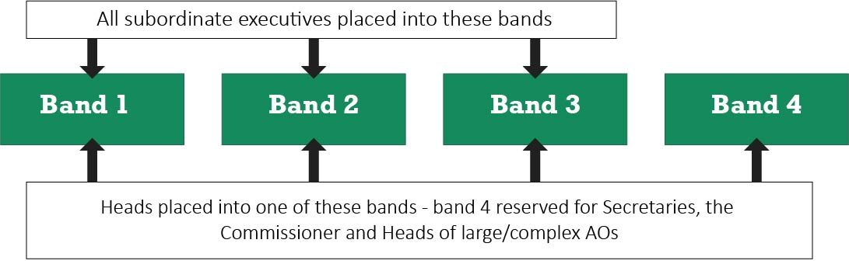
Option 2 – establish an additional remuneration band for Secretaries and the Commissioner above the SES bands and a separate remuneration band for AO Heads
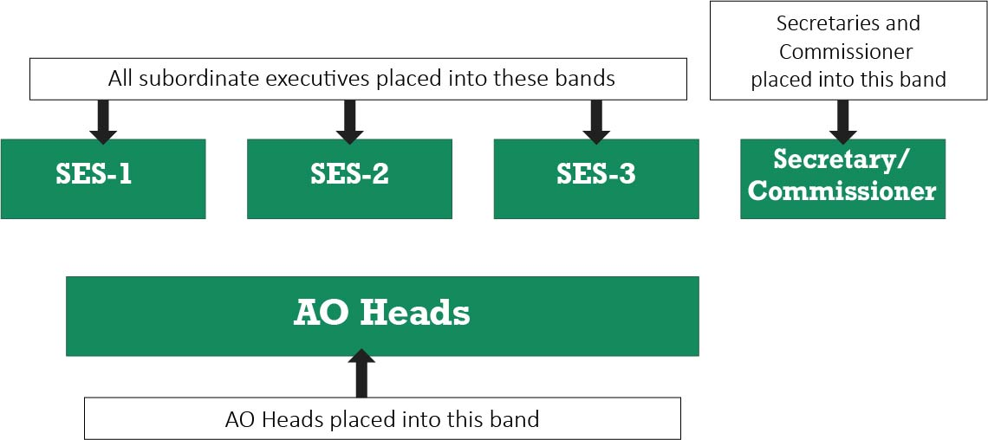
Option 3 – establish an additional remuneration band for Secretaries and the Commissioner above the SES bands and three additional remuneration bands for AO Heads
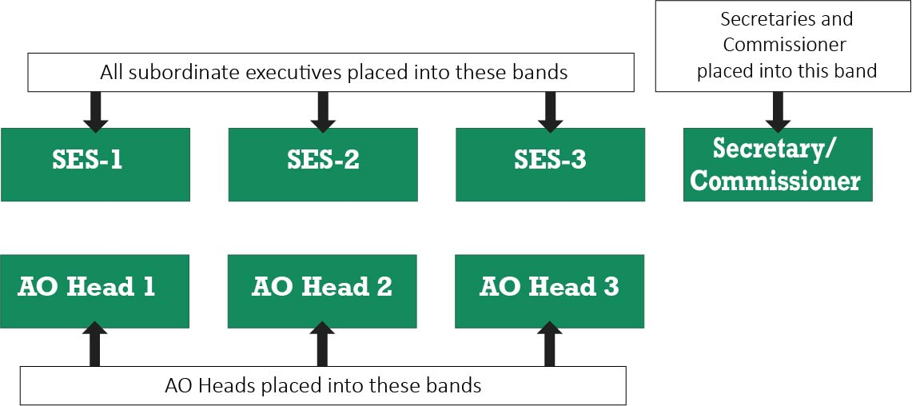
The advantages and disadvantages of these options are summarised in table 6.3.
Table 6.3: options for remuneration bands for public service body Heads
Option | Advantages | Disadvantages
1. Establish an additional remuneration band above the SES bands for Secretaries, the Commissioner and the Heads of large and complex AOs. | - Relatively simple to administer as all Heads are assigned to a single band structure. | - May not adequately recognise different responsibilities and reporting arrangements for Secretaries, the Commissioner and AO Heads.  - A fourth band for Heads may increase the risk that the remuneration of Heads will cluster toward the top of the structure.
2. Establish an additional band for Secretaries and the Commissioner, above the SES bands, as well as a separate band for AO Heads. | - Recognises different responsibilities and reporting arrangements between Secretaries, the Commissioner and AO Heads.  - Relatively simple to administer as Heads are assigned to one of two bands depending on their role. | - A single wide band for AO Heads may increase the risk that remuneration of all AOs will cluster towards the top of the band.  - Would not recognise the diversity of roles and responsibilities between AOs.
3. Establish an additional band for Secretaries and the Commissioner, above the SES bands, as well as three additional bands for AO Heads. | - Recognises different responsibilities and reporting arrangements between Secretaries, the Commissioner and AO Heads.  - Mitigates risk that remuneration of all AO Heads will cluster towards the top of the band. | - Relatively complex to administer. Guidance may need to be issued about which band each AO Head should be placed in.
The Tribunal received two submissions from current AO Heads, both expressing a preference for option 1.
One submission noted that this option would be preferable because:
Alignment with the Executive Classification Framework facilitates the movement of public sector executives between public sector organisations… [and] The complexity of the other options may be an issue for smaller agencies (such as Administrative Offices) which do not have access to significant HR resources.
The Tribunal did not receive any feedback in relation to options 2 or 3.
The Tribunal considered that AO Heads should be treated as a separate cohort, distinct from Secretaries and the Commissioner to reflect:
- the importance of AO Heads in leading and managing sometimes large and complex organisations
- the role of an AO Head as an employer
- the reporting and governance arrangements in place for AOs.
Taking into account all of the above, the Tribunal decided to adopt option 3 for the overall remuneration structure for public service body Heads. This option recognises the discrete roles and responsibilities of Secretaries, the Commissioner and AO Heads, and further distinguishes these from subordinate executive roles. The option also provides the opportunity to consider the alignment of the values of the remuneration bands for AO Heads with the remuneration bands for subordinate executives (set out in section 6.3).

Tribunal’s decision on the new executive remuneration band structure
Figure 6.2 outlines the new executive remuneration structure, consisting of:
- three distinct and contiguous bands for subordinate executives aligned to the VPSC’s executive classification framework
- a single band for the remuneration of Secretaries and the Commissioner
- a distinct and contiguous three-band structure for AO Heads.
Figure 6.2: new remuneration structure for executives employed in public service bodies, including public service body Heads

6.3 Value of the remuneration bands
Having addressed structural issues, the Tribunal turned to setting the values of the remuneration bands, including by examining:
- the roles and responsibilities of VPS executives
- trends in the attraction and retention of VPS executives
- the gap between non-executive and executive remuneration bands
- remuneration ranges for roles with similar work value
- executive remuneration arrangements in other jurisdictions.

Roles and responsibilities of executives
Generally speaking, the remuneration paid for a given role reflects factors such as the knowledge and skills required and the span of its responsibilities. Chapter 2 sets out the roles and responsibilities of executives including public service body Heads.
In summary, the role of public service body Heads is to assume the stewardship, leadership and direction of, and accountability for, the effective operation of the agency to which they have been appointed. They have widespread responsibilities as leaders, employers and office holders with legislated duties and powers.
Along with public service body Heads, subordinate executives are responsible for setting the strategic direction within their organisation. Subordinate executives also play an integral role in the implementation of the government’s agenda, provide authoritative advice to their public service body Head and the Minister and may be responsible for the delivery of large-scale programs and projects.
Through its consultative process and from its own research, the Tribunal found evidence that the roles and responsibilities of executives are becoming more demanding. For example, the Board’s submission noted that:
As Victoria continues to grow rapidly, the pace, volume, complexity of public service work also continues to grow. The government has directed significant additional investment to service delivery initiatives and has committed to an unprecedented infrastructure program.

Respondents to the Tribunal’s executive questionnaire commented that the expectations and demands placed on executives had grown dramatically over the last five years. These pressures related to the increased scale of investment in public infrastructure to support the needs of Victoria’s growing population, and the need for increased coordination across government to respond to complex policy issues.
The Tribunal also heard that executives may be expected to be on call at all times to respond to requests from a Minister. As noted by a respondent to the executive questionnaire:
[there is an] increased pressure to support Ministers, respond to 24 [hour] media cycle… [to be] on call around the clock.
And another commented:
There has also been an increasing movement to always being available - after hours including weekends. Technology has facilitated this and ministers often expect it. I generally work 11-12 hours a day as well as at least a couple of hours in the weekend and am effectively 'on call' every weekend in case something arises before the Ministers meeting and cabinet on Monday.
Respondents also commented on the increasing burden of regulatory compliance. Executives are accountable for ensuring that policy programs and processes are compliant with various pieces of legislation and regulations. In particular, the Tribunal heard that, in the corporate area, the burden of compliance is an increasing feature of the role of an executive. As noted by an executive:
[there has been an] increase in policy changes or government (State and Federal) reform projects which impact on the delivery of corporate services.
The same respondent also noted that:
The private sector is attractive to a VPS executive due to the extra remuneration, but also the ability to not be bound to government legislative constraints and endless regulation/compliance.

Executives are also responsible for managing the risks associated with non-compliance. In some cases, non-compliance may be administratively simple to rectify, and the risk relatively low. However, for large scale projects or policy programs, non-compliance may have widespread ramifications. Around 14 per cent of respondents to the Tribunal’s executive questionnaire suggested that the Tribunal should consider the risk carried by executives in making its Determination.
The Tribunal also noted other changes in the nature of the roles of executives, including:
- The increasing trend towards devolution in decision-making means that many executives carry greater responsibility than in the past.
- Flatter organisational structures and increasing spans of control, particularly in service, program and project delivery significantly impact the administrative and management dimensions of the executive role.
- The rate of introduction of new technologies and the rapidly growing part played by these increasingly complex systems in the production of the agency’s output means that responsibility for the operation and integrity of these systems can no longer be left to IT specialists. Given the personal and agency reputational damage that flow from the failure of these systems, a high level of technological literacy increasingly forms part of the core competency of every executive role.

Attracting and retaining executive talent
The level of remuneration is an important factor in attracting and retaining talent to the VPS executive workforce. The Board’s submission commented:
… it [is] imperative that Victoria can provide a competitive and attractive offering to both attract and retain senior leader talent.
The Department of Health and Human Services’ submission also noted the need for the VPS to be competitive in the external market.
Some executives responding to the Tribunal’s questionnaire reported that the remuneration offered in the private sector is greater than they currently receive in the VPS. Others told the Tribunal that they had taken a reduction in pay to take up an executive role in the VPS. Many executives who indicated that they intend to leave the VPS for a private sector role cited the comparatively low, uncompetitive and inconsistent remuneration arrangements for VPS executives.
Trends in applications for executive roles
Conventional wisdom suggests that, the greater the number of applications for executive roles, the more likely it is that the remuneration offer is positioned appropriately to attract suitable talent.
The Tribunal sourced data from the VPSC about the number of applications per executive role over time. In 2018-19, there were 270 VPS executive roles advertised, with a median of 20 applications received per role. In comparison, in 2015-16 there were 229 executive roles advertised, with a median of 10 applications per role. This suggests, firstly, that the supply of executives has increased at a greater rate than the demand for them and, secondly, that the existing remuneration offer is viewed favourably by potential executives. A limitation of this metric, however, is that it says nothing about the quality of the applicants. A field of five highly talented candidates says more about the competitiveness of the offer than a field of 20 applicants most or all of whom are not qualified for the position.
The Tribunal’s analysis of executive labour market trends in chapter 4 shows that the majority of VPS executive roles are filled from within the Victorian public sector. Responses to the executive questionnaire showed that around 69 per cent of current executives were employed in the VPS or the broader Victorian public sector prior to their current role. The Tribunal was advised that a causal factor may be that VPS executive remuneration is uncompetitive with the general market, including with other Australian jurisdictions, making it difficult to attract external talent to the VPS. For example, the New South Wales public service generally pays its executive cohort an average of 5-10 per cent higher for comparable roles.
The Tribunal was also advised that it can be challenging to recruit senior executives from the Australia Public Service (APS), given that some experienced APS executives have access to more generous superannuation arrangements. For example, some APS executives employed before 2003 are members of defined benefit superannuation schemes (now closed). In contrast, defined benefit schemes for VPS executives were closed to new members in 1993.
In some cases, VPS employers need to recruit externally to bring required specialist skills into the organisation. The Tribunal was advised about difficulties in sourcing candidates for roles requiring specialist skills in the transport, construction, health and energy sectors. The Tribunal’s analysis showed that half of the executives who had a private sector role immediately prior to their EO-1 role had a starting TRP above the EO-1 band, and that each of these executives had worked in transport or infrastructure-delivery related roles.
The Tribunal was also informed that departments were experiencing difficulty attracting suitable candidates to some positions requiring legal, digital, customer service or data analytics skills. Moreover, filling EO-3 roles could be particularly challenging due to the relative narrowness of this band.
Trends in the retention of executives
The Tribunal examined data on the rate at which executives left their roles.
VPSC data shows that during the last four financial years, the annual separation rate for VPS executives ranged from 12 to 16 per cent. This separation rate appears high relative to comparators. For example:
- according to the Australian Bureau of Statistics, 8.5 per cent of Australian employed persons changed employers/businesses in the twelve months to February 2019, and only 5 per cent of employees working in ‘public administration and safety’ changed employers/businesses
- the Australian Public Service Commission reported a 9.4 per cent separation rate for senior executive service employees for the 2018-19 financial year
- the VPSC reported an 8.7 per cent separation rate for ongoing, non-executive VPS employees for the 2017-18 financial year.
The 2018 People Matter Survey revealed that of the executives who said that they intend to leave the VPS in the next two years, 17 per cent indicated better remuneration as a major reason.
The Tribunal’s executive questionnaire also asked executives to reflect on their career intentions over the next five years. Compared to executives who came from the VPS, executives who came from the private sector were more likely to intend to leave for a private sector executive role. Of the respondents who were a private sector executive immediately prior to their current role, 30 per cent intended to return to the private sector within the next five years. This suggests that the VPS may have difficulties in retaining some executives sourced from the private sector.
Attraction and retention trends for Secretaries of departments
The Tribunal also considered data on appointments made to Secretary roles. Between 2015 and 2019, there were 14 appointments made to Secretary roles. Of these, 11 were executives in the VPS immediately prior to their appointment as Secretary. Two appointees were drawn from public services in other jurisdictions, while one appointee came directly from the private sector.
Of the six Secretaries who are no longer in their roles:
- two moved into academia
- two moved into the private sector
- two moved to other roles in the Victorian public sector.

Gap between non-executive and executive remuneration bands
The Tribunal examined the gap between the VPS non-executive and executive remuneration bands noting that the work value, and corresponding remuneration, for a VPS executive role should be higher than for a non-executive role.
The VPS Enterprise Agreement 2016 (Enterprise Agreement) governs the employment and remuneration arrangements for non-executive employees. The Enterprise Agreement provides for a seven-band, non-overlapping classification and remuneration structure for non-executive employees. The relevant non-executive band for comparison purposes is the VPS Grade 6 (VPS-6) band. This is because the VPS Grade 7 band should be reserved for a small number of ‘Senior Technical Specialist’ roles that require specialist skills and do not usually have a people management function.
Non-executive staff employed under the Enterprise Agreement have relatively greater security of employment and protection against redundancies or at-will terminations. In comparison, executives are employed on a contract of no more than five years which may be terminated at any time with four months’ notice. The results of the Tribunal’s executive questionnaire suggest that a significant source of VPS executives were staff promoted from non-executive roles, with around 43 per cent of respondents in a non-executive role in the Victorian public sector prior to their current position. In turn, the size of the ‘remuneration gap’ between a non-executive and an executive role is an important factor affecting the choice of non-executive staff to apply for promotion, particularly where promotion would also result in negative impacts on their employment conditions.
Changes in the size of the remuneration gap
The VPSC’s 2016 Review of Victoria’s Executive Officer Employment and Remuneration Framework (review) noted the importance of maintaining a suitable remuneration gap between non-executive and executive staff, taking into account differences in employment conditions.
The review found the remuneration for VPS-6 staff at the top of the band, taking into account employer superannuation contributions, had overtaken the base of the EO-3 band ($155,458 p.a. for VPS-6 staff compared with $152,560 p.a. for EO-3 staff). The review noted that this was acting as a deterrent to non-executive staff seeking promotion. The Government subsequently increased the base of the EO-3 remuneration band to $175,000 p.a. from 1 July 2016.
Lifting the base of the EO-3 band created a gap of around nine per cent ($19,500) between the top of the VPS-6 and the base of the EO-3 band when comparing total remuneration packages (TRPs). This corresponded with an increase in the median number of applications received per EO-3 role advertised from 18 in 2015-16 to 22 in 2016-17. This may be partly attributed to the increase in the EO-3 remuneration offer.
The review also recommended the government match executive annual adjustments with Enterprise Agreement outcomes to prevent the top of the VPS-6 band from overlapping with the bottom of the EO-3 band in the future.
The gap between the top of the VPS-6 remuneration band and the base of the EO-3 band has since narrowed, in TRP terms, from nine per cent to five per cent. This is due to lower average annual increases to the EO-3 remuneration band (2 per cent p.a.) relative to non-executive Enterprise Agreement outcomes (3.25 per cent p.a.) between 2016-17 and 2019-20 (figure 6.3).
Figure 6.3: comparison of the top of the VPS-6 remuneration band^{(a)} with the base of the EO-3 remuneration band, July 2009 – July 2019
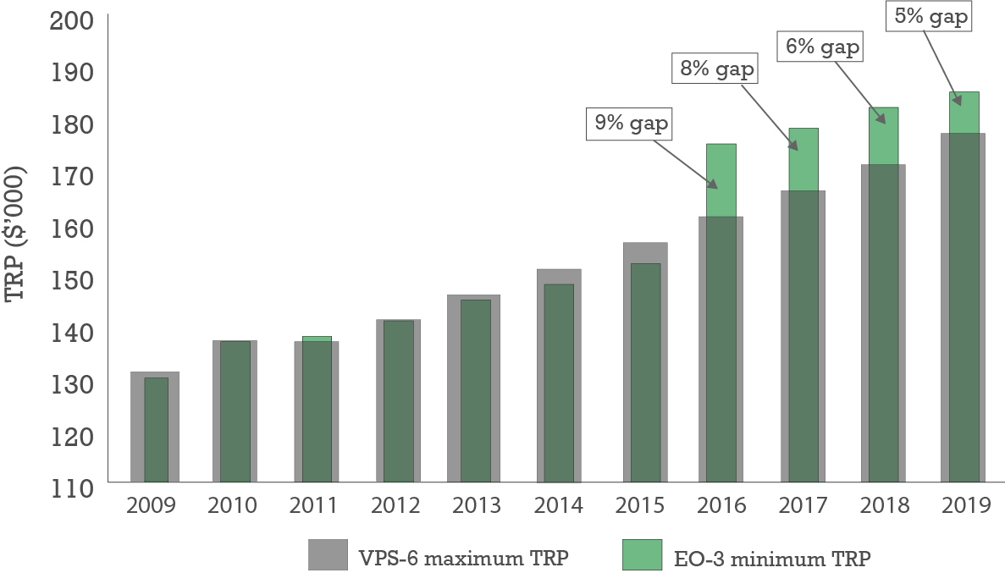
Notes: (a) VPS-6 remuneration includes notional superannuation employer contribution of 9% between 2009-2013, 9.25% in 2014, 9.5% between 2015-2019.
Sources: Victorian Public Service Agreement 2006 [AG847284 varied by PR987723], Victorian Public Service Workplace Determination 2012 [AG895510]; Victorian Public Service Enterprise Agreement 2016 [AG2016/2919]; VPSC, The State of the Public Sector in Victoria reports 2009 – 2019.

General market benchmarking
The Department of Health and Human Services submission stated:
To ensure that the Victorian Public Service can be competitive… we need to benchmark our executive officer roles with similar roles in the broader community.
The Tribunal commissioned Mercer Consulting (Australia) to independently recommend TRP ranges for subordinate executives, based on the role descriptors of the revised executive classification framework.
When conducting a work value assessment of a position, Mercer applies its ‘job evaluation methodology’ to the roles and responsibilities of the position to express its ‘worth’ in terms of a ‘work value points score’.
To assess the work value of subordinate executive roles, Mercer applied its methodology to the ‘work value standards’ contained in the VPSC’s revised subordinate executive classification framework. Mercer developed minimum and maximum work value points scores for each of the three levels and then benchmarked TRPs based on roles of similar work value.
Mercer provided contiguous TRP ranges for the subordinate executive remuneration bands at the 10th, 15th and 20th percentiles of the Australian General Market, noting that public sectors across Australia generally pay at or above the 10th percentile.
Mercer recommended that the Tribunal adopt the TRP range at the 10th percentile or, alternatively, if a more competitive offer was required, the TRP range at the 15th percentile (table 6.4). In this respect, it is worth noting that based on Mercer’s analysis, the existing VPS subordinate executive offer falls between the 10th and 15th percentile of the general market.
Table 6.4: Mercer analysis of TRP ranges for subordinate executives
Level | Work value points range | General Market TRP range ($ p.a.)
Level | Work value points range | 10th percentile | 15th percentile | 20th percentile
SES-1 (EO-3) | 751 – 1230 | 176,000 – 234,600 | 187,300 – 249,700 | 199,100 – 265,400
SES-2 (EO-2) | 1231 – 1720 | 234,601 – 339,400 | 249,701 – 360,000 | 265,401 – 385,300
SES-3 (EO-1) | 1721 – 2250 | 339,401 – 454,200 | 360,001 – 479,900 | 385,301 – 517,400
Source: Mercer Consulting (Australia), Report for Secretary and SES Remuneration Framework, report prepared for the Victorian Independent Remuneration Tribunal, (Melbourne, Victoria: December 2019).
Mercer also undertook a desk-top work value assessment of the eight VPS Secretary roles and the Commissioner. Mercer considered the relative work value of these roles compared with subordinate executive roles, the current pay practices for these roles, and relativities with other head of agency roles across jurisdictions. Again, Mercer recommended a TRP range at the 10th percentile, with an alternative TRP range at the 15th percentile to provide a more competitive market offer (table 6.5).
Table 6.5: Mercer analysis of TRP ranges for Secretaries and the VPSC Commissioner
Grade | Work value points range | General Market TRP range ($ p.a.)
Grade | Work value points range | 10th percentile | 15th percentile | 20th percentile
Secretary  and VPSC Commissioner | 2251 – 3800 | 454,201 – 669,800 | 479,901 – 701,800 | 517,401 – 768,800
Source: Mercer, Report for Secretary and SES Remuneration Framework.
The Tribunal noted that the existing remuneration range for Secretaries and the Commissioner falls within Mercer’s benchmarked TRP ranges.

Jurisdictional comparisons
In relation to other jurisdictions, the Tribunal compared the VPS executive remuneration framework with similar frameworks in the APS, and the New South Wales and Queensland public services. The Tribunal was of the view that these jurisdictions are the most comparable in terms of population, size of the executive and non-executive workforce, the number of departments and the geographical location.
Figure 6.4 and table 6.6 (overleaf) show that the existing VPS subordinate executive remuneration bands:
- start and finish lower at all levels compared to the New South Wales public service
- span a significantly greater range across all levels compared to the Queensland public service and across the SES-2 level compared to the NSW public service
- are higher at all levels compared to the Queensland public service.
In the APS, each department/agency has discretion to set its own executive remuneration framework, making comparisons with the more centralised VPS executive remuneration framework difficult. Nonetheless, the Tribunal observed that:
- the minimum of the VPS EO-3 range is lower than the minimum TRP paid to an APS executive
- the maximum TRP payable to a subordinate executive is much higher in the APS, at around $714,000 p.a. compared to around $460,000 p.a. in the VPS.
Figure 6.4: comparison of TRP ranges^{(a)} for subordinate executives^{(b)} in selected Australian public services, January 2020
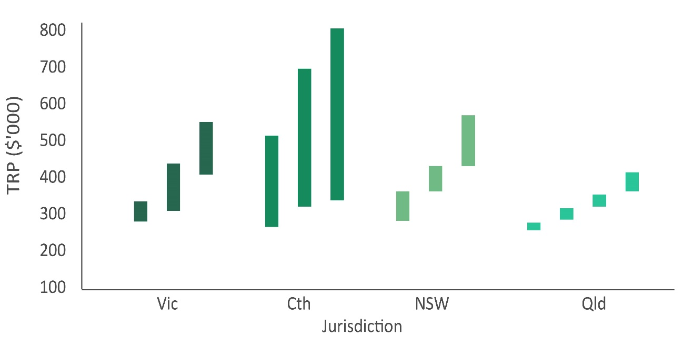
Table 6.6: comparison of TRP ranges for subordinate executives in selected Australian public services, January 2020
Grade | Victoria |  | Commonwealth^{(c)} |  | NSW |  | Queensland
Grade | Min $ | Max $ | Min $ | Max $ | Min $ | Max $ | Min $ | Max $
Band 1 | 185,711 | 240,789 | 190,933 | 428,327 | 192,600 | 274,700 | 162,474 | 182,751
Band 2 | 249,701 | 343,938 | 216,696 | 664,748 | 271,701 | 345,550 | 191,269 | 222,277
Band 3 | 313,274 | 457,081 | 243,540 | 713,899 | 345,551 | 487,050 | 226,609 | 259,283
Band 4 | n.a | n.a | n.a | n.a | n.a | n.a | 268,409 | 320,047
Notes to figure 6.4 and table 6.6: (a) Excludes bands reserved for agency/department heads; (b) bands are exclusive of variable remuneration (e.g. bonus opportunities); (c) the APS does not have formal remuneration bands for executives — the figures provided in this table are the maximum and minimum amounts actually paid, based on most recently published data.
Sources for figure 6.4 and table 6.6: APSC, APS Employment Data, 2019; NSW Statutory and Other Offices Remuneration Tribunal Public Service Senior Executive Determination 2019; Queensland Public Service Commission Directive 10/17.

Remuneration structures also vary for head of agency roles across these jurisdictions (table 6.7).
Table 6.7: comparison of TRP ranges for Secretaries, or equivalent, of departments in selected Australian public services, January 2020
Jurisdiction | Minimum TRP ($ p.a.) | Maximum TRP ($ p.a.)
Victoria | 530,000 | 650,000
Commonwealth | 720,000 | 914,460
NSW^{(a)} | 599,000 | 629,100
Queensland^{(a)} | 195,206 | 744,000
Note: (a) reflects range in which Secretaries in NSW and Queensland are actually paid. The range determined by the relevant Tribunal/Commission is $487,501 to $562,650 in the case of NSW and $195,206 to $712,516 in the case of Queensland.
Sources: CRT, Departmental Secretaries—Classification Structure and Terms and Conditions) Determination 2019; NSW Statutory and Other Offices Remuneration Tribunal Public Service Senior Executive Determination 2019; Queensland Chief Executive pay and benefits, Queensland Public Sector Commission, 2019.

Tribunal’s decision on the value of the remuneration bands
Values of the remuneration bands for subordinate executives
Taking into account all of the above, in relation to subordinate executives, the Tribunal decided to set the:
- base of the SES-1 band at $192,800 p.a.
- top of the SES-1 band and the base and top of the SES-2 and SES-3 bands with reference to the 15th percentile of the Australian General Market.
Setting the base of the SES-1 band at $192,800 p.a. will restore the nine per cent gap between the top of the VPS-6 band and the base of the SES-1 band. It will increase the incentive for non-executive VPS staff to apply for executive roles by, at least in part, compensating for the reduction in employment conditions when moving from a non-executive to an executive role.
The Tribunal’s decision will also improve fairness by removing the overlaps between the bands and ensuring that the remuneration offer reflects the increased complexity and demands of subordinate executive roles. The decision will position the VPS more competitively against the APS and New South Wales public service, the two most comparable jurisdictions for remuneration purposes. It should also increase the government’s ability to attract and retain executives with the necessary skillsets and experience required to deliver the government’s agenda, particularly in highly competitive areas, such as the transport infrastructure, construction, energy and health sectors. Table 6.8 shows the values of the new remuneration bands for subordinate executives.
Table 6.8: new remuneration bands for subordinate executives employed in public service bodies
Classification | Minimum TRP ($p.a.) | Maximum TRP ($p.a.)
SES-1/EO-3 | 192,800 | 249,700
SES-2/EO-2 | 249,701 | 360,000
SES-3/EO-1 | 360,001 | 479,900
Values of the remuneration bands for public service body Heads
In addition, the Tribunal decided to align the remuneration bands for AO Heads with the bands set for subordinate executives (table 6.9). This is generally consistent with the existing remuneration arrangements for AO Heads, reflects the diversity in their roles, will promote ease of administration and may facilitate the movement of executives between AOs and other public service bodies.
Table 6.9: new remuneration bands for AO Heads
Classification | Minimum TRP ($ p.a.) | Maximum TRP ($ p.a.)
AO Head 1 | 192,800 | 249,700
AO Head 2 | 249,701 | 360,000
AO Head 3 | 360,001 | 479,900
Aligning the value of the remuneration bands for subordinate executives and AO Heads also took into consideration the feedback the Tribunal received in relation to the overall remuneration structure for public service body Heads. While the structure itself is modelled on option 3, this decision reflected elements of option 1 (under which AO Heads would have been placed within the same remuneration band structure as subordinate executives – see section 6.2).

For Secretaries and the Commissioner, the Tribunal decided to set the base of the Secretary/Commissioner band at $520,000 p.a. This decision references the existing remuneration arrangements, reflects the greater roles and responsibilities of Secretaries relative to subordinate executives and will provide incentives for advancement. It establishes a remuneration gap of around nine per cent between the top of the SES-3 remuneration band and the base of the Secretary/Commissioner band, which is broadly consistent with the decision regarding the gap between the top of the VPS-6 band and the SES-1 band.
Finally, the Tribunal decided to set the top of the Secretary/Commissioner band with reference to the 15th percentile of the Australian General Market. The Tribunal considers this will allow the remuneration offer to be fair, reasonable and competitive against other jurisdictions and the broader market (table 6.10).
Table 6.10: new remuneration band for Secretaries of departments and the Commissioner
Classification | Minimum TRP ($ p.a.) | Maximum TRP ($ p.a.)
Secretary/VPSC Commissioner | 520,000 | 701,800
Section 37 of the VIRTIPS Act requires an employer who proposes to pay a VPS executive remuneration that exceeds the maximum of the relevant remuneration band set by a Determination to apply to the Tribunal for advice as to the remuneration proposed to be paid and consider the advice provided.

6.4 The new executive remuneration framework
The new executive remuneration framework for executives employed in public service bodies consists of:
- three distinct and contiguous bands for subordinate executives aligned to the VPSC’s executive classification framework
- three distinct and contiguous bands for AO Heads aligned to the subordinate executive bands
- a single band for the remuneration of Secretaries and the Commissioner
The framework also sets a similar gap in percentage terms between the top of the highest non-executive remuneration band and the base of the SES-1 band and the top of the SES-3 and the Secretary/Commissioner bands.

Implementation of the new executive remuneration framework
In considering the implementation of the new executive remuneration framework, the Tribunal was cognisant of the interaction between the VIRTIPS Act and the Public Administration Act 2004 (Vic) (PAA).
Firstly, section 25(4) of the VIRTIPS Act provides that the Tribunal’s first Determination setting the values of the remuneration bands for executives employed in public service bodies takes effect six months after the day of Royal Assent of the Act. This means that by the operation of the VIRTIPS Act the Tribunal’s Determination takes effect from 20 September 2019.
Secondly, under section 25(4)(a) of the PAA, the remuneration paid to an executive employed in a public service body must be within the values of their relevant remuneration band. The effect of this means that VPS executives who are paid below the values of their relevant remuneration band will receive an increase in their TRP up to the new base of the band.
The Tribunal noted that, while only around 200 executives employed in public service bodies would receive an increase in their TRP because of the new executive remuneration framework, the TRP increase for those eligible executives could be back-dated to 20 September 2019 in the absence of any phasing.
Taking into account the current and expected economic and fiscal conditions outlined in chapter 5 arising from the COVID-19 pandemic, the Tribunal considered this would not be appropriate in the current environment.
As such, the Tribunal decided to ‘freeze’ VPS executive remuneration for 12 months by implementing its decision in relation to the values attached to the new remuneration band framework in two stages.
From 20 September 2019 until 30 June 2020, the values of the remuneration bands for VPS executives are as set in figure 6.5. The Tribunal has decided to set the values of the remuneration bands for subordinate executives, and for Secretaries and the Commissioner, based on the values of the bands and remuneration paid for these roles as at 1 July 2019 or currently, whichever is the lower. This means that, in general, affected executives will not receive backpay.
Figure 6.5: summary of the Tribunal’s Determination of remuneration bands for executives employed in public service bodies effective 20 September 2019 – 30 June 2020
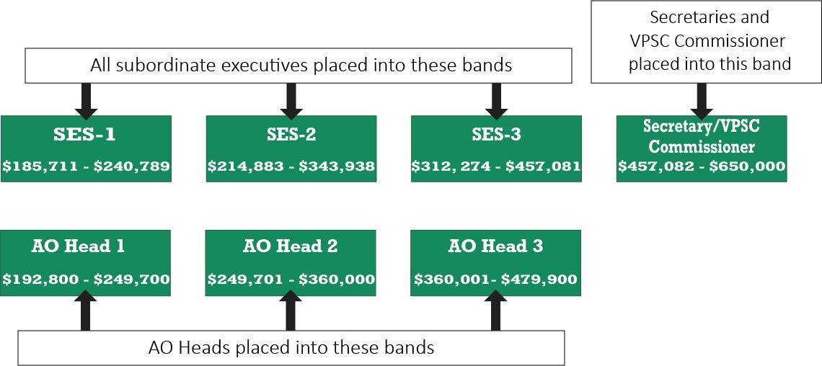
From 1 July 2020, the values of the remuneration bands for VPS executives are as set out in figure 6.6.
Figure 6.6: summary of the Tribunal’s Determination of remuneration bands for executives employed in public service bodies effective 1 July 2020
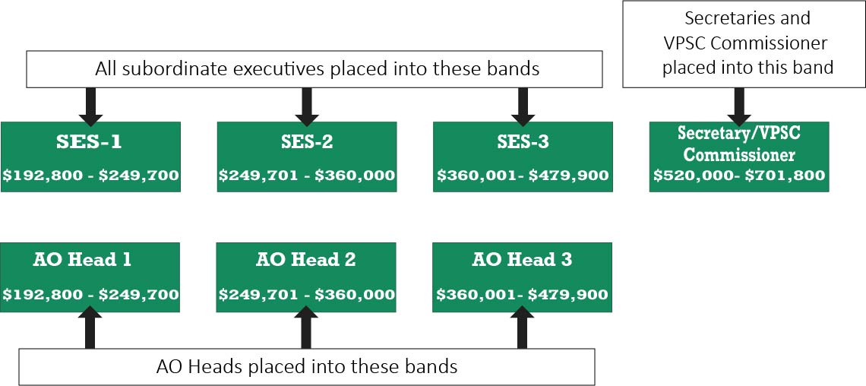
The values of the remuneration bands for AO Heads are the same in both stages because as at 20 September 2019, there were no relevant remuneration bands for AO Heads.
To ensure that all VPS executives are covered by the Determination, the Tribunal has determined that the relevant remuneration band for each subordinate executive corresponds to:
- if the classification of the executive’s position has not been determined using the revised executive classification framework, the EO classification specified in their contract of employment
- if the classification of the executive’s position has been determined using the revised executive classification framework, the SES classification of that position determined under that framework.
The VPSC’s revised executive classification framework is also applicable to the role of an AO Head. In relation to AO Heads, the Tribunal has determined that the relevant remuneration band for each AO Head corresponds to:
- if the classification of the AO Head’s position has not been determined using the revised executive classification framework and their TRP immediately prior to the making of the Determination was:
  - $360,001 per year or greater, AO Head-3;
  - between $249,701 and $360,000 (inclusive) per year, AO Head-2;
  - $249,700 per year or less, AO Head-1.
- if the classification of the AO Head’s position has been determined using the revised executive classification framework, the AO Head classification of that position determined under that framework.

6.5 Conclusion
This Statement of Reasons deals with the Tribunal’s first Determination of the remuneration bands for executives employed in public service bodies. Under the VIRTIPS Act, the Tribunal can adjust the values of the remuneration bands it has set annually, except when a Determination has been made under section 21 of the VIRTIPS Act in the preceding nine months (s22(2) of the VIRTIPS Act).
In making the Determination, the Tribunal has comprehensively reviewed the roles of executives, including public service body Heads and the existing remuneration framework for executives, as well as relevant policies and financial, fiscal and economic factors. This has included consideration of the nature of the labour market for executives in the VPS and the competitiveness of the existing executive remuneration bands against the Australian General Market, including other Australian jurisdictions. The Tribunal has also taken into account the need for the executive remuneration framework to support fair remuneration outcomes for executives and to attract and retain talent to the VPS executive workforce.
The Tribunal has been assisted by the many submissions it received in relation to the proposed Determination for executives in VPS bodies, including the responses to the VPS executive questionnaire.
The resultant Determination for executives employed in public service bodies takes effect from 20 September 2019 pursuant to section 25 of the VIRTIPS Act.

Reference list
ABS (Australian Bureau of Statistics). Australian Demographic Statistics.
cat. no. 3101.0. September 2019.
———. Average Weekly Earnings, Australia. cat. no. 6302.0. May 2019.
———. Consumer Price Index. cat. no. 6401.0. June 2019.
———. Participation, Job Search and Mobility. cat. no. 6226.0. February 2019.
———. Wage Price Index. cat. no. 6345.0. June 2019.
———. Wage Price Index, cat. no. 6345.0. December 2019.
Andrews, Daniel. ‘Crisis Council of Cabinet set up to combat coronavirus.’ Media release. 3 April 2020.
APSC (Australian Public Service Commission). ‘APS Employment Data 30 June 2019 Release’. Commonwealth of Australia, 2019.
Butler, Ben. ‘Bank Bosses Acting like Pilots Who Have Parachutes Their Passengers Don’t, Regulator Says’. The Guardian, 13 November 2019.
CRT (Commonwealth Remuneration Tribunal). Departmental Secretaries—Classification Structure and Terms and Conditions) Determination 2019. Canberra, July 2019.
DET (Department of Education and Training). Annual Report 2018-19. State Government of Victoria: Melbourne, Victoria 2019.
DELWP (Department of Environment, Land, Water and Planning). Annual Report 2018-19. State Government of Victoria: Melbourne, Victoria 2019.
DHHS (Department of Health and Human Services). Annual Report 2018-19. State Government of Victoria: Melbourne, Victoria 2019.
DJPR (Department of Jobs, Precincts and Regions). Annual Report 2018-19. State Government of Victoria: Melbourne, Victoria 2019.
DJCS (Department of Justice and Community Safety). Annual Report 2018-19. State Government of Victoria: Melbourne, Victoria 2019.
DPC (Department of Premier and Cabinet). Annual Report 2018-19. Melbourne, Victoria: State Government of Victoria, 2019.
DoT (Department of Transport). Annual Report 2018-19. State Government of Victoria: Melbourne, Victoria 2019.
DTF (Department of Treasury and Finance). Annual Report 2018-19. State Government of Victoria: Melbourne, Victoria 2019.
———. Victorian Budget 19/20: 2019/20 Budget Update. State Government of Victoria: Melbourne, Victoria, December 2019.
———. Victorian Budget 2019/20. State Government of Victoria: Melbourne, Victoria, May 2019.
Donaldson, David. ‘Richard Bolt on Victorian Department of Economic Development’. The Mandarin, 18 November 2015.
———. ‘Super-Departments in Government: Policy Locked Out?’. The Mandarin, 15 December 2014.
Eccles, Chris. ‘Leadership from the Centre’. presented at the Institute of Public Administration Australia - Public Sector Week, Melbourne, Victoria, 23 June 2015.
Falato, Antonio, Todd Milbourn, and Dan Li. ‘CEO Pay and the Market for CEOs’. Working Papers - U.S. Federal Reserve Board’s Finance & Economic Discussion Series, July 2012, 1–67.
Fels, Allan. ‘Why I Tried to Cut CEO Pay Packets’. Australian Financial Review, 30 August 2019.
Hough, Andrew, and Jade Gailberger. ‘What Public Service Bosses Are Paid: See the Full List’. The Advertiser, 24 October 2019.
Industrial Relations Victoria, ‘Victorian Government Wages Policy,’ Wages Policy and the Enterprise Bargaining Framework. State Government of Victoria: Melbourne, Victoria, 2019.
Legislative Council, Legal and Social Issues Committee. 'Inquiry into Machinery of Government Changes'. Parliament of Victoria: Melbourne, Victoria, May 2016.
Lowe, Philip. ‘Statement by Philip Lowe, Governor: Monetary Policy Decision.’ Media Release. 3 March 2020.
———. Statement by Philip Lowe, Governor: Monetary Policy Decision.’. Media release. 5 May 2020.
Mercer Consulting (Australia). Report for Secretary and SES Remuneration Framework. report prepared for the Victorian Independent Remuneration Tribunal. Melbourne, Victoria: December 2019.
Productivity Commission. ‘Executive Remuneration in Australia’. Melbourne: Productivity Commission, 2009.
RBA (Reserve Bank of Australia). Statement on Monetary Policy. Sydney, New South Wales, 7 November 2019.
Victoria, Parliamentary Debates, ‘Legislative Assembly’, 6 February 2019.
Victorian Auditor-General’s Office. Auditor-General’s Report on the Annual Financial Report of the State of Victoria: 2018-19. Victorian Government Printer: Melbourne, Victoria, February 2020.
VPSC (Victorian Public Sector Commission). Review of Victoria’s Executive Officer Employment and Remuneration Framework: Summary Report. State Government of Victoria: Melbourne, Victoria, August 2016.
———. Serving Government: A Guide to the Victorian Public Sector for Ministerial Officers. State Government of Victoria: Melbourne, Victoria, February 2019.
———. Statistical Compendium to the State of the Public Sector in Victoria 2017-2018 Report. State Government of Victoria: Melbourne, Victoria, 2018.
———. The State of the Victorian Public Sector in Victoria. published annually between 2009-2010 and 2017-18. State Government of Victoria: Melbourne, Victoria.
Yeates, Clancy. ‘Qantas Chief Alan Joyce Tops CEO Pay Table’. The Sydney Morning Herald, 16 September 2019.
Yohan, Ramasundara and Andrew Johnson. ACS Australia’s Digital Pulse 2019. Deloitte Access Economics: Sydney, New South Wales, August 2019.

Appendix A – consultation
In accordance with section 24(1) of the Victorian Independent Remuneration Tribunal and Improving Parliamentary Standards Act 2019 (Vic), on 29 July 2019, and before making this Determination, the Victorian Independent Remuneration Tribunal (Tribunal):
- published notice of its intention to make a Determination on its website (www.remunerationtribunal.vic.gov.au), including details about the proposed Determination
- gave any affected person or a class of affected persons a reasonable opportunity to make a submission in relation to the proposed Determination.
The Tribunal:
- invited submissions from any person through its Notice of Intention
- distributed an anonymous questionnaire to all subordinate executives employed in public service bodies (executive questionnaire)
- issued a discussion paper outlining three proposed options for establishing a remuneration band structure for public service body Heads, that is, Secretaries of departments, the Commissioner of the Victorian Public Sector Commission and Administrative Office Heads.
In total, the Tribunal received:
- three written submissions in response to the Notice of Intention
- 242 responses to the anonymous questionnaire
- two submissions in response to the discussion paper.
This document contains a list of the questions asked in the questionnaire and summarises the responses received. Other written submissions (except those where the author has requested and the Tribunal has agreed to confidentiality) are available on the Tribunal’s website (www.remunerationtribunal.vic.gov.au).
Submissions cited in this appendix and published on the Tribunal’s website have not been corrected for publication and do not necessarily represent the views of the Tribunal.
Executive questionnaire
The Tribunal invited approximately 1,000 Victorian Public Service (VPS) executives to make a submission via an online questionnaire in order to understand the roles and responsibilities of executives, the motivations of executives and how current arrangements could be improved. The questions asked are listed below:
- What is your executive classification level?
- What is your primary responsibility?
- How long have you been an executive in the VPS?
- What was your role immediately prior to your current role?
- What motivated you to apply for your current role?
- Please provide comment on any trends or significant changes over the last five years that affect your role.
- Please provide your views on VPS executive remuneration, for example, the competitiveness of remuneration structures in attracting and retaining suitable executives in a public sector context.
- What do you consider to be relevant factors and comparators for informing the determination of remuneration bands for executives in the VPS, and for determining the relativities between them?
- What are your future career intentions (in the next five years)?
- Please provide any other comment or feedback in relation to your role, or VPS executive remuneration, that you consider relevant to inform the Tribunal’s deliberations.

Profile of respondents
The figures below summarise the characteristics of executives who responded to the questionnaire.
Of the executives who responded, 53 per cent were classified as Executive Officer Level 3 (EO-3, the lowest level of executive), 39 per cent were EO-2s and eight per cent were EO-1s.
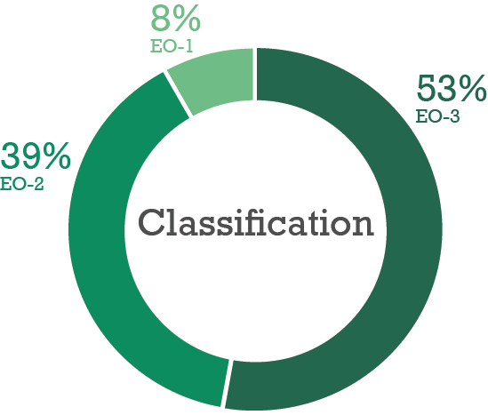
Executives were asked to identify their primary role or responsibility. The highest responses were for portfolio and program implementation (31 per cent), service delivery (24 per cent), policy advice (19 per cent) and specialist roles (19 per cent).
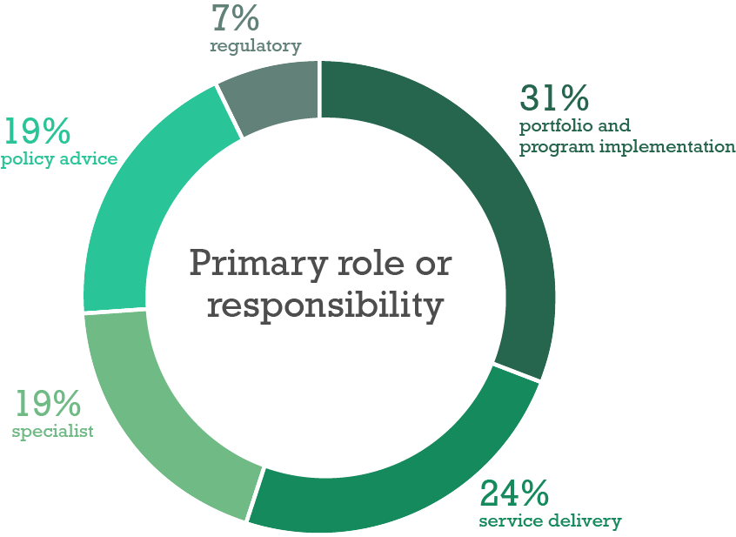
Some 64 per cent of respondents had been an executive for less than five years. Another 20 per cent had been an executive for between five and nine years, and 16 per cent had been an executive for over 10 years.
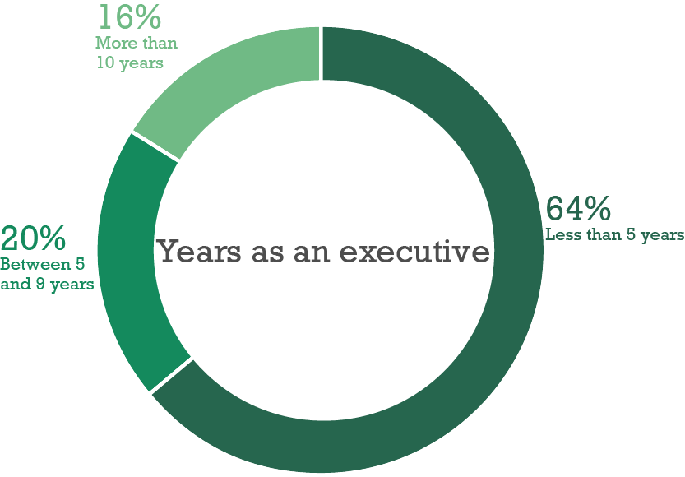
Respondents were also asked to identify their role immediately prior to their current role. While 32 per cent of respondents were executives in the VPS immediately prior to their current role, 26 per cent were non-executive VPS staff. Approximately 16 per cent had been executives in the private sector and seven per cent had been executives in the public sector in another Australian jurisdiction.
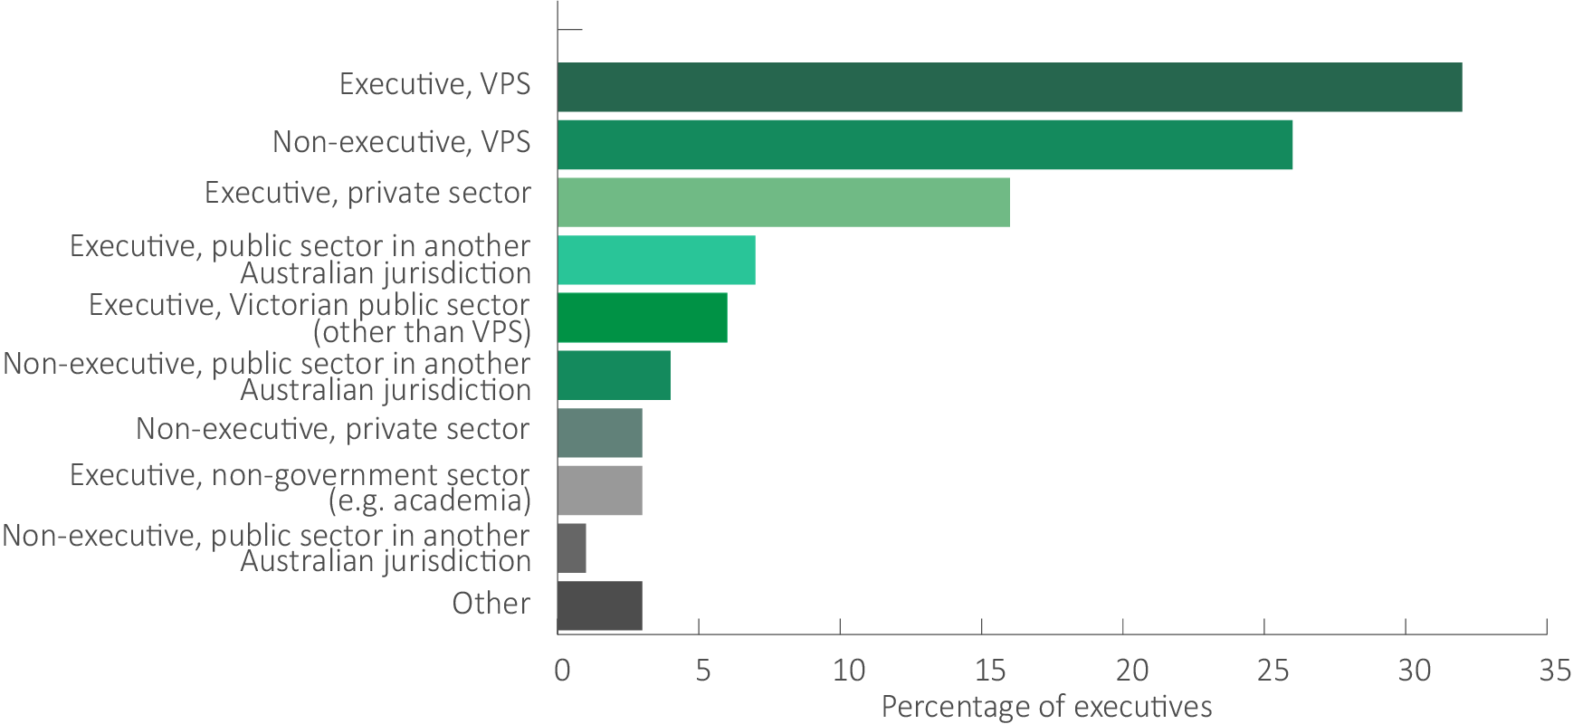
Other immediate prior positions listed by executives included:
- executive in a Ministerial Office
- consultant
- self-employed.

Overall themes
- Around 22 per cent of respondents considered their existing remuneration was sufficient.
- Around 20 per cent compared their remuneration to equivalent private sector roles and concluded it was lower.
- Around nine per cent considered their pay was insufficient, relative to their workload.
- A common suggestion was to make remuneration more competitive with equivalent roles in the private sector and with other public sectors, such as the Australian Public Service.
- Other key themes were:
  - the insufficient gap between the top of the non-executive VPS-6 salary band and the bottom of the EO-1 executive remuneration band
  - overlapping remuneration bands have created inequalities and anomalies between executives undertaking roles of similar work value
  - an evaluation of executive remuneration structures is needed due to increases in workload, responsibility and availability of executives.

Responses by question

Motivation for becoming an executive
The questionnaire asked executives to identify their motivation for applying for their current role.
Some 35 per cent cited the nature of the work as a key motivating factor for applying for an executive role. In this regard, respondents referred to the challenge and complexity of the work, the opportunity to provide specialist advice, and the opportunity to work at the centre of government.
For example, one executive stated:
Really interested in the work - in operations - and felt I had a contribution to make and wanted to take on additional responsibility.
And another said the:
Opportunity to lead change and policy and service improvement in a challenging role.
Another executive noted the:
Diversity of the role in my specialise area that looked both challenging and delivering social value. the role also managed a large branch and served multiple sectors giving me greater opportunity to apply my skills in different areas.
The ability to drive change and increase value for the community were cited as key motivations for around 19 per cent of respondents. A respondent noted:
The opportunity to improve justice outcomes and develop a whole of system approach with supporting capabilities and tools; the opportunity to transform the department; and to coach, support and develop the next suite of justice public service leaders.
Career progression was also identified as a motivating factor for around 16 per cent of respondents, while around five per cent of respondents were either asked or encouraged to move into their new role. Several executives noted that they had opportunities to act in higher roles before taking on permanent promotions. An executive reflected:
I believed I had spent quite a significant amount of time in an EO3 role which afforded me the opportunity to consolidate my skills and abilities at the level. I also had the opportunity to act in an EO2 role for 6 months which allowed me to test myself at that level. It seemed a natural progression to then apply for the EO2 role when the opportunity arose.
Some 11 per cent of respondents reported leadership opportunities as a key motivating factor. Respondents cited the opportunity to establish and lead a new organisation, to develop a strategy, and the desire to lead a team as relevant examples of this motivation.
For example, an executive noted:
I was also motivated by continuing to work in a leadership role with the opportunity to work with others and lead a group of people through changes to create a well performing team.
Three per cent of executives reported that remuneration was a motivating factor. One respondent stated their reasons as:
… a good salary and conditions, ability to contribute to… the efficient and effective delivery of a community service.
And another said:
Interesting work opportunity - competitive remuneration - relatively more affordable than [previous location].
Other factors cited by respondents included:
- a desire to try something new
- better work life balance
- leadership and/or management dimension of the new role
- unhappiness in their previous role
- re-location or geographical location.

Trends, or significant changes over the last five years
Executives were asked to comment on the trends or significant changes over the last five years that have affected their role.
Approximately 20 per cent of executives reported increased work demands against tighter time frames and constrained budgets. For example, one executive noted the:
Increase[d] demands both from a workplan an[d] priorities perspective and HR and personal support for staff as they are constantly required to deal with more stressful environments.
While another said:
Doing more with less (tight budgets), but with increasing Ministerial expectation to get everything right, to consult with everyone, and to get it done quickly.

And another said:
There has been an increasing expectation to deliver more at a faster pace with a reducing staffing base.
Around 17 per cent of respondents identified an increase in workload over the past five years. One respondent stated there has been a:
Significant increase in workload due to government led reform without an increase in staffing to deliver this reform.
Machinery-of-Government changes were cited as having significant impacts on their role by around 13 per cent of respondents. For example, an executive stated:
Organisational re-structure and changes in machinery of government have changed scope and focus of role. This has seen this constrict and then significantly expand since 2016.
Some 12 per cent of respondents reflected that larger government programs and agendas, along with an expectation that these are delivered more quickly, have had a significant effect. One executive noted:
Significant investment in transport infrastructure have seen the portfolio of responsibilities and risk management increase extensively for executives.
The table below provides more examples of responses which reflect these and other trends and changes to executive roles over the last five years.
Comments on trends and changes to executive roles over the last five years
… work is highly scrutinised and we have to provide daily responses to a number of external stakeholders… as well as Ministers.
Pace, risk aversion, institutional change, loss of capability in team.
Increasing pressure to deliver projects in unreasonable time frames.
Increased insecurity, particularly with MOG changes…
Direct span of control and level of risk mitigation required by a EO in operational services has significantly increased such as volume of oncall and availability out of core hours.
An approach to centralise functions that can be very disempowering for executives.
A greater focus… on integrity, financial management and working across Government.
Constant organisational transformation activity... A lack of tenure/security or sense of stability in executive roles…
Constant restructuring and increased workload of self and staff as a consequence of savings and staff freezes.
EO roles in the VPS are far more complex and nuanced than they were five years ago.
Note: quotes have not been corrected for publication and do not necessarily represent the views of the Tribunal.

Executives’ views on their remuneration
Executives were asked to provide their views on VPS executive remuneration, for example, the competitiveness of remuneration structures in attracting and retaining suitable executives in a public sector context.
Around 22 per cent of respondents expressed satisfaction or were content with the level of remuneration they were receiving. For example, one executive said:
I am broadly comfortable with the remuneration structure and my current salary. For most roles in the VPS (excluding those requiring very specialist expertise), I believe the salary levels are competitive.
And another stated:
I feel very well remunerated, particularly in comparison to what I could have earned in the public sector [in another jurisdiction] where I came from.
In contrast, nine per cent stated that they were not paid enough. One respondent noted:
I still am not receiving a comparable salary or benefits for my experience or qualifications… I could easily up my salary by $50k if I went back into the private sector (or be a contractor or consult to government) with similar performance expectations.
With regards to other sectors, 22 per cent of respondents believed that they were paid lower than comparable roles in the private sector, while three per cent felt their remuneration is competitive with the private sector. For example, an executive stated:
My previous role in the private sector had far less risk, demand and complexity and the hours I had to work to manage the workload were far fewer. I was paid an equivalent salary with access to bonuses.
While another reflected:
When competing with the private sector, particularly in a well-paid specialised area such as legal services, public service remuneration is not competitive.
However, some executives noted that other benefits available to VPS executives somewhat balanced the lower remuneration offer. As one executive said:
The VPS executive remuneration band is competitive and allows employers to negotiate individual remunerations. The roles of executives allow flexibility to maintain work life balance.
And another noted:
I think with the combination of the salary, executive vehicle scheme and flexible work arrangements, I think the remuneration is competitive. The high profile nature and expectation of some VPS exec roles may diminish the attractiveness (ie equivalent private sector roles arguably have higher remuneration with less pressure / public criticism).
Several respondents also stated that the remuneration for VPS executives is lower than other public sectors.
Some 12 per cent of executives reflected that the remuneration offered does not attract or retain talent. One respondent stated:
… the executive remuneration is not competitive in the current environment and it’s difficult to attract highly experiences people into the public sector. Equivalent positions within the private sector are attracting double the remuneration for similar roles.
While 11 per cent of respondents noted there are varying remuneration arrangements between executive roles. For example, one respondent noted:
Uneven and inconsistent - roles at the same level and similar pay can vary hugely in responsibilities, span of control, pressure, etc.
Another said:
There is a huge amount of inconsistency at EO3 level. I have a team of 25 and work exclusively on multiple strategic priorities for my department, yet am paid at the base of the band due to length of tenure, although there are EO3's around me with just 4-6 reports and a single function that are better remunerated.
Some respondents called for greater transparency in setting remuneration for executives, with one executive stating that the existing approach leads to competition between executives:
A more transparent approach to setting remuneration is needed to foster greater executive collaboration rather than competition.
Many executives also noted that higher remuneration for non-executive staff and overlapping executive bands caused confusion and acted as disincentives to seek promotion. One executive said:
… the TRP requirements at an EO level meant that they [new executives] were financially better off remaining at the 6.2, in some cases there was only a dollar differential. This causes attraction issues.
And another noted:
The difference between the top of a VPS 6 band and the bottom of an EO3 is negligible, and it begs the question as to why anyone would take an EO3 role where there is more scope for a pay increase, and much more security at a VPS 6 level.
Finally, some respondents made comments about the impact of the removal of the bonus opportunity from VPS executive employment contracts, while others discussed the executive vehicle scheme.

Relevant factors and comparators
Executives were asked about what they would consider to be relevant factors and comparators for informing the Determination of remuneration bands for executives in the VPS, and for determining the relativities between them.
Around 23 per cent of respondents stated that similar industries in the private sector or public sectors in other Australian jurisdictions could be considered as comparators. For example, one respondent said:
… [remuneration] must though be at least competitive or comparative with private, particularly if certainty of tenure via Executive contracts is ostensibly no better or improved than private industry.
And another suggested:
… if the VPS wants to attract and retain talent, they need to more closely align executive remuneration with APS frameworks to ensure there is, at least, parity between the roles.
While another noted:
It is difficult to use other jurisdictions for pay comparisons as they are different labour markets with different cost drivers – but there should be an understanding of relativities for similarly sized roles (not levels).
Many executives also suggested that the responsibilities of individual roles should be considered when setting remuneration. One executive stated:
The classifications should be tied more closely to the level of responsibility and accountability held by the executive. If possible it would also be ideal if the current difference in titles and structures across departments could be harmonised.
Some 13 per cent of respondents identified the experience and skill of the executive as relevant factors, while nine per cent also suggested the complexity of an executive’s role is relevant. One respondent reflected that:
The key factors should relate to span of role and degree of technical specialisation needed to manage the role.
The table below provides further examples of responses which identified factors and comparators the Tribunal should take into consideration.
Comments on other relevant factors and comparators identified by executives
I would expect factors to be level of risk the executive is responsible to manage, financial and governance responsibility, complexity of the organisation and its portfolio responsibilities.
Autonomy, risk carried by the role, span of control, Ministerial engagement, direct stakeholder management.
Level of risk being managed; size & complexity of business unit(s); outcomes; budget (expense & revenue).
Accountability, autonomy and risk
Breadth of influence and accountability
Size of Division/Business Unit
Degree of specialist knowledge and comparative private sector remuneration.
Quantum of budget accountability, expected intersection/relationship with Secretary/Ministers and other senior leaders (e.g. Commissioners, agency heads etc), accountability for risk and reputation of department and government.
Note: quotes have not been corrected for publication and do not necessarily represent the views of the Tribunal.

Future career intentions
Executives were asked about their career intentions over the next five years.
Some 66 per cent of respondents stated that they were likely to remain in the VPS or other Victorian public sector organisation. Eight per cent indicated they would likely move to an executive role in another Australian public sector.
Around 17 per cent of respondents indicated an intention to take on an executive role in the private sector. Five per cent identified ‘other’ career intentions (for example, seeking a non-executive role in another market or in the non-government sector such as in academia).
Finally, two per cent responded that they were unsure about their future career intentions, and another two per cent were planning to retire within the next five years.

Victoria, Parliamentary Debates, ‘Legislative Assembly’, 6 February 2019 (Jacinta Allan, Leader of the House, Minister for Transport Infrastructure).
VPSC, The State of the Public Sector in Victoria 2017-2018, (State Government of Victoria: Melbourne, Victoria, March 2019).
PAA s43; Administrative Arrangements Order (No. 221) 2016.
VPSC, The State of the Public Sector in Victoria 2017-2018.
VPSC, The State of the Public Sector in Victoria 2017-2018.
ABS, Australian Demographic Statistics, cat. no. 3101.0, 19 September 2019.
VPSC, The State of the Public Sector in Victoria 2014-2015 (State Government of Victoria: Melbourne, Victoria, March 2016); VPSC, The State of the Public Sector in Victoria 2018-2019.
VPSC, The State of the Public Sector in Victoria 2018-19.
VPSC, The State of the Public Sector in Victoria 2017-18.
DPC, Annual Report 2018-19, (Melbourne, Victoria: State Government of Victoria); DHHS, Annual Report 2018-19, (Melbourne, Victoria: State Government of Victoria).
The Hon. Daniel Andrews MP, Premier of Victoria, ‘Crisis Council of Cabinet set up to combat coronavirus’, media release, 3 April 2020.
‘Organising Government for COVID-19 and service continuity – key responsibilities,’ accessed 7 May 2020, https://www.cpsuvic.org/public_docs/2020/VicGov%20Crisis%20Council%20and%20VPS%20Missions%20CC.pdf.
PAA, s13.
Children, Youth and Families Act 2005 (Vic), s16.
David Donaldson, ‘Super-Departments in Government: Policy Locked Out?’, The Mandarin, 15 December 2014.
Legislative Council, Legal and Social Issues Committee, ‘Inquiry into Machinery of Government Changes’ (Melbourne, Victoria: Parliament of Victoria, May 2016).
Chris Eccles, ‘Leadership from the Centre’ (Institute of Public Administration Australia - Public Sector Week, Melbourne, Victoria, 23 June 2015).
‘Organising Government for COVID-19 and service continuity – key responsibilities,’ accessed 7 May 2020, .
PAA, s13A.
PAA, s13.
DTF, Standing Directions 2018 under the Financial Management Act 1994, (State Government of Victoria: Melbourne, Victoria, December 2019).
DELWP, Annual Report 2018-19, (State Government of Victoria: Melbourne, Victoria, 2019).
VPSC, Serving Government: A Guide to the Victorian Public Sector for Ministerial Officers (State Government of Victoria: Melbourne, Victoria February 2019).
PAA, s14.
VPSC, The State of the Public Sector in Victoria 2017-2018.
VPSC revised executive classification framework, 2019.
David Donaldson, ‘Richard Bolt on Victorian Department of Economic Development’, The Mandarin, 18 November 2015.
Ramasundara Yohan and Andrew Johnson, ACS Australia’s Digital Pulse 2019, (Deloitte Access Economics: Sydney, New South Wales, August 2019).
VPSC, Victorian Public Service Executive Employment Handbook, (State Government of Victoria: Melbourne, Victoria, February 2019).
80 per cent of non-executive staff are employed in an ongoing position. VPSC, The State of the Public Sector in Victoria 2017-2018.
VPSC, Review of Victoria’s Executive Officer Employment and Remuneration Framework: Summary Report.
VPSC, Review of Victoria’s Executive Officer Employment and Remuneration Framework: Summary Report.
The VPS Grade 6 classification is the highest non-executive classification under the 2016 VPS Enterprise Agreement, excluding ‘Senior Technical Specialists’ which is a classification reserved for a small number of specialist roles.
VPSC, Review of Victoria’s Executive Officer Employment and Remuneration Framework: Summary Report.
See for example: Allan Fels, ‘Why I Tried to Cut CEO Pay Packets’, Australian Financial Review, 30 August 2019; Clancy Yeates, ‘Qantas Chief Alan Joyce Tops CEO Pay Table’, The Sydney Morning Herald, 16 September 2019; Antonio Falato, Todd Milbourn, and Dan Li, ‘CEO Pay and the Market for CEOs’, Working Papers - U.S. Federal Reserve Board’s Finance & Economic Discussion Series, July 2012, 1–67; Ben Butler, ‘Bank Bosses Acting like Pilots Who Have Parachutes Their Passengers Don’t, Regulator Says’, The Guardian, 13 November 2019; Andrew Hough and Jade Gailberger, ‘What Public Service Bosses Are Paid: See the Full List’, The Advertiser, 24 October 2019.
Productivity Commission, ‘Executive Remuneration in Australia’ (Productivity Commission: Melbourne, Victoria, 2009).
Productivity Commission, ‘Executive Remuneration in Australia'.
Includes some executives who separated to move to another agency but excludes movements due to Machinery-of-Government changes.
Philip Lowe, RBA, Statement on Monetary Policy, (Sydney, New South Wales, May 2020).
DTF, Victorian Budget 19/20: 2019/20 Budget Update, (State Government of Victoria: Melbourne, Victoria, December 2019).
ABS, Consumer Price Index, Australia, cat. no. 6401.0, June 2019.
ABS, ‘Wage Price Index Explanatory Notes’, Wage Price Index, cat. no. 6345.0, June 2019.
Victorian Auditor-General’s Office, Auditor-General’s Report on the Annual Financial Report of the State of Victoria: 2018-19, (Melbourne, Victoria: Victorian Auditor-General's Office, 13 November 2019).
DTF, Victorian Budget 19/20: 2019/20 Budget Update.
DTF, Victorian Budget 19/20: 2019/20 Budget Update.
VPSC, Review of Victoria’s Executive Officer Employment and Remuneration Framework: Summary Report.
PAA, s56.
Defined benefits schemes provide a fixed benefit based on factors such as an executive’s length of membership, age, contribution rate and final average salary; Commonwealth Superannuation Corporation, ‘How super works’, (Commonwealth of Australia, 2020).
VPSC, Victorian Public Service Executive Employment Handbook.
Includes some executives who separated to move to another agency but excludes movements due to Machinery-of-Government changes.
ABS, Participation, Job Search and Mobility, Australia, cat. no. 6226.0, 2019.
APSC, ‘APS Employment Data 30 June 2019 Release’ (Canberra, ACT: Commonwealth of Australia, 2019).
VPSC, Statistical Compendium to the State of the Public Sector in Victoria 2017-2018 Report, (Melbourne, Victoria: State Government of Victoria, 2019).
The People Matter Survey is an annual employee survey run by the VPSC across the VPS and public sector bodies.
Victorian Public Service Enterprise Agreement 2016 [AG2016/2919]
Victorian Public Service Enterprise Agreement 2016 [AG2016/2919]
VPSC, Review of Victoria’s Executive Officer Employment and Remuneration Framework: Summary Report.
The Mercer General Market refers to all data within the Mercer remuneration database for Australia and New Zealand. The data has over 450,000 data points. By way of example, the 10th percentile is the position at which 10 per cent of positions are paid below and 90 per cent are paid above.

