

Annual Report
2022–23

Authorised and published by the Victorian Independent Remuneration Tribunal
Ground Floor, 1 Treasury Place
Melbourne VIC 3002
ISSN 2653-7648 - Online (pdf/word)
© State of Victoria.

You are welcome to re-use this work under a Creative Commons Attribution 4.0 licence, provided you credit the State of Victoria (Victorian Independent Remuneration Tribunal) as author, indicate if changes were made and comply with the other licence terms. The licence does not apply to any branding, including government logos.
Except where otherwise indicated, the images in this publication show models and illustrative settings only, and do not necessarily depict actual services, facilities or recipients of services.

Contents
Message from the Chair 2
Abbreviations and glossary 4
1. About the Tribunal 5
1.1 Functions of the Tribunal 5
1.2 Tribunal Members 6
Warren McCann – Tribunal Chair 6
The Honourable Jennifer Acton – Tribunal Member 6
Laurinda Gardner – Tribunal Member 7
1.3 Annual report requirements 8
2. Review of operations 9
2.1 Members of Parliament 9
2023 Determination of salaries and allowances 10
2023 MP Guidelines 12
2.2 Public sector executives 13
Annual adjustment Determinations 14
Payment above the band advice 16
Requests for advice from the Minister about public sector executives 17
2.3 Mayors, Deputy Mayors and Councillors 17
2.4 State Budget performance measures 19
3. Other Tribunal matters 20
3.1 Tribunal meetings 20
3.2 Finance 20
3.3 Freedom of information requests 21
4. Office of the Compliance Officer 22
4.1 Compliance Officers 23
Peter Lewinsky 23
Jane Brockington 23
4.2 Report on the function of the Compliance Officer 24

Message from the Chair
Dear Assistant Treasurer
The main task undertaken by the Tribunal in financial year 2022-23 was a comprehensive Determination of salaries and allowances for MPs. This was the first comprehensive Determination since the original Determination in 2019.
In the course of this work, the Tribunal sought to extend its engagement and opportunities to participate in the process. In addition to a formal notice of intention inviting submissions, the Tribunal published a consultation paper containing background information and outlining issues on which it was seeking input and met with a number of individual MPs as well as a roundtable group drawn from across the Parliament. These were important steps towards an open and consultative approach. The Tribunal will continue to look for opportunities to broaden its engagement with its constituent groups.
In response to submissions a number of changes were made to the MP Guidelines as part of the Determination – including providing greater flexibility for MPs in using the Electorate Office and Communications Budget to communicate with their constituents and making it clear that an MP may claim the travel allowance for an overnight stay immediately preceding and following parliamentary, committee or ministerial business. The Tribunal was pleased to be able to make these changes to support MPs in carrying out their public duties and will look to further refinements in the future wherever improvements can be made.
I would like to acknowledge the excellent cooperation of the Department of Parliamentary Services and its Secretary, Trish Burrows, in raising matters for consideration and in advising on the workability or otherwise of the various proposals. I would also like to thank the Clerks of the Parliament of Victoria, Bridget Noonan and Robert McDonald, for their assistance during the Determination process.
In addition to the comprehensive Determination for MPs, the Tribunal also made annual adjustments to the remuneration bands for public service and public entity executives, and to the value of allowances for Local Government Mayors, Deputy Mayors and Councillors. In so doing, the Tribunal took the opportunity to bring the timing of future annual adjustments for Local Government into alignment with MPs and executives.
The comprehensive Determination for MPs and each of the annual adjustments were made during a period of relatively high inflation in Australia and the world. Although all of the matters the Tribunal is required to consider under its legislation were weighed carefully, the Tribunal was mindful of the impact of its decisions on the broader economy. Thus, particular weight was given to the Government’s wages policy and current and projected economic conditions and trends, in seeking to find the right balance between wages fairness for the occupational groups within the Tribunal’s jurisdiction and the need for restraint dictated by the prevailing economic circumstances.
During the year the Tribunal surveyed MPs, Local Government Mayors and public sector employers about the Tribunal’s performance in relation to its communication and consultation processes, the timeliness of its decisions and its method of responding to viewpoints and issues raised by stakeholders. Respondents reported an overall satisfaction level of 87 per cent — significantly above the target rate of 80 per cent.
Nevertheless, over the coming year, the Tribunal proposes to further improve the information it provides about the reasons for its decisions and to reach out to key stakeholders to explain the Tribunal’s statutory responsibilities and how it goes about its decision-making process. Public commentary including in the mainstream media suggests that there is only limited understanding of the legislative framework within which the Tribunal operates – notwithstanding the detailed statement of reasons that accompanies each Tribunal Determination and the comprehensive information available on its website.
This financial year was the second full year of the operation of the payment above the band process. As you know, if an employer proposes to pay an executive above the maximum of the relevant remuneration band, the employer must first seek and consider the advice of the Tribunal. The employer is not bound to accept the advice. In providing advice, the Tribunal strives to protect the integrity of the overall remuneration structure and at the same time recognise that there may be circumstances where prevailing market conditions justify a departure from the standard structure.
Over the course of the year, the Tribunal provided advice in response to 44 requests from public sector employers; 14 were from Victorian Public Service employers and related to 36 individual executives and 30 were from public entity employers and related to 40 individual executives – an overall decline of 20 per cent in the number of requests from the previous year.
Stated in another way, there are around 2,700 executives employed in the Victorian public sector that are within the Tribunal’s jurisdiction (based on the latest available data), and payment above the band requests were made for less than 3 per cent of these in 2022-23. Thus, it is pleasing to be able to again report that the remuneration bands determined by the Tribunal appear to be appropriate for the vast majority of executives.
During the course of the year the Tribunal welcomed a new Member – Laurinda Gardner – to its ranks. Laurinda brings vast experience in the Victorian Public Service, Local Government and various government boards to the role, and it is a pleasure to work with her.
Finally, I would like to acknowledge the continuing exemplary performance of the Tribunal’s Secretariat in every aspect of its work in supporting the Tribunal.
On behalf of the Tribunal’s Members, it is my pleasure to submit this report to you.
Yours sincerely

Warren McCann
Chair
Victorian Independent Remuneration Tribunal
17 October 2023

Abbreviations and glossary

Abbreviation or term | Definition
2023 MP Determination | Members of Parliament (Victoria) Determination  No. 01/2023
2019 MP Determination | Members of Parliament (Victoria) Determination  No. 01/2019
2023 MP Guidelines | Members of Parliament (Victoria) Guidelines No. 01/2023
Council Members | Mayors, Deputy Mayors and Councillors
CPI | Consumer Price Index
DFFH | Department of Families, Fairness and Housing
DJCS | Department of Justice and Community Safety
EO&C Budget | Electorate Office and Communications Budget
FMA | Financial Management Act 1994 (Vic)
MP | Member of the Parliament of Victoria
p.a. | per annum
PE | Prescribed public entity
Tribunal | Victorian Independent Remuneration Tribunal
TRP | Total Remuneration Package
VIRTIPS Act | Victorian Independent Remuneration Tribunal and Improving Parliamentary Standards Act 2019 (Vic)
VPS | Victorian Public Service
VPSC | Victorian Public Sector Commission

1. About the Tribunal
The Victorian Independent Remuneration Tribunal provides transparent, accountable and evidence-based decision-making in relation to the remuneration of Members of the Parliament of Victoria (MPs), Victorian public sector executives and elected local government officials.
The Tribunal is established under the Victorian Independent Remuneration Tribunal and Improving Parliamentary Standards Act 2019 (Vic) (VIRTIPS Act).
The Minister responsible for the Tribunal in 2022-23 was the Minister for Government Services. In performing its functions, the Tribunal must act independently and impartially and is not subject to the control or direction of any person, including the Minister.

1.1 Functions of the Tribunal
The VIRTIPS Act requires the Tribunal to inquire into and make determinations in relation to:
- salaries and work-related parliamentary allowances for MPs
- remuneration bands for executives employed in public service bodies
- remuneration bands for executives employed in prescribed public entities
- allowances for elected local government officials — Mayors, Deputy Mayors and Councillors.
Amongst other functions, the VIRTIPS Act also provides the Tribunal with powers to:
- make guidelines with respect to the use of work-related parliamentary allowances and the Electorate Office and Communications Budget (EO&C Budget) for MPs
- issue guidelines with respect to the placement of public sector executives within the remuneration bands determined by the Tribunal
- provide advice for proposals to pay executives above the relevant remuneration band set by a Determination
- provide advice to the Minister on any matter relating to the remuneration of any specified occupational group.

1.2 Tribunal Members
The Tribunal consists of up to three Tribunal members. A Secretariat, which sits within the Department of Premier and Cabinet, supports the work of the Tribunal.

Warren McCann – Tribunal Chair
 | Mr McCann has an extensive public service career, with senior appointments in Victoria, South Australia and at the Commonwealth level, including as Chief Executive Officer of the South Australian Department of Premier and Cabinet, Commissioner for Public Sector Employment in South Australia and as Secretary of the former Victorian Departments of Justice and Human Services. Mr McCann is a Fellow of the Australian Institute of Public Administration.  Mr McCann has been a Member of the Tribunal since its inception.

The Honourable Jennifer Acton – Tribunal Member
 | Ms Acton has significant workplace relations experience, including as a former Presidential Member of Australia's national workplace relations tribunal.  She is currently the Chair of the Victorian State Trustees Ltd, the Port of Hastings Corporation and LeavePlus. In addition to being a lawyer and economist, Ms Acton is a graduate of the Australian Institute of Company Directors.  Ms Acton has been a Member of the Tribunal since its inception.

Laurinda Gardner – Tribunal Member
Ms Gardner is a board director, organisational reform and change management consultant and career coach. She has over 25 years senior executive experience and was formerly a Deputy Secretary with the Victorian Department of Treasury and Finance and a Director at the City of Melbourne. She has led large operational teams in diverse areas including strategic and business planning, HR, IT, communications, town planning, stakeholder engagement, finance and risk.
Ms Gardner has performed the role of trusted adviser to several Chief Executive Officers, was an Administrator at the City of Greater Geelong, is currently on the Boards of the Victorian Planning Authority and the Victorian Equal Opportunity and Human Rights Commission, and is a member of several remuneration, and audit and risk committees.
Ms Gardner commenced as a Member of the Tribunal in September 2022.

1.3 Annual report requirements
The VIRTIPS Act specifies that the Tribunal is to prepare, as soon as practicable after the end of each financial year (and no later than 31 October), an annual report to the Minister about the following activities in the previous 12 months:
- information about the number of Determinations made by the Tribunal
- details of any disclosure of an interest recorded in the minutes of a meeting of the Tribunal under section 14(4) of the VIRTIPS Act
- a review of the operations of the Tribunal, including the work undertaken by the Tribunal
- the number of MPs who have not complied with requests for further information by the Compliance Officer in the preceding year in relation to Determinations about separation payments
- the number of appeals heard by the Compliance Officer in the preceding year in relation to separation payments and the outcome of the appeals
- the number of MPs who have not complied with requests for further information by the Compliance Officer in the preceding year in relation to appeals relating to work-related parliamentary allowances and the EO&C Budget
- the number of appeals heard by the Compliance Officer in the preceding year in relation to appeals relating to work-related parliamentary allowances and the EO&C Budget and the outcome of the appeals
- a report on the performance of the function of the Compliance Officer in the preceding year
- any other prescribed matter.
These matters are addressed in this report.

2. Review of operations
In 2022-23, the Tribunal undertook work in relation to the remuneration arrangements for the following occupational groups:
- Members of the Parliament of Victoria (MPs)
- executives employed in Victorian Public Service (VPS) bodies and prescribed public entities (PEs)
- Mayors, Deputy Mayors and Councillors in local governments in Victoria.

2.1 Members of Parliament
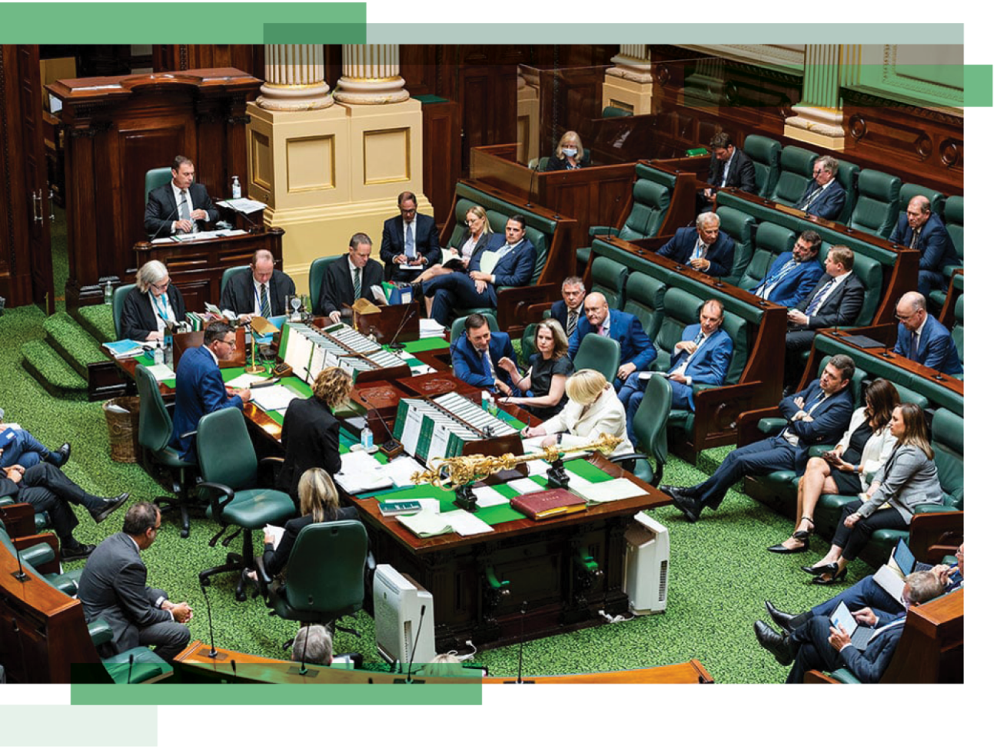
The Victorian Legislative Assembly.
Source: Department of Parliamentary Services
The Tribunal is responsible for inquiring into and setting the value of salaries and work-related parliamentary allowances for MPs. It may also make guidelines with respect to the use of some work-related parliamentary allowances and the EO&C Budget.
The Tribunal made its first Determination of MP salaries and allowances in 2019 — the Members of Parliament (Victoria) Determination No. 01/2019 (2019 MP Determination). In 2020, 2021 and 2022, the Tribunal made Determinations providing for an annual adjustment to the values of the salaries and allowances set in the 2019 MP Determination.
The Tribunal is required to make a new Determination setting the values of salaries and allowances for MPs within six months after the first sitting day of each subsequent Parliament. The 60th Parliament of Victoria held its first sitting on 20 December 2022. Thus, the Tribunal was required to make a new Determination no later than 20 June 2023.

2023 Determination of salaries and allowances
On 20 June 2023, the Tribunal made the Members of Parliament (Victoria) Determination No. 01/2023 (2023 MP Determination). This Determination set the values of MP salaries, work-related parliamentary allowances and the EO&C Budget with effect from 1 July 2023.
In making the MP Determination the Tribunal considered the role of an MP which encompasses parliamentary duties, work within their electorates, management of an electorate office and party-political activities (Figure 1).
Figure 1: Categories of responsibilities and duties of MPs
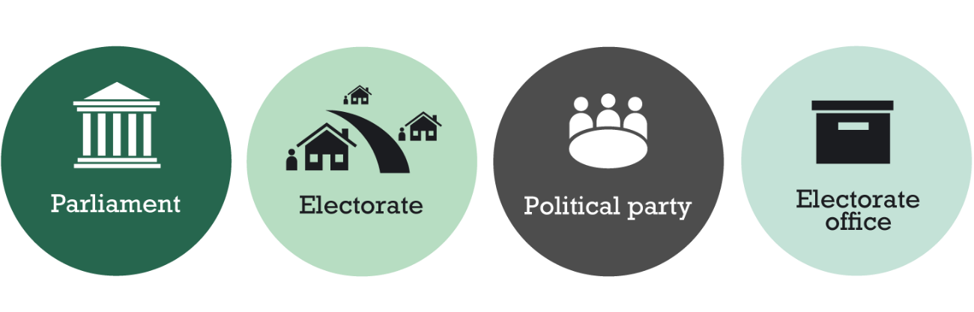

The Tribunal strives to achieve fair and reasonable recompense for MPs in performing their public duties. Having regard to that foundation principle and legislative factors, the Tribunal set the value of the basic salary for an MP at $198,839 per annum. This represented an annual increase of 3.5 per cent. In making its Determination, the Tribunal gave particular weight to current Wages Policy, the Victorian Government’s financial and fiscal objectives and prevailing economic conditions and trends.
The Tribunal determined the values of additional salaries and expense allowances for eligible specified parliamentary office holders. Additional salaries were set in the range of $7,954 to $221,871 per annum. The expense allowance for 15 specified parliamentary offices varies from $3,558 to $60,480 per annum. These decisions also represented a 3.5 per cent annual increase.
The Tribunal also set the values of several work-related parliamentary allowances, which are provided to MPs to assist them in performing their public duties. Table 1 outlines the types of allowances set by the Tribunal, their values as at 1 July 2023 and the change in values compared to 1 July 2022.
Table 1: Types of work-related parliamentary allowances for MPs
Type of allowance | Purpose | Value as at 1 July 2023  ($ p.a.) | Change compared to 1 July 2022  (per cent)
Electorate allowance | Cover costs associated with providing services to constituents. | 45,022 – 53,933 | 6.8
Motor vehicle allowance | Available to MPs who elect not to be provided with a fully maintained motor vehicle. | 23,225 – 34,994 | 3.9
Commercial transport allowance | Cover eligible transport costs  (on a reimbursement basis). | 5,195 – 17,898 | 3.9
Travel allowance | Cover the costs of commercial accommodation, meals and incidentals for overnight stays  (on a reimbursement basis). | As per the travelling allowance rate set by the Commonwealth Remuneration Tribunal | Not  Applicable
International travel allowance | Cover eligible international travel costs (on a reimbursement basis). | 10,765 | 6.8
Parliamentary accommodation sitting allowance | Cover costs incurred by MPs in certain regional electorates who choose to maintain a residence in metropolitan Melbourne to help them carry out their public duties. | 26,609 – 53,217 | Unchanged
The increase to the electorate and international travel allowances was consistent with the annual percentage increase in the Melbourne Consumer Price Index (CPI). The increase to the motor vehicle and commercial transport allowances were consistent with the annual percentage change in the ‘Transport’ sub-group of the Melbourne CPI.
The Tribunal continues to link the value of the travel allowance to rates set by the Commonwealth Remuneration Tribunal. The Tribunal left unchanged the value of the parliamentary accommodation sitting allowance.
The values of three allowances — the electorate, motor vehicle and commercial transport allowances — were also set to vary depending on the size of the MP's electorate. This recognises the additional costs incurred by MPs in serving larger electorates.
The Tribunal also took the opportunity to reset the formula for the EO&C Budget. The effective rate per voter was increased by 6.8 per cent, reflecting movements in the Melbourne CPI.
Further information about the 2023 MP Determination, including a detailed Statement of Reasons accompanying the Determination, is available on the Tribunal’s website.

2023 MP Guidelines
On 20 June 2023, the Tribunal made the Members of Parliament (Victoria) Guidelines No. 01/2023 (2023 MP Guidelines). The 2023 MP Guidelines aim to better support MPs to carry out their public duties, consistent with legislative principles and overarching obligations. They provide MPs with greater flexibility in using the EO&C Budget to communicate with their electorate, including by allowing an MP to communicate with their constituents on any matter that they reasonably believe is of importance or interest to them, subject to the legislative framework and prohibitions on party political activity. They also enable joint communication between two or more MPs from any geographical location or House of Parliament.
The 2023 MP Guidelines also clarify:
- that an MP may claim the travel allowance for an overnight stay immediately preceding and following their parliamentary business, committee business or Ministerial business
- that an MP must not make a claim under the EO&C Budget for costs incurred or activity undertaken to communicate with their electorate between the issuing of writs for a general election or by-election and the declaration of the poll for the electorate
- the arrangements for an MP to carry over unspent funds from the EO&C Budget remaining from a pre-election period, including where an MP is elected to a different electorate.
The 2023 MP Guidelines are available on the Tribunal’s website.

2.2 Public sector executives

Treasury Gardens, Melbourne.
Source: Visit Victoria
The Tribunal is responsible for inquiring into and determining the remuneration bands for executives employed in VPS bodies and PEs.
The Tribunal also has the functions of:
- issuing guidelines with respect to the placement of executives within the remuneration bands
- providing advice to employers proposing to pay an executive above the relevant remuneration band
- providing advice to the Minister about the remuneration of executives.
In 2022-23, the Tribunal’s work in relation to executives comprised:
- Determinations providing for an annual adjustment to the values of the remuneration bands for executives employed in VPS bodies and PEs
- advice to public sector employers proposing to pay an executive above the relevant remuneration band
- completing a review of remuneration arrangements for executives in the major transport infrastructure sector.
Figure 2 summarises the VPS and PE employers within the scope of the Tribunal’s Determinations.
Figure 2: VPS and PE Employers within the scope of the Tribunal’s Determinations
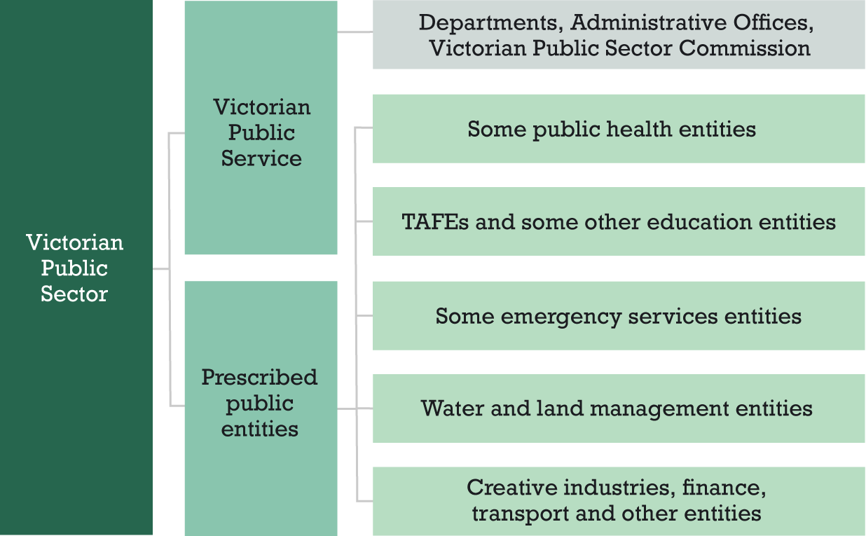

Annual adjustment Determinations
In 2022-23, the Tribunal was required to make an annual adjustment to the values of the remuneration bands for both VPS and PE executives, originally set in 2020 and adjusted in subsequent years.
On 29 June 2023, the Tribunal made the Remuneration bands for executives employed in public service bodies (Victoria) Annual Adjustment Determination 2023 and the Remuneration bands for executives employed in prescribed public entities (Victoria) Annual Adjustment Determination 2023.

The annual adjustment Determinations took effect on 1 July 2023 and provided for:
- an adjustment of 4 per cent to the notional salary component of the remuneration bands
- a further adjustment to reflect increases to executives’ statutory superannuation entitlements which took effect on 1 July 2023.
Tables 2–4 below outline remuneration bands for VPS executives from 1 July 2023. The remuneration bands are expressed as a total remuneration package (TRP), defined as the sum of:
- base salary
- employer superannuation contributions
- employment benefits (i.e. non-salary) specified in the executive’s contract of employment
- the annual cost to the employer of providing the non-monetary benefits, including any fringe benefits tax payable.
All values are for executives employed on a 1.0 full-time equivalent basis and apply pro rata to executives employed on a part-time basis.
The values of the remuneration bands for executives employed in PEs are available on the Tribunal’s website.
Table 2: Values of remuneration bands for the VPS Senior Executive Service
Classification | Base of band TRP  ($ p.a.) | Top of band TRP  ($ p.a.)
Senior Executive Service-3 | 401,018 | 533,431
Senior Executive Service-2 | 279,239 | 401,017
Senior Executive Service-1 | 216,376 | 279,238
Table 3: Values of remuneration bands for Administrative Office Heads
Classification | Base of band TRP  ($ p.a.) | Top of band TRP  ($ p.a.)
Administrative Office Head-3 | 401,018 | 533,431
Administrative Office Head-2 | 279,239 | 401,017
Administrative Office Head-1 | 216,376 | 279,238

Table 4: Values of remuneration band for Department Heads and the Victorian Public Sector Commissioner
Classification | Base of band TRP  ($ p.a.) | Top of band TRP  ($ p.a.)
Department Head / Victorian Public Sector Commissioner | 577,716 | 778,492
The Tribunal considered several legislative requirements in making the annual adjustment Determinations:
- the Victorian Government’s Wages Policy
- the financial position and fiscal strategy of the State of Victoria
- current and projected economic conditions and trends
- submissions received in relation to the proposed Determinations.
The Tribunal’s decisions are consistent with ensuring that public sector employers are able to offer remuneration arrangements that are fair and reasonable to attract and retain talented executives to deliver the agenda of the government of the day.
The annual adjustment Determinations and accompanying Statements of Reasons are available on the Tribunal’s website.

Payment above the band advice
The Tribunal is required to provide advice to public sector employers proposing to pay an executive above the maximum of the relevant remuneration band set by a Determination.
In 2022-23, the Tribunal provided advice in response to 44 requests from public sector employers to pay an executive or executives above the maximum of the relevant remuneration band. 14 requests for advice were made by VPS employers and related to 36 individual executives, while 30 requests were made by PEs and related to 40 individual executives (Table 5).
Table 5: Requests for payment above the band advice by employer type, 2022-23
Employer type | Number of requests | Number of executives
Victorian Public Service | 14 | 36
Prescribed public entity | 30 | 40
The majority of requests for advice related to executives employed in the major transport and finance sectors (Figure 3).
Figure 3: Requests for payment above the band advice by sector, 2022-23
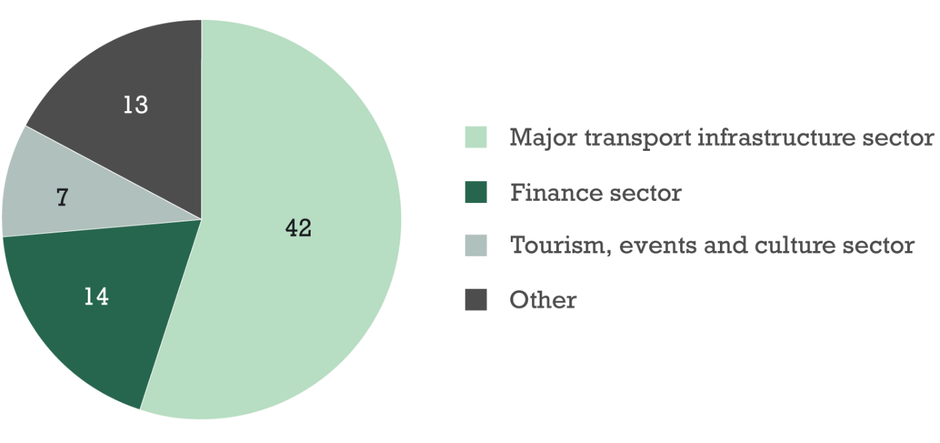

Requests for advice from the Minister about public sector executives
The Minister may request the Tribunal provide advice about remuneration and funding in relation to any specified occupational group and remuneration in relation to prescribed public sector bodies.
The Tribunal submitted its advice to the Minister about remuneration arrangements for executives in the major transport infrastructure sector in December 2022.

2.3 Mayors, Deputy Mayors and Councillors
The Tribunal is responsible for making Determinations setting the value of the allowance payable to Mayors, Deputy Mayors and Councillors (Council Members) in all 79 local governments in Victoria.
The Tribunal’s first Determination for Council Members was made in March 2022. The Determination set a base allowance for each Council Member, the value of which varies according to the role (Mayor, Deputy Mayor or Councillor) and the allowance category to which the Council has been assigned.
The Determination also provided for a remote area travel allowance and set eligibility criteria for claiming it.
The Tribunal is required to make annual adjustments to the value of the allowances payable to Council Members. In 2022-23, the Tribunal was required to make two annual adjustments, one in 2022 and another in 2023.
On 8 December 2022, the Tribunal made the Allowance payable to Mayors, Deputy Mayors and Councillors (Victoria) Annual Adjustment Determination 2022. This Determination increased the value of allowances by 1.5 per cent from 18 December 2022, taking into account:
- current and projected economic conditions and trends
- the financial position and fiscal strategy of the State of Victoria
- the Victorian Government’s Wages Policy
- recent remuneration adjustments for comparable roles
- the limited period of time that had passed since the Tribunal made its first Determination setting the values of allowances for Council Members.
On 30 June 2023, the Tribunal made the Allowance payable to Mayors, Deputy Mayors and Councillors (Victoria) Annual Adjustment Determination 2023. This Determination increased the values of allowances by a further 2 per cent with effect from 1 July 2023, consistent with the timing of the annual adjustment for public sector executives.
In addition to legislative requirements, the Tribunal also considered:
- the limited amount of time that had passed since the last annual adjustment to allowances of 1.5 per cent
- remuneration adjustments for comparable local government roles in other Australian jurisdictions
- the Victorian Government’s rate cap of 3.5 per cent for all Councils for 2023-24
- its 2023 Determination of salaries and allowances for MPs, which resulted in a 3.5 per cent increase in the MP basic salary.
The current value of allowances for Mayors, Deputy Mayors and Councillors are set out at Table 6. Further increases to allowances are scheduled to be phased in from 18 December 2023.
Table 6: Value of the base allowance for Mayors, Deputy Mayors and Councillors, by Council allowance category, 1 July 2023 until 17 December 2023
Council allowance category | Mayors | Deputy Mayors | Councillors
Council allowance category | Value of allowance ($ p.a.)
Category 1 | 79,492 | 39,746 | 25,650
Category 2 | 102,650 | 51,325 | 31,980
Category 3 | 126,958 | 63,480 | 38,316
Category 4 – Melbourne City Council | 253,920 | 126,959 | 57,473
The annual adjustment Determinations — including details of scheduled phased increases — and accompanying Statements of Reasons are available on the Tribunal’s website.

2.4 State Budget performance measures
The Victorian Budget 2022/23 specifies one quality and one timeliness performance measure for the Tribunal.
The quality measure relates to the satisfaction of key stakeholders — including MPs, public sector employers and Council Members — with the Tribunal’s processes regarding Determinations, reviews and advice.
To measure stakeholder satisfaction a questionnaire was sent to approximately 380 stakeholders, including MPs and the Clerks of the Parliament of Victoria, PE board Chairs, senior VPS department human resources officers and local government Mayors. The questionnaire asked respondents to rate their overall satisfaction with the Tribunal’s delivery of outputs.
The Tribunal recorded an overall level of stakeholder satisfaction of 87 per cent against a target of 80 per cent, based on 75 responses to the questionnaire.
The timeliness measure related to delivery of the Tribunal’s legislated work program within established timeframes. In 2022-23, the Tribunal’s legislated work program comprised:
- making comprehensive and annual adjustment Determinations consistent with timeframes set out in the VIRTIPS Act
- responding to requests for advice submitted by VPS and PE employers proposing to pay an executive above the relevant remuneration band — the Tribunal aims to provide advice within 15 business days of a complete request being received
- providing advice as requested by the Minister for Government Services — the advice must be provided within a reasonable time after receiving the request
- provision of the Tribunal’s 2021-22 annual report by 31 October 2022.
In 2022-23, the Tribunal delivered 96 per cent of its legislated work program within established timeframes, against a target of 85 per cent.

3. Other Tribunal matters

3.1 Tribunal meetings
The Tribunal held 25 regular meetings and three special meetings in 2022-23.
Minutes were kept for each meeting. There were three disclosures of an interest by a Tribunal Member recorded in the minutes of a Tribunal meeting.
- On 25 August 2022, Chair McCann advised that he had been appointed as an independent member of the Department of Justice and Community Safety (DJCS) remuneration committee and noted there was a potential conflict of interest arising from the appointment, including about any future proposals from DJCS to pay an executive above the relevant band.
- On 12 January 2023, Member Gardner declared a potential conflict of interest in respect of a payment above the band request from the Department of Families, Fairness and Housing (DFFH) and recused herself from consideration of the matter (Advice 2023/01).
- On 4 May 2023, Member Gardner advised she had been appointed as an independent member of the DFFH executive remuneration committee.

3.2 Finance
Section 45 of the Financial Management Act 1994 (Vic) (FMA) requires the Tribunal to prepare a report of operations and financial statements for each financial year. However, in accordance with a determination made by the Assistant Treasurer under section 53(1)(b) of the FMA, the Tribunal’s report of operations and financial statements is consolidated with the annual report of the Department of Premier and Cabinet.
Under section 8(3)(d) of the FMA, and Standing Direction 1.5, the Assistant Treasurer has also exempted the Tribunal from the requirements of the Standing Directions.

While the exemption has been provided on an ongoing basis, it is subject to the Tribunal confirming with the Executive Director, Budget Strategy, Department of Treasury and Finance, prior to the end of May each year, that:
- the Tribunal has established and maintained alternative arrangements to ensure that no aspect of financial governance is compromised
- there has not been any significant change to the Tribunal’s risk profile and functions
- there has not been any key audit finding that might suggest deficiencies in the Tribunal’s financial management and internal control systems.
The Tribunal Chair, as the Accountable Officer for the Tribunal, provided this confirmation for the 2022-23 financial year.

3.3 Freedom of information requests
In July 2022 the Tribunal made a decision regarding one freedom of information request received in June 2022. The Tribunal identified nil (0) documents within scope of the request. The request was responded to within the statutory timeframe.
The Tribunal did not receive any freedom of information requests in 2022-23.

4. Office of the
Compliance Officer
The VIRTIPS Act establishes an office of the Compliance Officer. The office does not constitute a part of the Tribunal. The VIRTIPS Act requires that the activities of the office are included in the Tribunal’s annual report.
The VIRTIPS Act and the Parliamentary Salaries, Allowances and Superannuation Act 1968 (Vic) specify the Compliance Officer’s functions and powers.
The Compliance Officer is responsible for independently hearing and determining appeals from current and former MPs in relation to the use of work-related parliamentary allowances, the EO&C Budget and the separation payment.
MPs may appeal a decision made by a Clerk of the Parliament, or by the Secretary of the Department of Parliamentary Services, to reject a claim for a work-related parliamentary allowance or regarding their entitlement to receive the separation payment.
The Compliance Officer:
- is not subject to the direction or control of any person
- is not bound by the rules of evidence
- may conduct proceedings with as little formality as considered appropriate
- may publish a statement of findings, and any required actions, on the Tribunal’s website, which is absolutely privileged.

4.1 Compliance Officers

Peter Lewinsky
Mr Lewinsky is the primary Compliance Officer, appointed to the role on 16 March 2022 for a period of five years.
Mr Lewinsky is an experienced Board and Audit Committee chair and member with a broad portfolio over 25 years covering private and ASX listed companies and the Government sector in a wide range of business areas and professional disciplines. He has extensive experience in financial management, internal and external audit, risk and compliance, governance, strategic decision making and the provision of advice to Board Chairs, Department Secretaries and leaders of a range of organisations.
Mr Lewinsky is a Fellow of the Institute of Chartered Accountants in Australia and New Zealand and a Fellow of the Australian Institute of Company Directors. He has a Bachelor of Economics (Monash University) with an accounting major and a Master of Business Administration degree (University of Melbourne) with a major in finance.

Jane Brockington
Ms Brockington is the secondary Compliance Officer, appointed to the role on 10 June 2020 for a period of five years.
Ms Brockington is an adviser and independent reviewer with a focus on regulation, integrity and governance. She is Principal of the consultancy Bridging Policy and Practice and was previously a senior executive in the public sector. Ms Brockington holds several non-executive director positions and is a fellow of the Institute of Public Administration Australia (Victoria).

4.2 Report on the function of the Compliance Officer
In 2022-23, the Compliance Officer heard and determined nil (0) appeals. Table 7 summarises the Compliance Officer’s activities in 2022-23 and 2021-22.
Table 7: Summary of the Compliance Officer’s activities, 2022-23 and 2021-22
Function | VIRTIPS Act reporting provision | 2022-23 | 2021-22
Separation payment
Number of MPs who have not complied with requests for further information by the Compliance Officer in relation to Determinations about separation payments | s. 40(d) | 0 | 0
Number of appeals heard in relation to separation payments | s. 40(e) | 0 | 0
Work-related parliamentary allowances and the EO&C Budget
Number of MPs who have not complied with requests for further information in relation to appeals relating to work-related parliamentary allowances and the EO&C Budget | s. 40(f) | 0 | 0
Number of appeals heard in relation to work-related parliamentary allowances and the EO&C Budget | s. 40(g) | 0 | 2

VIRTIPS Act, s. 6(1).
VIRTIPS Act, s. 36(1).
VIRTIPS Act, ss. 6(1)(e) and 6(1)(h).
VIRTIPS Act, ss. 6(1)(i) and 37(1).
VIRTIPS Act, s. 6(1)(l).
VIRTIPS Act, s. 40.
VIRTIPS Act, ss. 6(1)(a)-(c).
VIRTIPS Act, s. 36(1).
VIRTIPS Act s. 17(7).
Year ending March quarter 2023.
Year ending March quarter 2023.
VIRTIPS Act, ss. 6(1)(d) and 6(1)(g).
VIRTIPS Act, ss. 6 and 37.
Remuneration bands for executives employed in public service bodies (Victoria) Determination No. 01/2020; Remuneration bands for executives employed in prescribed public entities (Victoria) Determination No. 01/2020.
VPSC. 2022, Victorian Public Service Executive Employment Handbook.
VIRTIPS Act, s. 37(1).
VIRTIPS Act, s. 37(3).
VIRTIPS Act, s. 23A.
Allowance payable to Mayors, Deputy Mayors and Councillors (Victoria) Determination No. 01/2022.
Department of Treasury and Finance (2022), Budget Paper No. 3 – Service Delivery, pp. 327-328.
The question asked was ‘Considering consultation methods, consideration of views and issues, communication of outcomes, and timeliness, how satisfied were you overall with the Tribunal's delivery of determinations, reviews and advice in 2022-23’.
VIRTIPS Act ss. 12 and 14(4).
VIRTIPS Act, s. 27.
VIRTIPS Act, s. 40.
These functions are performed by the primary Compliance Officer or, if not available or otherwise unable to hear an appeal, by the secondary Compliance Officer (VIRTIPS Act, Part 4).
VIRTIPS Act, Part 4.

