

Remuneration Bands for Executives Employed in Public Service Bodies (Victoria) Determination No. 01/2024


ISBN

DETERMINATION | [2024] DVPS 01
Victorian Independent Remuneration Tribunal and Improving Parliamentary Standards Act 2019 (Vic)
Part 3—Determination of the remuneration bands for executives employed in public service bodies.

Remuneration Bands for Executives Employed in Public Service Bodies (Victoria) Determination No. 01/2024

Table of contents
Part 1 – Legal matters and definitions
- Title
- Effective date
- Definitions
- Coverage and application
Part 2 – Remuneration bands for the senior executive service
- Senior executive service
Part 3 – Remuneration bands for public service body Heads
- Administrative Office Heads
- Department Heads and the Victorian Public Sector Commissioner
Statement of Reasons

Part 1 – Legal matters and definitions
- Title: This Determination is the Remuneration Bands for Executives Employed in Public Service Bodies (Victoria) Determination No. 01/2024 and is made under Part 3 of the Victorian Independent Remuneration Tribunal and Improving Parliamentary Standards Act 2019 (Vic) by the Victorian Independent Remuneration Tribunal.
- Effective date: This Determination takes effect on 1 July 2024.
- Definitions
  - Terms not defined in this Determination have the same meaning as in the Public Administration Act 2004 (Vic), unless the contrary intention appears.
  - In this Determination, unless the contrary intention appears:
FTE means Full Time Equivalent;
Public service body Head means:
- a Department Head;
- an Administrative Office Head;
- the Victorian Public Sector Commissioner;
Senior Executive Service comprises executives other than a public service body Head;
TRP means Total Remuneration Package, and is the sum of:
- base salary;
- superannuation contributions;
- employment benefits (i.e. non-salary) specified in the executive’s contract of employment; and
- the annual cost to the employer of providing the non-monetary benefits, including any fringe benefits tax payable;
VPS Executive Classification Framework means the Victorian Public Service Executive Classification Framework in relation to Senior Executive Service classifications issued by the Victorian Public Sector Commission and available on its website, as amended from time to time.
- Coverage and application
  - This Determination sets the values of the remuneration bands for executives employed in public service bodies.

Part 2 – Remuneration bands for Senior Executive Service executives
- Senior Executive Service
  - The values of the remuneration bands for the Senior Executive Service executives employed in public service bodies are set out in Table 1.
  - The relevant remuneration band for each executive corresponds to the Senior Executive Service classification of that position determined under the VPS Executive Classification Framework.
Table 1: Values of remuneration bands for the Senior Executive Service
Classification | Base of band TRP  $ per annum | Top of band TRP  $ per annum
Senior Executive Service-1 | 225,000 | 290,600
Senior Executive Service-2 | 290,601 | 419,000
Senior Executive Service-3 | 419,001 | 557,435
Note: the above values are for executives employed on a 1.0 FTE basis, and apply pro rata to executives employed on a part-time basis.

Part 3 – Remuneration bands for public service body Heads
- Administrative Office Heads
  - The values of the remuneration bands for Administrative Office Heads are set out in Table 2.
  - The relevant remuneration band for each Administrative Office Head corresponds to the Administrative Office Head classification of that position determined under the VPS Executive Classification Framework.
Table 2: Values of remuneration bands for Administrative Office Heads
Classification | Base of band TRP  $ per annum | Top of band TRP  $ per annum
Senior Executive Service-1 / Administrative Office Head-1 | 225,000 | 290,600
Senior Executive Service-2 / Administrative Office Head-2 | 290,601 | 419,000
Senior Executive Service-3 / Administrative Office Head-3 | 419,001 | 557,435
Note: the above values are for executives employed on a 1.0 FTE basis, and apply pro rata to executives employed on a part-time basis.
- Department Heads and the Victorian Public Sector Commissioner
  - The values of the remuneration band for Department Heads and the Victorian Public Sector Commissioner are set out in Table 3.
Table 3: Values of remuneration band for Department Heads and the Victorian Public Sector Commissioner
Classification | Base of band TRP  $ per annum | Top of band TRP  $ per annum
Department Head / Victorian Public Sector Commissioner | 603,713 | 813,524
Note: the above values are for executives employed on a 1.0 FTE basis, and apply pro rata to executives employed on a part-time basis.

 | 
Warren McCann  Chair  Victorian Independent Remuneration Tribunal | Laurinda Gardner  Member  Victorian Independent Remuneration Tribunal
Date: 2 July 2024

Contents

Abbreviations and glossary 7
Executive summary 10
1 About this Determination 20
1.1 The Determination applies to executives in VPS bodies 21
1.2 The Tribunal considered legislative requirements 24
1.3 The Tribunal updated its Guidelines for placement of executives within the bands 25
1.4 The Tribunal undertook extensive consultation 25
1.5 Acknowledgement 26
2 Roles of VPS executives 27
2.1 Public service body Heads have specific obligations and
responsibilities 27
2.2 The executive classification framework sets out expectations for
the SES 33
2.3 Influences on executive roles since the 2020 VPS Determination 35
2.4 Executives reported increased scrutiny, workload and complexity 43
2.5 Future influences on executive roles 48
2.6 Summary 50
3 Existing arrangements 52
3.1 Executive employment is governed by the PAA and supporting
policies 52
3.2 SES roles are classified into one of three levels 54
3.3 Executives are paid a total remuneration package 56
3.4 The Tribunal sets the value of the remuneration bands 58
3.5 Employers set the remuneration of individual executives 61
3.6 Summary 63

4 Labour market considerations 64
4.1 Conditions in the broader labour market are tight 64
4.2 Demand for VPS executives is moderating 66
4.3 The supply of VPS executives is matching demand, with
some exceptions 68
4.4 How the remuneration bands influence the supply of executives 72
4.5 The remuneration bands are positioned towards the lower end of the market 79
4.6 Summary 83
5 Jurisdictional comparisons 85
5.1 Commonwealth public service 85
5.2 New South Wales public service 91
5.3 Queensland public service 96
5.4 Summary 99
6 Economic and financial considerations 102
6.1 Current economic conditions 102
6.2 Economic outlook 110
6.3 Financial position and fiscal strategy of the State of Victoria 115
6.4 Victorian Public Sector Wages Policy 120
7 Tribunal’s considerations 123
7.1 Factors supporting an increase in the level of the remuneration
bands 124
7.2 Factors suggesting restraint 127
7.3 The Tribunal’s decision 129
7.4 Other factors 131
8 VPS Executive Remuneration Guidelines 133
Appendix A – summary of executive questionnaire responses 135
Questionnaire responses 136
Segment analysis 151
References 156

Abbreviations and glossary
Term or abbreviation | Definition
2020 VPS Determination | Remuneration bands for executives employed in public service bodies (Victoria) Determination No. 01/2020
2024 VPS Determination | Remuneration bands for executives employed in public service bodies (Victoria) Determination No. 01/2024
2024-25 Budget | Victorian Budget 2024-25
AI | Artificial intelligence
ABS | Australian Bureau of Statistics
AGM | Australian General Market — Mercer’s remuneration database for positions within Australia, which is linked to work value.
AO | Administrative Office
APS | Australian Public Service
APSC | Australian Public Service Commission
ASD | Australian Signals Directorate
BIS | Bank for International Settlements
BRP | Base remuneration point — the fixed minimum remuneration point for a particular executive role in New South Wales, which is calculated based on the work value score using a specific formula.
CE | Chief Executive
CPI | Consumer Price Index
CSIRO | Commonwealth Scientific and Industrial Research Organisation
Cth | Commonwealth
DE | Department of Education
DEECA | Department of Energy, Environment, and Climate Action
DELWP | Department of Environment, Land, Water and Planning
DET | Department of Education and Training
DFFH | Department of Families, Fairness and Housing
DGS | Department of Government Services
DH | Department of Health
DHHS | Department of Health and Human Services
DJPR | Department of Jobs, Precincts and Regions
DJSIR | Department of Jobs, Skills, Industry and Regions
DJCS | Department of Justice and Community Safety
DOT | Department of Transport
DPC | Department of Premier and Cabinet
DTP | Department of Transport and Planning
DTF | Department of Treasury and Finance
EA | Enterprise Agreement
ES | Executive Summary
EVP | Employee value proposition
FMA | Financial Management Act 1994 (Vic)
FTE | Full-time equivalent
FWC | Fair Work Commission
GDP | Gross Domestic Product
GE Act | Gender Equality Act 2020 (Vic)
GGS | General Government Sector
GSP | Gross State Product
Guideline rate | Premier’s annual adjustment guideline rate
IABAC | International Association of Business Analytics Certification
IBAC | Independent Broad-based Anti-corruption Commission
JSA | Jobs and Skills Australia
JSE | Jobs and Skills Exchange
Melbourne CPI | All Groups Consumer Price Index for Melbourne
MSCB | Maximum superannuation contribution base
NMW | National Minimum Wage
NSW | New South Wales
NSWPSC | NSW Public Sector Commission
OECD | Organisation for Economic Co-operation and Development
OVIC | Office of the Victorian Information Commissioner
PAA | Public Administration Act 2004 (Vic)
PAEC | Public Accounts and Estimates Committee
PSSE | Public Service Senior Executive (NSW)
PSSE Determination | Public Service Senior Executives — Annual Determination
PSSE Framework | Public Service Senior Executive Remuneration Management Framework
QPSC | Queensland Public Sector Commission
RBA | Reserve Bank of Australia
SES | Senior Executive Service
SG | Superannuation guarantee
SOORT | NSW Statutory and Other Offices Remuneration Tribunal
Standard contract | Standard executive contract template published by the Victorian Public Sector Commission
STS | Senior Technical Specialist
TEI | Total estimated investment
Tribunal | Victorian Independent Remuneration Tribunal
TRP | Total remuneration package
Wages Policy | Wages Policy and the Enterprise Bargaining Framework
WPI | Wage Price Index
VAGO | Victorian Auditor-General’s Office
VPSC | Victorian Public Sector Commission
VPS | Victorian Public Service
VPS EA | Victorian Public Service Enterprise Agreement
VPS Executive Classification Framework | Victorian Public Service Executive Classification Framework
VPS Guidelines | Victorian Public Service Executive Remuneration Guidelines
VPS Handbook | Victorian Public Service Executive Employment Handbook
VSB | Victorian Secretaries Board
VIRTIPS Act | Victorian Independent Remuneration Tribunal and Improving Parliamentary Standards Act 2019 (Vic)
WPI | Wage Price Index

Executive summary
The Victorian Independent Remuneration Tribunal is responsible for setting remuneration bands for executives employed in public service bodies. This Statement of Reasons relates to the Tribunal’s second comprehensive Determination of remuneration bands for public service body Heads and the Senior Executive Service (SES) in the Victorian Public Service (VPS). A comprehensive Determination requires the Tribunal to review the roles and responsibilities of executives and provides an opportunity to reset the values of the remuneration bands in line with market conditions.

The Tribunal has increased the values of each of the remuneration bands
In this Determination, the Tribunal has decided to maintain a remuneration band structure for the SES that consists of three distinct and contiguous remuneration bands that align with the executive classification framework administered by the Victorian Public Sector Commission (VPSC). The remuneration bands are expressed in terms of total remuneration package (TRP), including salary and employer superannuation contributions.
For public service body Heads, the Tribunal has also maintained a separate remuneration band to apply to department Heads (Secretaries) and the Victorian Public Sector Commissioner, and has continued to align the remuneration bands for Administrative Office (AO) Heads with the values of the SES remuneration bands.
The values of the remuneration bands that apply from 1 July 2024 are shown in Tables ES.1 and ES.2. The Tribunal’s decisions result in an increase of between 4.0 and 4.5 per cent to each of the values of the remuneration bands.
It is important to note that the increases in the remuneration bands are inclusive of Commonwealth Government-legislated changes to statutory superannuation entitlements that take effect from 1 July 2024. In particular, the superannuation guarantee (SG) will increase from 11 per cent to 11.5 per cent and the maximum superannuation contribution base (which caps the salary to which the SG applies) will increase from $249,080 to $260,280. Victorian Government policy is that VPS employers must bear the cost of such changes, which is reflected in an increase in each executive’s TRP. Once the impact of the superannuation changes are accounted for, the effective increase in the remuneration bands is between 3.5 per cent and 4.3 per cent.
It should be noted that an increase to the bands will not automatically result in a corresponding increase for all executives. The task of the Tribunal is to determine the value of the bands. Responsibility for what executives are paid resides with employers taking account of the Premier’s annual adjustment guideline rate.
Table ES.1: Values of the remuneration bands for the SES and AO Heads from 1 July 2024
Classification | Base of band TRP  ($ p.a.) | Top of band TRP  ($ p.a.)
SES-1 / AO Head-1 | 225,000 | 290,600
SES-2 / AO Head-2 | 290,601 | 419,000
SES-3 / AO Head-3 | 419,001 | 557,435
Table ES.2: Value of remuneration band for department Secretaries and the Victorian Public Sector Commissioner from 1 July 2023
Classification | Base of band TRP  ($ p.a.) | Top of band TRP  ($ p.a.)
Department Secretary /  Victorian Public Sector Commissioner | 603,713 | 813,524
Following is a summary of the matters the Tribunal considered, and the weight it gave to various factors, to reach a decision about the value of the remuneration bands.
The overall analytical framework is set by the Victorian Independent Remuneration Tribunal and Improving Parliamentary Standards Act 2019 (Vic) (VIRTIPS Act) which requires that, in making a comprehensive Determination, the Tribunal must consider the following:
- the existing remuneration provided to executives
- any statement or policy issued by the Government of Victoria which is in force with respect to its wages policy
- the financial position and fiscal strategy of the State
- current and projected economic conditions and trends
- submissions received in relation to the proposed Determination
- a comprehensive review of the roles of executives employed in public service bodies.
Detailed information and data supporting the analysis can be found in the various chapters of this statement. Chapter 2 discusses the roles and responsibilities of VPS executives, drawing on the Tribunal’s consultations and research. An overview of the existing employment and remuneration arrangements for executives is provided in Chapter 3.
Chapter 4 describes the executive labour market, including current demand and supply factors and presents the remuneration benchmarking analysis commissioned by the Tribunal. In Chapter 5, comparisons are made between executive remuneration arrangements across selected Australian jurisdictions. Chapter 6 details relevant macroeconomic and financial considerations. Submissions received by the Tribunal, including responses to the Tribunal’s executive questionnaire, are cited throughout the Statement of Reasons.

Factors supporting an increase in the level of the remuneration bands
The changing nature of the role
The first part of this section identifies a number of factors which, taken together, provide evidence for the appropriateness of a significant increase to the remuneration bands for VPS executives. The second part sets these considerations in a broader context including the government’s wages policy and the financial position and fiscal strategy of the State.
First, in support of an increase, there is compelling evidence of a significant change in the role of executives since the Tribunal’s first Determination four years ago. While core responsibilities have more or less remained constant, workload, complexity and public scrutiny associated with the role have all increased. While workload might suggest solutions other than remuneration, the latter two — and in particular public scrutiny — bear directly on considerations for setting remuneration bands.
A high degree of accountability and the public examination of executives in the VPS is, and has always been, highly appropriate. However, information provided to the Tribunal suggests that the shift in public scrutiny has been towards personal targeting and the introduction of a political dimension and a level of aggressiveness not evident in the past.
The resultant increased risk of reputational damage, together with a limited capacity to respond and an associated damage to employment prospects, has had a significant impact on the number of people willing to serve in senior roles in the VPS. Moreover, those who are risk averse are discouraged leading to negative consequences for diversity.
Similar views were expressed in the submission from the VPSC which noted that, notwithstanding the importance of accountability, the frequency, intensity and often widely reported nature of this scrutiny can have a negative impact on executives’ mental health and their future financial earning capacity.
It is the view of the Tribunal that this is not simply a passing phase but rather reflects structural changes in the system which are here to stay. The situation is not eased when the challenges of the near future are considered. There is an increasing tendency, for example, for personal responsibility to attach to big system failures including as the result of cyber-attacks, as well as to the management of natural disasters and to those functions involving the direct care of community members.
In each of these areas and others the level of exposure and risk for senior executives has increased dramatically leading some to not take up more senior roles or to contemplate whether a career in the private sector may be a more attractive option.
In terms of complexity, there are a number of challenges that arise from leading a hybrid workforce including finding new ways to stimulate connections and creativity, manage performance and to build trust and relationships within and across teams and organisations. These challenges include maximising productivity by redesigning work to focus on a ‘digital-first’ way of working and by managing the introduction of artificial intelligence.
There has been a major expansion in program and project delivery across all spheres of government co-existent with the implementation of savings initiatives and the re-setting of staffing levels. And there has been a significant growth in the number of portfolios serviced by the VPS along with a continued focus on cross-portfolio and social reform initiatives that touch on every aspect of public service activity.
Market positioning and competitiveness
The second issue relates to the level of competitiveness of the VPS compared to the private sector and other public sector jurisdictions with which Victoria competes for talent.
The Tribunal engaged recruitment firm Mercer Consulting (Australia) to undertake a detailed analysis of the market for executives. Of particular relevance is the positioning of the VPS in the Australian General Market (AGM).
Pay practices for public sector executives in most Australian jurisdictions are generally closer to the 15th percentile of the AGM. This means that 85 per cent of all executives performing roles with the same work value are paid more than executives in the VPS — reflecting, in part, the value attached to the non-salary benefits of working in the public service — the satisfaction that comes from the opportunity to serve the community and make a difference for example.
The critical part of Mercer’s analysis is that, compared to four years ago, current executive remuneration — particularly for senior executives — has fallen further below the 15th percentile of the AGM. Given the importance of a high-performing public sector to the economic performance of the State, this decline in positioning and its impact of the State’s ability to compete for talent should be viewed with some concern.
This is not simply a theoretical observation. As part of the Tribunal’s questionnaire, executives who are involved in the recruitment of other executives were asked to identify the factors affecting the willingness of potential candidates to apply for executive positions or accept an employment offer. Around two-thirds reported ‘significant challenges’ attracting executives. Of these, approximately 90 per cent indicated that the main factor was that the TRP is too low. These are the people who have first-hand experience of executive recruitment and are more likely to have real knowledge of contemporary market realities.
In addition to the current remuneration bands, there is evidence that broader terms and conditions — such as the termination provisions of the employment contract — have also adversely affected recruitment and retention.
Economic considerations
Although the economic outlook remains mixed, a number of indicators suggest a trend towards a more positive environment for wages growth over the coming years. Nominal wages growth has picked up in response to the tight labour market and high inflation. Real wages are growing again but remain lower than they were a few years ago. For example, since the Tribunal’s first comprehensive Determination four years ago, real wages for executives have declined by 7.1 per cent. Moreover, public sector wages are growing more slowly than private sector wages in Victoria.
Economic growth in both Australia and Victoria is expected to pick up in the latter part of this year again creating a more positive outlook for wages growth. Although not directly relevant to the public sector executive cohort, as an indicator of trends in the broader economy, of note is the Fair Work Commission’s decision of 3 June 2024 to lift the minimum wage by 3.75 per cent slightly above annual inflation to March this year of 3.6 per cent (although it did warn of the inappropriateness of increasing the minimum wage significantly above inflation due to limited growth in labour productivity).

Factors suggesting restraint
Views of the VPS leadership
The first point to note is that submissions from the Victorian Secretaries Board and the VPSC expressed the view that the remuneration bands for public service executives are broadly appropriate.
Part of the reasoning can be found in the payment above the band provision in the VIRTIPS Act. Under this provision, an employer may pay an executive above the maximum of the relevant band but first must seek and consider the advice of the Tribunal. The employer is not bound to accept the advice. The fact that relatively few executives are paid above the band (less than 3 per cent) suggests that the bands are generally fair, equitable and competitive for the vast majority of executives.
The availability of this mechanism also enables employers, where there are competitive market pressures, to enter the realm of the general market and, together with the flexibility provided by the width of the bands (up to $132,413 for the current SES-3 band), should equip them with the capacity to offer competitive remuneration in most cases.
Wages policy and the financial position and fiscal strategy of the State
Although the government’s wages policy is one of many factors the Tribunal is required to consider in making its decisions, in light of the current financial circumstances of the State and its strategies for dealing with net debt, the Tribunal felt it appropriate that the policy be given considerable weight in the decision-making process.
Prior to the making of this Determination, the Victorian Government and the Community and Public Sector Union announced that they had reached in-principle agreement on the terms and conditions for a new VPS enterprise agreement.
Relevant aspects of the proposed agreement, which applies to non-executive VPS employees, include annual salary increases of 3 per cent, a once-off lump sum payment of $5,600 (pro-rated for part-time employees) and an increase in the lump sum progression payment available for employees at the top of their grade. The Tribunal notes that equivalent lump sum and progression payments are not typically available to VPS executives.
The Tribunal heard that maintaining relativities between non-executive and executive employees is important for attraction and retention of executives. It is also a matter of fairness that increases in non-executive remuneration should inform the Tribunal’s consideration of the executive remuneration bands. For example, as a reference point, if the $5,600 lump sum payment was amortised over the four-year term of the proposed VPS enterprise agreement and considered as forming part of salary, the effective salary increase for VPS employees on 1 July 2024 would range from 5.7 per cent at the lowest VPS grade to 3.6 per cent at the highest grade.
The Tribunal’s rationale for giving some weight to wages policy is not related to the financial impact of any increase in the executive remuneration bands. Given the relatively small size of the executive cohort compared to total public sector employment, any increase in the executive remuneration bands will not have a significant impact on the budget’s bottom line.
Rather, the challenges facing the State are considerable and a degree of discipline and a high level of adherence to policy objectives will be required to overcome them. If any group is seen to be given ‘special treatment’ it will inevitably weaken the collective effort.
The social compact
In making this decision — and indeed all decisions — the Tribunal did so having weighed the impact that its decision may have on the level of trust between the community and the VPS if increases in remuneration for senior public servants are perceived as out of step with community standards and expectations and prevailing economic conditions.
Jurisdictional comparisons
The comparison focussed on the Commonwealth, New South Wales and Queensland public services. They are the most comparable in terms of population and geographical location, as well as the number of public service departments, the size of the executive and non-executive workforce.
Although different structural arrangements make direct comparisons difficult, it appears that the disparities are not sufficient to suggest that weight should be given to jurisdictional comparisons in this analysis.

The Tribunal’s decision
As discussed earlier, the VPS has fallen behind movements in the AGM compared to where it was four years ago — for example, the top of the SES-3 band is now 8.4 per cent below where it would have been if it had been adjusted in line with market movements. In recognition of this Mercer recommended increases set out in Table ES.3 — a pay position which ‘references the 15th percentile’ and which is considered by Mercer to be affordable and a solution which would not drive a step change in executive remuneration.

Table ES.3: Mercer recommendation compared to the current VPS remuneration bands
Band | Description | Base of band | Top of band
SES-1 /  AO Head-1 | Current band ($ p.a.) | 216,376 | 279,238
SES-1 /  AO Head-1 | Mercer recommendation ($ p.a.) | 218,000 | 290,600
SES-1 /  AO Head-1 | Change (%) | +0.8 | +4.1
SES-2/  AO Head- | Current band ($ p.a.) | 279,239 | 401,017
SES-2/  AO Head- | Mercer recommendation ($ p.a.) | 290,601 | 419,000
SES-2/  AO Head- | Change (%) | +4.1 | +4.5
SES-3 /  AO Head-3 | Current band ($ p.a.) | 401,018 | 533,431
SES-3 /  AO Head-3 | Mercer recommendation ($ p.a.) | 419,001 | 578,300
SES-3 /  AO Head-3 | Change (%) | +4.5 | +8.4
Department Secretary / Victorian Public Sector Commissioner | Current band ($ p.a.) | 577,716 | 778,492
Department Secretary / Victorian Public Sector Commissioner | Mercer recommendation ($ p.a.) | 578,301 | 832,800
Department Secretary / Victorian Public Sector Commissioner | Change (%) | +0.1 | +7.0
Sources: Mercer (2024); Victorian Independent Remuneration Tribunal (Tribunal) (2023b).
The Tribunal is of the view that the remuneration structure recommended by Mercer is justified by the evidence and particularly if the significant changes to the role of executives is taken into account.
However, having weighed all of the factors discussed above and in particular the financial position of the State and the likely public reaction to significant increases in public service executive pay at this time, it has decided to make the following adjustments to Mercer’s recommended structure:
- changes to the band structure at the more senior levels have been capped at 4.5 per cent
- in response to submissions received by the Tribunal and matters raised in the executive questionnaire, the gap between the top of the VPS-6 band and the base of the SES-1 band has been increased from 11.5 per cent to 12 per cent to further encourage a flow of employees into the executive ranks
- the gap between the top of the SES-3 band and the Secretary/Commissioner band has been maintained at its current level to reflect the important differences between these roles, including the different level of responsibility, risk and scrutiny attached to Secretary roles.
Overall, the new remuneration bands set by the Tribunal result in an increase to the current bands of between 4 and 4.5 per cent.
The effect of the Tribunal’s decision is shown in Table ES.4:
Table ES.4: Tribunal’s decision compared to the current VPS remuneration bands
Band | Description | Base of band |  | Top of band
SES-1 /  AO Head-1 | Current band ($ p.a.) |  | 216,376 | 279,238
SES-1 /  AO Head-1 | Tribunal’s decision ($ p.a.) |  | 225,000 | 290,600
SES-1 /  AO Head-1 | Change (%) |  | +4.0 | +4.1
SES-2/  AO Head- | Current band ($ p.a.) |  | 279,239 | 401,017
SES-2/  AO Head- | Tribunal’s decision ($ p.a.) |  | 290,601 | 419,000
SES-2/  AO Head- | Change (%) |  | +4.1 | +4.5
SES-3 /  AO Head-3 | Current band ($ p.a.) |  | 401,018 | 533,431
SES-3 /  AO Head-3 | Tribunal’s decision ($ p.a.) |  | 419,001 | 557,435
SES-3 /  AO Head-3 | Change (%) |  | +4.5 | +4.5
Department Secretary / Victorian Public Sector Commissioner | Current band ($ p.a.) |  | 577,716 | 778,492
Department Secretary / Victorian Public Sector Commissioner | Tribunal’s decision ($ p.a.) |  | 603,713 | 813,524
Department Secretary / Victorian Public Sector Commissioner | Change (%) |  | +4.5 | +4.5

Other factors
A number of submissions received by the Tribunal raised issues relating to conditions of executive employment — including contract length, termination provisions and the ‘right of return’. Employment conditions are not within the scope of the Tribunal’s Determination. However, such conditions — together with the remuneration offered — affect the attraction and retention of executives and for this reason are relevant to the Tribunal’s considerations.
Attention is drawn in particular to the termination provisions of the employment contract. Under the current provisions, four months’ notice of termination is required to be given. This is significantly less than other Australian jurisdictions considered by the Tribunal. It discourages potential candidates from seeking employment at the executive level in Victoria particularly in the light of the increased risk and reputational damage associated with executive employment referred to above.
The Tribunal has been told that previous recommendations to extend the period of notice to nine months have not been actioned. The Tribunal recommends that the Government give further consideration to this issue.

1 About this Determination
The Victorian Independent Remuneration Tribunal provides transparent, accountable and evidence-based decision-making about the remuneration of Members of the Parliament (MPs) of Victoria, public sector executives and elected local government officials.
The Tribunal was established under the Victorian Independent Remuneration Tribunal and Improving Parliamentary Standards Act 2019 (Vic) (VIRTIPS Act). The VIRTIPS Act requires the Tribunal to inquire into and make Determinations in relation to the:
- salaries and allowances for MPs
- remuneration bands for executives employed in public service bodies
- remuneration bands for executives employed in prescribed public entities
- allowances provided to Mayors, Deputy Mayors and Councillors.
In performing its functions and exercising its powers, the Tribunal must act independently and impartially and is not subject to the control or direction of any person, including the Minister.
The Tribunal made its first Determination of remuneration bands for public service body Heads and other executives employed in Victorian Public Service (VPS) bodies on 14 May 2020 — the Remuneration bands for executives employed in public service bodies (Victoria) Determination No. 01/2020 (2020 VPS Determination). In 2021, 2022 and 2023, the Tribunal made Determinations providing for an annual adjustment to the values of the remuneration bands set in the 2020 VPS Determination.
The Tribunal is required to make a new comprehensive Determination for executives at the end of the four-year period after the making of the 2020 VPS Determination. The Tribunal has flexibility to specify when a Determination takes effect and has decided that the Remuneration bands for executives employed in public service bodies (Victoria) Determination No. 01/2024 (2024 VPS Determination) will take effect on 1 July 2024.
The Tribunal must include a Statement of Reasons in a Determination.

1.1 The Determination applies to executives in VPS bodies
The Tribunal’s Determination applies to remuneration bands for executives employed in public service bodies — as defined under Part 3 of the Public Administration Act 2004 (Vic) (PAA).
The Tribunal distinguishes between two groups of VPS executives:
- public service body Heads: department Heads, Administrative Office (AO) Heads and the Victorian Public Sector Commissioner
- members of the Senior Executive Service (SES): executives employed by a public service body Head to perform a defined function.
Employers of executives retain the power to set an individual executive’s remuneration within the relevant remuneration band in a Determination made by the Tribunal.
Employers proposing to pay an executive above the maximum of the relevant band must apply for and consider advice from the Tribunal.
The standard terms and conditions of an executive’s employment, including contract length and termination provisions, are set out in the PAA as well as in the Victorian Public Service Executive Employment Handbook (VPS Handbook) and standard contract template for executives published by the Victorian Public Sector Commission (VPSC). While these matters are not formally within the scope of the Determination, they are discussed in this Statement of Reasons where relevant.

There are three types of public service bodies
Executives are employed in three types of public service bodies:
- departments
- AOs
- the VPSC.
Departments are the key portfolio advisers to government
Departments are established by the Governor in Council under section 10 of the PAA. Departments are the central portfolio advisers for ministers and government. They support ministers and the government to create and implement policies and manage programs and services.
At the time of making the Determination there were 10 departments with different purposes and functions (Table 1.1).
Table 1.1: Summary of purpose and functions of VPS departments
Department | Summary of purpose and functions
Department of Education (DE) | - Focuses on achieving education outcomes for children and young people across Victoria by providing policy leadership, planning for the future of education in Victoria and leading on key cross-sector collaboration.
Department of Energy, Environment, and Climate Action (DEECA) | - Brings together Victoria’s energy, environment, water, agriculture, forestry, resources, climate action, and emergency management functions into a single department to maximise connections between the environment, community, industry and economy.
Department of Families, Fairness and Housing (DFFH) | - Responsible for child protection, prevention of family violence, housing, disability, LGBTIQA+ equality, veterans, and the Offices for Women and Youth.
Department of Government Services (DGS) | - Improve how Victorians and businesses engage with government and accelerate digital transformation and corporate services reform across the VPS.
Department of Health (DH) | - Focuses on delivering a world-class health system that focuses on improving patient outcomes and experience for all Victorians.
Department of Jobs, Skills, Industry and Regions (DJSIR) | - Focuses on industry development, attracting investment, growing exports, creating jobs, administering the skills and training system and supporting our suburbs and regions.
Department of Justice and Community Safety (DJCS) | - Leads the delivery of justice and community safety services in Victoria by providing policy and operational management.
Department of Premier and Cabinet (DPC) | - Focuses on pursuing policy and service delivery excellence and reform, improving outcomes and services for First Peoples through prioritising actions to enable self-determination and fostering and promoting a high-performing public service.
Department of Transport and Planning (DTP) | - Focuses on ensuring Victoria’s transport network and land use is safe, sustainable, and integrated.
Department of Treasury and Finance (DTF) | - Provides economic, financial and resource management advice to help the Victorian Government deliver its priorities.
Sources: DE (2023); DEECA (2023); DFFH (2023a); DGS (2023); DH (2023); DJCS (2023); DJSIR (2023a); DPC (2023); DTF (2023a); DTP (2023).
AOs are established in relation to a department
AOs are public service bodies established by the Governor in Council under section 11 of the PAA. Under the PAA, AOs are established in relation to a department, are not incorporated and do not have a separate legal identity.
As at the time of making the Determination, there were 14 AOs. Table 1.2 summarises the purpose and functions of each AO.
Table 1.2: Summary of purpose and functions of AOs
Administrative Office | Summary of purpose and functions
Invest Victoria | - Foster long-term economic prosperity by enabling business opportunities and job creation for Victoria.
Latrobe Valley Authority | - Work with the local community and key stakeholders to help build regional capability and improve economic outcomes.
Local Government Inspectorate | - Dedicated integrity agency for local government.
Office of Projects Victoria^{(a)} | - Lead and influence excellence in major infrastructure project delivery.
Office of the Chief Parliamentary Counsel | - Draft and publish legislation for the government and the Parliament of Victoria.
Office of the Governor | - Support the Governor in carrying out all aspects of their official duties for the benefit of the community.
Office of the Victorian Government Architect | - Provide leadership and independent advice to the government about architecture and urban design.
Public Record Office Victoria | - Maintain the archive of state and local governments in Victoria and manage these for use by the community.
Safer Care Victoria | - Work with clinicians and consumers to help health services deliver better, safer healthcare to Victorians.
Service Victoria | - The Victorian Government’s dedicated customer service delivery agency.
VicGrid | - Coordinate the planning and development of Victoria’s Renewable Energy Zones and transmission infrastructure to support the transition to renewable energy.
Victorian Government Solicitor’s Office | - Provide legal advice and services for the Victorian Government and its statutory authorities.
Victorian Infrastructure Delivery Authority^{(b)} | - Deliver the state’s transport and health infrastructure programs.
Victorian Skills Authority | - Provide evidence-based planning and solutions to meet current and future skills needs in Victoria.
Notes: (a) The Office of Projects Victoria has merged with the Department of Treasury and Finance to form part of a new Infrastructure Division within the Department. (b) The Victorian Infrastructure Delivery Authority was formed in April 2024 by the merger of the Major Transport Infrastructure Authority and the Victorian Health Building Authority.
Sources: DEECA (2024a); DGS (2024d); Governor of Victoria (2024); Invest Victoria (2024a); Latrobe Valley Authority (n.d.); LGI (2023a), p. 6; Office of the Chief Parliamentary Counsel (2023); Office of the Victorian Government Architect (2023); OPV (2024); Public Record Office Victoria (2023); Safer Care Victoria (n.d.); Victorian Government Solicitor's Office (2021); Victorian Infrastructure Delivery Authority (2024); VPSC (2024b); Victorian Skills Authority (2024).
The VPSC works to improve the performance of the public sector
The VPSC is a statutory body established under section 37 of the PAA to strengthen the efficiency, effectiveness and capability of the public sector and to promote public sector professionalism and integrity.

1.2 The Tribunal considered legislative requirements
The Tribunal is required to take the following matters into account in making its Determination:
- the roles of executives and the existing remuneration provided to executives
- any statement or policy issued by the Government of Victoria which is in force with respect to its wages policy (or equivalent) and the remuneration and allowances of any specified occupational group
- the financial position and fiscal strategy of the State of Victoria
- current and projected economic conditions and trends
- submissions received in relation to the proposed Determination.
The Tribunal may also provide for any other matter it considers relevant.

1.3 The Tribunal updated its Guidelines for placement of executives within the bands
In addition to being required to make Determinations of remuneration bands for executives, the Tribunal may also make guidelines for or with respect to the placement of executives within the remuneration bands set by a Determination.
The Tribunal’s original guidelines were made in May 2020, and the Tribunal has issued updated guidelines – the Victorian Public Service Executive Remuneration Guidelines (VPS Guidelines).
The VPS Guidelines complement this Determination by assisting public service employers to identify and consider relevant factors when setting and reviewing the remuneration for an executive position.

1.4 The Tribunal undertook extensive consultation
Pursuant to section 24(1) of the VIRTIPS Act, and before making the Determination, the Tribunal:
- published a notice of its intention to make a Determination on its website on 1 December 2023, including details about the proposed Determination
- gave any affected person or a class of affected persons a reasonable opportunity to make a submission in relation to the proposed Determination.
The Tribunal has carefully considered the submissions it received in making its Determination and expresses its appreciation to those who made submissions and otherwise contributed to the Tribunal’s work.

The Tribunal’s notice of intention invited stakeholder views
The notice of intention invited stakeholder views about:
- how the role of the VPS, and of executives, has changed since 2020
- whether the values of the existing remuneration bands are competitive in terms of attracting and retaining executive talent
- whether the values of the existing remuneration bands are fair and equitable for employers and executives
- an appropriate market positioning for executives against the broader market
- whether the difference in remuneration levels for non-executives and executives is appropriate
- whether the values of the existing remuneration bands aligned with government policies in relation to gender equality and broader diversity objectives
- the non-financial aspects of working as an executive in the VPS, that is, the employee value proposition
- whether the Tribunal’s guidelines for placement of executives within the relevant remuneration band are fit-for-purpose
- any other matters the Tribunal should consider as part of its deliberations.
Written submissions closed on 1 March 2024. The Tribunal received submissions from the Commission for Gender Equality in the Public Sector, the Victorian Secretaries Board (VSB) and the VPSC. Where permission has been given by the submitter, a submission is published on the Tribunal’s website.

The Tribunal invited executives to participate via a questionnaire
The Tribunal also invited 1,665 executives employed in public service bodies to make a submission via an online questionnaire. The questionnaire helped the Tribunal to better understand the roles and responsibilities of executives, their career intentions and their views on the level and structure of the remuneration bands. The Tribunal received 628 responses to the questionnaire, representing approximately 38 per cent of all executives within the scope of the Determination. A summary of the responses to the executive questionnaire is at Appendix A.

1.5 Acknowledgement
The Tribunal would like to express its appreciation to the Honourable Jennifer Acton who served as a Tribunal Member until 3 June 2024. Jennifer was an inaugural member of the Tribunal, having been appointed to the role on 4 June 2019. The Tribunal thanks Jennifer for her many contributions as a Tribunal Member, including to this Determination, and wishes her all the best in her future endeavours.

2 Roles of VPS executives
In making this Determination, the Tribunal considered the role of executives employed in public service bodies and how those roles have changed since its 2020 VPS Determination.
Briefly stated, the role of the VPS is to support the government of the day to deliver its agenda. In accordance with the PAA and the Code of Conduct for Victorian Public Sector Employees, the VPS:
- is professional and apolitical
- provides frank and impartial advice to support government decision-making
- implements government decisions.
VPS executives — public service body Heads and the SES — are responsible for the leadership and stewardship of the public service.

2.1 Public service body Heads have specific obligations and responsibilities
A public service body Head can be the head of:
- a department
- an AO
- the VPSC.
Department and AO Heads are appointed by the Premier, while the Victorian Public Sector Commissioner is appointed by the Governor in Council on the recommendation of the Premier.

Secretaries lead departments, support portfolio entities, and serve as public sector leaders
In a department, the public service body Head is referred to as a Secretary. Each Secretary reports to specific ministers and is employed on the same standard contract as other executives.
Secretaries:
- manage their department
- advise ministers in all matters relating to their department and AOs
- advise ministers on public entities in their portfolio
- work with public entities on public administration and governance
- promote the VPS values and serve as public sector leaders.
Secretaries are responsible for the management of their department
A Secretary is responsible to a Minister or Ministers for the general conduct and the effective, efficient, and economical management of the functions and activities of the department. Secretaries, on behalf of the Crown, are responsible for exercising employment powers in relation to their department.
Under the Financial Management Act 1994 (Vic) (FMA), the Secretary of a department is the ‘accountable officer’, whose obligations include preparing and submitting financial statements of the department for the financial year.
This means that as well as the day-to-day management of their department, the Secretary is the official principal policy adviser to the minister on all matters related to their department and portfolio entities.
Some Secretaries have statutory policy and program responsibilities conferred on them under various Acts with a concomitant level of personal responsibility as the decision-maker. For example, the Secretary of DFFH has a legal responsibility to assist children who have suffered abuse and neglect. This may result in the Secretary of DFFH directly assuming sole parental responsibility for a child, including placing the child in an out of home care service.
Secretaries are responsible for supporting related AOs and portfolio entities
Secretaries are responsible to the Minister for the effective, efficient, and economical management of AOs established in relation to the department.
In addition, Secretaries have obligations under the PAA in relation to public entities where the Minister responsible for the public entity is also the Minister who has responsibility for the department.
Such obligations include:
- advising the Minister on matters relating to the public entity including the discharge by the public entity of its responsibilities
- working with, and providing guidance to, public entities on matters relating to public administration and governance.
As the accountable officer under the FMA, a Secretary must also:
- provide advice and support to the department’s portfolio agencies in relation to financial management, performance and sustainability
- support the Minister in the oversight of portfolio agencies in the Minister’s portfolio, including providing information on agencies’ financial management, performance and sustainability
- provide information to DTF to support the government’s delivery of sound financial management.
Table 2.1 displays for each Secretary:
- the number of departmental employees
- the number of direct reports
- the departmental budget allocation.
Table 2.1: Summary of Secretaries’ span of responsibilities
Department  Secretary | Headcount  (non-executive)^{(a)} | Headcount (executive)^{(a)(b)} | No. direct reports^{(c)} | 2024–25 Budget  ($ million)^{(d)}
DE | 4,584 | 97 | 10 | 17 359
DEECA^{(e)} | 5,892 | 201 | 12 | 2 676
DFFH | 6,882 | 204 | 10 | 5 189
DGS | 1,551 | 66 | 5 | 832
DH | 3,099 | 209 | 10 | 28 120
DJSIR | 1,888 | 142 | 6 | 4 358
DJCS^{(f)} | 9,573 | 155 | 10 | 9 637
DPC | 533 | 60 | 6 | 537
DTP | 4,625 | 191 | 9 | 7 985
DTF^{(g)} | 1,256 | 70 | 6 | 452
Notes: (a) As of last pay period in June 2023. (b) ‘Executive’ defined as SES-1, SES-2, and SES-3 only. (c) As of June 2024. (d) Total revenue and income from transactions as listed in Victorian Budget 2024-25 — Budget Paper No. 5: Statement of Finances. (e) DEECA non-executive headcount includes Sustainability Victoria. (f) DJCS non-executive headcount includes service delivery personnel such as custodial officers and sheriffs. (g) DTF non-executive headcount includes State Revenue Office.
Sources: DE (2024); DEECA (2024b); DFFH (2024b); DGS (2024c); DH (2024c); DJCS (2024); DJSIR (2024); DPC (2024a); DTF (2024b); DTF (2024g); DTP (2024b); Tribunal analysis of VPSC data.
The broad range of portfolios supported by departments means that executives, particularly Secretaries and SES-3s, must be familiar with a wider variety of initiatives and subjects, and manage relationships with multiple Ministers. This is complicated by the scale of change over the past four years (see section 2.3). The portfolios and Ministers supported by each department have undergone multiple changes since the 2020 VPS Determination.
Table 2.2 displays for each department:
- the number of Ministers serviced
- the number of portfolios supported.
Table 2.2: Number of ministers and portfolios per department, as of June 2024
Department | No. ministers | No. portfolios
DE | 2 | 2
DEECA | 4 | 6
DFFH | 7 | 10
DGS | 2 | 3
DH | 3 | 6
DJSIR | 9 | 11
DJCS | 4 | 9
DPC | 4 | 4
DTP | 5 | 8
DTF | 2 | 4
Sources: DE (2024x); DEECA (2024c); DFFH (n.d.); DGS (2024b); DH (2024b); DJCS (2024); DJSIR (2023b); DPC (2024b); DTF (2024a); DTF (2024e); DTP (2024a).
Tables 2.1 and 2.2 do not suggest a hierarchy of Secretary roles. Various factors, other than the size of the budget and the number of ministers, need to be taken into account to determine the work value attached to each role. For example, central agencies have whole-of-government coordination and leadership responsibilities that are not present to the same degree in portfolio agencies.
Secretaries serve as public sector leaders
Secretaries must promote the Victorian public sector values as set out in the PAA.
As members of the VSB, Secretaries play a central role in promoting leadership and coordinating initiatives across the public sector.

AO Heads are responsible for the management of their agency
In an AO, the public service body Head is often titled Chief Executive Officer, but some have more specific titles relevant to their position. For the purposes of this Determination, this group of public service body Heads will be referred to as AO Heads.
The PAA confers on the AO Head the same functions as a Secretary in relation to a department. AO Heads employ people under Part 3 of the PAA and perform activities under the direction of Ministers. AO Heads are employed by the Premier using the same standard contract as other executives.
AO Heads are responsible to the relevant Secretary for the management of the functions and activities of the AO – except where functions are conferred on the AO Head under another Act. For example, the Chief Municipal Inspector — the head of the Local Goernment Inspectorate — reports to the Attorney-General with respect to powers derived from the Local Government Act 2020 (Vic).
The size of the workforce for each AO varies considerably (Table 2.3).
Table 2.3: Summary of workforce data for AOs, June 2023^{(a)}
Administrative Office | Headcount (non-executive) | Headcount (executive)^{(b)}
Major Transport Infrastructure Authority^{(c)} | 2,575 | 176
Victorian Government Solicitor’s Office | 343 | 7
Service Victoria | 212 | 5
Safer Care Victoria | 186 | 11
Invest Victoria | 92 | 13
Victorian Skills Authority | 73 | 4
Public Record Office Victoria | 70 | 1
Office of the Governor | 52 | 3
Office of the Chief Parliamentary Counsel | 39 | 4
Office of Projects Victoria | 38 | 12
Latrobe Valley Authority | 27 | 4
Office of the Victorian Government Architect | 15 | 1
Local Government Inspectorate | 10 | 1
Notes: (a) Vic Grid was established as an AO in March 2024. (b) ‘Executive’ defined as SES-1, SES-2, SES-3, AO Head-1, AO Head-2 and AO Head-3. (c) The Victorian Infrastructure Delivery Authority was established in April 2024, incorporating the functions of the Major Transport Infrastructure Authority and the Victorian Health Building Authority.
Source: Tribunal analysis of VPSC data.

The Victorian Public Sector Commissioner oversees the VPSC’s functions to strengthen public sector performance
The VPSC is led by a Commissioner who oversees its’ objectives to:
- strengthen the efficiency, effectiveness and capability of the public sector to meet existing and emerging needs and deliver high quality services
- maintain, and advocate for, public sector professionalism and integrity.
To give effect to these objectives, the VPSC has the following functions:
- provide advice and support on issues relevant to public sector administration, governance, service delivery and workforce management and development
- conduct research and disseminate best practice in relation to public sector administration, governance, service delivery and workforce management and development
- collect, analyse, and report on whole-of-government data
- conduct enquiries as directed by the Premier.
According to the VPSC’s Strategic plan 2023–26, the Victorian Public Sector Commissioner acts as an independent steward of the public sector, providing counsel on difficult ethical and integrity issues to leaders. The Victorian Public Sector Commissioner has the power to issue binding codes of conduct and employment standards to the sector, and to make recommendations to agencies about adherence to them.

2.2 The executive classification framework sets out expectations for the SES
Public service body Heads employ executives (the SES) to help in the delivery of the government’s objectives. The Victorian Public Service Executive Classification Framework (VPS Executive Classification Framework), administered by the VPSC, provides clear expectations for the SES at different levels. This framework does not apply to public service body Heads.
The framework uses a work value assessment methodology where executive positions are assessed and classified using work level standards which vary in complexity and responsibility across three executive bands.
The VPS Executive Classification Framework notes that executive positions may include responsibility for:
- large-scale service delivery
- the direction of program or project-based delivery functions
- development or implementation of public policy
- development and implementation of compliance and enforcement programs
- the provision of expertise which ensures the integrity of decision making and planning processes of government.

The executive classification framework has eight executive work level standards
The VPS classification framework enables each SES role to be assessed against eight work level standards (Table 2.4).
Table 2.4: VPS Executive Classification Framework work level standards
Competency | Definition
Knowledge | - level of required knowledge, skills, and expertise  - proficiency in a specialised discipline  - level of authority  - depth of understanding of the work environment.
Relationships | - requirement to influence and negotiate  - interact with internal and external stakeholders  - level of sensitivity and complexity of issues and interactions.
Judgement and risk | - level of required judgement and degree of ambiguity inherent in the position  - degree to which the position must consider alternative courses of action  - level of risk to be mitigated.
Independence | - requirement to make decisions without support  - authority and freedom to plan objectives  - requirement to contribute to or lead whole of entity strategic direction.
Strategic change | - extent of responsibility for significant strategic change management or reform agenda  - contribution to business improvement  - impact and complexity of change.
Impact | - scope of the position’s impact within an organisation, into the sector, across the state or national or international impact.
Breadth | - diversity of activities  - geographical breadth of responsibility  - variety of products and services managed by the position.
Resource management | - number of staff and size of resources and budget.
Source: VPSC (2024h).
The standards are indicative, rather than prescriptive, offering a broad framework for executive classification decisions in the VPS. They focus on essential components, allowing flexibility for diverse positions, and require organisations to exercise judgement based on specific requirements. Definitions provided are general and need interpretation based on the unique characteristics of each position. This approach acknowledges the diversity of executive positions across the VPS.
In its 2020 VPS Determination, the Tribunal adopted the three-level classification structure within the VPS classification framework and aligned the three remuneration bands with this structure. For this Determination, the Tribunal is again aligning the remuneration bands with the VPS classification system.

2.3 Influences on executive roles since the 2020 VPS Determination
While legislative requirements and the VPS classification framework are useful in understanding the broad nature of executive roles, the roles are also shaped by the environment in which they operate.
The Tribunal observed that over the past four years, VPS executives have operated within a dynamic environment influenced by factors such as:
- growth in the number of portfolios serviced by the VPS
- an increase in government demands on the VPS, along with the implementation of savings initiatives
- shifts in ways of working across the VPS
- a public commitment to improving gender equality, diversity and inclusion in the VPS
- a greater focus on promoting adherence to the public sector values.

There has been growth in Ministerial portfolios
The VSB submission noted that there has been growth in the number of Ministerial portfolios supported by the VPS since 2019 (Table 2.5).
Table 2.5: Number of portfolios per department as of 30 June each year
Department | June 2019 | June 2020 | June 2021 | June 2022 | June 2023
DPC | 9 | 10 | 4 | 4 | 5
DTF | 3 | 4 | 4 | 4 | 3
DELWP/DEECA | 5 | 5 | 4 | 5 | 6
DOT/DTP | 6 | 7 | 6 | 8 | 9
DET/DE | 3 | 3 | 4 | 4 | 2
DJPR/DJSIR | 10 | 14 | 15 | 17 | 15
DJCS | 8 | 9 | 8 | 9 | 9
DHHS/DH | 7 | 8 | 4 | 4 | 6
DFFH | n/a | n/a | 9 | 9 | 9
DGS | n/a | n/a | n/a | n/a | 4
Total | 51 | 60 | 58 | 64 | 68
Source: VSB submission.
At the time of making this Determination, there were 63 portfolios, up from 51 in 2019 (Figure 2.1).
Figure 2.1: Number of portfolios across all VPS departments as of 30 June each year
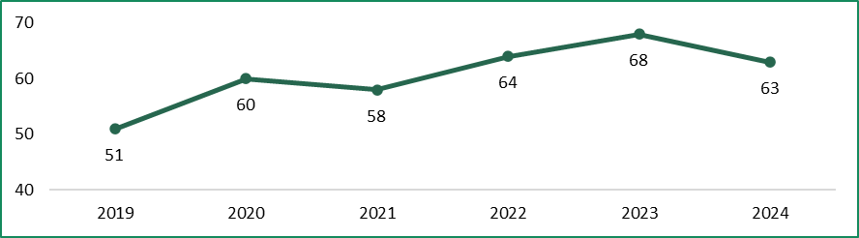
Note: 2024 data is current as of May 2024.
Sources: DTF (2024e); VSB submission.
The number of government departments has also grown from eight to 10. The two new departments are:
- The Department of Families, Fairness and Housing — established on 1 February 2021 — is responsible for child protection, prevention of family violence, housing, disability, LGBTIQA+ equality, veterans, and the offices for Women and Youth.
- The Department of Government Services — established on 1 January 2023 — aims to improve the experience Victorians have when they do business and interact with government.
There have also been changes to AO arrangements, with AOs established, absorbed into department structures, or becoming a public entity. As of May 2024, there were 14 AOs, compared to 16 at the time of the 2020 VPS Determination.
The VSB submission observed that:
… machinery of government changes, which will always be a feature of working in the VPS, have placed significant demands on [executive officers] since 2020. As senior leaders, [executive officers] are responsible for ensuring that organisational changes are implemented effectively and efficiently, including managing the impacts of change on non-executive staff.

Government demands on the VPS have increased alongside changes in the fiscal environment
Since the Tribunal’s 2020 VPS Determination, the Victorian Government has continued to advance large-scale social initiatives, such as becoming the first Australian jurisdiction to begin negotiating a treaty with Victoria’s First Peoples. Other significant commitments include reducing Victoria’s emissions to net zero by 2050 and implementing all 65 recommendations from the Royal Commission into Victoria’s Mental Health System.
Additionally, there has been a strong emphasis on cross-portfolio collaboration across various policy and service delivery areas. For example, seven government departments are working together to progress the government’s strategy to prevent family violence.
Alongside the above initiatives – principally from 2020 to 2022 – the Victorian Government undertook a range of activities related to the COVID-19 pandemic, including emergency response and providing support to Victorian households and businesses.
Recent state budgets have announced significant increases in output funding. While a substantial portion of this funding was allocated in response to the COVID-19 pandemic, other priorities and activities also received significant funding. In examining the aggregate output initiative spending across recent budgets, the Tribunal observed notable allocations and priorities:
- Victorian Budget 2021–22: New output funding of $19 billion over five years, with approximately $6 billion dedicated to health services (including public health activities and COVID-19 measures) and a further $3.3 billion for mental health reforms.
- Victorian Budget 2022–23: New output funding of $22.2 billion over five years, with $9.3 billion for health services to respond to the COVID-19 pandemic and for increased demand, plus $2.6 billion allocated for the Commonwealth Games. Following the cancellation of the 2026 Commonwealth Games, the Victorian Government announced a $2 billion package for regional Victoria, including housing, tourism and sporting infrastructure.
- Victorian Budget 2023–24: New output funding of $15.4 billion over five years, with $4.5 billion for health (primarily for public hospitals) and $2.9 billion for education (including $600 million for additional kindergarten services).
- Victorian Budget 2024–25: New output funding of $20.5 billion over five years, with $11.7 billion for health services, mainly public hospitals.
In addition to output funding, the government’s infrastructure program has continued to grow. Government infrastructure investment increased from $12.0 billion in 2019-20 to $24.0 billion in 2023-24. However, the Victorian Budget 2024–25 (2024-25 Budget) estimates that government infrastructure investment will moderate in future years and return to pre-pandemic levels by 2027-28. While the majority of the government’s investment program focuses on transport infrastructure, significant construction is also underway or planned for public hospitals, schools, and public housing.
Along with investment in public services, there is also a focus on identifying savings and enhancing efficiency in government activities.
The Victorian Government estimated a direct COVID debt of $31.5 billion for activities primarily delivered between 2019-20 and 2022-23. In response, the government announced a COVID Debt Repayment Plan in May 2023, which includes $2.1 billion in savings over four years to restore the size of the VPS back towards pre-pandemic levels, with a reduction of around 3,000 to 4,000 roles in 2023-24. Additionally, $800 million in general savings and efficiency measures were announced at the same time.
The 2024-25 Budget included further measures, such as consolidating certain services, concluding specific programs, and rephasing expenditure, expected to realise approximately $1.8 billion over five years.
The trends identified above have significant implications for VPS executives. For instance, the VSB’s submission highlighted that market constraints are disrupting infrastructure projects, including nationwide labour shortages and supply chain issues. As a result, executives will need to adopt innovative approaches to procurement and construction to address these challenges. Additionally, the VSB’s submission noted that recent saving initiatives have substantially impacted the role of executives, with key components of roles being:
Planning, communicating and implementing workforce reductions, while supporting staff wellbeing and engagement and delivering on priorities …
The Tribunal’s consultations with individual Secretaries further revealed that executives must respond to increasing demands due to expanding levels of government activity and heightened public expectations across a broad range of areas.

There have been shifts in ways of working across the VPS
One of the legacies of the COVID-19 pandemic has been increased flexible working arrangements, particularly for office-based workers. VPSC data shows that half of VPS employees are choosing to work remotely some of the time.
The VSB submission noted:
… hybrid and flexible working has been normalised, embedding working-from-home and the office as a feature of public service employment. While hybrid-working opportunities are available across many industries, particularly within Victoria, the embedding of hybrid-working is a benefit of working in the VPS.
The VPSC’s Flexible work policy applies to all VPS staff, including executives. The policy states that ‘flexible work is the government’s default position’ and provides examples of flexible work including compressed work weeks, flexible start and finish times and flexible daily schedules. VSB also published guidance providing further detail to the policy for office-based employees, which states that the ‘default starting position for application of the flexible work policy is three days a week in the office for full-time office-based VPS employees.’
The Organisation for Economic Co-operation and Development (OECD) commented on the public service’s role in the future of hybrid work:
… public administrations must reconcile the tension between going back to the way things were before the pandemic … and shaping a ‘new normal’ centred around greater individualisation of working modalities, including greater flexibility in working hours and location.
Some challenges for public sector executives in managing a hybrid workplace include:
- maximising productivity, including by redesigning work to focusing on a ‘digital-first’ way of working
- creating opportunities for socialisation, networking, and mentoring, including by encouraging employees to strategically plan their in-person days
- adapting the physical workplace for the needs of hybrid work, such as increased use of collaborative spaces.
Access to flexible working arrangements is also a critical factor for progressing gender equal workplaces. Under the Gender Equality Act 2020 (Vic) (GE Act), the availability and utilisation of flexible working arrangements is listed as a workplace gender equality indicator. According to DFFH, optimising flexible working into the future will be vital for the VPS as it works towards halving the gender pay gap in the Victorian public sector within five years (by 2028).

The government has committed to improving gender equality in the VPS
Under the GE Act, public sector organisations are required to prepare a Gender Equality Action Plan. This plan must include the results of a workplace gender audit, assessing the current state of gender equality within the organisation, and strategies for promoting gender equality in the workplace. Additionally, the GE Act mandates that organisations publicly report on their progress in improving workplace gender equality every two years.
In 2023, the Victorian Government released a gender equality strategy and action plan aimed at achieving gender parity in senior leadership positions within the Victorian public sector within five years.
In its submission, the VSB recommended that the Tribunal consider the ‘current gender balance’ of executive roles in this Determination. Similarly, the VPSC’s submission highlighted that the Tribunal’s current guidelines for placement of executives within the relevant band ‘do not adequately address gender equality’. VPSC suggested this issue could be addressed by providing gender disaggregated executive remuneration data to employers to inform remuneration decisions. Chapter 8 of this Statement of Reasons outlines changes to the Tribunal’s guidelines made in response to feedback from these submissions.
VPS executives will play a key role in implementing organisational strategies and action plans, translating them into specific actions and driving cultural change to achieve the government’s gender equality objectives.

There has been an increased focus on the application of public sector values in recent years
This focus has been driven by several inquiries and reports scrutinising the actions of the Australian and Victorian public sectors, revealing various challenges such as:
- poorly defined governance arrangements leading to a lack of accountability
- an excessive focus on efficiency and short-term responsiveness over long-term expertise and capability
- limited understanding of statutory obligations, administrative law, and natural justice, including for procurement practices
- a lack of accountability for Australian Government employees in cases of misconduct or breaches of the code of conduct.
In response to these challenges in Victoria, Secretaries and the Victorian Public Sector Commissioner have issued additional integrity guidance and policy statements aimed at assisting executives and staff in fulfilling their obligations. For instance, the VPSC’s Secretaries guide for informing and advising ministers includes:
- an outline of the legal responsibilities and obligations for a Secretary
- clarification of the difference between accountability and responsibility
- a definition for what constitutes a briefing, encompassing both formal briefings and digital communications such as email, texts, and messaging platforms.
Additionally, in 2023, VSB published an Integrity Statement committing to:
- supporting all staff to feel confident in understanding public sector integrity obligations through increased training opportunities
- fostering open and transparent communication to ensure staff have avenues to raise concerns at all levels
- cultivating a ‘safe to speak up’ culture, ensuring anonymous integrity reporting avenues are available and acted upon
- consistently applying merit-based employment processes
- embedding integrity expectations in performance development plans for all staff, including mandatory training in ethical decision-making for executives.
To support these objectives, Secretaries and executive leadership teams will need to:
- engage in conversations with employees about providing full and frank advice
- welcome difficult advice from employees
- encourage staff to raise significant issues with managers or executives to ensure timely and high-quality advice
- develop and implement a model protocol for engaging with ministerial offices.

2.4 Executives reported increased scrutiny, workload and complexity
Submissions cited the increased scrutiny, workload and complexity of executive roles associated with changes in the operating environment described above. For example, the VSB submission noted that:
… since 2020, expectations that [executive officers] will be available and responsible at all times have increased. This may be an unintended consequence of hybrid and flexible working, a hangover from the pandemic, or it may be the result of an overall increase in the pace and complexity of work the VPS delivers…
And the VPSC submission drew attention to the legacy of the COVID-19 pandemic on executive roles:
The COVID-19 response placed extreme pressure on and increased the public visibility of VPS executives. This included the need to work long hours (12–18-hour days were normal for those with direct COVID-19 response roles) for extended periods of time. In extremely tight timeframes and with imperfect information, VPS executives made weighty recommendations to government. For some executives their decisions or practice had life changing impacts for Victorians. While VPS executives did not request nor expect to receive overtime for this work, it is worth noting they did not receive it. While the expectations and timeframes have diminished since 2022, the VPSC considers that they have not returned to pre-2020 levels.
Similar views were expressed by respondents to the Tribunal’s executive questionnaire. For example, one executive commented:
Within the context of a shrinking public service that has already seen a shift to centralised decision making, the overhead and burden of both strategic and transactional decision-making sits with the executives. This requires executives to have greater breadth of knowledge and expertise than ever before. Combined with the accelerated pace of digital transformation … this has created an unsustainable workload where 70+ hours per week is [standard]. This unsustainable workload has led to almost 10 executives holding this position in just the last five years.
Another observation shared with the Tribunal during consultations with Secretaries was that the current level of government activity is unsustainable given the resource constraints.

Executives reported increased risk of reputational damage associated with public scrutiny
The VSB submission noted that public scrutiny is an important and expected part of working in government:
Providing account for public service actions before inquiries and parliamentary hearings is an important aspect of Victoria’s system of government and an expected function of public service [executive officers]. These hearings are demonstrable of the high-level of scrutiny and public examination to which public service [executive officers] are rightly subject, but which also constitute a distinct responsibility of [executive officers] within the public service.
As public service body Heads, Secretaries generally face the highest levels of scrutiny. For example, Secretaries are regularly required to appear at parliamentary hearings such as the Public Accounts and Estimates Committee (PAEC) Budget Estimates hearings. In recent years, PAEC has also conducted inquiries into the financial and performance outcomes of each department, which involved further participation at hearings from Secretaries.
This is in addition to other inquiries which arise from time to time such as the COVID-19 Hotel Quarantine Inquiry and the Yoorrook Justice Commission hearings, both of which were highly publicised. While PAEC is attended by Secretaries (and AO Heads), executives at any level might be called in to appear at other inquiries. For example, the VSB submission noted that more than 15 public service executives were required to appear before the COVID-19 Hotel Quarantine Inquiry.
As noted by one Secretary during consultations, the way Parliament operates has changed – particularly in regard to unscheduled inquiries. While some inquiries undertaken by Parliament or other bodies may be focussed on specific or narrow issues, there has been a structural change in the level of scrutiny on senior executives.
While submissions acknowledged the appropriateness of public scrutiny, the Tribunal also heard concerns about risks to executives.
The Tribunal’s consultations with Secretaries revealed that the most significant change impacting the role is the level of public scrutiny that Secretaries (and senior executives) are now subject to. A high degree of public accountability is, and has always been, highly appropriate but there has been a shift in the manner in which such scrutiny is being applied.
The VPSC expressed similar views in their submission which noted that notwithstanding the importanace of accountability:
… the frequency, intensity and often widely reported nature of this scrutiny can have a negative impact an executives’ mental health and their future financial earning capacity.
A respondent to the Tribunal’s executive questionnaire also explained the impact of higher levels of public scrutiny:
… there is also a much greater risk for [executives] with more public/media exposure when things go wrong (which used to be borne more by elected members of Parliament) and no contract protection.

Executives reported growth in the nature and scale of their roles
The Tribunal’s executive questionnaire asked executives to rate the work level standards for their role as having either ‘reduced’, ‘grown’ or remained ‘unchanged’ over the past four years (Figure 2.2).
Figure 2.2: Ratings for the executive work level standards
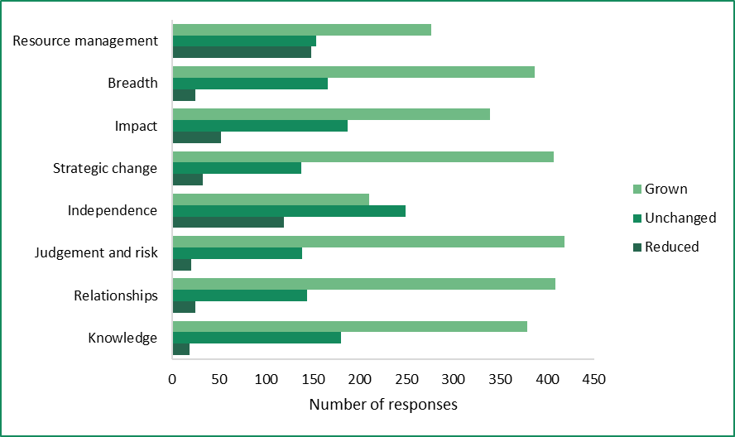
Source: Tribunal analysis of responses to executive questionnaire. VPS executives were asked ‘Over the past four years, how have the following competencies changed for you in working as a VPS executive? If you have worked in more than one executive role in the last four years, please respond based on your longest role.’
For seven of the eight standards, most executives selected the option of ‘grown’. This indicates that most executives perceive that the overall work value of their role has increased.
The only standard where most executives did not select ‘grown’ was for ‘independence’ which indicates some executives may be feeling constrained in their ability to make decisions without support.
Box 2.1 sets out selected feedback from executives explaining their reasons for their responses. A common theme was the growth in expectations on the VPS, and in particular, executives, since the start of the COVID-19 pandemic.
Box 2.1: Executive views – increased workload and complexity
‘The role hasn’t changed but the expectations on delivery timeframes and workload have increased dramatically.’
‘My answers are attempting to communicate that I am expected to deliver highly complex, nuanced and challenging advice across more topics, with fewer resources to validate and inform my judgements. This increases the risk which I have to navigate increasingly alone, because no one above me or alongside me has the capacity to back me in. It’s a quality issue, which quickly becomes a values and integrity issue.’
‘The expectations on the VPS [have] grown significantly, particularly since COVID. The breadth of work and speed of delivery puts significant pressure on the middle executive cadre to lead this work. This is exacerbated by recruitment challenges and the reductions in [workforce] numbers which mean that teams are rarely at full strength or adequately resourced to meet expectations. The unwritten expectation is that middle executives will put in significant overtime and do what it takes to get things done and be on call almost 24/7, while having limited opportunities to shape policy and programs in a ‘top down’ environment.’
‘The demands and expectations of my role continue to grow, without any concomitant expansion in resourcing, professional supervision, learning and development and support roles to assist me with my job, and the expectation that I work well beyond business hours, including on call duties on weekends and after hours with no remuneration or recognition of this work.’
‘COVID changed how we worked, then because government has overspent budgets, we are now left with trying to cut resources in a political environment where there is no appetite to cut external funding. It has made the task so much more difficult. Team morale is terrible due to the change approach we adopted for this downsizing and that has been taxing in terms of time and effort to do the work.’
Note: Responses have been edited only where necessary to improve clarity.
Source: Tribunal executive questionnaire.

Some executives reported reduced levels of independence
Several executives also commented that while workload and complexity had grown, they had less independence. This contributed to confusion about accountabilities, frustration, and job dissatisfaction (Box 2.2).
Box 2.2: Executive views – independence and autonomy
‘Independence has been curtailed due to onerous and restrictive policies announced by the Secretary – that basically centralises decision making and increases the level of administrative burden and frustration.’
‘Although the scope of responsibilities seems to have increased, the ability to independently make decisions has diminished – decisions are increasingly being escalated to higher levels in the hierarchy, including for resource management.’
‘Size of departments have grown so this has increased remit, however VPS resources have diminished. Since COVID, there is an expectation to work seven days and be on call weekdays – this is impacting the number of [executives] leaving the VPS. Stakeholder management has grown and I support this – both internally and externally. Most of my colleagues would say their ability to make decisions freely or without influence has diminished.’
‘There are many layers of executives in my organisation so my ability to be involved in strategic planning and decision making is reduced. This can also apply to day-to-day decision making where the level of accountability is not always clear.’
‘The level of responsibility and delivery has significantly increased while resourcing has been downsized. The level of impact has reduced, and decision-making is being centralised in the SES-3 and above levels while risks are still being borne by SES-1 and -2 [executive] staff. The required hours to complete tasks are now regularly exceeding 50 hours per week and SES-1 and -2 staff are being required to produce more operational artifacts (including drafting briefs due to staff shortages).’
Note: Responses have been edited only where necessary to improve clarity.
Source: Tribunal executive questionnaire.

2.5 Future influences on executive roles
The Tribunal’s research and consultations identified several factors likely to affect executive roles in the coming years. These include:
- harnessing the power of artificial intelligence
- protecting against cyber threats and ensuring data integrity
- geopolitical influences.
In light of these factors, the Tribunal considers that the exposure to risk for VPS executives is now generally broader than it was at the time of the 2020 VPS Determination.

Harnessing the potential of artificial intelligence
According to the Australian Government’s Australian Signals Directorate (ASD), artificial intelligence (AI) is an emerging technology that is likely to play an increasingly influential role in everyday life.
AI is already being used in the Australian public sector to improve outcomes. For example, the Commonwealth Scientific and Industrial Research Organisation has developed an AI-enabled system that can model bushfire spread to help plan for and manage bushfires. According to the Productivity Commission (PC), AI may impact the public sector in several ways in the future, including:
- utilising large, underutilised data sets to help identify risks and improve outcomes in human services such as health, education and housing
- updating existing regulations to ensure AI use is adequately covered, including approval processes for vehicles, machinery and medical equipment
- demonstrating safe and effective uses of AI in service delivery as governments are significant procurers and users of technology, including through pilots and trials.
Utilising AI in the public sector presents several risks, including potential biases in decision-making algorithms that could lead to unfair or discriminatory outcomes and legal proceedings by affected parties. Additionally, there is a risk of data breaches and privacy concerns if sensitive public information used to train AI systems is not adequately protected.
In this context, a recent survey on the application of AI highlighted the challenges for the public service in applying technologies to:
… complex real world scenarios without a clear understanding of the limits of the technology, a transparent or unambiguous definition of the problem the technology is being applied to, or surety on what the desired outcome is. Relatedly surveys of public attitudes have found AI related failures in government contribute to negative valuations of government in general.

The importance of cyber security and data integrity
The rapid adoption of AI technology also presents a challenge for executives in upholding cyber security and preserving data integrity within the VPS. In 2022, nine out of 10 Victorian Government organisations experienced a cyber incident. Protecting against cyber threats is essential to prevent data breaches, particularly given the sensitive nature of some personal information held by government, and maintain operational continuity, especially in critical sectors like healthcare and transportation.
Senior executives, particularly public service body Heads, will likely bear considerable personal responsibility in mitigating the risks of catastrophic system failures. Prioritising cyber security and data integrity is therefore likely to become an increasingly important component of VPS executive roles.

A challenging global environment
The operating environment for VPS executives has always been influenced by global factors, but consultation with Secretaries revealed that geopolitical dynamics are increasingly shaping the strategic landscape. Rising global tensions, trade disputes, and supply chain disruptions are having profound effects on local economies, security, and public policy. These challenges create a complex and dynamic environment for VPS executives, who must navigate the impacts of international events on domestic circumstances.
For example, international conflicts have disrupted global supply chains, affecting the availability of construction materials, which are important for the delivery of infrastructure projects and housing affordability.

2.6 Summary
Public service body Heads are leaders responsible for the management of their agency, including advising Ministers and employing staff. The Secretary of a department is also responsible for supporting the governance of AOs and public entities in their portfolio. AO Heads also employ their own staff and perform activities under the direction and control of Ministers. The Victorian Public Sector Commissioner oversees the VPSC’s functions of strengthening public sector efficiency, effectiveness, and capability.
Within a public service body, executive positions generally include responsibility for large-scale service delivery, development of public policy and implementation of compliance and enforcement programs.
Since the Tribunal’s 2020 VPS Determination, the VPS workforce has expanded in response to the impacts of the COVID-19 pandemic, growth in infrastructure investment and new economic and social priorities. There has also been increased scrutiny of the advice provided and decisions made by executives.
In response to these trends, executives report heightened expectations and increased workload, complexity, and scrutiny. Some executives also report reduced levels of independence, with decision-making increasingly centralised.
Factors that are likely to influence executive roles in the future include harnessing the potential of AI and addressing geopolitical issues that impact service delivery obligations.

3 Existing arrangements
In making this Determination, the Tribunal comprehensively reviewed the existing employment arrangements and remuneration provided to executives employed in VPS bodies.
Some conditions of executive employment — including contract length, termination provisions and the ‘right of return’ — are out of scope of the Tribunal’s Determination. However, such conditions — together with the remuneration offered — affect the attraction and retention of executives and for this reason are relevant to the Tribunal’s considerations.

3.1 Executive employment is governed by the PAA and supporting policies
The PAA is the key piece of legislation governing the employment of executives. The VPS Handbook provides the policy framework for employing executives under the PAA. The VPSC also maintains a ‘standard contract’, which is compulsory for all executive employment in the VPS. The contract template incorporates all the required government executive employment policies and ensures a consistent approach to executive employment across the VPS.
Table 3.1 summarises key employment conditions in the executive employment contract.

Table 3.1: Summary of key employment conditions in the standard contract
Provision | Conditions
Re-employment | Executive contracts are for terms of up to five years, but some VPS employers may offer shorter contract terms. There is no minimum contract term.  Contracts cannot be extended but may be renewed, with renewal decisions reached no later than four months prior to contract expiry.
Performance plan and review | All executives must have a written performance plan that must be reviewed by the employer at least once a year.
Termination | An employer can terminate a contract at any time, without showing cause, with four months’ notice or pay in lieu of notice.  Other termination provisions apply where an executive has failed to fulfil their duties or if the executive commits an act of misconduct.
Expenses | Executives will be reimbursed for any necessary and reasonable expenses incurred in the performance of their duties subject to appropriate prior authority and provision of documentary evidence.
Leave | Over 25 different leave categories, including:  - 20 days annual leave per year  - 15 days personal leave per year  - parental leave (16 weeks paid, and up to 36 weeks unpaid for the primary caregiver; 4 weeks paid, and up to 12 weeks additional paid leave for the secondary caregiver subject to assuming primary responsibility for the child within the first 78 weeks)  - 20 days of family violence leave per year  - up to 52 weeks of leave because of a work-related injury  - for every 10 years continuous service, 3 months of long service leave (with access to pro-rata long service leave after 7 years).
Source: VPSC (2021).
Some conditions of executive employment specified in the executive contract are like those that apply to non-executive VPS employees covered by the Victorian Public Service Enterprise Agreement 2020 (VPS EA 2020). These include access to a range of leave entitlements and access to long service leave. However, executives do not have access to annual leave loading, which, for non-executive employees, is calculated at the rate of 17.5 per cent of the employee’s salary for the period of annual leave.
Executives are also not eligible for the type of overtime payments that are available for certain employees covered by the VPS EA. The standard executive contract states:
You [an executive] are required to work the hours necessary for you to perform your duties in a satisfactory manner, including reasonable additional hours which may include, without limitation, working on weekends and public holidays. Your remuneration includes compensation for all hours you may work, including reasonable additional hours.
The PAA provides for the ‘right of return’ for an executive to the highest non-executive level in certain circumstances (Box 3.1).
Box 3.1: Right of return for certain executives
The right of return is available where an executive’s contract is terminated for reasons other than misconduct, or the contract has expired, and the following circumstances apply:
- the executive was employed as a non-executive VPS employee immediately prior to becoming an executive
- the executive has been continuously employed as an executive ever since.
The executive is entitled to be employed in the highest classification of non-executive role, currently the VPS Grade 7 Senior Technical Specialist classification.
Executives who exercise a right of return are only entitled to be remunerated at the mid-point of that classification. However, if employment at that mid-point would result in the former executive being employed at a higher total remuneration level than when they were last employed as an executive, they are entitled to be remunerated at the highest point of that classification that would not have that result.
When an executive exercises a right of return they may be able to take up a substantive and ongoing non-executive position within a VPS body. However, this may not always be the case – for example, a position may be declared surplus in which case the executive may commence a redeployment process and be transferred to a new position or be made redundant.
Sources: PAA, s 27(2); VPSC (2022e).

3.2 SES roles are classified into one of three levels
As discussed in Chapter 2, the VPS Executive Classification Framework uses a work level assessment methodology to classify each SES in one of three levels. The executive classification framework does not apply to public service body Heads.
The classification level to which an executive role is assigned is determined by a work value score for that role. Work value scores are calculated by assessing each executive role against eight standards, with a score of 1, 3, 5 or 7 against each. The final tally is a work value score which determines the appropriate classification level for the role. The highest level is SES-3, followed by SES-2 and SES-1 (Table 3.2).
The framework also includes standard position titles for each classification level. There is flexibility for non-standard titles to be used to accommodate the diverse nature of the VPS. However, employers are encouraged to aim for an 80/20 standard to non-standard ratio.
Table 3.2: VPS executive classification levels, standard titles and work value scores
Classification | Standard title | Work value score range
SES-1 | Director | 21 to 35
SES-2 | Executive Director | 36 to 47
SES-3 | Deputy Secretary | 48 to 56
Source: VPSC (2024h).
While the number of executives has increased from June 2019 to June 2023, the proportion of executives in each band has been broadly stable. Table 3.3 compares the distribution of SES (and AO Head) positions between June 2019 and June 2023.
Table 3.3: Distribution of SES and AO Head roles, 2019 to 2023
Classification | June 2019 |  | June 2023
Classification | Number | Per cent | Number | Per cent
SES-1 / AO Head-1 | 529 | 52 | 917 | 56
SES-2 / AO Head-2 | 430 | 43 | 633 | 39
SES-3 / AO Head-3 | 53 | 5 | 96 | 6
Notes: The number of executives refers to those employed in departments, AOs and the VPSC. In 2019, SES-1 positions were known as executive officer band 3 or EO-3s, SES-2s were known as EO-2s, SES-3s were known as EO-1s. The VPSC executive workforce data collection does not separately report the number of AO Heads and consolidates these with the equivalent SES position (e.g. an AO Head-1 position is reported as a SES-1 position). The number of positions as reported as of the last pay period in June 2019 and June 2023.
Sources: Tribunal (2020a), p. 48; Tribunal analysis of VPSC data.
Figure 3.1 shows the number of departmental executives (headcount) within each classification level as of the last pay period in June 2023. The greatest number of executives were employed by DH (209), DFFH (204) and DEECA (201).
Figure 3.1: number of executives (headcount) by classification band and department, June 2023
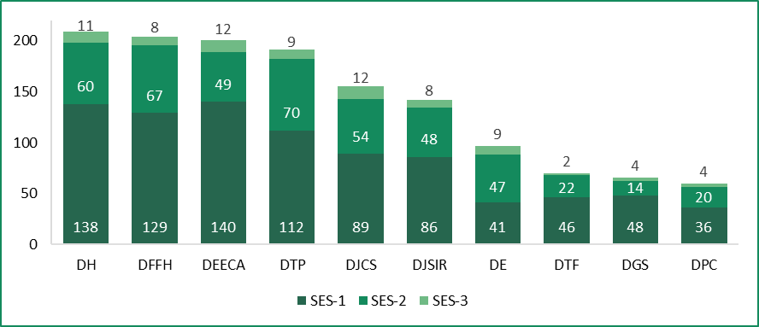
Note: numbers are correct as of last pay period in June 2023 and do not include acting arrangements.
Source: Tribunal analysis of VPSC data.

3.3 Executives are paid a total remuneration package
The VPS Handbook defines the components of an executive’s total remuneration package (TRP) as the sum of:
- base salary
- employer superannuation contributions (see Box 3.2)
- employment benefits (non-salary benefits) – the executive meets the full cost of any benefits
- the annual cost to the employer of providing the non-monetary benefits, including any fringe benefits tax payable.
Employers are required to make superannuation contributions in accordance with Commonwealth law.

Box 3.2: Employer superannuation contributions for executives who are members of an accumulation scheme
The superannuation guarantee (SG) and maximum superannuation contribution base (MSCB) apply to executives who are members of an accumulation scheme.
The SG is the minimum amount of employer superannuation contributions to which an employee is entitled, expressed as a percentage of the employee’s ‘ordinary time earnings’. The MSCB serves to limit the ‘ordinary time earnings’ that are used to calculate an employee’s superannuation entitlements – that is, earnings over the MSCB are not counted for the purpose of calculating entitlements.
The superannuation entitlements of executives in an accumulation scheme may change from year to year due to the indexation of the MSCB or changes to the SG rate.
On 1 July 2024:
- the SG increases from 11 per cent to 11.5 per cent
- the MSCB increases from $249,080 per annum to $260,280 per annum.
The VPS Handbook states that ‘VPS employers who use the VPS contract must bear the cost’ of such increases in superannuation entitlements. This means that the salary and other components of TRP cannot be reduced to offset changes to Commonwealth superannuation obligations.
Sources: Superannuation Guarantee (Administration) Act 1992 (Cth); VPSC (2022e).
Executives can also include non-salary benefits as part of their TRP. These include a motor vehicle obtained through the Executive Motor Vehicle Scheme (Box 3.3).
Box 3.3: Executive Motor Vehicle Scheme
Executives can access a motor vehicle for business and private use under a salary sacrifice arrangement. Executives are required to contribute towards the cost of the private use of the executive vehicle.
Executives who choose to use the Executive Motor Vehicle Scheme are responsible for:
- two thirds of the approved costs of the vehicle plus any accessories agreed with the employer through a salary sacrifice plan
- paying all e-TAGs and tolls
- paying the associated fringe benefits tax
- ensuring the vehicle is available for business use during business hours, if required.
Employers are responsible for:
- meeting one third of the approved costs for business use
- arranging provision of fuel cards
- providing car parking at work sites
- maintenance, insurance and servicing of the vehicle, and arranging accident management services and manufacturer’s roadside assistance.
Source: VPSC (2022e).

3.4 The Tribunal sets the value of the remuneration bands
The remuneration band structure for the SES set by the Tribunal consists of three distinct and contiguous bands aligned to the executive classification framework (Table 3.4).
Table 3.4: Values of the remuneration bands for the SES from 1 July 2023
Classification | Base of band TRP  ($ p.a.) | Top of band TRP  ($ p.a.)
SES-1 | 216,376 | 279,238
SES-2 | 279,239 | 401,017
SES-3 | 401,018 | 533,431
Source: Tribunal (2023b).
In its 2020 VPS Determination, the Tribunal considered how public service body Heads should be classified for remuneration purposes. The Tribunal decided to establish an additional band for Secretaries and the Victorian Public Sector Commissioner above the SES bands, as well as three additional bands for AO Heads.
The Tribunal has traditionally maintained a gap between the top of the SES-3 band and the base of the band for Secretaries and the Victorian Public Sector Commissioner. This gap reflects the greater roles and responsibilities of Secretaries and the Victorian Public Sector Commissioner and provides an incentive for advancement. As of 1 July 2023, this gap was around 8 per cent.
Table 3.5 shows the current value of the remuneration band for Secretaries and the Victorian Public Sector Commissioner.
Table 3.5: Value of remuneration band for Secretaries and the Victorian Public Sector Commissioner from 1 July 2023
Classification | Base of band TRP  ($ p.a.) | Top of band TRP  ($ p.a.)
Department Secretary or  Victorian Public Sector Commissioner | 577,716 | 778,492
Source: Tribunal (2023b).
A comparison of the values of remuneration bands for non-executive VPS staff with the values of the SES remuneration bands is set out in Chapter 4.
In making its 2020 VPS Determination, the Tribunal decided to align the remuneration bands for AO Heads with the SES remuneration bands. At that time, the Tribunal mapped the remuneration for AO Heads against the existing SES remuneration bands (then referred to as ‘subordinate executives’). It found that almost all AO Heads were paid within the existing subordinate executive remuneration bands.
Following consultation, the Tribunal decided to formally align the remuneration bands for AO Heads with the SES remuneration bands to:
- reflect the diversity in their roles
- promote ease of administration
- facilitate the movement of executives between AOs and other public service bodies.
The current values of the remuneration bands for AO Heads are shown in Table 3.6.
Table 3.6: Values of remuneration bands for AO Heads from 1 July 2023
Classification | Base of band TRP  ($ p.a.) | Top of band TRP  ($ p.a.)
AO Head-1 | 216,376 | 279,238
AO Head-2 | 279,239 | 401,017
AO Head-3 | 401,018 | 533,431
Source: Tribunal (2023b).
Figure 3.2 illustrates the current values of the remuneration bands for the SES and public service body Heads.

Figure 3.2: Values of the VPS executive remuneration bands from 1 July 2023
Source: Tribunal (2023b).
8%
gap
Department Secretary or
Victorian Public Sector Commissioner
$577,716
to
$778,492
SES-1 or  AO Head-1  $216,376  to  $279,238 | SES-2 or  AO Head-2  $279,239  to  $401,017 | SES-3 or  AO Head-3  $401,018  to  $533,431

3.5 Employers set the remuneration of individual executives
The PAA provides that an executive’s remuneration must fall within the relevant remuneration band set by the Tribunal, unless an employer seeks and considers the Tribunal’s advice on a proposal to pay an executive above the top of the relevant band.
The Tribunal has issued guidelines with respect to the placement of public service body Heads and other executives within the remuneration bands. Prior to this Determination, the Tribunal’s guidelines referred to several factors which employers should consider:
- the work value score for the role
- the experience, knowledge and capability of the individual
- the remuneration relativities of other executives within the organisation
- the remuneration of the line manager (if within the same band)
- the current remuneration of the individual
- labour market pressures on the position.
Following consultation for this Determination, the guidelines have been revised. A summary of these revisions is provided in Chapter 8.

There are opportunities to adjust individual executive TRPs
Unlike eligible VPS employees covered by the VPS EA, there is no formal process for executives who meet performance criteria to progress through the relevant remuneration band.
An executive’s remuneration may be adjusted annually by their employer up to a maximum rate set by the Premier. This is known as the ‘Premier’s annual adjustment guideline rate’ (guideline rate). Employers have discretion as to whether to pass on the guideline rate to executives who have been:
- appointed within six months of the date the guideline rate takes effect
- recently granted a remuneration uplift.
The standard executive contract provides for an annual review of an executive’s remuneration. An employer may also agree to undertake a remuneration review ‘at any time’ in recognition of changes in responsibility, accountability or for retention purposes.

Executives may be paid above the relevant remuneration band
If an employer proposes to pay an executive above the maximum of the remuneration band, it must seek and consider the advice of the Tribunal. This includes mid-contract adjustments, reappointments, new appointments and temporary appointments. Employers are also required to request the Tribunal’s advice when passing on the guideline rate if this would result in an executive being paid (or continuing to be paid) above the relevant remuneration band.
As of 30 June 2023, around 3 per cent of VPS executives were paid above the band, with most of these executives classified at the SES-2 band and employed in the transport infrastructure sector. Table 3.7 shows the number and proportion of executives paid above the relevant band for each classification.
Table 3.7: Number and proportion of VPS executives paid above the relevant remuneration band as of 30 June 2023
Classification | Number of executives paid above the band | Proportion of executives paid above the band (%)
SES-1 | 7 | 0.8
AO Head-1 | nil | nil
SES-2 | 31 | 4.9
AO Head-2 | nil | nil
SES-3 | 6 | 6.7
AO Head-3 | 1 | 14.3
Department Secretary or  Victorian Public Sector Commissioner | nil | nil
Source: Tribunal analysis of VPSC data.
Since the payment above the band process was established in 2020, the Tribunal’s advice has most often been sought for VPS executive roles in the major transport infrastructure portfolio. These types of roles accounted for 75 per cent of the requests received over the past four years (Figure 3.3).
Figure 3.3: Requests for Tribunal advice, VPS executives, 2020-21 to 2023-24*
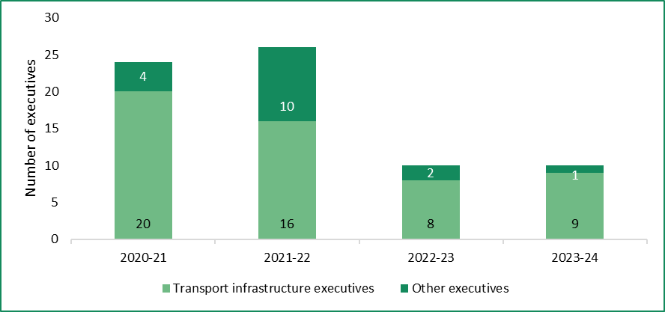
*Financial year to 11 June 2024.
Notes: Includes requests for advice for new appointments, re-appointments and mid-contract adjustments. The Suburban Rail Loop Authority became a public entity during December 2021 and is included in the data for 2020-21 and part of 2021-22.
Sources: Tribunal (2021); Tribunal (2022); Tribunal (2023a); Tribunal data.

3.6 Summary
Executive employment policy is governed by the PAA, the VPS Handbook, the standard executive employment contract and the executive classification framework.
The Tribunal is responsible for determining the values of the remuneration bands for executives. The remuneration band structure for the SES consists of three distinct and contiguous bands aligned to the VPS Executive Classification Framework. The Tribunal has also established an additional classification and remuneration band for Secretaries and the Victorian Public Sector Commissioner above the SES bands, as well as three additional bands for AO Heads.
Employers retain the power to set an individual executive’s remuneration. There are opportunities to adjust an executive’s remuneration, including through the application of the guideline rate.

4 Labour market considerations
In making its Determination, the Tribunal sought to understand the key characteristics of the VPS executive labour market.
Stated simply, labour markets match the supply of labour from employees with the demand for that labour from employers. In the VPS context, this means the supply of individuals with the necessary skills, experience and willingness to take on an executive role, and the demand for their services from VPS employers and market competitors.
This chapter examines:
- demand and supply conditions in the broader labour market, where the VPS competes with other employers for executive talent
- indicators of demand and supply in the market for VPS executives, including trends in executive numbers and available data on advertisements and applications for executive roles
- how the existing values of the remuneration bands influence the supply of executives
- remuneration benchmarking and advice from Mercer Consulting (Australia) Pty Ltd (Mercer), which the Tribunal commissioned to inform the Determination.
The various data, observations and analyses set out in this chapter, along with the jurisdictional comparisons in Chapter 5 and economic and financial analysis in Chapter 6, will be brought together in Chapter 7 to explain the Tribunal’s decision on the values of the remuneration bands.

4.1 Conditions in the broader labour market are tight
The ‘market’ for VPS executives is influenced by conditions in the broader labour market. This is because, to a certain extent, the VPS competes for executive talent with firms in the for-profit and not-for-profit sectors looking to employ executives with similar skills, knowledge and experience, as well as public services in other Australian jurisdictions.
Conditions in the broader labour market are currently tight by historical standards. According to the Bank for International Settlements, a ‘tight’ labour market is one where an:
… imbalance between labour supply and labour demand manifests itself in an abundance of job opportunities along with a scarcity of workers available and willing to take those jobs.
The Bank has estimated that the demand for labour in the Australian economy grew faster than the labour supply between 2019 and 2023, with reduced migration during the pandemic a key factor.
Australian labour market conditions are tighter across a range of indicators than they were before the Tribunal made its 2020 VPS Determination, though they have eased in recent times (see Chapter 6). For example, the national unemployment rate fell from an average of 5.2 per cent in 2019 to an average of 3.7 per cent in 2023, before gradually increasing to 4.1 per cent in April 2024 (Table 4.1).
Table 4.1: Changes in selected indicators of spare capacity in the Australian labour market, 2019 to 2024
Indicator^{(a)} | Average value in 2019 | Average value in 2023 | Current value
Unemployment rate (%)^{(b)} | 5.2 | 3.7 | 4.0^{(d)}
Underemployment rate (%)^{(b)} | 8.3 | 6.4 | 6.7^{(d)}
Unemployed persons per job vacancy^{(b)} | 3.1 | 1.3 | 1.5^{(e)}
Job vacancies as share of total employment (%)^{(c)} | 1.8 | 2.9 | 2.5^{(e)}
Job advertisements as share of labour force (%)^{(c)} | 1.3 | 1.9 | 1.6^{(d)}
Notes: (a) All data are seasonally adjusted. (b) Lower value indicates a tighter labour market. (c) Higher value indicates a tighter labour market. (d) Value at May 2024. (e) Value at February 2024.
Sources: Australian Bureau of Statistics (ABS) (2024d); ABS (2024e); Jobs and Skills Australia (2024a).
The Victorian Budget 2024-25 (2024-25 Budget) observed that the Victorian labour market remains strong, noting that:
… the share of working-age Victorians in employment and labour force participation [remains] near record high levels… [and] forward indicators of labour market demand, including job advertisements and job vacancies remain healthy and above levels seen before the COVID-19 pandemic.
More broadly, the Reserve Bank of Australia (RBA) has observed that the resumption of overseas migration has added to Australia’s labour supply and helped to relieve labour shortages in some industries. In 2022-23, net overseas migration was 518,000 people, with migrant arrivals up 73 per cent compared to 2021-22. On the demand side, the latest Labour Market Update (March 2024) from Jobs and Skills Australia (JSA) pointed to signs that the demand for labour is softening.
In particular, it observed that growth in full-time employment had ‘weakened considerably’ over the 12 months to March 2024, compared with much stronger growth in part-time employment. However, JSA noted that employers are still experiencing challenges finding suitably skilled workers to fill vacant positions.
Governments have developed policies and initiatives aimed at addressing labour market pressures. For example, as part of its new Migration Strategy, the Australian Government announced the creation of a new, three-tiered ‘Skills in Demand’ visa. In particular, the ‘Core Skills Pathway’ will focus on in-demand occupations (as identified by JSA) and seek to balance Australia’s labour market needs with providing opportunities to skilled migrants.

4.2 Demand for VPS executives is moderating
The Tribunal has previously observed that the Victorian Government’s demand for executives may be influenced by factors such as its policy agenda, philosophy regarding the size and role of the public service, and prevailing economic and fiscal conditions.
In its 2020 VPS Determination, the Tribunal observed strong growth in the number of VPS executives over the previous four years. This trend has continued, with the number of executives employed in public service bodies increasing from around 1,000 to around 1,650 between June 2019 and June 2023.
According to VPSC analysis, the number of VPS executives increased between 2020 and 2021 ‘to meet demands for leadership in social policy areas and to help manage the impacts of COVID-19’. The VPSC’s submission also cited the following factors as contributing to the overall increase in VPS executive numbers over recent years:
- requirements for increased senior oversight, including for capital projects
- an increase in the use of job-share arrangements
- reclassifications of some positions to ensure fairness and consistency.
More recently, VPSC data indicates that growth in executive numbers has begun to moderate, coinciding with the winding up of many COVID-19 related programs and initiatives. Further, while exact numbers are not yet available, the Tribunal expects executive numbers to have declined since mid-2023, consistent with the Victorian Government’s commitment to reducing the number of VPS staff and returning the size of the VPS towards pre-pandemic levels.
Moderating demand for VPS executives is also evidenced by the number of advertisements for VPS executive roles. According to data provided by the VPSC, advertisements for SES roles in public service bodies increased significantly between mid-2020 and mid-2021 (Figure 4.1). The number of job advertisements has been trending downwards since then, though recent data suggest they may be stabilising.
Figure 4.1: Monthly job advertisements for SES roles in public service bodies,
July 2019 to March 2024
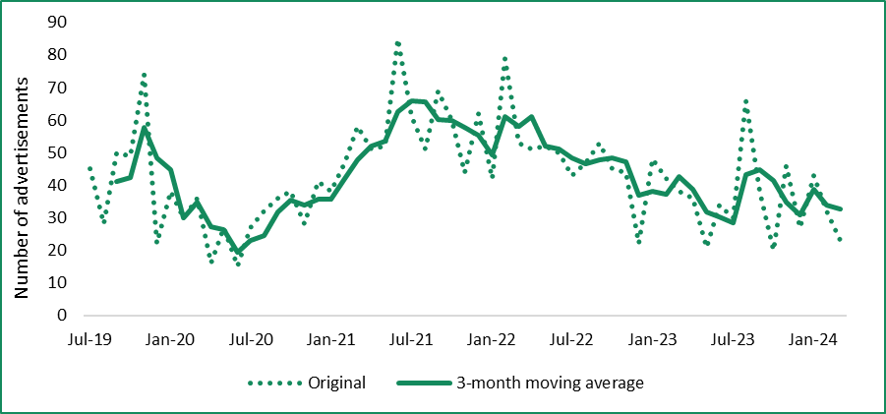
Note: Job advertisements that were active for less than six days have been excluded from the data, while instances where an advertisement was posted to multiple platforms in parallel have been counted as a single advertisement. The number of job advertisements in any given period may not equal the number of executive vacancies, as some advertisements relate to multiple positions and some positions may be advertised multiple times.
Source: Tribunal analysis of VPSC data.

4.3 The supply of VPS executives is matching demand, with some exceptions
The Tribunal has previously noted that factors which influence the supply of executives include the cost of accumulating the requisite skills, education and experience, potential remuneration for other positions, the nature of the work and other non-monetary factors.
The VSB submission noted ongoing challenges in recruiting for some executive roles, associated with a tight labour market and significant government investment in large-scale initiatives. Recruitment difficulties are also evident in the broader labour market. For example, 64 per cent of Australian employers surveyed by JSA in the December quarter 2023 reported experiencing difficulties recruiting for professionals.
Around two-thirds of respondents to the Tribunal’s executive questionnaire involved in executive recruitment indicated they were experiencing significant challenges in attracting executives within the existing remuneration bands.
Respondents were also asked to nominate the functional areas in which they were experiencing significant challenges. The most common response was ‘project and program management’, which was chosen by 45 per cent of respondents who specified one or more functional area, followed by ‘policy and strategy’ (29 per cent). Other responses included ‘engineering’ (18 per cent), ‘digital and technology’ (17 per cent), ‘regulation, governance and risk’ (16 per cent) and ‘legal’ (15 per cent) (Figure 4.2).
Figure 4.2: Responses from the executive questionnaire — areas of executive recruitment difficulty
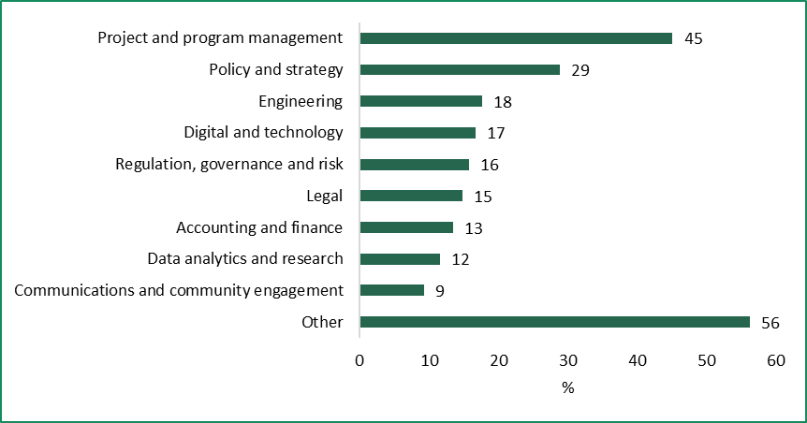
Notes: The figure shows responses to the question ‘What are the functional areas in which you are experiencing significant challenges in attracting VPS executives? Select all that apply.’ 215 responses were received.
Source: Tribunal analysis of responses to executive questionnaire.

The average number of applications for executive roles is increasing
The Tribunal obtained data from the VPSC about the number of people who applied for advertised VPS executive roles. Using this data, the Tribunal was able to approximate the supply of executive candidates to the demand from the government, subject to the limitations noted below.
The data show that the average number of applications for executive roles is increasing. For example, over 2023, advertisements for SES positions in public service bodies attracted around 20 applications on average, compared to an average of around 10 applications in 2021 (Figure 4.3).
Figure 4.3: Average number of applications per advertisement for SES positions in public service bodies, June 2021 – March 2024
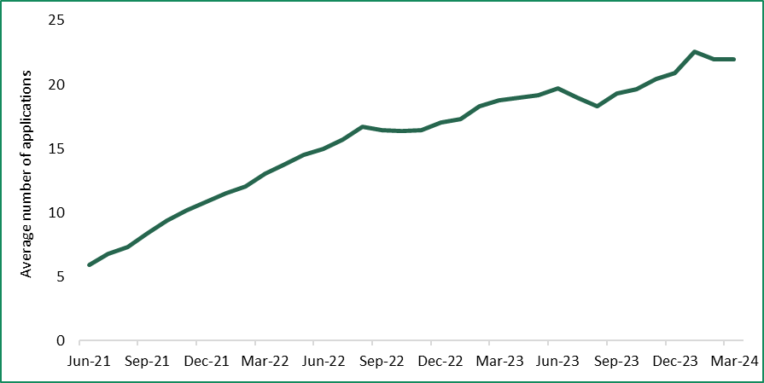
Note: Job advertisements that were active for less than six days have been excluded from the data. The number of job advertisements in a given financial year may not equal the number of executive vacancies, as some advertisements relate to multiple vacancies and some vacancies may be advertised multiple times.
Source: Tribunal analysis of VPSC data.
The VPSC data also showed that:
- advertisements for SES-1 positions generally attracted more applicants than SES-2 positions, which in turn tended to attract more applicants than SES-3 positions
- advertisements for positions based in Greater Melbourne generally attracted more applicants than positions based in regional Victoria.
Advertising of executive roles is subject to the requirements of the Victorian Government’s Jobs and Skills Exchange (JSE) Recruitment Policy. This policy states that, with limited exceptions, all positions must first be advertised on the JSE, which is an internal resource for current and recently departed VPS employees. If a suitable candidate is not found, approval may be granted to advertise a position externally, in parallel with re-advertising on the JSE. The data show that job advertisements that were posted to external platforms (e.g., Careers.vic, SEEK) tended to attract more applicants than those that were advertised on the JSE only.
The data on the number of applications should be treated with caution as it includes a time period when the COVID-19 pandemic was causing significant disruptions in the labour market. Indeed, the RBA has observed that job mobility (the proportion of employees changing jobs) fell to multi-decade lows at the onset of the pandemic and that this was likely attributable to increased risk aversion amid heightened uncertainty. In particular, these factors may explain the relatively low number of applications per SES position in 2020-21.
Further, the data do not indicate how many applicants were shortlisted or otherwise considered ‘suitable’ for a given executive role. Indeed, a given advertisement — particularly one posted to an external platform(s) — may attract a high number of applicants, and potentially many qualified applicants, yet only a small number of whom are deemed suitable for the role. For example, through its role advising on proposals to pay an executive above the relevant remuneration band, the Tribunal has heard examples where a recruitment process identified only a handful, or even a single, suitable candidate for a particular role. More broadly, data from JSA indicate that, across the organisations surveyed in 2022 and 2023, around 1516 per cent of applicants for a given vacancy were considered suitable on average.

Most VPS executives continue to be recruited internally
The Tribunal’s 2020 VPS Determination noted that executives may be sourced either internally (e.g. via promotion or lateral movement) or externally (e.g. from a public service in another jurisdiction or the for-profit sector). At that time, the Tribunal observed that most executives were being recruited internally, either from within the VPS or broader Victorian public sector.
The Tribunal’s questionnaire indicates a continuation of this trend, with around 70 per cent of respondents indicating they had worked in the Victorian public sector immediately prior to their first VPS executive role. Most of these respondents held a non-executive role in the VPS. Around 20 per cent of respondents came from the ‘for-profit’ or ‘not-for-profit’ sectors, while four per cent were sourced from a public sector in another Australian jurisdiction. The JSE Recruitment Policy may be contributing to this trend where it results in existing VPS employees having priority access to executive roles.
The Tribunal also analysed the previous roles of the 16 individuals who have held the position of department Secretary or Victorian Public Sector Commissioner since 2022. The vast majority (14 individuals, or 88 per cent) held senior executive positions in the VPS immediately prior to becoming Secretary or Commissioner, including 12 Deputy Secretaries and two AO Heads. The remaining two held roles in the not-for-profit and for-profit sectors respectively.

4.4 How the remuneration bands influence the supply of executives
Remuneration is an important factor in attracting and retaining talent to the VPS executive workforce, which is necessary to carrying out the work of government and delivering the priorities of the government of the day.
The Tribunal’s 2020 VPS Determination set the minimum and maximum values of the remuneration bands with reference to the 15th percentile of the Australian General Market (AGM). The Tribunal subsequently made annual adjustment Determinations in 2021, 2022 and 2023, which adjusted the values of the remuneration bands each 1 July. In determining an appropriate adjustment rate, the Tribunal considered a range of factors such as the Victorian Government’s wages policy, movements in prices and wages in the broader economy, the financial position and fiscal strategy of the State of Victoria and relativities with non-executive remuneration arrangements.

Stakeholders expressed mixed views on the competitiveness of the remuneration bands
The Tribunal’s consultations with individual Secretaries discussed whether positioning at the lower end of the market adequately recognised the impact that a high performing public sector has on the Victorian economy and society more broadly. In considering this question, participants noted:
- that remuneration for executives should be discounted in recognition of the ‘public service’ dimension of the role, and that the opportunity to undertake important work for the benefit of the community continues to be a motivating factor in seeking employment in the public service
- the social compact between government and citizens and whether lifting the values of the bands would impact trust between government and citizens.
The consultations also highlighted that the VPS is increasingly competing with the private sector when recruiting for certain roles (e.g. technology roles), and that this is making it challenging to attract and retain talented executives to those roles within the existing remuneration bands.
The VSB submission cited the relatively small number of payment above the bands proposals received by the Tribunal since 2020 as evidence that the remuneration bands were generally appropriate:
The low number of requests compared to the size of the [executive] cohort in the public service suggests that the scope of the remuneration bands is appropriately flexible for the majority of public service [executive] positions. Fewer requests also suggests the scope of the bands are generally fair, equitable and competitive for [executives].
A majority (55 per cent) of respondents to the Tribunal’s questionnaire did not consider the existing remuneration bands to be competitive for the type of work they do (Figure 4.4). Some respondents suggested that they could earn more working in an equivalent role in the private sector, particularly in certain industries or role types (e.g. infrastructure, legal).
Figure 4.4: Responses to the executive questionnaire — ‘Do you consider the existing remuneration bands to be competitive for the type of work you do?’
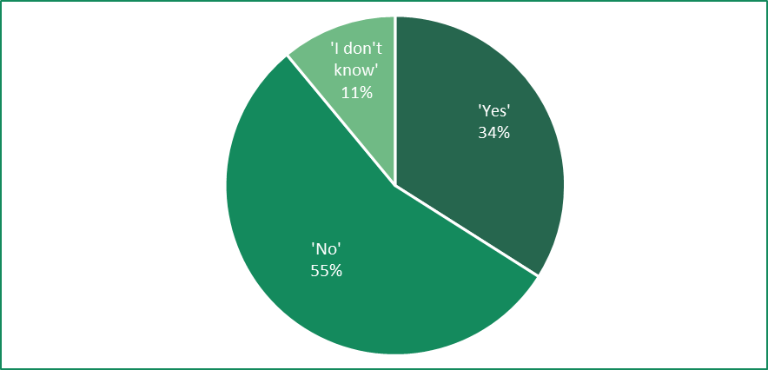
Source: Tribunal analysis of responses to executive questionnaire.
The questionnaire also asked respondents involved in executive recruitment to identify the factors affecting the willingness of potential candidates to apply for executive positions or accept an employment offer. ‘Total remuneration package is too low’ was chosen by around 90 per cent of respondents and was by far the most common response (Figure 4.5).
Figure 4.5: Executive questionnaire — factors affecting potential candidates’ interest in applying for, or accepting, executive employment in the VPS
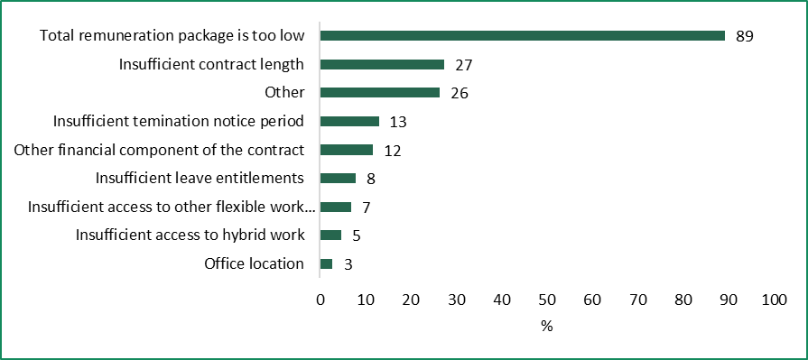
Note: The figure shows responses to the question ‘What factors do you think are affecting potential candidates' interest in applying for, or accepting employment offers? Please select all that apply.’ 216 responses were received.
Source: Tribunal analysis of responses to executive questionnaire.
Inadequate levels of remuneration was also cited as a key factor by:
- around two-thirds of respondents who reported an increase in the rate at which executives were voluntarily departing their organisation
- 63 per cent of executives who indicated an intention to leave their role within the next year.
Notwithstanding these responses, almost 70 per cent of executives who responded to the questionnaire indicated an intention to remain in the VPS as an executive for at least the next three years, including 47 per cent who intend to stay for over five years. Among executives who indicated an intention to stay for one year or more (accounting for around 90 per cent of all respondents), the factors most influencing their decision included the intellectual challenge provided by the role (63 per cent) and the opportunity to contribute to the community (61 per cent). Notably, around half cited remuneration as a factor in their decision to stay.
Responses to the executive questionnaire may also have been influenced by employer decisions about the placement of executives within the relevant band. For example, one respondent noted:
[The] bands are OK but requirement to appoint within 10% of base makes most of the band redundant & creates challenges and delays in recruitment.
This suggests that it may be important to distinguish between the remuneration bands themselves and the pay practices/policies of individual employers (e.g. defaulting to paying at or near the bottom of the bands) in assessing the former’s competitiveness. Indeed, a potential candidate for an executive role may consider the advertised remuneration range (i.e. the relevant remuneration band) to be competitive, but not the specific employment offer. This may particularly be the case where the employment offer is towards the bottom of the band. Chapter 8 discusses updates to the Tribunal’s guidelines which may address this matter, including by:
- clarifying that employers are not required to remunerate an individual executive at the bottom of the band
- encouraging regular reviews of remuneration at an individual and workforce level, including consideration of relativities and performance.

Remuneration relativities are likely affecting the supply of executives
As discussed earlier in this chapter, the primary source of new executive talent is non-executives moving into executive positions. The Tribunal’s previous Determinations have sought to ensure that the values of the remuneration bands, particularly at the SES-1 level, are sufficiently attractive to facilitate a steady flow of high-performing non-executives into executive positions.
The Tribunal has previously used the ‘gap’ between the SES-1 band and the VPS Grade 6 (VPS-6) salary band as a reference point when considering remuneration relativities between executives and non-executives. Specifically, when it made its 2020 VPS Determination, the Tribunal decided to set the value of the base of the SES-1 band nine per cent higher than the top of the VPS-6 salary range (inclusive of superannuation contributions).
At the time, the Tribunal stated that this gap would:
… increase the incentive for non-executive VPS staff to apply for executive roles by, at least in part, compensating for the reduction in employment conditions when moving from a non-executive to an executive role.
The Tribunal’s annual adjustment Determinations, made in 2021, 2022 and 2023, maintained a gap between the values of the VPS-6 and SES-1 bands, although the value of the gap has fluctuated over time due to salary increases under the VPS EA 2020 (Figure 4.6). Since 1 December 2023, when the last increase under the VPS EA 2020 took effect, the gap has been 11.5 per cent ($22,271 including superannuation).
The Tribunal also notes that VPS-6 employees receive other entitlements, including an annual mobility payment and a top of value range payment (paid to employees at the top of their value range who satisfy their progression criteria), that serve to reduce the effective gap in remuneration vis-à-vis executives.
Figure 4.6: Percentage gap between the VPS-6 and SES-1 bands, 2020 – 2023
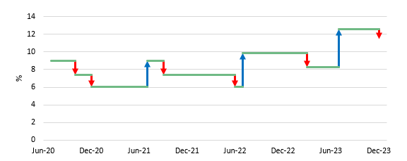
Note: The red arrows indicate the impact of a salary increase under the VPS EA 2020. The blue arrows indicate the impact of the Tribunal’s annual adjustment Determinations, which take effect on 1 July each year.
The VSB submission considered it important to preserve the gap between SES and VPS-6 remuneration:
To ensure [executives] receive an appropriate premium for foregoing an ongoing role, executive roles are attractive to VPS staff, from both a remuneration and non-monetary benefits perspective, and there is a sufficient pipeline of talent to fill executive roles, remuneration arrangements for the SES-1 remuneration band should preserve an appropriate gap between VPS-6 and SES-1 remuneration levels.
The Tribunal’s questionnaire asked current executives if they consider the difference in remuneration between executives and non-executives to be appropriate. A majority (57 per cent) of respondents responded in the negative, while around 10 per cent were not sure.
Many respondents felt that the difference in remuneration between the non-executive and SES-1 levels does not reflect the additional responsibilities, workload and risk associated with taking on an executive role.
For example, one executive stated:
The level of personal responsibility and risk, and required commitment (hours, availability etc) is considerably higher for executives [than non-executives] and the difference in [the remuneration] bands does not feel adequate to address this.
Similarly, many respondents considered that the difference in remuneration did not adequately compensate for the reduction in employment conditions upon becoming an executive (e.g. fixed-term contracts, no leave loading). According to one executive:
Conditions of employment are much better for non-executive VPS employees. Frequent comments I hear from talented up and coming VPS staff is ‘why would you take an exec role in the VPS when you have the certainty of a VPS-6 role?'.
The VPS EA 2020 also provides for a VPS Grade 7 salary band for Senior Technical Specialists (STS), which sits above the VPS-6 band. STS employees are entitled to the same employment conditions as other non-executives. Adjusting for superannuation payable to non-executives, there is a considerable overlap between the STS ($197,012 - $267,940) and SES-1 ($216,376 - $279,328) bands, and a relatively small gap (4.2 per cent) between the former and the top of the SES-1 band (Figure 4.7).
Figure 4.7: Comparison of current VPS executive and non-executive remuneration bands, as at 1 December 2023
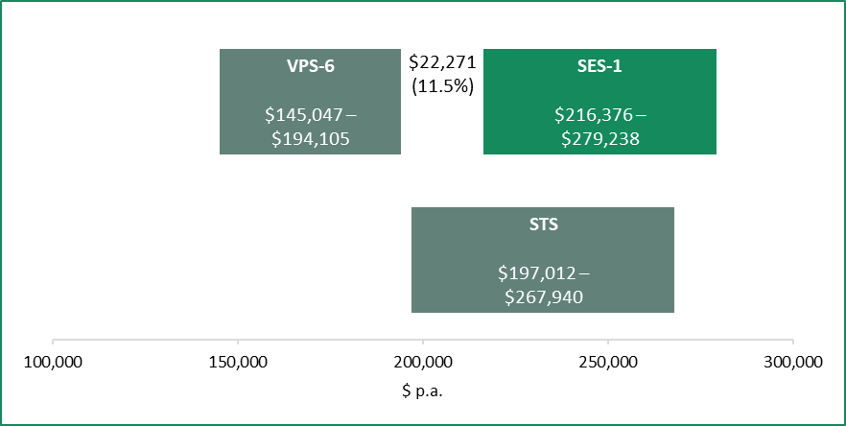
Note: The employer superannuation contribution has been added to the VPS-6 and STS salary ranges for comparison.
Sources: VPS EA 2020; Tribunal (2023b).
Between June 2020 and June 2023, the number of STS employees in public service bodies that were paid at or above the base of the SES-1 band increased from 446 to 653 (Figure 4.8), but declined as a proportion of all STS employees (from 92 per cent to 78 per cent).

Figure 4.8: Number of STS employees in public service bodies paid at or above the base of the SES-1 band, June 2020 – June 2023
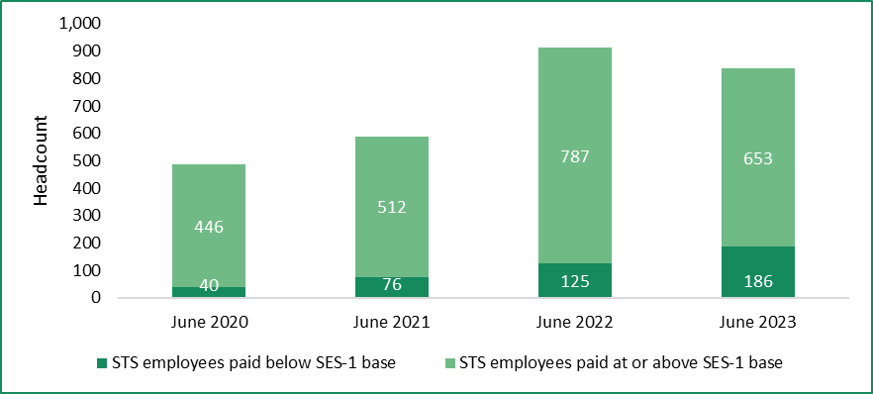
Note: To enable a like-for-like comparison with the base of the SES-1 band (which is inclusive of superannuation), superannuation was added to the base salary reported for each STS employee.
Source: Tribunal analysis of VPSC data.
The Tribunal has not previously considered the relativity between the STS and SES bands. This is because STS employees are considered to be:
… experts in specific fields of work, whose roles primarily involve specialist work rather than people management, and whose knowledge is rare and therefore highly valued (beyond the market value of a VPS-6).

4.5 The remuneration bands are positioned towards the lower end of the market
To support the making of the Determination, the Tribunal commissioned Mercer to undertake work value assessments and remuneration benchmarking for VPS executive roles, including Secretaries and the Victorian Public Sector Commissioner, and provide advice on market positioning. The key findings are summarised below.
In 2019, Mercer undertook work value assessments for each SES level using its proprietary job evaluation system to inform the Tribunal’s 2020 VPS Determination (Box 4.1). These assessments were based on the work value descriptors in the VPS Executive Classification Framework and resulted in notional ‘low’ and ‘high’ work value scores for each level. Mercer then used the notional work value assessments to develop contiguous work value ranges for each level. Mercer also undertook desktop work value assessments for the roles of Secretaries and the Victorian Public Sector Commissioner, which were used to develop a single work value range for this cohort.
Box 4.1: Overview of Mercer CED Job Evaluation System
Mercer’s CED Job Evaluation System is used to measure the relative ‘size’ or ‘worth’ of individual jobs/positions in terms of work value points (the VPS Executive Classification Framework is another such system, developed for internal use by the VPS).
Points are assigned according to how a position is assessed against eight sub-factors, which are grouped into the following primary factors:
- The judgement factor evaluates reasoning components of a job, focusing on the task definition and complexity, the constraining within which employees need to resolve problems and other thinking challenges of the position.
- The expertise factor measures the requirements of the position for education, training and work experience, the diversity of individual tasks as well as interpersonal skills.
- The accountability factor evaluates the nature of the position’s authority and involvement in managing the organisation’s resources. It includes the influence of the position’s advice and accountability for results of decisions.
Source: Mercer (2024).
For this Determination, Mercer reviewed the work value assessments previously undertaken for each SES level to determine whether any updates were required. Some updates were made to reflect increased budgets at each SES level, although these did not change the overall work value outcomes which, in Mercer’s assessment, continued to be valid for remuneration benchmarking purposes.
Mercer also reviewed its previous assessments for department Secretaries and the Victorian Public Sector Commissioner based on recent position descriptions and its understanding of changes to the roles since 2019 (e.g. due to machinery of government changes). This resulted in revised work value outcomes for some positions, which in turn resulted in a higher work value mid-point and work value maximum for the cohort overall.
The work value ranges for each of the SES levels and for Secretaries and the Victorian Public Sector Commissioner are shown in Table 4.2.

Table 4.2: Work value ranges developed by Mercer^{(a)}
Classification | Minimum | Mid-point | Maximum
SES-1 | 751 | 990 | 1,230
SES-2 | 1,231 | 1,475 | 1,720
SES-3 | 1,721 | 1,985 | 2,250
Department Secretary/  Victorian Public Sector Commissioner | 2,251 | 3,176 | 4,100
Note: (a) Work value ranges are expressed in terms of Mercer’s proprietary CED methodology.
Source: Mercer (2024).
Consistent with the approach taken in 2019, Mercer used the work value mid-point for each SES level and the Secretaries and Commissioner cohort to reference market remuneration data. Table 4.3 presents remuneration data corresponding to the 15th, 25th and 50th percentiles of the AGM, and how these compare to the maximums of the existing remuneration bands.
Table 4.3: Comparison of current maximum SES ranges with the Australian General Market data, April 2024
Classification | Maximum TRP at  1 July 2023 ($ p.a.) | Percentile ($ p.a.)^{(a)}
 |  | 15th | 25th | 50th
SES-1 | 279,238 | 290,600 | 328,500 | 401,500
SES-2 | 401,017 | 418,700 | 482,800 | 590,700
SES-3 | 533,431 | 578,300 | 679,400 | 809,800
Department Secretary/  Victorian Public Sector Commissioner | 778,492 | 832,800 | 1,009,000 | 1,321,700
Note: (a) AGM data was referenced at the mid-point of the work value ranges for each classification.
Source: Mercer (2024).
Mercer noted that, based on the same approach it adopted in advising the Tribunal in 2020, the existing remuneration bands (applying from 1 July 2023) are now positioned below the 15th percentile of the AGM (AGM 15). This means that movements in AGM 15 have exceeded the Tribunal’s adjustments to the values of the bands since 2020.
Mercer noted that public services in other Australian jurisdictions do not have clearly articulated positioning strategies, but did observe that pay practices are conservative overall (being generally lower than AGM 25, and closer to AGM 15). Based on its analysis, Mercer advised that the existing remuneration bands for VPS executives appear to be positioned more or less competitively in the broader market relative to other jurisdictions.
By comparison, Mercer advised that private sector organisations tend to position their executive remuneration more competitively in the market, such as at AGM 50, and in some cases even higher.

Advice on market positioning
Table 4.4 sets out Mercer’s recommended TRP ranges. Consistent with the approach taken in 2019, the work value mid-point for each level was used to reference the market data, with the AGM 15 used to set the maximum TRP for each level. Minimum TRPs were then constructed based on a 25 per cent spread (adjusted so that the ranges are contiguous).
Table 4.4: TRP ranges proposed by Mercer
Classification | Minimum TRP ($ p.a.) | Maximum TRP ($ p.a.)
SES-1 | 218,000 | 290,600
SES-2 | 290,601 | 419,000
SES-3 | 419,001 | 578,300
Department Secretary / Victorian Public Sector Commissioner | 578,301 | 832,800
Source: Mercer (2024)
According to Mercer:
This pay position is considered an affordable approach which will not drive a step-change in … executive remuneration within the Victorian public service.
In detailing the specific reasons for its recommendation, Mercer noted the following considerations:
- the remuneration bands were originally set with reference to AGM 15
- subsequent adjustments to the values of the remuneration bands have not kept pace with movements in AGM 15
- relativities and competitiveness with public services in other Australian jurisdictions
- balancing the development of executive talent within the VPS with attracting talent, skills and experience from the private sector
- the financial implications of a higher pay position, particularly in light of budgetary pressures.
Mercer observed that the proposed TRP ranges are higher than the existing remuneration bands, and that this would provide an increased level of flexibility to accommodate TRPs that would otherwise be considered ‘above band’. Nonetheless, Mercer noted that there would still be ‘particular roles that will justifiably command a premium’ above the relevant band, although perhaps with less regularity.
Alongside its recommendation, Mercer also suggested that the Tribunal take into account the employee value proposition (EVP) of VPS executive employment in considering the competitive positioning of the VPS in the broader labour market. In particular, Mercer observed that the size of public services (including the VPS) provides for a broader range of career pathways and development opportunities compared to the private sector. Mercer also noted that public service EVP is leveraged towards the nature of the work, while the EVP in the private sector is more clearly leveraged towards remuneration.

4.6 Summary
Conditions in the Australian labour market have tightened since the Tribunal made the 2020 VPS Determination, though there are signs of easing. Similar signs are appearing in the market for VPS executives, with the demand for executives moderating in recent years following a period of strong growth. Meanwhile, the supply of executives appears to be generally matching demand, although recruitment difficulties are being experienced for some types of roles.
The Tribunal heard mixed views from stakeholders on whether the existing remuneration bands are competitive in terms of attracting and retaining executive talent. The Tribunal also heard concerns about VPS employers’ policies/practices regarding the placement of executives within the remuneration bands, which may be affecting the perceived competitiveness of executive employment offers. Executives also cited inequities in their employment and remuneration arrangements when compared to those available to non-executives, particularly when viewed in light of differences in responsibility and workload.
To inform the making of the Determination, the Tribunal commissioned Mercer to undertake work value assessments and remuneration benchmarking for VPS executive roles, and to provide advice on market positioning. Mercer’s analysis shows that the remuneration bands continue to be positioned towards the lower end of the broader market. This is consistent with the positioning of public services in other jurisdictions and an EVP that, according to Mercer, is leveraged more towards the nature of the work than remuneration.

5 Jurisdictional comparisons
In this chapter, the VPS executive classification and remuneration framework is compared with arrangements in other selected Australian public service jurisdictions.
The comparison focusses on the Commonwealth, New South Wales (NSW) and Queensland public services. They are the most comparable in terms of population and geographical location, as well as the number of public service departments, the size of the executive and non-executive workforce.
These jurisdictions are also comparable based on the role and functions of public service executives and their employment and remuneration arrangements. However, there are some specific differences in employment and remuneration arrangements that need to be accounted for – for example, in the design of executive remuneration bands.
These jurisdictions are also likely both potential sources and competitors for VPS executives, with responses to the Tribunal’s executive questionnaire showing that of those VPS executives who were considering leaving their executive position, around 30 per cent would prefer to join the public sector in another Australian jurisdiction (see Appendix A).

5.1 Commonwealth public service
The Commonwealth has separate classification and remuneration arrangements for Secretaries and the Senior Executive Service (SES) respectively.

Secretary classification and remuneration
The Commonwealth Remuneration Tribunal is responsible for determining a classification and remuneration structure for department Secretaries.
The structure consists of four levels, with Level 1 being the highest and Level 4 the lowest (Table 5.1). The Secretary of the Department of Prime Minister and Cabinet is classified at Level 1 and the Secretary of the Treasury is classified at Level 2. Twelve other Secretaries are classified at Level 3 and two at Level 4. The Tribunal may also set pay points within each level.
Table 5.1: Classification and remuneration structure for Commonwealth Secretaries, from 1 July 2023
Level | Pay point | TRP  ($ p.a.)
Level 1 (Prime Minister and Cabinet) | N/A | 977,200
Level 2 (Treasury) | N/A | 952,770
Level 3 | 1 | 928,340
Level 3 | 2 | 879,480
Level 4 | 1 | 830,620
Level 4 | 2 | 781,760
Note: For Secretaries, TRP is referred to as ‘total remuneration’ and represents the value, calculated at the total cost to the Commonwealth (including fringe benefits tax), of salary, allowances and lump sum payments, benefits and the employer superannuation contribution.
Source: Remuneration Tribunal (Cth) (2023b).
In determining appropriate remuneration, the Commonwealth Remuneration Tribunal takes into account factors such as:
- the main functions, responsibilities and accountabilities of the office
- the organisational structure, budget and workforce
- the requisite characteristics, skills or qualifications required of the office
- the remuneration of similar, comparator, offices within its jurisdiction.
In June 2024 the Commonwealth Remuneration Tribunal announced a 3.5 per cent remuneration increase from 1 July 2024 for offices in its jurisdiction, including department Secretaries.
Table 5.1 shows the classification and remuneration structure for Commonwealth Department Secretaries.
The Tribunal observed that:
- The lowest pay point of the Commonwealth’s Level 4 Secretary band —$781,760 — is close to the top of Victoria’s Department Secretary/Victorian Public Sector Commissioner band ($778,492).
- The TRP for the Level 1 and 2 Commonwealth Secretaries is between 22 and 26 per cent higher than the top of Victoria’s Department Secretary/Victorian Public Sector Commissioner band. This likely reflects the greater scope of responsibilities of Level 1 and 2 Commonwealth Secretaries.

APS SES classification structure
In the Commonwealth, approved classifications for public service employees — including for the SES — are specified in a legislative instrument. All agency Heads must allocate an approved classification to each Australian Public Service (APS) employee in their agency. There are three approved SES classifications — Senior Executive Band 1, 2 and 3 — with one being the lowest and three being the highest classification.
The Australian Public Service Commission (APSC) provides guidance on determining and managing classification arrangements in the APS. Similar to the VPSC, the APSC publishes a set of work level standards to describe the work level requirements of SES roles at each of the three classification levels.
For SES-1 and SES-2 roles, the standards describe the work value of the SES by classifying the role into one of four work streams — delivery, public policy, regulatory or professional/specialist. SES-3 roles are considered to have broader functions and accountabilities and therefore work streams are not included.
For all SES roles, the standards define the work value of SES roles through five factors split into:
- leadership, incorporating the dimensions of knowledge and accountability
- diversity/span, incorporating resource management and complexity of roles
- stakeholder management
- job context and environment, including the complexity of the operating environment
- judgement and independence, including the degree of guidance provided by operating frameworks and the scope for discretion.
A role analysis tool is used to assess roles against the standards. Each evaluation factor is assigned a points score and the combined scores indicate the appropriate SES classification (SES-1: 34 – 44 points; SES-2: 45 – 53 points; SES-3: 54 – 60 points).

APS SES remuneration
Unlike Victoria, there are no defined whole of APS executive remuneration bands that correspond to the SES classification framework.
The APS Executive Remuneration Management Policy sets out arrangements for executive remuneration, including the objective of maintaining appropriate pay relativity between Secretaries, the most senior members of the SES and other staff to reflect their respective roles and responsibilities.
Agencies have flexibility to set their own levels of SES remuneration, subject to a maximum amount that an executive can be paid. This is known as the ‘notional amount’ and is equivalent to 65 per cent of the lowest pay point of the Secretaries’ classification and remuneration structure. The notional amount is $508,144 per annum from 1 July 2023.
The remuneration of any SES executive can only exceed the notional amount in ‘exceptional circumstances’ with the approval of the APS Commissioner. Proposals to the APS Commissioner need to be supported by appropriate justification, including market data and other relevant evidence.
While there are no whole of APS remuneration bands, the APSC publishes summary statistics on actual remuneration paid to the SES. Table 5.2 shows the 5th, 50th (median) and 95th percentiles of the remuneration distributions for each of the SES-1, SES-2 and SES-3 classifications, using the most recent data published for the 2022 calendar year.

Table 5.2: Total remuneration package^{(a)} by APS SES classification, 2022
Percentile^{(b)} |  | SES-1  ($ p.a.) | SES-2  ($ p.a.) | SES-3  ($ p.a.)
5th percentile |  | 235,089 | 304,405 | 399,233
Median |  | 266,235 | 339,782 | 457,474
95th percentile |  | 300,554 | 391,852 | 551,727
Notes: (a) For the APS SES, TRP is defined as base salary plus benefits including employer superannuation contributions, motor vehicle cost (or cash in lieu of a vehicle), motor vehicle parking, personal benefits and supplementary payments. (b) Percentiles mark intervals within the data, in relation to the whole dataset. For example, the 5th percentile is the position at which 5 per cent of positions are paid below and 95 per cent are paid above.
Source: APSC (2023b), pp. 73-75.
Under the Commonwealth Government’s Public Sector Workplace Relations Policy 2023, general pay increases for SES executives must not exceed those provided for non-SES employees of the APS. The Commonwealth Government’s final APS pay offer in November 2023 was for pay increases of four per cent from December 2023, 3.8 per cent from March 2025 and 3.4 per cent from March 2026.
While comparisons with the more centralised VPS executive remuneration framework are difficult, based on the latest APS data the Tribunal observed that:
- the lowest TRPs paid to APS executives — based on the 5th percentile of the remuneration distribution for SES-1 executives — are around 9 per cent higher than the minimum that can be paid to a VPS executive
- the highest TRPs paid to APS SES — based on the 95th percentile of the remuneration distribution for SES-3 executives — are around 3 per cent higher than the maximum of the VPS SES-3 band
- the ‘notional amount’ is around 5 per cent lower than the maximum of the VPS SES-3 band.
Progression within the band and performance bonuses
The APSC has implemented an overarching SES Performance Leadership Framework that provides discretion for APS agencies to establish their own performance management approach. Under this framework APS agencies have discretion to establish their own reward and recognition arrangements, including through adjustments to base pay (‘progression’) and non-monetary rewards, such as public recognition.
The Commonwealth Government has also released guidance on paying performance bonuses for Commonwealth entities and companies. The guidance sets out the expectation that performance bonuses are used only in limited circumstances. These include for roles that involve significant at-risk investment outcomes, meet significant public milestones or involve non-tax revenue raising. APSC data shows that the use and size of SES performance bonuses decreased in 2022, with only 36 (or 1.2 per cent of) SES employees paid a bonus, a 69 per cent decrease from 2021. The median SES performance bonus paid in 2022 was $6,022, compared to $10,249 in 2021.

Other relevant contractual matters
The Tribunal also compared other relevant contractual matters that affect executive attraction and retention, namely termination and right of return provisions.
As discussed in Chapter 3, in Victoria there is no compensation for termination of a contract without cause beyond payment in lieu of notice and accrued leave.
In the Commonwealth, before terminating the employment of a Secretary or SES executive, the APS Commissioner must issue a report or a certificate respectively. For an SES executive, the certificate must state that relevant employment provisions have been satisfied and that the termination of the executive is in the public interest.
Also, if a Secretary is terminated and an ‘exclusion event’ (such as a breach of the APS Code of Conduct) has not occurred, the Secretary is entitled to be paid based on the term of their appointment:
- for a termination 12 months or more before the end of the Secretary’s term of appointment — 12 months’ reference salary at the time of termination
- for a termination less than 12 months before the end of the Secretary’s term of appointment — one month’s reference salary for each full month of the balance of the term not served, subject to a minimum payment of six months’ reference salary at the time of termination.
As discussed in Chapter 3, Victoria provides a right of return for some executives. The right of return is available to an executive where their contract is terminated and the executive was a VPS employee prior to their initial employment as an executive and this employment was continuous.
Unlike Victoria, the Commonwealth public service does not have right of return provisions for Secretaries or the SES.
An APS agency may offer an incentive to retire payment to any SES employee regardless of whether the employee has reached the prescribed minimum retirement age. In certain circumstances, an SES employee who has received an incentive to retire payment can be re-engaged by an APS agency, including as an ongoing or non-ongoing employee.

5.2 New South Wales public service
NSW has an integrated classification and remuneration framework for Secretaries and other public service executives.

Classification framework
In NSW, a classification band framework may be applied to ‘Public Service Senior Executives’ (PSSE), comprised of Secretaries and other executives employed in the public service.
The following four band classification structure is currently applied:
- PSSE Band 1 – Director
- PSSE Band 2 – Executive Director
- PSSE Band 3 – Deputy Secretary
- PSSE Band 4 – Secretary.
The NSW Public Sector Commission (NSWPSC) issues work level standards to assist departments and agencies to determine an appropriate PSSE band. The standards are the classifying tool for determining the band for a new PSSE role. Applying the standards involves considering:
- the ‘Distinguishing Characteristics’ of a role, for example, Band 1 executives are characterised as ‘Deliverers of agency services and outcomes’
- six factors for describing the Band: Expertise; Accountability; Dimensions; Key Relationships; Role Context and Environment; Judgement and Independence
- the relevant work contribution stream to confirm the band. There are five streams: Service/Operational Delivery; Professional/Technical/Specialist; Policy; Regulatory/Compliance; Agency Head.

Remuneration framework
The NSW Statutory and Other Offices Remuneration Tribunal (SOORT) determines remuneration bands for each classification (Table 5.3).
Table 5.3: Classification and remuneration framework for NSW Secretaries and senior executives, from 1 July 2023
Classification | Values of the remuneration band  ($ p.a.)^{(a)}
PSSE Band 1 – Director | $201,350 – $287,200
PSSE Band 2 – Executive Director | $287,201 – $361,300
PSSE Band 3 – Deputy Secretary | $361,301 – $509,250
PSSE Band 4 – Secretary | $509,251 – $588,250
Note: (a) SOORT determinations set TRP bands, where TRP is defined by the NSWPSC as the total amount paid to a senior executive out of which the executive is required to pay the employer contributions to superannuation.
Sources: NSWPSC (n.d.); SOORT (2023).
On 30 May 2023, the NSW Government announced a freeze on wages for PSSEs for the 2023-24 and 2024-25 financial years. SOORT’s governing legislation was amended, requiring it to give effect to any government policy about the remuneration of executives that is declared by regulations. Consequently, SOORT determined there was to be no increase to the remuneration ranges in its 2023 Public Service Senior Executives Annual Determination (PSSE Determination).
The NSWPSC also publishes a Public Service Senior Executive Remuneration Management Framework (PSSE Framework) to guide the placement of an executive within the relevant remuneration band. An executive’s remuneration within the band is set by combining a base remuneration point (BRP) and a discretionary remuneration range.
The BRP for a role is calculated using a proprietary work value methodology to determine the work value points for the role. The formula assumes a linear relationship between work value and remuneration. For example, for a PSSE Band 3 role evaluated using the Mercer CED methodology, the BRP is calculated as 92.871 multiplied by the work value points (ranging from 1,475 to 2,459), plus 224,316.
As discussed, each PSSE Band 1 to 3 executive role has an individual discretionary remuneration range that can be applied. The maximum remuneration that can be paid to an executive within each band is obtained by adding the amount of the discretionary remuneration range for the relevant band to the BRP for a PSSE role.
The discretionary remuneration ranges are as follows:
- PSSE Band 1: up to $24,103
- PSSE Band 2: up to $36,154
- PSSE Band 3: up to $48,205.
An executive’s initial remuneration within the discretionary remuneration range is determined by the agency based on individual merit factors, including capability and knowledge, and experience. Labour market factors may be taken into account in exceptional cases but only if based on verifiable evidence.
The Tribunal sought to examine the Victorian and NSW executive remuneration bands on a consistent basis using the Mercer CED work value methodology to compare remuneration at the same work value points (Figure 5.1).
Figure 5.1: Comparison of executive remuneration in Victoria and NSW for equivalent positions based on Mercer CED work value methodology
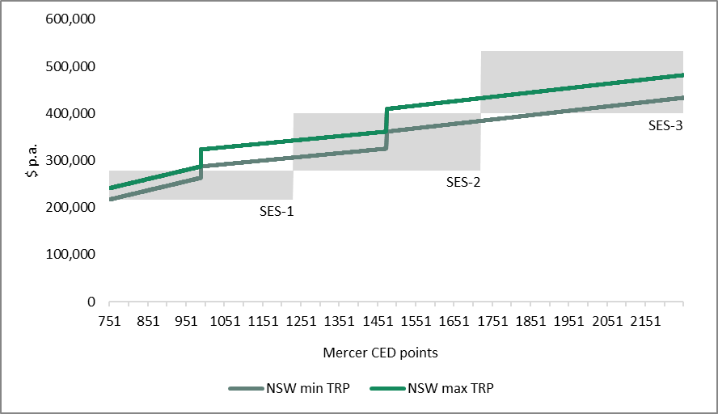
Sources: NSWPSC (n.d.); (Tribunal (2023b).
There are, however, some challenges in making a clear comparison between the remuneration bands in this way. These include differences in the design of the remuneration bands in each jurisdiction — for example, based on work value, the NSW PSSE Band 2 overlaps with the top of the SES-1 band and bottom of the SES2 band in Victoria — and a lack of publicly available information on whether or how discretionary remuneration ranges are applied in NSW.
Overall, the Tribunal considered that the structure and level of the current remuneration bands in Victoria and NSW were broadly comparable, but noted the following points:
- the bottom of each remuneration band in Victoria was generally below the minimum remuneration payable to an equivalent executive in NSW – particularly for the SES-1 and SES-2 bands
- the maximum of the SES-1 band in Victoria means that executives in the upper part of that band (based on work value) are currently paid below their counterparts in NSW
- the SES-2 remuneration band in Victoria generally provides sufficient flexibility for executives to be paid comparably to their counterparts in NSW
- the SES-3 remuneration band provides greater flexibility for VPS employers to pay Victorian executives more than their NSW counterparts where they deem it appropriate.
Progression within the band
The NSW PSSE Framework provides for progression within the remuneration range over time based on assessed performance. However, it notes that progression should not be ‘automatic’.
There is also the opportunity for an employer to approve within band remuneration adjustments due to labour market factors. In this case, ‘verifiable market remuneration evidence’ is required, and the employer should consider the impact of an increase on the average remuneration of senior executives within a band for their Department or agency.
Payment above the relevant band
The NSW Premier has the power to direct SOORT to make a determination to pay an executive above the relevant band.
The PSSE Framework states that an employer should seek a SOORT determination only where there is clear market-based evidence to support the application for such a determination and in line with guidance issued by the NSWPSC.
The 2023 PSSE Determination provided for continued payment above the band for the following executive roles:
- the Secretary of the Premier’s Department and the Cabinet Office, paid $657,750 per annum, or around 12 per cent above PSSE Band 4
- seven other Secretaries and the Chief Executive Officer of the NSW Reconstruction Authority paid $623,300, or around 6 per cent above PSSE Band 4.

Other relevant contractual matters
The Tribunal also compared other relevant contractual matters, namely termination and right of return provisions.
A Secretary’s or other PSSE executive’s employment may be terminated at any time, for any or no stated reason without notice. The employer is required to provide a written report to the NSW Public Service Commissioner on the termination, including the reasons for the termination.
When an executive’s employment is terminated they are entitled to an amount equal to their remuneration package for a period of 38 weeks or for the period remaining on the term of the contract (whichever is the lesser), although other arrangements apply where an executive’s employment is terminated for unsatisfactory performance or misconduct.
The NSW public service does not have right of return provisions for Secretaries or PSSE executives.

5.3 Queensland public service
Queensland has separate classification and remuneration frameworks for Chief Executives (CEs) of departments — equivalent to a Victorian Secretary — and senior executives.

Chief executive classification and remuneration
The Queensland public sector chief executive remuneration framework applies to CEs on appointment. Table 5.4 sets out the current TRP ranges that apply to CEs. Band 1 is the highest and band 6 is the lowest classification.
Table 5.4: Classification and remuneration for Queensland CEs, from 1 September 2022
Classification | TRP range  ($ p.a.)^{(a)}
Band 1 (Central agencies) | $682,125 – $852,628
Band 2 | $610,960 – $763,699
Band 3 | $473,154 – $709,732
Band 4 | $371,667 – $502,910
Band 5 | $290,206 – $392,711
Band 6 | $210,215 – $284,436
Note: (a) TRP comprises superannuable salary (including an executive vehicle allowance and annual leave loading) set at 88.69176 per cent of TRP and employer superannuation contributions at 12.75 per cent of superannuable salary.
Source: Queensland Public Sector Commission (QPSC) (2023b).
The Tribunal observed that the CE bands overlap and that the maximum TRP that may be paid to a CE in a central agency is around 10 per cent higher than the maximum TRP that may be paid to a Victorian Secretary.

Senior executive classification and remuneration
The Queensland Public Sector Commission (QPSC) issues directives governing senior executive employment and employment conditions.
There are four classification and remuneration bands, with each band split into low/high ranges based on work value (the low/high ranges are treated as different classification levels). Band 1 is the lowest and band 4 is the highest.
Bands are differentiated by the Mercer points score for each role. There is a further split within each band into four or five ‘package’ points for remuneration purposes. Senior executive remuneration is set in accordance with the assessed classification level and work value range.
The classification of an executive position is determined using a Job Evaluation Management System that uses a points system to assess the work value of a position across three broad factors:
- expertise, which considers the knowledge, skills and experience needed for the position
- judgement, which incorporates the operating environment for the employing agency, the complexity of the position’s requirements and problem solving
- accountability, which reflects the scope, responsibility, impact and influence of the position.
Table 5.5 shows the current value of the Queensland remuneration bands. A four per cent increase to the bands is scheduled from 1 July 2024 and a further three per cent increase is scheduled from 1 July 2025.
Table 5.5: Classification and remuneration for Queensland senior executives, from 1 July 2023
Classification | TRP range  ($ p.a.)^{(a)}
Band 1 | $183,637 - $206,382
Band 2 | $216,238 - $251,015
Band 3 | $255,975 - $292,625
Band 4 | $302,860 - $360,779
Note: (a) TRP for Queensland senior executives is defined in terms of Total Fixed Remuneration, comprising remuneration package (salary plus an executive vehicle allowance), leave loading and superannuation (which is 12.75 per cent of remuneration package plus leave loading).
Source: QPSC (2023c).
The default positioning for an executive’s TRP on appointment is at the bottom of the remuneration band. There is limited flexibility to position an executive’s TRP above the band minimum on appointment in ‘exceptional circumstances’ with the approval of the Queensland Public Sector Commissioner.
The Tribunal observed that:
- the minimum TRP that can be paid to a Queensland executive is around 15 per cent lower than that for a Victorian executive
- the maximum TRP that can be paid to a Queensland executive is around 32 per cent lower than that for a Victorian executive.
Progression within the band
There are opportunities for an executive to progress within their band. This is tied to the executive achieving and exceeding agreed performance objectives. The employer may approve:
- a single package point increase based on evidence of sustained high performance
- other package point increases, in exceptional circumstances, with prior endorsement by the Commissioner.
Payment above the band
There is no published information on paying an executive above the relevant band in Queensland.

Other relevant contractual matters
In Queensland, when a Secretary or an executive has their employment terminated, they are provided with at least a one month notice period.
The standard executive contract states that if an executive’s employment is terminated without reason, they will be paid a Separation Payment and a Service Payment. Where an executive’s employment is terminated for other specified reasons, including a breach of the employment contract or relevant code of conduct, a termination payment is not available.
The Separation Payment is based on the executive’s contract period remaining. If the contract has 2.5 years or greater remaining, the executive is entitled to an amount equal to 26 weeks’ remuneration. If the contract has less than 2.5 years remaining, an amount equal to 20 per cent of the executive’s remuneration will be paid.
A Service Payment is equal to two weeks of the executive’s remuneration for each year of continuous service as a public service officer (with a proportionate amount for an incomplete year), with a minimum payment of four weeks and a maximum payment of 52 weeks.
The Queensland public service does not have right of return provisions for Secretaries or SES.

5.4 Summary
This chapter compared the VPS executive classification and remuneration framework with arrangements in the Commonwealth, NSW and Queensland.
Both the Commonwealth and Queensland have separate classification and remuneration frameworks for their Secretaries and their SES respectively, while Victoria and NSW have integrated frameworks.
The Commonwealth uses six defined pay points for the Secretary cohort. The lowest Commonwealth remuneration point ($781,760) is above the maximum set for Secretaries in other jurisdictions, with the exception of the maximum remuneration for Queensland Secretaries ($852,628). The NSW Secretary band is narrower than the equivalent Victorian band, although all NSW Secretaries are paid outside the band.
There are no whole of APS remuneration bands for SES executives, although data is published on the actual remuneration paid to SES executives at different remuneration percentiles. Victoria and NSW have three remuneration bands for the SES, whereas Queensland has four. The values of the Victorian and NSW remuneration bands are broadly comparable, whereas the Queensland bands are generally narrower and lower. NSW is the only jurisdiction that calculates the remuneration for individual executives based on work value assessment formulas.
The lowest TRP paid to a Commonwealth SES executive is around 9 per cent higher than the minimum that can be paid to a VPS SES executive. When compared with NSW and Queensland, Victoria has the highest minimum TRP required to be paid to an SES executive ($216,376).
Some jurisdictions have recently implemented increases to executive remuneration, with increases for Commonwealth Secretaries (3.5 per cent from 1 July 2024) and executives (up to 3.8 per cent from December 2023, consistent with the pay offer for non-executive employees) and a 4 per cent increase to the Queensland executive remuneration bands from 1 July 2024. However, the executive remuneration bands in NSW will not increase in the 202324 and 202425 financial years.
Although the Tribunal did not undertake a systematic comparison of the employment and remuneration arrangements in each jurisdiction, it did note that:
- the Commonwealth, NSW and Queensland have formal progression mechanisms that enable executive remuneration to be increased following a performance review
- default termination provisions for executive employment in other jurisdictions appear more generous than those in Victoria.
Figures 5.2 and 5.3 illustrate the remuneration ranges for both Secretaries (or equivalents) and SES (or equivalent) for Victoria, the Commonwealth, NSW and Queensland.
Figure 5.2: Secretary remuneration bands, selected jurisdictions, current as at 1 July 2023
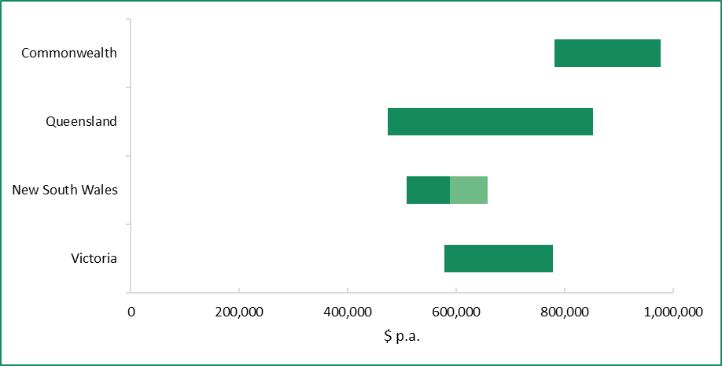
Notes: The lighter shaded bar is the upper bound of actual remuneration paid to Department Secretaries in New South Wales approved by SOORT. The remuneration range for Department Secretaries in Queensland is based on Bands 1 to 3 of the Queensland public sector chief executive remuneration framework.
Sources: Remuneration Tribunal (Cth) (2023b); SOORT (2023); QPSC (2023b); Tribunal (2023b).
Figure 5.3: Executive remuneration bands, selected jurisdictions, current as at 1 July 2023
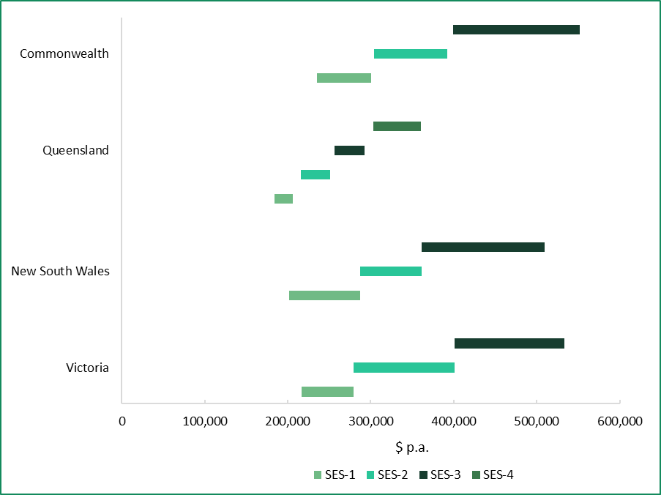
Note: The remuneration bands for the APS are based on the actual TRPs paid at the 5th, median and 95th percentiles for each of the SES 1, 2 and 3 classifications using the most recent data published by the APSC for the 2022 calendar year.
Sources: APSC (2023b) APS rem report; SOORT (2023); QPSC (2023c); Tribunal (2023b).

6 Economic and financial considerations
In making its Determination, the Tribunal was required to consider:
- current and projected economic conditions and trends
- the financial position and fiscal strategy of the State of Victoria
- any statement or policy issued by the Government of Victoria which is in force with respect to its wages policy (or equivalent) and the remuneration of executives employed in public service bodies.

6.1 Current economic conditions
The following discussion of current economic conditions has been informed by a range of sources, including the latest data on key economic indicators published by the ABS, statements by the RBA and the 2024-25 Budget.
Figure 6.1 provides a high-level overview of current economic conditions, which are described in further detail in the coming sections.
Figure 6.1: Overview of conditions in the Australian and Victorian economies, June 2024
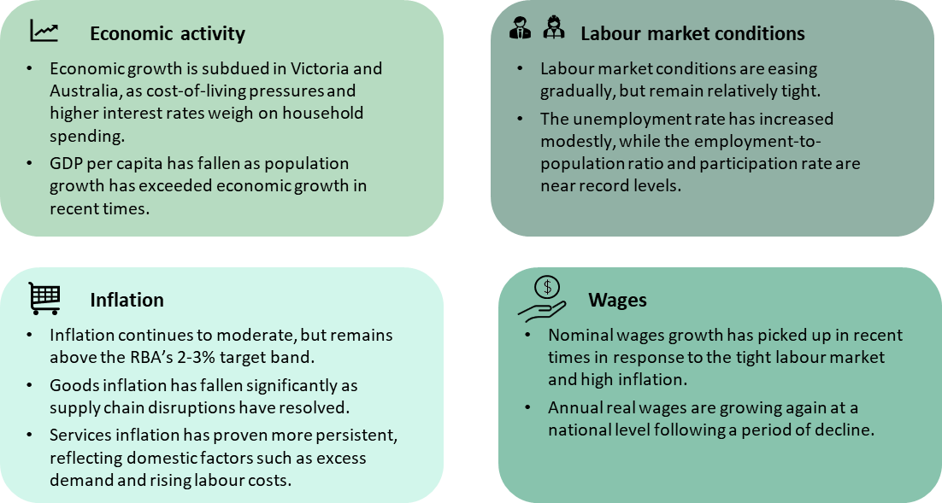

Economic growth is subdued as cost-of-living pressures and higher interest rates weigh on household consumption
Economic growth has slowed in Australia and Victoria from the high levels associated with the recovery from the COVID-19 pandemic.
Australia’s real Gross Domestic Product (GDP) rose 0.1 per cent over the March quarter 2024 (down from a revised 0.3 per cent in the December quarter 2023), and 1.1 per cent through the year. Excluding the pandemic, this was the weakest annual growth since the early 1990s. Victoria’s State Final Demand held steady in the March quarter 2024 (up from a revised 0.1 per cent fall in the December quarter 2023) and rose 1.5 per cent through the year (Figure 6.2). The latter is well below its long-run (excluding the pandemic) average growth rate of 3.5 per cent.
Figure 6.2: Quarterly and annual growth in real GDP and Victoria’s State Final Demand, December quarter 2021 to March quarter 2024
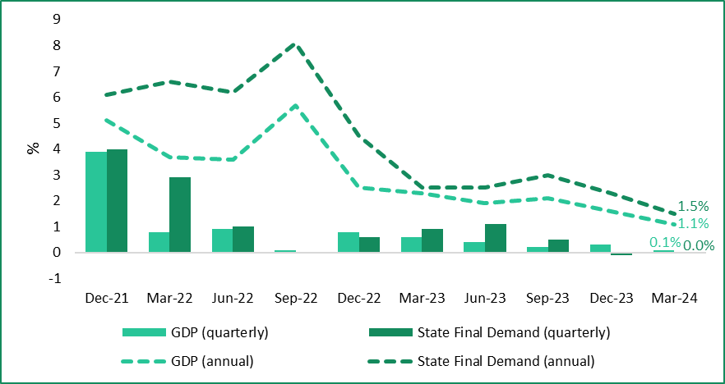
Source: ABS (2024a).
According to the ABS, the ‘weak’ GDP result in the March quarter 2024 reflects subdued domestic demand, with increased consumption offset by falling investment. The ABS noted that its latest release included upward revisions to recent data on household consumption, which has been stronger than previously indicated. Despite this, growth in household consumption remains subdued by historical standards and continues to be driven by spending on essentials.
The 2024-25 Budget observed that growth in the Victorian economy over 2023-24 has been supported by strong business investment and population growth. Meanwhile, growth in household consumption has been subdued amid ongoing pressure on household budgets from high inflation and higher interest rates.
Population growth has rebounded significantly since Australia’s international borders were re-opened in early 2022 and has exceeded economic growth rates in recent times. As a result, real GDP per capita has declined for four consecutive quarters, falling 0.4 per cent in the March quarter 2024 and 1.3 per cent through the year.
ABS data shows that GDP per hour worked — a measure of labour productivity — held steady in the March quarter 2024, after growing over the second half of 2023. This recent growth follows a period of five quarters in which labour productivity declined. The RBA observed that an improvement in productivity outcomes had been expected, partly due to strong business investment, though it noted that growth was weaker than expected in the December quarter 2023.

Inflation has moderated, but remains high
Headline inflation has moderated in Victoria and Australia more broadly but remains above the RBA’s 2 to 3 per cent target band.
ABS data show that annual growth in the All Groups Consumer Price Index for Melbourne (Melbourne CPI) declined to 3.6 per cent in the March quarter 2024, well below the peak of 8 per cent recorded in the December quarter 2022. However, strong price growth in the ‘education’ (6.2 per cent) and ‘health’ (3.1 per cent) groups and ‘rents’ sub-group (2.1 per cent) contributed to a larger than expected quarterly rise (1 per cent), which saw the annual inflation rate decline more slowly than in previous quarters (Figure 6.3).
Figure 6.3: Quarterly and annual growth in the Melbourne CPI, March quarter 2015 to March quarter 2024
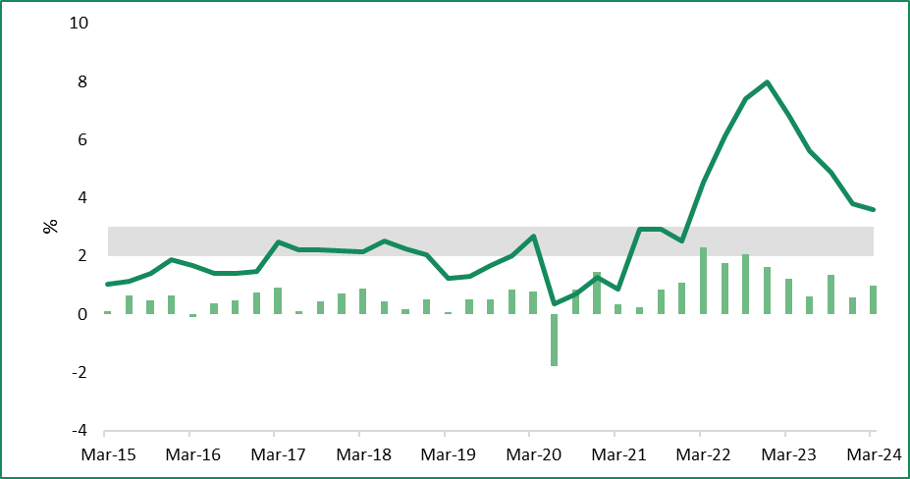
Annual CPI growth
RBA target band (annual)
Quarterly CPI growth
Source: ABS (2024c).
Movements in the Melbourne CPI were consistent with national outcomes, with the Australian CPI rising 1 per cent in the March quarter 2024 and 3.6 per cent through the year. Measures of Australian underlying inflation, which reduce the impact of irregular or temporary price changes, have also eased. Annual trimmed mean inflation — the RBA’s preferred measure of underlying inflation — fell to 4 per cent in the March quarter 2024, having decreased for five consecutive quarters since peaking at 6.8 per cent in the December quarter 2022.
Conversely, the monthly Australian CPI indicator has risen for two consecutive months, from 3.4 per cent in February 2024 to 3.6 per cent in April 2024. Eight out of the 11 CPI groups also recorded increases over that period, indicating that inflationary pressures remain elevated and broad-based.
The RBA’s latest Statement on Monetary Policy (May 2024 Statement) and the 2024-25 Budget both noted that the recent moderation in inflation outcomes in Australia and Victoria has been largely due to slower growth in the prices of goods. ABS data show that goods inflation has fallen sharply since its peak in mid-2022, consistent with the easing of global supply chain pressures. By contrast, services inflation peaked later and is declining more gradually. According to the 2024-25 Budget, the so-called ‘stickiness’ of services inflation reflects:
… the pass-through of domestic cost pressures to consumers in an environment of elevated demand … includ[ing] labour costs, which have risen due to higher wages growth coupled with a lack of productivity growth, as well as non-labour costs such as energy and transport.

Labour market conditions are gradually easing, but remain tight
As discussed in further detail in Chapter 4, conditions in the Australian and Victorian labour markets have been ‘tight’ in recent years but are gradually easing.
In its May 2024 Statement, the RBA observed that the easing in the national labour market had been slower than expected, with much of the easing occurring through declines in average hours worked and job vacancies. On the other hand, it noted that the Australian unemployment rate — a key indicator of spare capacity in the labour market — had increased only modestly.
In its latest Labour Force release (May 2024), the ABS observed that Australia’s employment-to-population ratio and participation rate remain much higher than their pre-pandemic levels. According to the ABS:
Together with elevated levels of job vacancies, this suggests the labour market remains relatively tight, though less [tight] than in late 2022 and early 2023.
The Australian participation rate also remains near record high levels, while the Australian unemployment rate rose modestly over the past year to be 4 per cent in May 2024 (compared with 4.1 per cent in April 2024 and 3.6 per cent in May 2023).
A similar scenario is unfolding in the Victorian labour market. According to the 2024-25 Budget, the State’s labour market remains ‘strong’, with the share of working-age Victorians in employment and labour force participation remaining near record levels. Nonetheless, it also noted that employment growth has eased from the relatively high levels observed in previous years. Since the release of the 2024-25 Budget, ABS data show that the Victorian unemployment rate increased to 4.4 per cent in May 2024 (compared with 4.3 per cent in April 2024 and 3.7 per cent in May 2023) to be the highest of the states and territories.

Nominal wages growth has picked up in recent years
In response to the tight labour market and high inflation, nominal wages growth is currently around its highest level in over a decade. The Australian Wage Price Index (WPI) rose 4.2 per cent over 2023, which was the highest annual growth rate since early 2009. Growth moderated slightly to 4.1 per cent in the March quarter 2024 but remains above its long-run (excluding the pandemic) average of 3.2 per cent.
The RBA has observed that wages growth appears to have peaked for workers on individual arrangements, whose wages are the most responsive to economic conditions. By contrast, it noted that wages growth is continuing to strengthen for enterprise agreements (EAs), which are slower to respond to economic conditions. Data from the Commonwealth Department of Employment and Workplace Relations show that the average annualised wage increase for agreements approved in the December quarter 2023 was 4.3 per cent, compared with 4.1 per cent in the previous quarter and 3 per cent in the December quarter 2022.
Award wages and the National Minimum Wage (NMW) have also grown in recent years. In its Annual Wage Review 2023-24, the Fair Work Commission (FWC) increased the NMW and all modern award minimum wages by 3.75 per cent with effect from 1 July 2024. This followed a 5.75 per cent increase from 1 July 2023. In explaining the reasons for its latest decision, the FWC stated that:
… a primary consideration has been the cost-of-living pressures [being experienced by] modern award-reliant employees … At the same time, we consider that it is not appropriate at this time to increase award wages by any amount significantly above the inflation rate, principally because labour productivity is no higher than it was four years ago ….
Wages growth has also picked up in Victoria, although to a lesser extent than in Australia as a whole. The Victorian WPI rose 3.6 per cent over the 12 months to the March quarter 2024, the lowest growth among the states, and has grown more slowly than the national WPI since mid-2023 (Figure 6.4).
Figure 6.4: Annual WPI growth (all sectors), Victoria and Australia, March quarter 2015 to March quarter 2024
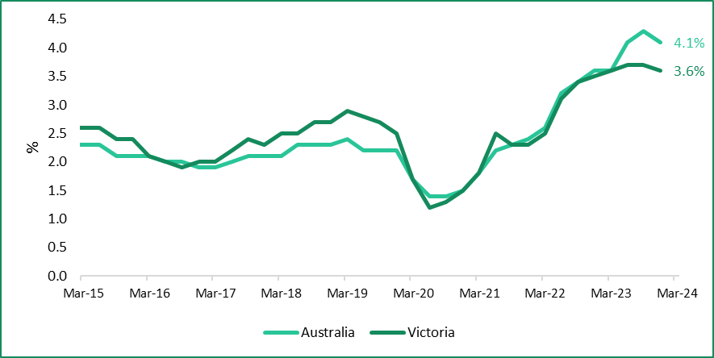
Source: ABS (2024h).
The public sector in Victoria (which comprises the Victorian Government, local governments and Australian Government agencies operating in Victoria) has experienced lower wages growth than the private sector in recent years, in a reversal of the pre-pandemic trend. Over the year to the March quarter 2024, public sector wages grew by 2.5 per cent, compared with 3.9 per cent in the private sector. The Victorian Government’s submission to the FWC’s Annual Wage Review 2023-24 observed that a relevant factor in this regard is the influence of the prevalent pay setting method in each sector (EAs in the public sector, individual arrangements in the private sector).
Nationally, broader measures of employee earnings have generally grown faster than base wages. Depending on the specific measure, this may reflect compositional factors (e.g. increases in full-time employment and hours worked) and/or the use of non-base wage forms of compensation (e.g. bonuses) to attract and retain employees in a tight labour market. For example, ABS data shows that:
- average compensation per employee (also known as Average Earnings from the National Accounts) grew by 5 per cent over 2023
- average weekly ordinary time earnings for full-time Australian adults grew by 4.5 per cent over the 12 months to November 2023
- the Australian WPI including bonuses rose 4.2 per cent over the 12 months to the March quarter 2024.

Real wages are growing again following a period of decline due to high inflation
While nominal wages are growing at the fastest pace in some time, real wages have declined considerably since the onset of the current inflationary episode and have only recently started growing again.
The Australian headline inflation rate consistently exceeded annual WPI growth from mid-2021 to mid-2023, signifying falling real wages. However, as inflation and nominal wages growth have moderated and strengthened, respectively, real wages have stabilised and begun to grow again. At the national level, real wages grew by 0.5 per cent over the 12 months to the March quarter 2024. By contrast, real wages in Victoria were unchanged over the same period and have not grown in annual terms since early 2021 (Figure 6.5).
Figure 6.5: Difference between annual CPI and WPI growth rates, Australia and Victoria, March quarter 2021 to March quarter 2024
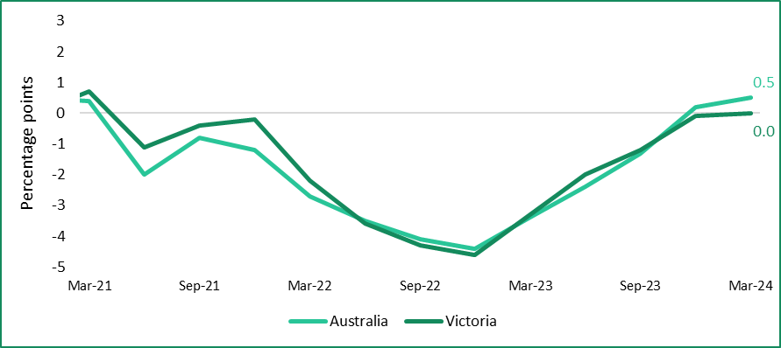
Note: Positive/negative values indicate that annual WPI growth for that period was higher/lower than annual CPI growth for the same period.
Sources: ABS (2024c); ABS (2024h).

6.2 Economic outlook
The following discussion of the outlook for the Australian and Victorian economies has been informed by the latest forecasts and analysis from the RBA and the federal and Victorian budgets. Key forecasts are reproduced in Tables 6.1 and 6.2, followed by more detailed analysis.
Table 6.1: Selected RBA and Commonwealth Treasury^{(a)} forecasts for the Australian economy
Indicator | Source | June 2024 | Dec 2024 | June 2025 | Dec 2025 | June 2026
Real GDP^{(a)} | RBA | 1.2 | 1.6 | 2.1 | 2.3 | 2.4
Population^{(a)} | RBA | 2.0 | 1.5 | 1.4 | 1.4 | 1.4
CPI^{(a)} | RBA | 3.8 | 3.8 | 3.2 | 2.8 | 2.6
CPI^{(a)} | Treasury | 3.5 | N/A | 2.8 | N/A | 2.8
Trimmed mean^{(a)} | RBA | 3.8 | 3.4 | 3.1 | 2.8 | 2.6
Employment^{(a)} | RBA | 2.1 | 1.4 | 1.2 | 1.3 | 1.4
Employment^{(a)} | Treasury | 2.3 | N/A | 0.8 | N/A | 1.3
Unemployment rate^{(b)} | RBA | 4.0 | 4.2 | 4.3 | 4.3 | 4.3
Unemployment rate^{(b)} | Treasury | 4.0 | N/A | 4.5 | N/A | 4.5
WPI^{(a)} | RBA | 4.2 | 3.8 | 3.6 | 3.4 | 3.3
WPI^{(a)} | Treasury | 4.0 | N/A | 3.3 | N/A | 3.3
Labour productivity^{(a)} | RBA | 1.8 | 0.8 | 1.3 | 1.2 | 1.1
Notes: (a) Commonwealth Treasury forecasts are presented to one quarter of one per cent and have been rounded up to one decimal place. (b) Percentage change through the year. (c) Average rate in the quarter.
Sources: RBA (2024b), p. 51; Commonwealth of Australia (2024), p. 53.

Table 6.2: 2024-25 Budget forecasts for the Victorian economy
Indicator | 2023-24 | 2024-25 | 2025-26 | 2026-27 | 2027-28
Real Gross State Product^{(a)} | 2.00 | 2.50 | 2.75 | 2.75 | 2.75
Population^{(b)} | 2.30 | 1.80 | 1.70 | 1.70 | 1.70
Melbourne CPI^{(a)} | 4.00 | 2.75 | 2.50 | 2.50 | 2.50
Employment^{(a)} | 3.25 | 1.00 | 1.75 | 1.75 | 1.75
Unemployment rate^{(c)} | 4.00 | 4.25 | 4.50 | 4.75 | 4.75
Victorian WPI^{(a)} | 3.75 | 3.75 | 3.25 | 3.25 | 3.25
Notes: (a) Percentage change in year-average terms compared with the previous year. (b) Percentage change over the year to 30 June. (c) Year average.
Source: DTF (2024d), p. 18.

Economic growth is forecast to pick up in coming years, driven by a recovery in household spending
The RBA expects economic growth to remain subdued in the near-term, before picking up from late 2024 as the recovery in real incomes leads to a pick-up in household consumption. Annual growth in real GDP is forecast to be 1.2 per cent in June 2024, before increasing to 2.1 per cent in June 2025 and 2.4 per cent in June 2026. Nonetheless, growth is expected to remain below the long-run (excluding the pandemic) average of 2.9 per cent.
The 2024-25 Budget forecast Victoria’s real Gross State Product (GSP) to grow by 2 per cent in 2023-24, before picking up to 2.5 per cent in 2024-25. Similar to the national outlook, the pick-up in growth is expected to be driven by household consumption, which is forecast to contribute 1.5 percentage points to GSP growth in 2024-25. On the other hand, public demand — which includes spending and capital expenditure by the Victorian Government — is expected to make a broadly flat contribution to growth, consistent with a moderating investment pipeline (see section 6.3).
The RBA is forecasting population growth to moderate over the next couple of years and return to its pre-pandemic average, and to grow more slowly than real GDP from late 2024 onwards. Were this to eventuate, it would support a recovery in real GDP per capita.
In terms of productivity, the RBA expects growth to pick up further and stabilise around its long-run (excluding the pandemic) average, but notes that the outlook is highly uncertain. In particular, the RBA observed that a return to the lower rates of business dynamism and competition that were associated with weak productivity outcomes in the 2010s would similarly weigh on growth going forward.

Inflation is forecast to ease in the medium-term, with a return to target expected in the next 6–18 months
The latest inflation forecasts published by the RBA, which preceded the federal budget, have Australian CPI growth rising in the near-term due to temporary factors such as rising petrol prices and the unwinding of energy rebates. Despite this, the RBA’s medium-term inflation outlook remains largely unchanged, with annual CPI growth expected to return to the 2 to 3 per cent target band by late 2025.
By comparison, the federal budget expects headline inflation to return to target by mid-2025, and potentially by the end of 2024. Specifically, the Commonwealth Treasury forecast annual CPI growth to be 3.5 per cent in June 2024, before declining to 2.75 per cent in June 2025 (compared with 3.8 per cent and 3.2 per cent, respectively, by the RBA) (Figure 6.6). One reason for the difference between Treasury’s forecasts and the most recent RBA forecasts is that the former considers the expected impact of cost-of-living measures announced in the federal budget, namely energy rebates for households and an increase in Commonwealth Rent Assistance. The Commonwealth Treasury expects that these measures will reduce headline inflation by 0.5 percentage points without adding to broader inflationary pressures.
Figure 6.6: RBA and Federal Budget forecasts for annual CPI growth
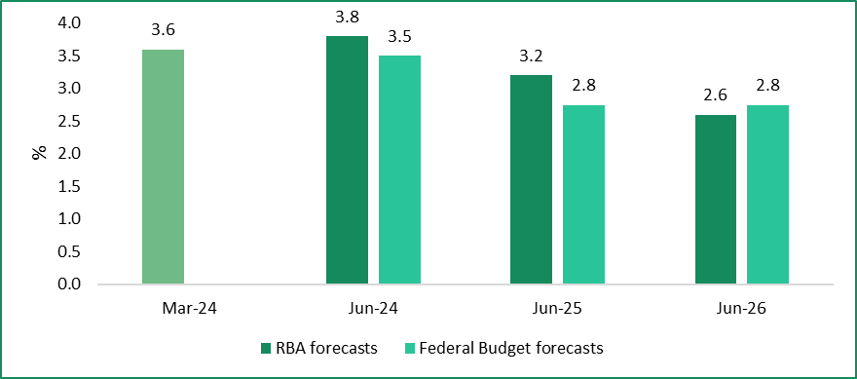
Notes: Annual CPI growth to March 2024 is actual. The RBA also produced forecasts for December 2024 and December 2025, which are reproduced in Table 6.1.
Sources: RBA (2024b), p. 51; Commonwealth of Australia (2024), p. 53.
The 2024-25 Budget forecast annual growth in the Melbourne CPI to average 4 per cent in 2023-24, before easing to 2.75 per cent in 2024-25. DTF noted that the pace of easing will be determined largely by the outlook for services inflation, which is expected to continue to decline more slowly than goods inflation.

Labour market conditions are expected to continue easing gradually
The easing in labour market conditions is expected to continue, with the RBA forecasting employment growth to slow and fall below growth in the working-age population for a time. This is expected to drive further easing in the national unemployment rate, which is forecast to rise to 4.2 per cent by the end of 2024, before stabilising around 4.3 per cent — a level considered consistent with full employment — from mid-2025. Labour force participation is expected to decline slightly due to cyclical factors, but to remain high by historical standards.
The Commonwealth Treasury’s outlook for the national labour market is broadly consistent with the RBA’s. Of note, Treasury is forecasting a sharper slowdown in employment growth, and consequently a larger increase in the unemployment rate, which it expects to reach 4.5 per cent by mid-2025.
In relation to the Victorian labour market, the 2024-25 Budget similarly forecast employment growth to slow from an average of 3.25 per cent in 2023-24 to 1 per cent in 2024-25. The unemployment rate is expected to average 4.25 per cent in 2024-25, before increasing to 4.5 per cent in 2025-26.

Wages growth is expected to moderate as the labour market eases
The RBA has observed that nominal wages growth appears to have peaked for the current cycle, with growth forecast to moderate gradually over the coming years. Annual growth in the Australian WPI is forecast to be 4.2 per cent in June 2024, before declining to 3.6 per cent by June 2025. The federal budget forecast a slightly faster decline in wages growth, with national WPI growth expected to be 4 per cent in June 2024 and 3.3 per cent in June 2025.
The 2024-25 Budget forecast annual growth in the Victorian WPI to average 3.75 per cent in each of 2023-24 and 2024-25, before returning to 3.25 per cent from 2025-26. The Tribunal notes that, at the time of making this Determination, the Victorian Government was negotiating several major public sector EAs under its revised wages policy, which provides for higher wage outcomes than previously (see section 6.4). Consistent with the experience in other states, the commencement of those agreements is likely to boost public sector wages growth, which has been relatively subdued compared with the private sector.
Real wages are expected to grow over the coming years in both Victoria and Australia, as nominal wages growth is forecast to moderate more slowly than inflation. For example, the RBA is forecasting real wages (in annual terms) to rise 0.4 per cent in June 2024, hold steady in December 2024, and then resume growing from June 2025.

There are risks to the economic outlook, particularly around inflation
In its May 2024 Statement, the RBA concluded that the risk that inflation takes longer than expected to return to target had increased since February 2024. It noted that the stronger-than-expected inflation outcome in the March quarter 2024 could indicate that domestic inflationary pressures are ‘stickier’ than currently assumed. This could be the case, for example, if the assumed pick-up in productivity growth does not eventuate, leading to higher input costs for businesses that may then be passed on to consumers.
Geopolitical tensions have also increased the risk of further supply shocks, according to the RBA, which could lead to a rebound in goods inflation. The RBA observed that a prolonged period of high inflation would risk ‘deanchoring’ inflation expectations, requiring further interest rate rises and a period of higher unemployment to return inflation to target.
On the other hand, the RBA noted that there is a risk that aggregate demand could be weaker than expected, such as if the recent weakness in household consumption were to persist. While noting that this could see inflation return to target more quickly than expected, the RBA also observed that it would likely come at the expense of its employment objective (i.e. it would lead to higher unemployment).
Overall, while the RBA judged the risks to Australia’s economic outlook to be ‘broadly balanced’, it assessed that the costs associated with the upside risks to inflation are greater than the costs associated with the downside risks.
The 2024-25 Budget cited similar risks in relation to the Victorian economy, including uncertainty around the outlooks for household consumption and inflation.

6.3 Financial position and fiscal strategy of the State of Victoria
The following discussion of the financial position and fiscal strategy of the State of Victoria has been informed by the 2024-25 Budget and the latest Auditor-General’s Report on the Annual Financial Report of the State of Victoria (November 2023).

The 2024-25 Budget builds on the savings and efficiency measures introduced in the previous budget
In the Victorian Budget 2023-24, the Victorian Government announced a range of strategies to improve the State’s financial position and manage debt. These included the introduction of a temporary COVID-19 Debt Levy to offset the cost of measures introduced by the Victorian Government in response to the COVID-19 pandemic. The Victorian Budget 2023-24 also included a range of savings and efficiency measures to be implemented across the public sector, including targeted reductions in the number of VPS staff.
According to the Victorian Government, the 2024-25 Budget builds on this strategy by:
… recalibrating the Government’s service delivery, departmental expenditure and capital program to take account of the increasing cost of labour and materials as well as supply constraints in the economy, including workforce availability and capacity.
In particular, the Victorian Government has announced that it will ‘progressively return its capital program towards pre-pandemic levels’ by the end of 2027-28. Government infrastructure investment is forecast to peak at $24 billion in 2023-24, before declining to around $16 billion in 2027-28. Overall, government infrastructure investment is forecast to average $19.3 billion per annum over the forward estimates, compared to the average of $21.3 billion per annum reported in the 2023-24 Budget Update (Figure 6.7).
Figure 6.7: 2024-25 Budget forecasts^{(a)} for government infrastructure investment
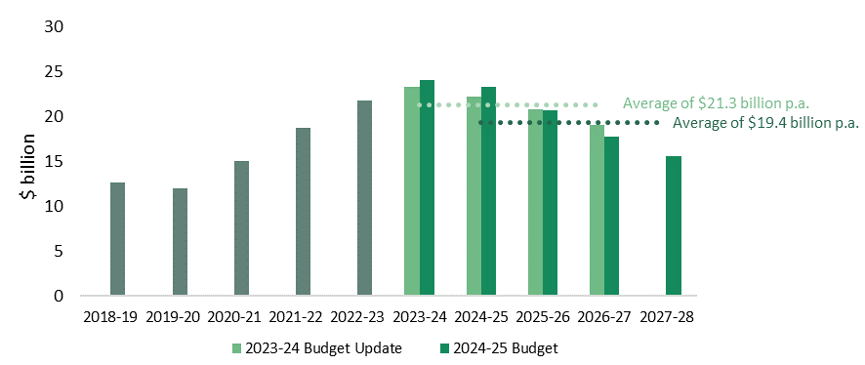
Note: (a) Actual values are shown for 2018-19 to 2022-23 (inclusive).
Sources: DTF (2023b), p. 17; DTF (2024d), p. 53.
The 2024-25 Budget also added a new step to the Victorian Government’s fiscal strategy, which was first outlined in the Victorian Budget 2020-21 in response to the COVID-19 pandemic:
- Step 1 – Creating jobs, reducing unemployment and restoring economic growth
- Step 2 – Returning to an operating cash surplus
- Step 3 – Returning to operating surpluses
- Step 4 – Stabilising debt levels
- Step 5 – Reducing net debt as a proportion of GSP (new).

A return to an operating surplus is expected in 2025-26, but net debt is forecast to continue rising
The Victorian Government achieved step 2 of its fiscal strategy in 2022-23, with the general government sector (GGS) recording an operating cash surplus of $4.2 billion. A smaller cash surplus of $0.4 billion is forecast for 2023-24, followed by larger surpluses in future years (Figure 6.8).
Figure 6.8: 2024-25 Budget forecasts^{(a)} for operating result and operating cash result
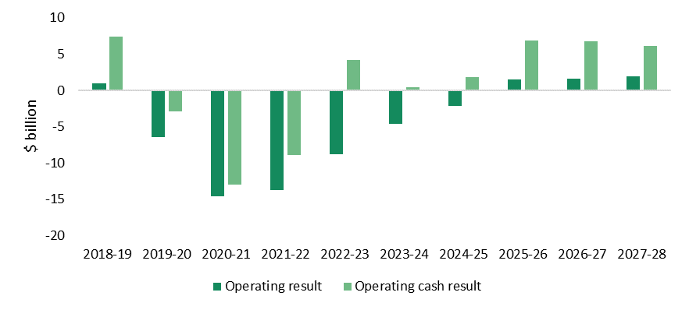
Note: (a) Actual values are shown for 2018-19 to 2022-23 (inclusive).
Sources: DTF (2024c); DTF (2024d), p. 53.
Operating deficits of $4.6 billion and $2.2 billion are forecast for the GGS in 2023-24 and 2024-25, respectively, before an expected return to surplus in 2025-26. This would be the first surplus since 2018-19, with larger surpluses forecast for 2026-27 and 2027-28. The 2024-25 Budget noted that these surpluses will fund an increasing share of the Victorian Government’s capital program, reducing the amount of new borrowing required and helping to stabilise and reduce net debt.
Net debt for the GGS was $115 billion (20.2 per cent of GSP) at 30 June 2023, and is forecast to be around $136 billion (22.3 per cent of GSP) at 30 June 2024. Net debt as a proportion of GSP is expected to stabilise at around 25 per cent from June 2026, consistent with achieving steps 4 and 5 of the fiscal strategy. However, debt is forecast to continue rising in nominal terms, and is expected to be around $188 billion by 30 June 2027 (Figure 6.9).
Figure 6.9: 2024-25 Budget forecasts^{(a)} for net debt and net debt to GSP
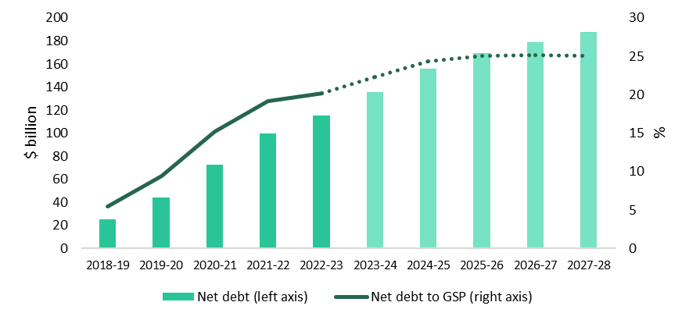
Note: (a) Actual values are shown for 2018-19 to 2022-23 (inclusive).
Sources: DTF (2024c); DTF (2024d), p. 53.

The Auditor-General has identified risks to Victoria’s fiscal outlook
Each year, the Victorian Auditor-General’s Office (VAGO) issues a report on the Annual Financial Report of the State of Victoria. The November 2023 report examined Victoria’s 2022-23 Annual Financial Report.
The report identified several emerging risks to Victoria’s fiscal outlook. Three of these — employee expenses, interest expenses and infrastructure spending — are discussed in Box 6.1.
Box 6.1: Emerging risks to Victoria’s fiscal outlook identified by VAGO
Sources: VAGO (2023a), pp. 20-25. VAGO (2023b), pp. 8-9.
 Employee expenses
- Employee costs are the state’s single largest operating expense, accounting for around 36 per cent of general government sector expenditure in 2022-23.
- Employee costs increased by 45 per cent between 2017–18 and 2022–23.
- The government determined that workforce transition, including staff reductions, is required to achieve its targeted cost reductions. If these initiatives are not implemented and realised as planned, future employee expenses may be greater than estimated.
- The prevailing economic environment of high inflation, a tight labour market and high wages growth may compound the challenge.
 Interest expenses
- Most of Victoria’s debt is fixed-rate debt issued at a low interest rate.
- $39 billion of debt needs to be refinanced by June 2027, which will likely be at a significantly higher interest rate.
- Interest expenses on new and refinanced debt are expected to increase significantly over the coming years, from $1.6 billion in 2023-24 to $5.5 billion in 2026-27.
 Infrastructure spending
- As at November 2023, the total estimated investment (TEI) of 89 existing and completed major capital projects had increased by $11 billion (11 per cent).
- Of the 101 new, existing or completed projects analysed by VAGO:
- 28 projects had a TEI increase of more than 10 per cent
- 12 projects had a TEI increase of more than 50 per cent.
- VAGO noted that further TEI increases would lead to more unplanned debt unless the government’s capital program was curtailed.

6.4 Victorian Public Sector Wages Policy
The Wages Policy and the Enterprise Bargaining Framework (Wages Policy) sets out the parameters within which Victorian public sector employers, including public service bodies, are required to bargain and make EAs.
Box 6.2 outlines the key features of the current Wages Policy, which was introduced by the Victorian Government in April 2023. In particular:
- increases in wages and conditions will be funded at a rate of growth of 3 per cent per annum over the life of an agreement (compared to 1.5 per cent under the previous policy)
- in addition to annual wage increases, a separate lump sum cash payment will be available, equivalent to 0.5 per cent of overall agreement costs.
Box 6.2: Victorian Public Sector Wages Policy — key features
Note: (a) The Public Sector Priorities are: ‘deliver exceptional services and value for Victorians’, ‘a professional and responsive public sector’ and ‘government as a fair and best practice employer’.
Pillar 1: Wages
- Increases in wages and conditions will be funded at a rate of growth of 3.0 per cent per annum over the life of the agreement. In practice, this means that employee wages and conditions will be allowed to grow at this rate.
- In addition to annual wage increases, a separate lump sum, cash payment will be available equivalent to an additional 0.5 per cent of overall agreement costs which for the purposes of this policy means a per annum amount calculated on wages and wage-related conditions.
Pillar 2: Best Practice Employment Commitment
- Public sector agencies may make a Best Practice Employment Commitment which outlines measures to operationalise elements of the Government’s Public Sector Priorities^{(a)} that reflect good practice within Government and can be implemented operationally or without significant costs.
Pillar 3: Additional strategic changes
- Additional changes to allowances and other conditions (not general wages) will only be allowed if Government agrees that the changes will address key operational or strategic priorities for the agency, and/or one or more of the Public Sector Priorities and provided the associated costs are funded through appropriate cash offsets or a government approved funding strategy.
Source: IRV (2023), pp. 3-4.

The Victorian Government has reached in-principle agreement on the core terms and conditions of a new VPS EA
Unlike executives, whose remuneration and employment conditions are set out in the VPS Handbook and standard contract (see Chapter 3), non-executive VPS employees are covered by an EA. The current agreement, the VPS EA 2020, nominally expired in March 2024, but remained in operation while a new agreement was being negotiated.
Prior to the making this Determination, the Secretary of DPC announced that the Victorian Government and the Community and Public Sector Union had reached in-principle agreement on the core terms and conditions that will form part of a new VPS EA. However, at the time of making this Determination, VPS staff had yet to vote on the agreement. If approved, the agreement will also need to be lodged with the FWC for approval.
The draft agreement provides for:
- annual salary increases of 3 per cent over the life of the agreement, effective from 1 May each year
- a once-off lump sum payment of $5,600 (pro-rated for part-time and eligible casual employees) for all non-executive employees, regardless of classification, who are employed on 28 June 2024
- an additional once-off payment of $1,000 (also calculated on a pro-rata basis) will also be payable to eligible shift workers employed on 1 October 2024
- an increase to the lump sum payment (from 1 per cent to 1.5 per cent of base salary) paid to employees at the top of their grade or value range who are assessed as having met their progression criteria.
Under the draft agreement, VPS staff would also retain access to annual progression payments and the mobility payment.

7 Tribunal’s considerations
The Tribunal now turns to a discussion of the matters it considered, and the weight it gave to various factors, to reach a decision about the value of remuneration bands for executives employed in public service bodies.
The overall analytical framework is set by the VIRTIPS Act which requires that, in making its determinations, the Tribunal must consider the following:
- the existing remuneration provided to executives
- any statement or policy issued by the Government of Victoria which is in force with respect to its wages policy
- the financial position and fiscal strategy of the State
- current and projected economic conditions and trends
- submissions received in relation to the proposed Determination.
- a comprehensive review of the roles of executives employed in public service bodies.
The Tribunal may also provide for any other matter it considers relevant.
Detailed information and data supporting the analysis can be found in the earlier chapters of this statement. Chapter 2 discusses the roles and responsibilities of VPS executives, drawing on the Tribunal’s consultations and research. An overview of the existing employment and remuneration arrangements for executives is provided in Chapter 3.
Chapter 4 describes the executive labour market, including current demand and supply factors and presents the remuneration benchmarking analysis commissioned by the Tribunal. In Chapter 5, comparisons are made between executive remuneration arrangements across selected Australian jurisdictions. Chapter 6 details relevant macroeconomic and financial considerations. Submissions received by the Tribunal, including responses to the Tribunal’s executive questionnaire, are cited throughout the Statement of Reasons.

7.1 Factors supporting an increase in the level of the remuneration bands

The changing nature of the role
The first part of the analysis identifies a number of factors which, taken together, provide evidence for the appropriateness of a significant increase to the remuneration bands for VPS executives. The second part sets these considerations in a broader context including the government’s current Wages Policy and the financial position and fiscal strategy of the State.
First, in support of an increase, there is compelling evidence of a significant change in the role of executives since the Tribunal’s first determination four years ago. While core responsibilities have more or less remained constant, workload, complexity and public scrutiny associated with the role have all increased. While workload might suggest solutions other than remuneration, the latter two — and in particular public scrutiny — bear directly on the considerations for setting remuneration bands.
A high degree of accountability and the public examination of executives in the VPS is, and has always been, highly appropriate. However, information provided to the Tribunal suggests that the shift in public scrutiny has been towards personal targeting and the introduction of a political dimension and a level of aggressiveness not evident in the past.
The resultant increased risk of reputational damage, together with a limited capacity to respond and an associated damage to employment prospects, has had a significant impact on the number of people willing to serve in senior roles in the Victorian public sector. Moreover, those who are risk averse are discouraged leading to negative consequences for diversity.
Similar views were expressed in the submission from the VPSC which noted that, notwithstanding the importance of accountability, the frequency, intensity and often widely reported nature of this scrutiny can have a negative impact on executives’ mental health and their future financial earning capacity.
It is the view of the Tribunal that this is not simply a passing phase but rather reflects structural changes in the system which are here to stay. The situation is not eased when the challenges of the near future are considered. There is an increasing tendency, for example, for personal responsibility to attach to big system failures including as the result of cyber-attacks, as well as to the management of natural disasters and to those functions involving the direct care of community members.
In each of these areas and others the level of exposure and risk for senior executives has increased dramatically leading some to not take up more senior roles or to contemplate whether a career in the private sector may be a more attractive option.
In terms of complexity, there are a number of challenges that arise from leading a hybrid workforce including finding new ways to stimulate connections and creativity, manage performance and to build trust and relationships within and across teams and organisations. These challenges include maximising productivity by redesigning work to focus on a ‘digital-first’ way of working and by managing the introduction of AI.
There has been a major expansion in program and project delivery across all spheres of government co-existent with the implementation of savings initiatives and the re-setting of staffing levels. And there has been a significant growth in the number of portfolios serviced by the VPS along with a continued focus on cross-portfolio and social reform initiatives that touch on every aspect of public service activity.

Market positioning and competitiveness
The second issue relates to the level of competitiveness of the Victorian Public Service compared to the private sector and other public sector jurisdictions with which Victoria competes for talent.
The Tribunal engaged recruitment firm Mercer to undertake a detailed analysis of the market for executives. The details of Mercer’s findings are set out in Chapter 4.
Of particular relevance to this analysis, however, is the positioning of the VPS in the AGM (which refers to Mercer’s remuneration database for positions within Australia comprising over 700,000 remuneration records covering the private, public and not-for-profit sectors).
Pay practices for public sector executives in most Australian jurisdictions are generally closer to the 15th percentile of the AGM. This means that 85 per cent of all executives performing roles with the same work value are paid more than executives in the VPS — reflecting, in part, the value attached to the non-salary benefits of working in the public service — the satisfaction that comes from the opportunity to serve the community and make a difference for example.
The critical part of Mercer’s analysis is that, compared to four years ago, current executive remuneration — particularly for senior executives — has fallen further below the 15th percentile of the AGM. Given the importance of a high-performing public sector to the economic performance of the State, this decline in positioning and its impact of the State’s ability to compete for talent should be viewed with some concern.
This is not simply a theoretical observation. As part of the Tribunal’s questionnaire, executives who are involved in the recruitment of other executives were asked to identify the factors affecting the willingness of potential candidates to apply for executive positions or accept an employment offer. Around two-thirds reported ‘significant challenges’ attracting executives. Of these, approximately 90 per cent indicated that the main factor was that the total remuneration package is too low. These are the people who have first-hand experience of executive recruitment and are more likely to have real knowledge of contemporary market realities.
In addition to the current remuneration bands, there is evidence that broader terms and conditions – such as the termination provisions of the employment contract – have also adversely affected recruitment and retention. This is further discussed at the conclusion of this chapter.

Economic considerations
Although the economic outlook remains mixed, a number of indicators suggest a trend towards a more positive environment for wages growth over the coming years. Nominal wages growth has picked up in response to the tight labour market and high inflation. Real wages are growing again but remain lower than they were a few years ago. For example, since the Tribunal’s first comprehensive Determination four years ago, real wages for executives have declined by 7.1 per cent. Moreover, public sector wages are growing more slowly than private sector wages in Victoria.
Economic growth in both Australia and Victoria is expected to pick up in the latter part of this year again creating a more positive outlook for wages growth. Although not directly relevant to the public sector executive cohort, as an indicator of trends in the broader economy, of note is the FWC’s decision of 3 June 2024 to lift the minimum wage by 3.75 per cent slightly above annual inflation to March this year of 3.6 per cent (although it did warn of the inappropriateness of increasing the minimum wage significantly above inflation due to limited growth in labour productivity).

7.2 Factors suggesting restraint

Views of the VPS leadership
The first point to note is that submissions from the VSB and the VPSC expressed the view that the remuneration bands for public service executives are broadly appropriate.
Part of the reasoning can be found in the payment above the band provision in the VIRTIPS Act. Under this provision, an employer may pay an executive above the maximum of the relevant band but first must seek and consider the advice of the Tribunal. The employer is not bound to accept the advice. The fact that relatively few executives are paid above the band (less than 3 per cent) suggests that the bands are generally fair, equitable and competitive for the vast majority of executives.
The availability of this mechanism also enables employers, where there are competitive market pressures, to enter the realm of the general market and, together with the flexibility provided by the width of the bands (up to $132,413 for the current SES-3 band), should equip them with the capacity to offer competitive remuneration in most cases.

Wages policy and the financial position and fiscal strategy of the State
Although the government’s current Wages Policy is one of many factors the Tribunal is required to consider in making its decisions, in light of the current financial circumstances of the State and its strategies for dealing with net debt, the Tribunal felt it appropriate that the policy be given considerable weight in the decision-making process.
The Wages Policy provides that:
- increases in wages and conditions will be funded at a rate of growth of 3 per cent per annum over the life of the agreement. In practice this means that employee wages and conditions will be allowed to grow at this rate
- in addition to annual wage increases, a separate lump sum cash payment will be available equivalent to an additional 0.5 per cent of overall agreement costs.
Prior to the making of this Determination, the Victorian Government and the Community and Public Sector Union announced that they had reached in-principle agreement on the terms and conditions for a new VPS EA.
Relevant aspects of the proposed EA, which applies to non-executive VPS employees, include annual salary increases of 3 per cent, a once-off lump sum payment of $5,600 (pro-rated for part-time employees) and an increase in the lump sum progression payment available for employees at the top of their grade. The Tribunal notes that equivalent lump sum and progression payments are not typically available to VPS executives.
The Tribunal heard that maintaining relativities between non-executive and executive employees is important for attraction and retention of executives. It is also a matter of fairness that increases in non-executive remuneration should inform the Tribunal’s consideration of the executive remuneration bands. For example, as a reference point, if the $5,600 lump sum payment was amortised over the four-year term of the proposed VPS enterprise agreement and considered as forming part of salary, the effective salary increase for VPS employees on 1 July 2024 would range from 5.7 per cent at the lowest VPS grade to 3.6 per cent at the highest grade.
The Tribunal’s rationale for giving some weight to Wages Policy is not related to the financial impact of any increase in the executive remuneration bands. Given the relatively small size of the executive cohort compared to total public sector employment, any increase in the executive remuneration bands will not have a significant impact on the budget’s bottom line.
Rather, the challenges facing the State are considerable and a degree of discipline and a high level of adherence to policy objectives will be required to overcome them. If any group is seen to be given ‘special treatment’ it will inevitably weaken the collective effort.
In relation to fiscal strategy, since the Tribunal’s 2020 VPS Determination the government has introduced a four-step strategy with the aim of returning Victoria’s finances to an operating cash surplus and stabilising debt levels. This includes the government’s commitment to rebalancing the public service and bringing staffing levels back to pre-pandemic levels.

The social compact
In making this decision — and indeed all decisions — the Tribunal did so having weighed the impact that its decision may have on the level of trust between the community and the Victorian Public Service if increases in remuneration for senior public servants are perceived as out of step with community standards and expectations and prevailing economic conditions.

Jurisdictional comparisons
The comparison focussed on the Commonwealth, New South Wales (NSW) and Queensland public services. They are the most comparable in terms of population and geographical location, as well as the number of public service departments, the size of the executive and non-executive workforce.
Although different structural arrangements make direct comparisons difficult, it appears that the disparities are not sufficient to suggest that weight should be given to jurisdictional comparisons in this analysis.
The values of the Victorian and NSW remuneration bands are broadly comparable, whereas the Queensland bands are generally narrower and lower. Although the Commonwealth does not have a remuneration band structure, comparisons with actual pay levels appear to appropriately reflect the responsibilities of the two levels of government.
The Tribunal also noted that executives employed in the Commonwealth could receive remuneration increases of up to 3.8 per cent from December 2023, while the executive remuneration bands in Queensland will increase by 4 per cent from 1 July 2024. Conversely, executive remuneration has been frozen in NSW in 2023-24 and 2024-25.

7.3 The Tribunal’s decision
As discussed earlier, the VPS has fallen behind movements in the AGM compared to where it was four years ago — for example, the top of the SES-3 band is now 8.4 per cent below where it would have been if it had been adjusted in line with market movements. In recognition of this Mercer recommended increases set out in Table 7.1 — a pay position which ‘references the 15th percentile’ and which is considered by Mercer to be affordable and a solution which would not drive a step change in executive remuneration.

Table 7.1: Mercer recommendation compared to the current VPS remuneration bands
Band | Description | Bottom of band | Top of band
SES-1 /  AO Head-1 | Current band ($ p.a.) | 216,376 | 279,238
SES-1 /  AO Head-1 | Mercer recommended option ($ p.a.) | 218,000 | 290,600
SES-1 /  AO Head-1 | Change (%) | +0.8 | +4.1
SES-2/  AO Head- | Current band ($ p.a.) | 279,239 | 401,017
SES-2/  AO Head- | Mercer recommended option ($ p.a.) | 290,601 | 419,000
SES-2/  AO Head- | Change (%) | +4.1 | +4.5
SES-3 /  AO Head-3 | Current band ($ p.a.) | 401,018 | 533,431
SES-3 /  AO Head-3 | Mercer recommended option ($ p.a.) | 419,001 | 578,300
SES-3 /  AO Head-3 | Change (%) | +4.5 | +8.4
Department Secretary / Victorian Public Sector Commissioner | Current band ($ p.a.) | 577,716 | 778,492
Department Secretary / Victorian Public Sector Commissioner | Mercer recommended option ($ p.a.) | 578,301 | 832,800
Department Secretary / Victorian Public Sector Commissioner | Change (%) | +0.1 | +7.0
Sources: Mercer (2024), Tribunal (2023b).
The Tribunal is of the view that the remuneration structure recommend by Mercer is justified by the evidence and particularly if the significant changes to the role of executives is taken into account.
However, having weighed all of the factors discussed above and in particular the financial position of the State and the likely public reaction to significant increases in public service executive pay at this time, it has decided to make the following adjustments to Mercer’s recommended structure:
- changes to the band structure at the more senior levels have been capped at 4.5 per cent
- the gap between the top of the VPS-6 band and the base of the SES-1 band has been increased from 11.5 per cent to 12 per cent to encourage the flow of employees into the executive ranks
- the gap between the top of the SES-3 band and the Secretary/Commissioner band has been maintained at its current level to reflect the important differences between these roles, including the different level of responsibility, risk and scrutiny attached to Secretary roles.
Overall, the new remuneration bands set by the Tribunal result in an increase to the current bands of between 4 and 4.5 per cent.
It is important to note that the increases in the remuneration bands are inclusive of Commonwealth Government-legislated changes to statutory superannuation entitlements that take effect from 1 July 2024. In particular, the superannuation guarantee (SG) will increase from 11 per cent to 11.5 per cent and the maximum superannuation contribution base (which caps the salary to which the SG applies) will increase from $249,080 to $260,280. Victorian Government policy is that VPS employers must bear the cost of such changes, which is reflected in an increase in each executive’s TRP. Once the impact of the superannuation changes are accounted for, the effective increase in the remuneration bands is between 3.5 per cent and 4.3 per cent.
It should be noted that an increase in the remuneration bands will not automatically result an increase in remuneration for all executives. The task of the Tribunal is to determine the value of the remuneration bands. While the remuneration for executives at the bottom of each band will need to be adjusted to remain within the relevant band, responsibility for what most executives are paid within the bands resides with employers taking account of the Premier’s annual adjustment guideline rate.
The effect of the Tribunal’s decision is shown in Table 7.2:
Table 7.2: Tribunal’s decision compared to the current VPS remuneration bands
Band | Option | Bottom of band | Top of band
SES-1 /  AO Head-1 | Current band ($ p.a.) | 216,376 | 279,238
SES-1 /  AO Head-1 | Tribunal’s decision ($ p.a.) | 225,000 | 290,600
SES-1 /  AO Head-1 | Change (%) | +4.0 | +4.1
SES-2/  AO Head- | Current band ($ p.a.) | 279,239 | 401,017
SES-2/  AO Head- | Tribunal’s decision ($ p.a.) | 290,601 | 419,000
SES-2/  AO Head- | Change (%) | +4.1 | +4.5
SES-3 /  AO Head-3 | Current band ($ p.a.) | 401,018 | 533,431
SES-3 /  AO Head-3 | Tribunal’s decision ($ p.a.) | 419,001 | 557,435
SES-3 /  AO Head-3 | Change (%) | +4.5 | +4.5
Department Secretary / Victorian Public Sector Commissioner | Current band ($ p.a.) | 577,716 | 778,492
Department Secretary / Victorian Public Sector Commissioner | Tribunal’s decision ($ p.a.) | 603,713 | 813,524
Department Secretary / Victorian Public Sector Commissioner | Change (%) | +4.5 | +4.5

7.4 Other factors
A number of submissions received by the Tribunal raised issues relating to conditions of executive employment – including contract length, termination provisions and the ‘right of return’. Employment conditions are not within the scope of the Tribunal’s Determination. However, such conditions — together with the remuneration offered — affect the attraction and retention of executives and for this reason are relevant to the Tribunal’s considerations.
Attention is drawn in particular to the termination provisions of the employment contract. Under the current provisions, four months’ notice of termination is required to be given. This is significantly less than other Australian jurisdictions considered by the Tribunal. It discourages potential candidates from seeking employment at the executive level in Victoria particularly in the light of the increased risk and reputational damage associated with executive employment referred to above.
The Tribunal has been told that previous recommendations to extend the period of notice to nine months have not been actioned. The Tribunal recommends that the Government give further consideration to this issue.
An issue relating to a disparity between the Premier’s guideline rate and the Tribunal’s annual adjustments was raised with the Tribunal by the Victorian Secretaries Board. Each year the Premier announces an annual adjustment guideline rate which represents the maximum percentage remuneration increase employers may apply to their executives. Basically, the rate reflects wages policy.
Over recent years the band adjustments determined by the Tribunal have been greater than the Premier’s guideline rate. This is because the Tribunal’s Act requires it to consider a range of factors beyond wages policy.
Over time, the cumulative impact of the guideline rate being lower than the Tribunal’s annual adjustments has resulted in more executives being paid closer to the base of the remuneration bands. Relativities between executive salaries, which may reflect experience and high performance, have not been maintained. This also means that executives may remain at the bottom of their respective bands for extended periods.
While the Tribunal does not directly set executive remuneration, it has made guidelines to assist VPS employers in managing this issue. This is further discussed in the following Chapter, including the importance of employers regularly reviewing executive remuneration to promote fair and equitable arrangements across the executive cohort

8 VPS Executive Remuneration Guidelines
This chapter discusses the Tribunal’s considerations when updating its guidelines with respect to the placement of executives within the remuneration bands. The updated Guidelines are available on the Tribunal’s website.
The existing Guidelines were first published in 2020 and aim to assist employers based on:
- ‘guiding principles’ drawn from matters considered by the Tribunal in making the Determination
- ‘specific factors’ that VPS employers should consider when setting the remuneration of executives.
The notice of intention invited specific feedback on whether the existing Guidelines were fit for purpose. The Tribunal received feedback on the existing Guidelines from stakeholder submissions, consultation with senior executives and through the questionnaire sent to VPS executives.
Stakeholders noted that the existing Guidelines did not explicitly support gender pay equality or diversity and inclusion, and would benefit from direct reference to the Government’s objectives in this area. Other feedback included providing more detailed advice to employers on the relative weighting of factors, and making greater use of VPS executive data to inform decision making, including consideration of relativities and gender equality objectives.
Some respondents to the executive questionnaire also indicated that remuneration relativities across an organisation were not being actively considered, and that the existing Guidelines may result in external experience being more heavily weighted than the accountabilities, responsibilities and requirement of the role. The questionnaire also revealed limited awareness of the Guidelines across the VPS.
The Tribunal also heard about a propensity for employers to place executives at the bottom of the relevant remuneration band, with limited ability for remuneration to be reviewed or adjusted during a contract term.
The Tribunal has made several changes to the Guidelines in response to this feedback.
Firstly, the ‘guiding principles’ have been amended. In particular, Principle 3.3 — Executive remuneration should be robust — has been amended to include a ‘transparency’ consideration, and an explanation added that the basis for decisions should be clearly understood (for example, through reference to a departmental executive remuneration framework or strategy).
Two additional guiding principles have also been added:
- Principle 3.4: Executive remuneration should consider Government policies — for example, to improve gender equality and promote diversity and inclusion.
- Principle 3.5: Executive remuneration should be regularly reviewed — both at an individual and workforce level, including consideration of relativities and performance.
Secondly, the Tribunal updated the ‘specific factors’ to emphasise the importance of carefully assessing the specific functions and responsibilities of an executive position (for example, contributing to or leading a major reform initiative) when setting remuneration. The Tribunal also noted that executives may undertake additional work beyond the specific functions and responsibilities of a position — for example, a First Nations’ executive may provide broader cultural leadership within an organisation — which should be considered in setting remuneration.
Thirdly, the Tribunal has provided two illustrative case studies to assist VPS employers in applying the ‘guiding principles’ and ‘specific factors’ when setting executive remuneration. The case studies highlight the importance of VPS employers regularly reviewing executive remuneration arrangements to ensure that they support the recruitment and retention of executives with the requisite skills, capability and experience, and that they are fair and equitable over time.
Finally, the Tribunal has clarified the Guidelines do not require employers to remunerate an executive at the bottom of the remuneration band.
The Tribunal does not consider it appropriate at this time to provide more detailed advice about the relative weighing of factors. Ultimately, judgement will need to be applied by each VPS employer when weighing up the various factors and data they hold in determining the appropriate remuneration for an executive.

Appendix A – summary of executive questionnaire responses
The Tribunal invited 1,665 VPS executives to make a submission via an anonymous questionnaire to better understand:
- the roles and responsibilities of executives
- their career intentions
- their views on the levels and structure of the remuneration bands.
The questionnaire contained 32 questions, 15 of which were mandatory. The questions were grouped into eight sections:
- introduction and pathway to a VPS executive role
- intention to stay
- attracting and retaining VPS executives
- roles and responsibilities of VPS executives
- levels and structure of the VPS executive remuneration bands
- about your work
- demographic information
- final comments and feedback on the questionnaire.
No single person could have answered all 32 questions as some questions contained branching logic.
The questionnaire received 628 responses, with 525 executives completing the questionnaire. This means that 38 per cent of invited executives answered at least one question, while 32 per cent completed the questionnaire.
The margin of error for the questionnaire, based on a population size of 1,665 and a 99 per cent confidence level, is between 4 and 5 per cent.
Several results are highlighted as being ‘significantly’ different. This wording is only used where there is a statistically significant difference between how certain response groups answered those questions. Statistical significance means that the numbers are reliably different using a standard 95 per cent confidence level. This means the difference between the two groups has less than a 5 per cent probability of occurring by chance or sampling error alone.

Questionnaire responses
A compilation of questions asked, and responses received is provided below. Some comments and text responses have been excluded due to the large volume of responses received. All feedback has been considered and some responses have been included verbatim in Chapter 2 and elsewhere in this Statement of Reasons.

Profile of executives
Table A.1 shows that more than half of respondents were employed in the SES-1 band, followed by SES-2, then SES-3. Four additional respondents were Administrative Office Heads (AO Head-2 and AO Head-3).
This distribution closely matches the actual VPS executive workforce data shown in Chapter 3 (Table 3.3).
Table A.1: What is your substantive classification?
Answer choices | Responses
 | Number | %
SES-1 | 274 | 52
SES-2 | 215 | 41
SES-3 | 37 | 7
AO Head-3 | 3 | 1
AO Head-2 | 1 | <1
AO Head-1 | 0 | 0
Total | 530
Note: The percentages in this table exceed 100 per cent due to the rounding of individual percentages to the nearest whole number.
More than one quarter of respondents worked in policy and strategy, while nearly one-fifth of respondents worked in project and program management. Together these two cohorts accounted for 45 per cent of respondents (Table A.2).
Table A.2: Which of these best describes the type of work you do day-to-day?
Answer choices | Responses
 | Number | %
Policy and strategy | 140 | 26
Project and program management | 99 | 19
Regulation, governance and risk | 32 | 6
Service delivery to the public | 27 | 5
Digital and technology | 21 | 4
Engineering | 20 | 4
Communications and community engagement | 18 | 3
Legal | 18 | 3
Other | 155 | 29
Total | 530
Note: The percentages in this table add to 99 per cent due to the rounding of individual percentages to the nearest whole number.

Most respondents were women, and less than one per cent described their gender as non-binary (Table A.3).
Table A.3: How do you describe your gender?
Answer choices | Responses
 | Number | %
Woman | 282 | 53
Man | 221 | 42
Prefer not to say | 23 | 4
Non-binary | 2 | <1
I use a different term | 0 | 0
Total | 528
All respondents were aged 25 years and older, with 77 per cent aged between 35 and 54 years old (Table A.4).
Table A.4: What is your age?
Answer choices | Responses
 | Number | %
15-24 years | 0 | 0
25-34 years | 14 | 3
35-44 years | 195 | 37
45-54 years | 214 | 41
55-64 years | 77 | 15
65+ years | 7 | 1
Prefer not to say | 21 | 4
Total | 528
Note: The percentages in this table exceed 100 per cent due to the rounding of individual percentages to the nearest whole number.
Over 90 per cent of respondents held positions primarily based in Melbourne (Table A.5).
Table A.5: Please select where you have primarily worked from over the last 3 months. If you work in more than one location, select the primary or ‘base’ location.
Answer choices | Responses
 | Number | %
Melbourne CBD | 417 | 79
Melbourne suburbs | 79 | 15
Regional city | 25 | 5
Location in Victoria outside of a regional city | 9 | 2
Other | 0 | 0
Total | 530
Note: The percentages in this table exceed 100 per cent due to the rounding of individual percentages to the nearest whole number.
Additionally, nearly 60 per cent of respondents regularly worked from home (or another private location) (Table A.6).
Table A.6: What have been your main places of work over the last 3 months? Please select all that apply.
Answer choices | Responses
 | Number | %
Your employer’s office | 497 | 94
Home or private location | 315 | 59
A frontline or service delivery location | 46 | 9
A Gov hub or suburban hub | 18 | 3
Other | 13 | 2
Total respondents | 530
Note: The percentages in this table exceed 100 per cent as respondents were asked to select multiple options if applicable.
Only 10 per cent of respondents lived in regional Victoria, while 23 per cent lived in Melbourne’s inner suburbs (Figure A.1 and Table A.7).
Figure A.1: What is the postcode for your usual place of residence?
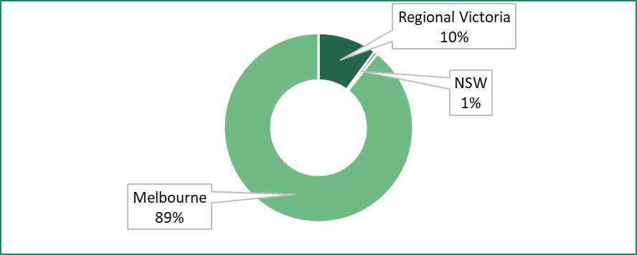
Table A.7: What is the postcode for your usual place of residence?
Answers | Responses
 | Number | %
Melbourne – northern suburbs | 123 | 23
Melbourne – inner suburbs | 120 | 23
Melbourne – south-eastern suburbs | 87 | 17
Melbourne – eastern suburbs | 75 | 14
Melbourne – western suburbs | 64 | 12
Regional – Grampians | 16 | 3
Regional – Barwon South West | 15 | 3
Regional – Loddon Mallee | 11 | 2
Regional – Gippsland | 6 | 1
Regional – Hume | 5 | 1
NSW | 3 | 1
Total | 525
Note: Respondents gave a postcode which have been sorted into the regions above.
While most respondents worked full-time, a small percentage reported they work full-time but would prefer to work part-time (Table A.8). Nearly 80 per cent of respondents who indicated they currently work full-time but would like to work part-time were women.
Table A.8: Do you work full-time or part-time?
Answer choices | Responses
 | Number | %
Full-time | 470 | 89
Part-time | 30 | 6
Full-time, but I would like to work part-time | 30 | 6
Part-time, but I would like to work full-time | 0 | 0
Total | 530
Note: The percentages in this table exceed 100 per cent due to the rounding of individual percentages to the nearest whole number.
Respondents were also asked to share the reasons why they work full-time but would prefer to work part-time. All respondents indicated that the demands of their role prevent them from working part-time. For example,
My workload is too high to work less than a 60-hour work week however I would very much like to work less (as would my family).

Pathway to a VPS executive role
Around 60 per cent of respondents were relatively new to the VPS executive workforce, having worked as a VPS executive for less than five years (Table A.9).
Table A.9: How many years in total have you been an executive within the VPS?
Answer choices | Responses
 | Number | %
Less than 5 years | 363 | 58
5-9 years | 171 | 27
10-14 years | 48 | 8
15-19 years | 25 | 4
20-24 years | 11 | 2
25 years or more | 10 | 2
Total | 628
Note: The percentages in this table exceed 100 per cent due to the rounding of individual percentages to the nearest whole number.
Respondents were asked to identify the type of position they held immediately prior to becoming a VPS executive for the first time (Table A.10):
- nearly half said they had worked at a non-executive level within the VPS
- more than a third (37 per cent) were already working at executive level when they joined the VPS executive workforce.
Table A.10: Which of the following best describes the position you held before your first VPS executive role?
Answer choices | Responses
 | Number | %
Non-executive – Victorian Public Service body | 310 | 49
Executive – Victorian public entity | 92 | 15
Executive – Victorian for-profit sector | 46 | 7
Non-executive – Victorian public entity | 38 | 6
Non-executive – Victorian for-profit sector | 26 | 4
Executive – public sector in another Australian jurisdiction | 24 | 4
Executive – Victorian not-for-profit sector | 21 | 3
Executive – international for-profit sector | 19 | 3
Executive – Victorian local government | 14 | 2
Executive – for-profit sector in another Australian jurisdiction | 7 | 1
Other | 31 | 5
Total | 628
Note: The percentages in this table add to 99 per cent due to the rounding of individual percentages to the nearest whole number.

Intention to stay
Nearly half of respondents planned to work for the VPS at executive level for over five years (Table A.11). Given the Public Administration Act 2004 (Vic) permits executive contracts of up to five years, this indicates most respondents were committed to working in the VPS for an extended period.
Conversely, over 10 per cent of respondents planned to leave the VPS executive workforce by December 2024 (one year from when the questionnaire was conducted).
Table A.11: I plan to work for the VPS at executive level for
Answer choices | Branching logic | Responses
 |  | Number | %
Over 5 years | Go to Table A.14 | 296 | 47
Over 3 years and up to 5 years | Go to Table A.14 | 133 | 21
Over 1 year and up to 3 years | Go to Table A.14 | 130 | 21
Over 6 months and up to 1 year | Go to Table A.12 | 40 | 6
6 months or less | Go to Table A.12 | 27 | 4
Total |  | 626
Of the 10 per cent that indicated they planned to leave the VPS executive workforce in 2024, nearly two thirds cited an inadequate total remuneration package (TRP) as a factor (Table A.12).
Table A.12: Which of the following most influences you to consider leaving the VPS at an executive level? Please select up to three.
Answer choices | Responses
 | Number | %
Total remuneration package is too low | 42 | 63
Workload is too high | 29 | 43
Insufficient career advancement opportunities | 24 | 36
Insufficient length of contract | 14 | 21
Insufficient professional development opportunities | 13 | 19
Other financial components of my contract (if applicable) | 8 | 12
Insufficient intellectual challenge | 8 | 12
My team or other colleagues | 7 | 10
Insufficient access to hybrid work | 5 | 7
Other | 36 | 54
Total respondents | 67
Notes: This question was only asked to respondents who answered ‘6 months or less’ or ‘Over 6 months and up to 1 year’ in Table A.11. The percentages in this table exceed 100 per cent as respondents were asked to select multiple options.
And of those who planned to leave the VPS executive workforce in 2024, over half said they would like to move to an executive position in the for-profit sector (Table A.13).
Table A.13: If you were to leave the VPS at executive level, which of the following levels of employment (executive or non-executive), and sectors would be your preference? Please select all that apply.
Answer choices | Responses
 | Number | %
Executive – Victorian for-profit sector | 34 | 52
Executive – Victorian not-for-profit sector | 22 | 34
Executive – public sector in another Australian jurisdiction | 21 | 32
Executive – Victorian public entity | 18 | 28
Executive – Victorian local government | 13 | 20
Executive – international for-profit sector | 13 | 20
Executive – international public sector | 8 | 12
Executive – for-profit sector in another Australian jurisdiction | 7 | 11
Executive – not-for-profit sector in another Australian jurisdiction | 7 | 11
Other | 37 | 57
Total respondents | 65
Branching logic – all responses go to Table A.15
Notes: This question was only asked to respondents who answered ‘6 months or less’ or ‘Over 6 months and up to 1 year’ in Table A.11. The percentages in this table exceed 100 per cent as respondents were asked to select multiple options.
Of those that indicated they planned to stay in the VPS executive workforce for at least one year, 63 per cent said this was due to the intellectual challenge their role provides them (Table A.14). Around half indicated that their TRP was another factor influencing their decision to remain in the VPS.
Table A.14: Which of the following most influences your intention to stay with the VPS at executive level? Please select up to three.
Answer choices | Responses
 | Number | %
The intellectual challenge my role provides | 346 | 63
Opportunity to contribute to the community | 337 | 61
Total remuneration package | 282 | 51
My team or other colleagues | 245 | 44
Access to hybrid work | 134 | 24
Access to other flexible work arrangements | 116 | 21
Career prestige or advancement | 87 | 16
Contract length | 70 | 13
Level of workload | 59 | 11
Other | 201 | 36
Total respondents | 553
Notes: This question was only asked to respondents who answered ‘Over 1 year and up to 3 years’, ‘Over 3 years and up to 5 years’ or ‘Over 5 years’ in Table A.11. The percentages in this table exceed 100 per cent as respondents were asked to select multiple options.

Attracting and retaining VPS executives
Respondents were asked if they were involved specifically in recruiting VPS executives (Table A.15). Those that answered ‘no’ skipped the seven questions in Tables A.16 to A.22.
Table A.15: Are you involved in recruiting VPS executives?
Answer choices | Branching logic | Responses
 |  | Number | %
Yes | Go to Table A.16 | 331 | 54
No | Go to Table A.23 | 284 | 46
Total |  | 615
Of those respondents involved in executive recruitment, two thirds indicated they were experiencing significant challenges attracting candidates within the VPS executive remuneration bands (Table A.16).
Table A.16: Are you experiencing any significant challenges attracting executives within the VPS executive remuneration bands?
Answer choices | Branching logic | Responses
 |  | Number | %
Yes | Go to Table A.17 | 220 | 66
No | Go to Table A.19 | 89 | 27
I don’t know | Go to Table A.19 | 23 | 7
Total |  | 332
Note: This question was only asked to respondents who answered ‘Yes’ in Table A.15.
A follow up question found that this group was mostly experiencing significant challenges in attracting VPS executives to project and program management roles (Table A.17).
Table A.17: What are the functional areas in which you are experiencing significant challenges in attracting VPS executives? Select all that apply.
Answer choices | Responses
 | Number | %
Project and program management | 97 | 45
Policy and strategy | 62 | 29
Engineering | 38 | 18
Digital and technology | 36 | 17
Regulation, governance and risk | 34 | 16
Legal | 32 | 15
Accounting and finance | 29 | 13
Data analytics and research | 25 | 12
Communications and community engagement | 20 | 9
Other | 121 | 56
Total respondents | 215
Notes: This question was only asked to respondents who answered ‘Yes’ in Table A.15 and ‘Yes’ in Table A.16. The answer choices were copied from the People Matter Survey questionnaire. The percentages in this table exceed 100 per cent as respondents were asked to select multiple options.
Respondents expressed that the primary disincentives for potential candidates were the TRP for the position and the contract length (Table A.18).
Table A.18: What factors do you think are affecting potential candidates’ interest in applying for, or accepting employment offers? Please select all that apply.
Answer choices | Responses
 | Number | %
Total remuneration package is too low | 193 | 89
Insufficient contract length | 59 | 27
Other | 57 | 26
Insufficient termination notice period | 28 | 13
Other financial component of the contract too low or not available | 25 | 12
Insufficient leave entitlements | 17 | 8
Insufficient access to other flexible work arrangements | 15 | 7
Insufficient access to hybrid work | 10 | 5
Office location | 6 | 3
Total respondents | 216
Notes: This question was only asked to respondents who answered ‘Yes’ in Table A.15 and ‘Yes’ in Table A.16. The percentages in this table exceed 100 per cent as respondents were asked to select multiple options.
Respondents involved in executive recruitment were also asked if they have noticed an increase in the rate of executives voluntarily leaving their organisation (Table A.19). They were asked to disregard redundancies, voluntary or otherwise.
Table A.19: Are you experiencing an increase in the rate of executives voluntarily leaving your organisation?
Answer choices | Branching logic | Responses
 |  | Number | %
Yes | Go to Table A.20 | 152 | 47
No | Go to Table A.23 | 115 | 35
I don’t know | Go to Table A.23 | 60 | 18
Total |  | 327
Note: This question was only asked to respondents who answered ‘Yes’ in Table A.15.
A follow up question asked those respondents who have experienced an increase in executives leaving their organisation what factors are at play (Table A.20). Nearly two thirds agreed TRPs being too low was a factor.
Table A.20: What factors do you think are influencing these executives to voluntarily leave? Please select up to three.
Answer choices | Responses
 | Number | %
Total remuneration package is too low | 98 | 65
Workload is too high | 87 | 58
Insufficient career advancement opportunities | 42 | 28
Insufficient contract length | 35 | 23
Other financial components of their contract too low or not available | 24 | 16
Insufficient professional development opportunities | 17 | 11
Their team or other colleagues | 14 | 9
Retirement | 9 | 6
Insufficient opportunity to contribute to the community | 7 | 5
Other (please specify) | 53 | 35
Total respondents | 150
Notes: This question was only asked to respondents who answered ‘Yes’ in Table A.15 and ‘Yes’ in Table A.19. The percentages in this table exceed 100 per cent as respondents were asked to select multiple options.
Another follow up question highlighted how retaining executives in project and program management roles is perceived to be a challenge (Table A.21).
Table A.21: What are the functional areas in which you are experiencing significant challenges in retaining executives? Select all that apply.
Answer choices | Responses
 | Number | %
Project and program management | 68 | 47
Policy and strategy | 61 | 42
Engineering | 24 | 17
Digital and technology | 23 | 16
Accounting and finance | 21 | 15
Regulation, governance and risk | 17 | 12
Business services | 16 | 11
Communications and community engagement | 15 | 10
Legal | 15 | 10
Other | 78 | 54
Total respondents | 144
Notes: This question was only asked to respondents who answered ‘Yes’ in Table A.15 and ‘Yes’ in Table A.19. The percentages in this table exceed 100 per cent as respondents were asked to select multiple options.
Of those that indicated there was an increase in executives leaving their organisation, half said executives were leaving to take up roles in the Victorian for-profit sector (Table A.22).
Table A.22: What types of roles are your executives taking up? Please select all that apply.
Answer choices | Responses
 | Number | %
Executive – Victorian for-profit sector | 73 | 50
Executive – Victorian public entity | 63 | 43
Executive – public sector in another Australian jurisdiction | 40 | 28
Executive – Victorian not-for-profit sector | 38 | 26
Executive – Victorian local government | 30 | 21
Executive – for-profit sector in another Australian jurisdiction | 25 | 17
Non-executive – Victorian for-profit sector | 11 | 8
Executive – international for-profit sector | 9 | 6
Executive – not-for-profit sector in another Australian jurisdiction | 8 | 6
Other | 41 | 28
Total respondents | 145
Notes: This question was only asked to respondents who answered ‘Yes’ in Table A.15 and ‘Yes’ in Table A.19. The percentages in this table exceed 100 per cent as respondents were asked to select multiple options.

Roles and responsibilities of VPS executives
All executives were asked to consider the eight core competencies from the VPS Executive Classification Framework (Table A.23). For most competencies, over half of the respondents reported an increase in their responsibilities, except for ‘resource management’ and ‘independence.’ However, a small number of respondents indicated a reduction in their responsibilities across each of the competencies.
Table A.23: Over the past four years, how have the following competencies changed for you in working as a VPS executive? If you have worked in more than one executive role in the last four years, please respond based on your longest role.
Competency | Responses
Knowledge:
- level of required knowledge, skills and expertise
- proficiency in your specialised discipline
- level of authority
- depth of understanding of the work environment.
Relationships:
- requirement to influence and negotiate
- interact with internal and external stakeholders
- level of sensitivity and complexity of issues and interactions.
Judgement and risk:
- level of required judgement and degree of ambiguity inherent in your position
- degree to which you must consider alternative courses of action
- level of risk to be mitigated.
Independence:
- requirement to make decisions without support
- authority and freedom to plan objectives
- requirement to contribute to or lead whole of entity strategic direction.
Strategic change:
- extent of responsibility for significant strategic change management or reform agenda
- contribution to business improvement
- impact and complexity of change.
Impact:
- scope of your position’s impact within an organisation, into the sector, across the state or national / international impact.
Breadth:
- diversity of activities
- geographical breadth of responsibility
- variety of products and services managed by the position.
Resource management:
- number of staff
- size of resources and budget.

Levels and structure of the VPS executive remuneration bands
Respondents were asked to identify factors relevant to setting the levels and structure of the VPS executive remuneration bands. They provided input through three open-ended text fields. Table A.24 displays the common key words that appeared in responses.
Table A.24: What do you consider to be relevant factors in setting the levels and structure of VPS executive remuneration bands?
Key words | Responses
Responsibility | 171
Risk | 114
Complexity | 109
Market comparison | 105
Experience | 77
Accountability | 67
Breadth | 47
Workload | 41
Cost of living and inflation | 33
Equity and fairness | 28
More than half of respondents did not consider the VPS executive remuneration bands to be competitive for the type of work that they do (Table A.25).
Table A.25: Do you consider the VPS executive remuneration bands to be competitive for the type of work that you do?
Answer choices | Responses
 | Number | %
Yes | 184 | 35
No | 292 | 55
I don’t know | 56 | 11
Total | 532
Similarly, over half (57 per cent) of respondents did not consider the difference in remuneration between non-executives and executives in the VPS to be appropriate (Table A.26).
Table A.26: Do you consider the difference in remuneration between non-executives and executives in the VPS to be appropriate?
Answer choices | Responses
 | Number | %
Yes | 173 | 33
No | 303 | 57
I don’t know | 52 | 10
Total | 528
Over half of the respondents believe the VPS executive remuneration bands align with public sector gender equality and other diversity policies (Table A.27).
Table A.27: Do you consider the VPS executive remuneration bands align with public sector gender equality and other diversity policies?
Answer choices | Responses
 | Number | %
Yes | 272 | 52
No | 95 | 18
I don’t know | 160 | 30
Total | 527
Men were significantly more likely to answer ‘Yes’ to this question, while women were significantly more likely to answer ‘No’ or ‘I don’t know’ (Figure A.2).
Figure A.2: Opinion on alignment of executive remuneration bands with gender equality and other diversity policies, by gender
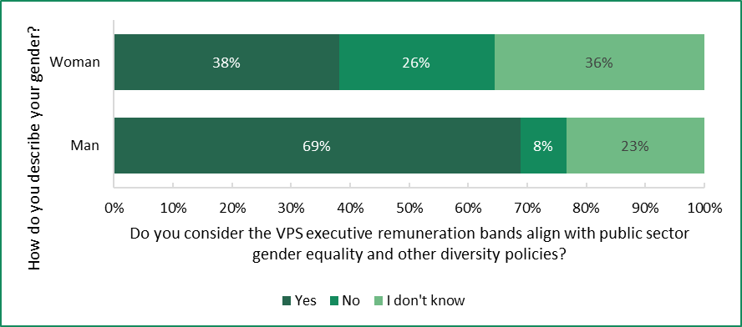
Over 60 per cent of respondents were not familiar with the Tribunal’s guidelines on placement of executives within the band.

Segment analysis
The questionnaire responses have been further analysed by classification level, gender and length of public service career.

Classification level
SES-1 level executives were significantly more likely to have worked at a non-executive level in the VPS before their first VPS executive role. SES-3 and SES-2 level executives were significantly more likely to have been an executive in the for-profit sector before their first VPS executive role (Figure A.3).
Figure A.3: Position held before first VPS executive role by classification level
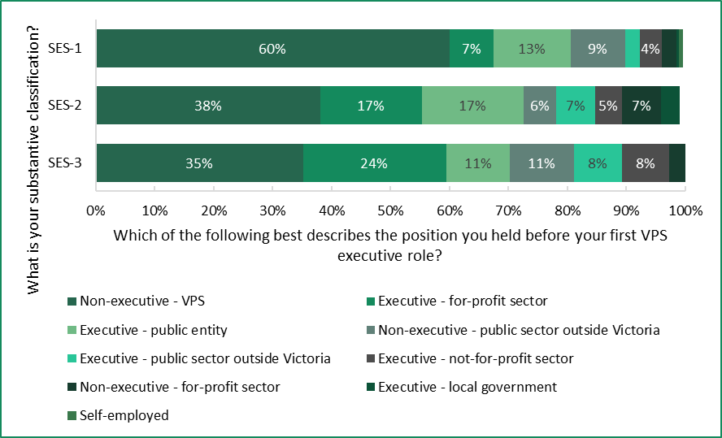
Note: Segments of 3 per cent or less are not labelled.

Gender
Of the respondents to the questionnaire, women were significantly more likely to:
- work as an SES-1 (Figure A.4)
- have been a VPS executive for 20 years or more
- have worked in the VPS at non-executive level before joining the VPS executive workforce
- work in policy and strategy
- work part-time or want to work part-time.
Of the respondents to the questionnaire, men were significantly more likely to:
- work as an SES-2 (Figure A.4)
- have started working as a VPS executive in the last 5 years
- have worked as an executive in the for-profit sector before joining the VPS executive workforce
- work in engineering or project and program management
- work full-time.
Figure A.4: Classification by gender
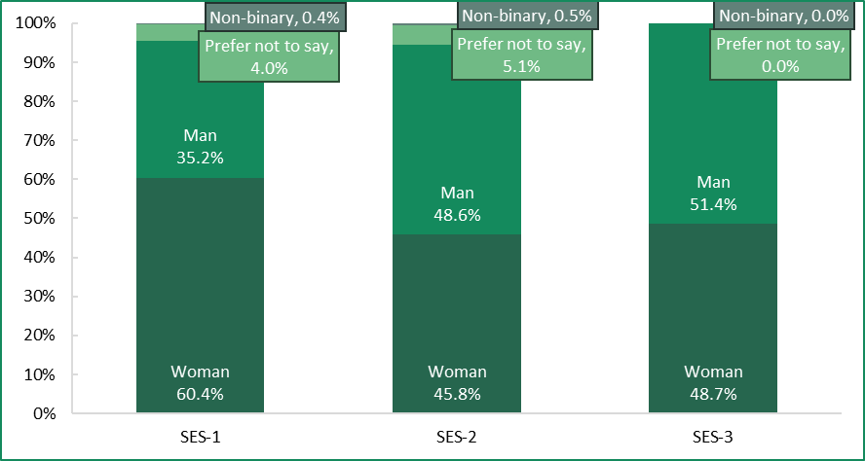
There were no significant differences between men and women respondents regarding:
- their intended tenure in the VPS executive workforce (Figure A.5)
- their views on the competitiveness of the executive remuneration bands (Figure A.6)
- their perception of the gap between non-executive and executive remuneration (Figure A.7).
Figure A.5: Intention to stay, by gender
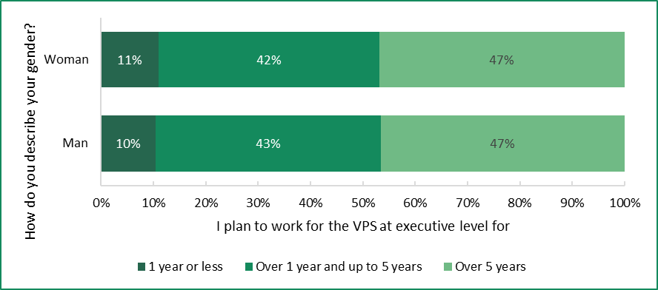
Figure A.6: Competitiveness of executive remuneration bands, by gender
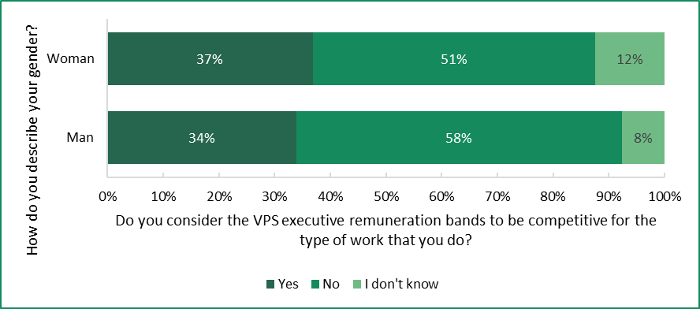
Figure A.7: Perception of gap between non-executive and executive remuneration bands, by gender
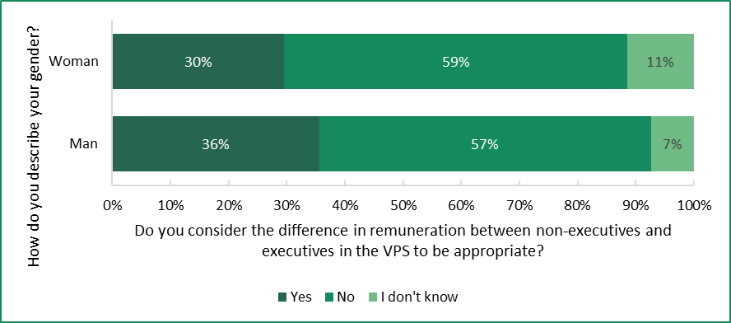

Public service careers
Those who previously held non-executive positions within the VPS were significantly more likely to plan to stay within the executive ranks of the VPS for ‘over 5 years’, compared with those who held executive roles in the for-profit sector or in a public entity. While only 15 per cent of respondents reported having served as a VPS executive for 10 years or more (see Table A.9), there appeared to be a correlation between tenure and intention to stay. For instance, respondents who have held executive positions for 10–14 years were significantly more likely to plan to stay in the executive workforce for 5 years or more than those who have been in the VPS executive workforce for less than 5 years (Figure A.8).
Figure A.8: Comparing length of time worked as a VPS executive with intention to stay
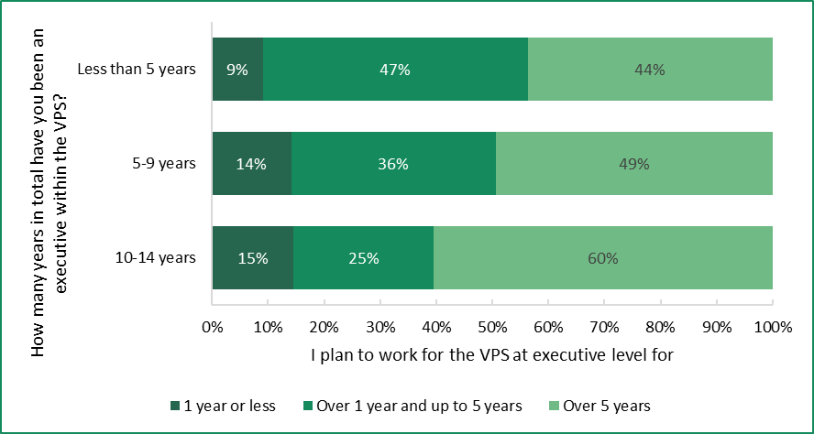
Those that consider the remuneration bands to be competitive for the work they do (see Table A.25) are significantly more likely to plan to work for the VPS at executive level for 5 years or more (Figure A.9).
Figure A.9: Comparing intention to stay and competitiveness of remuneration bands
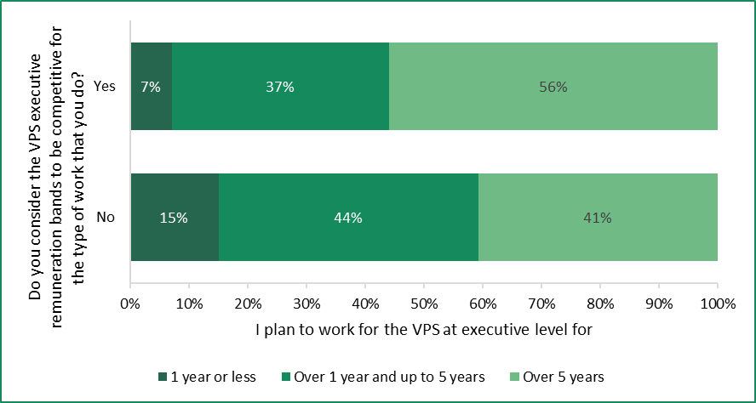

References
ABS (Australian Bureau of Statistics), (2023), National, state and territory population, December 2023.
——— (2024a), Australian National Accounts: National Income, Expenditure and Product, March 2024.
——— (2024b), Average Weekly Earnings, Australia, November 2023.
——— (2024c), Consumer Price Index, Australia, March quarter 2024.
——— (2024d), Job Vacancies, Australia, February 2024.
——— (2024e), Labour Force, Australia, May 2024.
——— (2024f), Monthly Consumer Price Index Indicator, April 2024.
——— (2024g), Overseas Migration, 2022-23 financial year.
——— (2024h), Wage Price Index, Australia, March quarter 2024.
APSC (Australian Public Service Commission) (2013), SES Evaluation Methodology — Guidelines and Workbook.
——— (2021), Performance Bonus Guidance — Principles governing performance bonus use in Commonwealth entities and companies, https://www.apsc.gov.au/circulars-guidance-and-advice/performance-bonus-guidance, last updated 13 August 2021.
——— (2022), Executive Remuneration Management Policy.
——— (2023a), Australian Government Public Sector Workplace Relations Policy 2023.
——— (2023b), Australian Public Service Remuneration Report 2022.
——— (2023c), Open letter to Australia Public Service Employees — APS bargaining 2023, https://www.apsc.gov.au/news-and-events/open-letters-australian-public-service/open-letter-australia-public-service-employees-aps-bargaining, last updated 23 November 2023.
——— (2024), Senior Executive Service performance, https://www.apsc.gov.au/working-aps/aps-employees-and-managers/senior-executive-service-ses/ses-performance, last updated 29 April 2024.
——— (n.d.), SES Performance Leadership Framework, https://www.apsc.gov.au/sites/default/files/2023-08/SES%20performance%20
leadership%20framework.pdf, accessed 21 June 2024.
ASD (Australian Signals Directorate) (2023), An introduction to Artificial Intelligence, https://www.cyber.gov.au/resources-business-and-government/
governance-and-user-education/artificial-intelligence/an-introduction-to-artificial-intelligence, last updated 24 November 2023.
Bank for International Settlements (2023), ‘Labour markets: what explains the resilience?’, https://www.bis.org/publ/qtrpdf/r_qt2312f.pdf.
Coate J (AO) (2020), COVID-19 Hotel Quarantine Inquiry, Final Report and Recommendations, Volume I.
Commonwealth of Australia (2019), Our Public Service, Our Future, Independent review of the Australian Public Service.
——— (2023a), Migration Strategy.
——— (2023b), Royal Commission into the Robodebt Scheme, Report, Volume 1.
——— (2024), Budget 2024-25 — Budget Paper No. 1: Budget Strategy and Outlook.
CSIRO (Commonwealth Scientific and Industrial Research Organisation) (n.d.), Spark: A wildfire simulation toolkit for researchers and experts in the disaster resilience field, https://research.csiro.au/spark/, accessed 9 March 2024.
Deloitte (2022), Hybrid hiccups: Moving to distributed work in the public sector, https://www.deloitte.com/global/en/our-thinking/insights/industry/government-public-services/hybrid-work-challenges.html, 14 January 2022.
Department of Employment and Workplace Relations (Cth) (2024), Trends in Federal Bargaining — December quarter 2023.
DE (Department of Education) (2023), Annual Report 2022-23.
——— (2024), Organisation chart: Department of Education, https://www.vic.gov.au/organisation-chart-department-education, last updated 23 May 2024.
DEECA (Department of Energy, Environment and Climate Action) (2023a), Annual Report 2022-23.
——— (2023b), Victorian Government action on climate change, https://www.climatechange.vic.gov.au/victorian-government-action-on-climate-change, last updated 16 May 2023.
——— (2024a), About VicGrid, https://www.energy.vic.gov.au/renewable-energy/vicgrid/about-vicgrid, last updated 27 March 2024.
——— (2024b), DEECA organisation chart, https://www.deeca.vic.gov.au/__data/
assets/pdf_file/0013/613111/DEECAOrgChart.pdf, last updated 1 March 2024.
——— (2024c), Our Ministers, https://www.deeca.vic.gov.au/our-department/
our-ministers, last updated 25 January 2024.
DFFH (Department of Families, Fairness and Housing) (2022), Free from Violence – Second Action Plan 2022–2025, https://www.vic.gov.au/free-violence-second-action-plan-2022-2025, last updated 1 June 2022.
——— (2023a), Annual Report 2022-23.
——— (2023b), Introduction — Our equal state, https://www.vic.gov.au/our-equal-state-victorias-gender-equality-strategy-and-action-plan-2023-2027/introduction-our-equal-state, last updated 24 August 2023.
——— (2024a), Department of Families, Fairness and Housing, https://www.dffh.vic.gov.au/, last updated 1 February 2024.
——— (2024b), Our structure, https://www.dffh.vic.gov.au/our-structure, last updated 6 May 2024.
——— (n.d.), Our Ministers, https://www.dffh.vic.gov.au/publications/our-ministers, accessed 7 June 2024.
DGS (Department of Government Services) (2023), Annual Report 2022-23.
——— (2024a), Department of Government Services, https://www.vic.gov.au/department-government-services, last updated 2 May 2024.
——— (2024b), DGS ministers, https://www.vic.gov.au/dgs-ministers, last updated 2 May 2024.
——— (2024c), DGS people and structure, https://www.vic.gov.au/dgs-people-and-structure, last updated 2 May 2024.
——— (2024d), DGS portfolios, entities and agencies, https://www.vic.gov.au/dgs-portfolios-entities-and-agencies#service-victoria, last updated 2 May 2024.
DH (Department of Health) (2023), Annual Report 2022-23.
——— (2024a), About the final report of the Royal Commission into Victoria’s Mental Health System, https://www.health.vic.gov.au/mental-health-reform/about-the-final-report-of-the-royal-commission-into-victorias-mental-health, last reviewed 1 February 2024.
——— (2024b), Our Ministers, https://www.health.vic.gov.au/our-ministers, last reviewed 30 May 2024.
——— (2024c), Senior management structure of the Department of Health, https://www.health.vic.gov.au/sites/default/files/2024-06/dh-senior-org-chart-june-2024.pdf, last updated 6 June 2024.
DJCS (Department of Justice and Community Safety) (2023), Annual Report 2022-23.
——— (2024), People and organisational structure, https://www.justice.vic.gov.au/people-and-organisational-structure, last reviewed 22 May 2024.
DJSIR (Department of Jobs, Skills, Industry and Regions) (2023a), Annual Report 2022-23.
——— (2023b), Our ministers and parliamentary secretaries, https://djsir.vic.gov.au/about-us/overview/our-ministers-and-parliamentary-secretaries, last updated 2 October 2023.
——— (2024), Department of Jobs, Skills, Industry and Regions – Organisational Chart, https://djsir.vic.gov.au/__data/assets/pdf_file/0007/2266531/DJSIR-Organisational-Structure-effective-15-April.pdf, page last updated 15 April 2024.
DPC (Department of Premier and Cabinet) (2023), Annual Report 2022-23.
——— (2024a), Department of Premier and Cabinet Organisational Chart (April 2024), https://content.vic.gov.au/sites/default/files/2024-04/DPC-Org-Chart-April-2024.pdf.
——— (2024b), DPC ministers, https://www.vic.gov.au/dpc-ministers, last updated 31 January 2024.
DTF (Department of Treasury and Finance) (2018), Standing Directions 2018 under the Financial Management Act 1994 (incorporating revisions to 4 September 2023), https://www.dtf.vic.gov.au/financial-management-government/standing-directions-2018-under-financial-management-act-1994, last reviewed 27 May 2024.
——— (2021), Victorian Budget 2021-22 — Budget Paper No. 3: Service Delivery.
——— (2022), Victorian Budget 2022-23 — Budget Paper No. 3: Service Delivery.
——— (2023a), Annual Report 2022-23.
——— (2023b), Victorian Budget 2023-24 — 2023-24 Budget Update.
——— (2023c), Victorian Budget 2023-24 — Budget Paper No. 3: Service Delivery.
——— (2023d), Victorian Budget 2023-24 — COVID Debt Repayment Plan.
——— (2024a), Ministers, https://www.dtf.vic.gov.au/our-people/ministers, last reviewed 5 June 2024.
——— (2024b), Organisational chart, https://www.dtf.vic.gov.au/sites/default
/files/document/DTF%20Org%20chart%20-%20DTF%20web.pdf, April 2024.
——— (2024c), Other financial aggregates, https://www.dtf.vic.gov.au/state-financial-data-sets/other-financial-aggregates, last reviewed 7 May 2024.
——— (2024d), Victorian Budget 2024-25 — Budget Paper No. 2: Strategy and Outlook.
——— (2024e), Victorian Budget 2024-25 — Budget Paper No. 3: Service Delivery.
——— (2023f), Victorian Budget 2024-25 — Budget Paper No. 4 – State Capital Program.
——— (2024g), Victorian Budget 2024-25 — Budget Paper No. 5: Statement of Finances (incorporating Quarterly Financial Report No. 3).
——— (2024h), Victorian Government submission to the Annual Wage Review 2023-24.
DTP (Department of Transport and Planning) (2023), Annual Report 2022-23.
——— (2024a), Department of Transport and Planning – Governance, https://www.vic.gov.au/department-of-transport-and-planning-governance, last updated 23 February 2024.
——— (2024b), Department of Transport and Planning — Organisation Structure, https://content.vic.gov.au/sites/default/files/2024-06/DTP-Divisional-Org-Chart-%28for-external-use%29-June-2024.pdf, last updated 3 June 2024.
FWC (Fair Work Commission) (2024), Decision — Annual Wage Review 2023-24.
Governor of Victoria (2024), Office of the Governor, https://www.governor.vic.gov.au/victorias-governor/office-governor, last reviewed 17 May 2024.
IABAC (International Association of Business Analytics Certification) (2023), AI and Privacy: Balancing Innovation with Data Protection, https://iabac.org/blog/ai-and-privacy-balancing-innovation-with-data-protection, last updated 26 July 2023.
IBAC (Independent Broad-based Anti-corruption Commission) and Victorian Ombudsman (2022), Operation Watts, Investigation into allegations of misuse of electorate office and ministerial office staff and resources for branch stacking and other party-related activities, report to the Victorian Government.
Invest Victoria (2024), About Us, https://www.invest.vic.gov.au/how-we-can-help/about-us/invest-victoria, last updated 13 February 2024.
IRV (Industrial Relations Victoria) (2023), Wages Policy and the Enterprise Bargaining Framework.
JSA (Jobs and Skills Australia) (2024a), Internet Vacancy Index, May 2024.
——— (2024b), Labour Market Update — February 2024.
——— (2024c), Labour Market Update — March 2024.
Latrobe Valley Authority (n.d.), About us, https://lva.vic.gov.au/about, accessed 20 June 2024.
LGI (Local Government Inspectorate) (2023a), Annual Report 2021-22.
——— (2023b), Chief Municipal Inspector, https://www.lgi.vic.gov.au/chief-municipal-inspector-local-government-inspectorate, last updated 15 March 2023.
Mercer (2024), Executive Remuneration Benchmarking and Advice – Secretary and Senior Executive Service, report to the Victorian Independent Remuneration Tribunal.
NSWPC (Public Service Commission) (NSW) (2014), NSW Public Service Senior Executive Work Level Standards (January 2014), https://www.psc.nsw.gov.au/sites/default/files/2020-12/NSW%20Public%20
Service%20Senior%20Executive%20Work%20Level%20Standards%20-%20Jan
%202014.pdf
——— (n.d.), Remuneration management framework 2023-2024, https://www.psc.nsw.gov.au/assets/psc/documents/2023-2024_NSW_Public_
Service_Senior_Executive_Remuneration_Framework.pdf, accessed 20 June 2024.
O’Connor R et al (2024), Artificial intelligence and complex sustainability policy problems: translating promise into practice, Policy Design and Practice.
Office of the Chief Parliamentary Counsel (2023), Office of the Chief Parliamentary Counsel, https://www.vic.gov.au/office-chief-parliamentary-counsel, last updated 3 July 2023.
Office of the Victorian Government Architect (2023), The Government Architect’s Office.
OPV (Office of Projects Victoria) (2024), Office of Projects Victoria, https://www.vic.gov.au/office-projects-victoria, last updated 13 March 2024.
OVIC (Office of the Victorian Information Commissioner) (2018), Artificial Intelligence and Privacy – Issues and Challenges, https://ovic.vic.gov.au/privacy/resources-for-organisations/artificial-intelligence-and-privacy-issues-and-challenges/#artificial-intelligence-in-the-public-sector.
OECD (Organisation for Economic Co-operation and Development) (2023), Public Employment and Management 2023: Towards a more flexible public service, https://www.oecd-ilibrary.org/governance/public-employment-and-management-2023_5b378e11-en, last updated 11 May 2023.
Parliament of Victoria (2023), Inquiry into the rental and housing affordability crisis in Victoria, Report of the Legislative Council Legal and Social Issues Committee’.
——— (2024), Inquiry into the 2021–22 and 2022–23 Financial and Performance Outcomes, Report of the Public Accounts and Estimates Committee.
PC (Productivity Commission) (2024a), Making the most of the AI opportunity: productivity, regulation and data access, https://www.pc.gov.au/
research/completed/making-the-most-of-the-ai-opportunity, last updated 1 February 2024.
——— (2024b), The right approach to AI regulation, https://www.pc.gov.au/media-speeches/articles/ai-regulation, last updated 22 February 2024.
Public Record Office Victoria (2023), About us, https://prov.vic.gov.au/about-us, last updated 11 September 2023.
QPSC (Queensland Public Sector Commission) (2023a), Contract of Employment for Senor Executive Service Officer, https://www.forgov.qld.
gov.au/__data/assets/pdf_file/0029/374726/Senior-executive-service-officer-Contract-of-Employment.pdf, last updated 1 March 2023.
——— (2023b), Queensland public sector chief executive remuneration framework, https://www.forgov.qld.gov.au/employment-policy-career-and-wellbeing/pay-benefits-and-leave/chief-executive-pay-and-benefits, last updated 14 November 2023.
——— (2023c), Senior executive service – employment conditions (Directive 09/23), https://www.forgov.qld.gov.au/pay-benefits-and-policy/directives-policies-circulars-and-guidelines/senior-executive-service-employment-conditions-directive-0923, effective 1 July 2023.
RBA (Reserve Bank of Australia) (2022), Job Mobility in Australia during the COVID-19 Pandemic.
——— (2024a), Statement on Monetary Policy — February 2024.
——— (2024b), Statement on Monetary Policy — May 2024.
Remuneration Tribunal (Cth) (2023a), Explanatory Statement: Remuneration Tribunal (Department Secretaries – Classification Structure and Terms and Conditions) Determination (No. 2) 2023.
——— (2023b), Remuneration Tribunal (Department Secretaries – Classification Structure and Terms and Conditions) Determination (No. 2) 2023.
——— (2024), 2024 Review of Remuneration for Holders of Public Office Statement, https://www.remtribunal.gov.au/sites/default/files/2024-06/2024
%20Remuneration%20Review%20Statement.pdf, last updated 17 June 2024.
Safer Care Victoria (n.d.), About us, https://www.safercare.vic.gov.au/about-us, accessed 20 June 2024.
SOORT (Statutory and Other Offices Remuneration Tribunal (NSW) (2023), Public Service Senior Executives — Annual Determination.
State Government of New South Wales (2023), Minns Government acts to freeze NSW public sector senior executive and politicians’ pay for 2 years, https://www.nsw.gov.au/media-releases/minns-government-acts-to-freeze-nsw-public-sector-senior-executive-and-politicians-pay-for-2-years, last updated 30 May 2023.
State Government of Queensland (2023), Establish or review a role’s classification level (JEMS), https://www.forgov.qld.gov.au/recruitment-performance-and-career/recruitment/start-a-recruitment-process/establish-or-review-a-roles-classification-level-jems, last reviewed 1 December 2023.
State Government of Victoria (2023a), New Wages Policy Strikes Responsible Balance For Victoria, https://www.premier.vic.gov.au/new-wages-policy-strikes-responsible-balance-victoria, last updated 4 April 2023.
——— (2023b), Cyber security in the Victorian Government, https://www.vic.gov.au/cyber-security-victorian-government, last updated 5 July 2023.
——— (2023c), Commonwealth Games Costs Too High At Over $6 Billion, https://www.premier.vic.gov.au/commonwealth-games-costs-too-high-over-6-billion, last updated 18 July 2023.
SurveyMonkey (n.d.), Statistical Significance, https://help.surveymonkey.com
/en/surveymonkey/analyze/significant-differences/, accessed 16 January 2024.
VAGO (2023a), Auditor-General’s Report on the Annual Financial Report of the State of Victoria: 2022–23.
——— (2023b) Major Projects Performance Reporting 2023.
Victorian Government Solicitor's Office (2021), About the Victorian Government Solicitor's Office, https://www.vgso.vic.gov.au/about-victorian-government-solicitors-office, last updated 7 July 2021.
Victorian Independent Remuneration Tribunal (2020a), Remuneration bands for executives employed in public service bodies (Victoria) Determination No. 01/2020.
——— (2020b), Victorian Public Service Executive Remuneration Guidelines, effective date 14 May 2020.
——— (2021), Annual Report 2020-21.
——— (2022), Annual Report 2021-22.
——— (2023a), Annual Report 2022-23.
——— (2023b), Remuneration bands for executives employed in public service bodies (Victoria) Annual Adjustment Determination 2023.
Victorian Infrastructure Delivery Authority (2024), About the Victorian Infrastructure Delivery Authority, https://bigbuild.vic.gov.au/about/vida, last updated 23 April 2024.
VPSC (Victorian Public Sector Commission) (2016), Review of Victoria’s executive officer employment and remuneration framework: summary report.
——— (2021), Standard contract for VPS executives, https://vpsc.vic.gov.au/wp-content/uploads/2020/08/VPS-Standard-Executive-Employment-Contract-July-2021-update.docx.
——— (2022a), Flexible work policy, https://vpsc.vic.gov.au/workforce-capability-leadership-and-management/flexible-work/flexible-work-policy, reviewed 23 June 2022.
——— (2022b), Officer and executive guide for informing and advising ministers, https://vpsc.vic.gov.au/ethics-behaviours-culture/inform-and-advise-ministers/officer-and-executive-guide-for-informing-and-advising-ministers/, last updated 11 November 2022.
——— (2022c), Secretaries guide for informing and advising ministers, https://vpsc.vic.gov.au/ethics-behaviours-culture/inform-and-advise-ministers/
secretaries-what-to-consider-when-advising-ministers/, last reviewed 28 October 2022.
——— (2022d), Victorian public sector, https://vpsc.vic.gov.au/ethics-behaviours-culture/codes-of-conduct/guide-for-ministerial-officers-in-the-victorian-public-sector/victorian-public-sector/, last reviewed 20 June 2022.
——— (2022e), Victorian Public Service Executive Employment Handbook, https://vpsc.vic.gov.au/executive-employment/victorian-public-service-executive-employment/victorian-public-service-executive-employment-handbook/, last reviewed 2 September 2022.
——— (2023a), Executive numbers, gender and remuneration, https://vpsc.vic.gov.au/workforce-data-state-of-the-public-sector/data-sets-and-results/past-releases/2021-workforce-data-facts-and-visuals/executive-numbers-gender-and-remuneration/, last updated 24 April 2023.
——— (2023b), Jobs and Skills Exchange Recruitment Policy.
——— (2024a), Flexible work 2023, https://vpsc.vic.gov.au/workforce-data-state-of-the-public-sector/employee-experiences-in-the-workplace-2023/flexible-work-2023/, last reviewed 17 May 2024.
——— (2024b), Machinery of Government, https://vpsc.vic.gov.au/about-public-sector/machinery-of-government/, last reviewed 30 April 2024.
——— (2024c), Number of executives, https://vpsc.vic.gov.au/data-and-research/data-facts-visuals-state-of-the-sector/executive-numbers-gender-and-remuneration/number-of-executives/, last updated 4 June 2024.
——— (2024d), Our role and our structure, https://vpsc.vic.gov.au/about-vpsc/our-role-and-structure/, last reviewed 5 March 2024.
——— (2024e), Section 11 – Administrative offices, https://vpsc.vic.gov.au/about-public-sector/register-of-instruments/orders/section-11-administrative-offices/, last reviewed 30 April 2024.
——— (2024f), Strategic plan 2023-2026, https://vpsc.vic.gov.au/about-vpsc/strategic-plan-2023-2026/, last reviewed 5 March 2024.
——— (2024g), The Victorian public sector, https://vpsc.vic.gov.au/about-public-sector/the-victorian-public-sector/, last reviewed 30 April 2024.
——— (2024h), Victorian Public Service Executive Classification Framework, https://vpsc.vic.gov.au/executive-employment/victorian-public-service-executive-employment/vps-executive-classification/vps-executive-classification-framework/, last reviewed 4 April 2024.
VSB (Victorian Secretaries Board) (2023), 2023 Integrity Statement from the Victorian Secretaries’ Board, https://www.vic.gov.au/2023-integrity-statement-victorian-secretaries-board, last updated 23 November 2023.
Victorian Skills Authority (2024), About the Victorian Skills Authority, https://www.vic.gov.au/about-victorian-skills-authority, last updated 17 May 2024.

VIRTIPS Act, s 5.
VIRTIPS Act, s 21(2).
VIRTIPS Act, s 25.
VIRTIPS Act, s 24(3).
PAA, s 25(4).
VIRTIPS Act, s 37(1)(b); PAA, s 25(4)(b).
VPSC (2021); VPSC (2022e).
PAA, s 4(1).
VPSC (2024g).
PAA, s 38.
VIRTIPS Act, s 21(1)(a) and ss 24(2)(a)-(d).
VIRTIPS Act, s 21(3).
VIRTIPS Act, s 36(6).
VIRTIPS Act, s 21.
VPSC (2022c).
VPSC (2022b).
PAA, s 4.
PAA, ss 12(2), 43(1).
VPSC (2024g).
PAA, s 13.
PAA, s 20.
FMA, ss 42, 45.
VPSC submission.
Children, Youth and Families Act 2005 (Vic), s 16(1)(b).
Children, Youth and Families Act 2005 (Vic), Div 2.
PAA, s 13.
PAA, s 13A.
PAA, s 13A(2).
DTF (2018), p. 18.
The seven public sector values are responsiveness, integrity, impartiality, accountability, respect, leadership, and human rights. PAA, s 7.
The Victorian Public Sector Commissioner and the Chief Commissioner of Victoria Police are also members of VSB. VPSC (2024g).
For example, the Head of the Victorian Infrastructure Delivery Agency is titled Director-General, and the Head of the Local Government Inspectorate is titled Chief Municipal Inspector.
PAA, s 14.
VPSC (2022f).
PAA, ss 12(2), 14.
LGI (2023b).
PAA, s 38.
VPSC (2024d).
VPSC (2024f).
VPSC (2024h).
VPSC (2024h).
The 2020 VPS Determination was published in May 2020. Consequently, it relied on 2019 data because 2020 data was not yet available.
DFFH (2024a).
DGS (2024a).
The changes to AOs since the Tribunal’s 2020 VPS Determination are: Victorian Agency for Health Information – abolished on 1 February 2021; Mental Health Reform Victoria – abolished on 1 July 2021; Family Safety Victoria – abolished on 1 November 2021; Suburban Rail Loop Authority – abolished on 1 December 2021, and established as a public entity on 1 December 2021; Bushfire Recovery Victoria – abolished on 18 October 2022; Invest Victoria – established on 8 December 2020; Victorian Skills Authority – established on 1 July 2021; VicGrid – established on 1 March 2024. VPSC (2024e).
DEECA (2023b); DH (2024a).
DFFH (2022).
DTF (2021), pp. 1, 59-65.
DTF (2022), pp. 1, 54-65, 72-87; State Government of Victoria (2023c).
DTF (2023c), pp. 1, 11-21, 54-65.
DTF (2024e), pp. 1, 46-54.
DTF (2024c); DTF (2024d), p. 53.
DTF (2024d), pp. 46-47.
DTF (2024f), pp. 7-22.
These savings are intended to be achieved through reducing corporate and back-office functions and spending less on consultants and labour hire; DTF (2003d), pp. 19-20.
DTF (2023c), p. 118.
DTF (2024e), p. 92.
Tribunal consultation with department Secretaries.
49 per cent of VPS employees who took part in the 2023 People matter survey selected ‘working from an alternative location’ as one of their flexible work arrangements. VPSC (2024a).
VPSC (2022a).
VPSC (2022a).
OECD (2023).
Deloitte (2022).
DFFH (2023b).
GE Act, ss 10, 19.
DFFH (2023b).
Coate J (AO) (2020).
Commonwealth of Australia (2019).
Commonwealth of Australia (2023b); IBAC and Victorian Ombudsman (2022).
Commonwealth of Australia (2023b).
VPSC (2022c).
VSB (2023).
VSB (2023).
Tribunal consultation with department Secretaries.
Parliament of Victoria (2024).
Tribunal consultation with department Secretaries.
Tribunal consultation with department Secretaries.
ASD (2023).
CSIRO (n.d.).
PC (2024a); PC (2024b).
OVIC (2018); IABAC (2023).
O’Connor R et al (2024), p. 2.
State Government of Victoria (2023b).
Tribunal consultation with department Secretaries.
Tribunal consultation with department Secretaries.
Parliament of Victoria (2023).
VIRTIPS Act, s 21.
VPSC (2022e).
DPC has primary responsibility for whole-of-government executive workforce policy and for the employment conditions set out in the contract.
VPSC (2022e).
In July 2021, the standard contract was updated with an additional two weeks of paid parental leave for primary caregivers. This brought the total to 16 weeks paid parental leave.
VPS EA 2020.
VPS EA 2020, clause 45.4.
VPS EA 2020.
VPSC (2021).
The work level standards are summarised in Chapter 2.
VPSC (2024h).
VPSC (2022e).
Tribunal (2020a).
Tribunal (2020a).
Tribunal (2020a), pp. 47-48.
Tribunal (2020a), p. 94.
PAA, s 25(4)(b).
VIRTIPS Act, s 6(1)(h).
Tribunal (2020b).
VPSC (2022e).
VPSC (2021).
VPSC (2022e).
VIRTIPS Act, s 37.
Bank for International Settlements (2023).
Bank for International Settlements (2023).
DTF (2024d), p. 27.
RBA (2024a), p. 23.
ABS (2024g).
Jobs and Skills Australia (2024c), p. 3.
Commonwealth of Australia (2023a), pp. 42-51.
Tribunal (2020a), p. 61.
Tribunal (2020a), p. 61.
The number of executives in public service bodies for the purpose of the 2024 VPS Determination comprises executives employed in Departments, AOs and the VPSC. Tribunal (2020a), p. 48; Tribunal analysis of VPSC data.
VPSC (2023a).
VPSC (2024c).
DTF (2023d), p. 17.
Tribunal analysis of VPSC data.
Tribunal (2020a), p. 61.
JSA (2024b), p. 24.
VPSC (2023b), JSE Recruitment Policy.
RBA (2022), p. 26.
The number of ‘suitable’ applicants does not necessarily equal the number of ‘qualified applicants’ (i.e. those who meet the minimum qualifications for the role). This is because some applicants may meet the minimum qualifications, but lack other attributes sought by the employer (e.g. employability skills, work experience).
Tribunal analysis of data published by JSA.
Tribunal (2020a), p. 62.
The Australian General Market (AGM) refers to Mercer’s remuneration database for positions within Australia, which is linked to work value. For a given work value score, the ‘nth’ percentile is the TRP value for which ‘n’ percent of positions of similar work value are paid less, and 100 minus ‘n’ per cent are paid more. For example, the 25th percentile is the TRP value for which 25 per cent of positions of similar work value are paid less, and 75 per cent are paid more.
Tribunal (2023b), p. 24.
Examples of common VPS-6 role titles are ‘Manager’ and ‘Principal Adviser’.
This was broadly consistent with a recommendation of the VPSC’s 2016 Review of Victoria’s executive officer employment and remuneration framework: summary report which called for the base of the EO-3 (now SES-1) band to be increased to create a ‘clear difference’ between the executive and non-executive remuneration ranges. When the increase to the EO-3 base took effect on 1 July 2016, the resulting remuneration gap was around nine per cent.
Tribunal (2020a), p. 93.
VPS EA 2020.
VPSC (2016), p. 6.
Mercer (2024), p. 18.
Mercer (2024), pp. 25, 27.
Mercer (2024), p. 25.
Mercer (2024), p. 25.
Mercer (2024), p. 30.
Mercer (2024), p. 26.
Remuneration Tribunal Act 1973 (Cth), Division 4.
Remuneration Tribunal (Cth) (2023b), pp. 6-7.
Remuneration Tribunal (Cth) (2023a), p. 1.
Remuneration Tribunal (Cth) (2024).
Public Service Classification Rules 2000 (Cth).
APSC (2013).
APSC (2013), p. 4.
APSC (2013), pp. 5-6.
APSC (2013), pp. 5-6.
APSC (2013), pp. 6-7.
APSC (2013), pp. 7-8.
APSC (2022), p. 1.
APSC (2022), p. 3.
APSC (2022), p. 1.
APSC (2023a), p. 6.
APSC (2023c).
APSC (n.d.).
APSC (2024).
APSC (2021).
APSC (2023b), p 21.
Public Service Act 1999 (Cth), ss 38 and 59.
Remuneration Tribunal (Cth) (2023b).
PAA, s 27.
Public Service Act (Cth) 1999, s 37.
Australian Public Service Commissioner's Directions 2022, cl. 66.
Government Sector Employment Act 2013 (NSW), ss 3, 35.
Government Sector Employment (Senior Executive Bands) Determination (NSW) 2014.
NSWPSC (n.d.).
NSWPSC (2014), p. 8.
Statutory and Other Offices Remuneration Act 1975 (NSW).
State Government of New South Wales (2023).
Statutory and Other Offices Remuneration Act 1975 (NSW), s 6AA.
SOORT (2023), pp. 8-9.
NSWPSC (n.d.), p. 13.
NSWPSC (n.d.), p. 19.
NSWPSC (n.d.), p. 13.
NSWPSC (n.d.), p. 13.
NSWPSC (n.d.), p. 14.
The Mercer CED Job Evaluation System was used to compare remuneration at the same work value points in Victoria (based on the Mercer analysis discussed in Chapter 4) and NSW (based on the remuneration framework published by the NSWPC). Mercer (2024); NSWPSC (n.d.).
NSWPSC (n.d.), p. 14.
NSWPSC (n.d.), pp. 14-15.
Statutory and Other Offices Remuneration Act 1975 (NSW), ss 24O and 24P.
NSWPSC (n.d.), p. 15.
SOORT (2023), pp. 10-11.
Government Sector Employment Act 2013 (NSW), s 41.
Government Sector Employment (General) Rules 2014 (NSW), s 42.
Government Sector Employment Regulation 2014 (NSW), cl 39.
QPSC (2023b).
QPSC (2023c).
QPSC (2023c).
State Government of Queensland (2023).
QPSC (2023c).
QPSC (2023c).
QPSC (2023c).
Public Service Act 2022 (Qld), ss 175, 191.
QPSC (2023a).
QPSC (2023a).
QPSC (2023a).
VIRTIPS Act, s 24(2).
ABS (2024a). Throughout this chapter, unless referring to an observation made by the RBA, long-run (excluding the pandemic) average refers to the average over the period from 2000 to 2019 (inclusive) as calculated by the Tribunal.
ABS (2024a).
DTF (2024d), p. 18.
ABS (2023).
ABS (2024a).
ABS (2024a).
RBA (2024b), pp. 29, 44.
ABS (2024c).
ABS (2024f).
ABS (2024c).
DTF (2024d), p. 29.
RBA (2024b), p. 28.
ABS (2024e).
ABS (2024e).
DTF (2024d), p. 27.
ABS (2024e).
ABS (2024h).
RBA (2024b), p. 29.
Department of Employment and Workplace Relations (Cth) (2024), p. 7.
FWC (2024), p. 8.
FWC (2024), p. 8.
ABS (2024h).
ABS (2024h).
DTF (2024h), p. 8.
ABS (2024a).
ABS (2024b).
ABS (2024h).
RBA (2024b), pp. 43, 51.
DTF (2024d), pp. 23-24, 26.
RBA (2024b), pp. 50-51.
RBA (2024b), pp. 44-45.
RBA (2024b), pp. 45-46.
Commonwealth of Australia (2024), pp. 53, 62.
DTF (2024d), p. 29.
RBA (2024b), pp. 43, 51.
Commonwealth of Australia (2024), p. 53.
DTF (2024d), p. 18.
RBA (2024b), pp. 28, 44, 51.
Commonwealth of Australia (2024), p. 53
DTF (2024d), p. 18.
RBA (2024b), pp. 44, 51.
RBA (2024b), pp. 5, 48-49.
RBA (2024b), pp. 48-49.
RBA (2024b), p. 5.
DTF (2024d), pp. 36-37.
DTF (2024d), p. 4.
DTF (2023d), p. 20.
DTF (2024d), p. 4.
DTF (2024d), p. 6.
DTF (2024d), p. 6.
DTF (2024d), pp. 3-4.
DTF (2024d), p. 53.
DTF (2024c); DTF (2024d), p. 53.
DTF (2024d), p. 4.
DTF (2024d), p. 53.
State Government of Victoria (2023a).
IRV (2023), p. 3.
Email from Jeremi Moule, Secretary, DPC, to VPS staff (2024), 9 April.
Branching logic is the term used when respondents are directed through different paths in the questionnaire based on their answers.
‘Completed’ in this instance means the respondent answered all mandatory questions at a minimum.
The margin of error indicates how much the questionnaire results can be expected to reflect the views of the whole cohort of VPS executives. The margin of error is a range of values above and below the actual results from the survey. For example, a 60 per cent ‘yes’ response with a margin of error of 5 per cent and a confidence interval of 99 per cent means that there is a 99 per cent probability that between 55 and 65 per cent of the whole cohort think that the answer is ‘yes’.
SurveyMonkey (n.d.).

