Remuneration Bands for Executives Employed in Prescribed Public Entities (Victoria) Determination No. 01/2024

ISBN 978-1-923295-05-6 (pdf/online/MS word)

DETERMINATION | [2024] DPPE 01
Victorian Independent Remuneration Tribunal and Improving Parliamentary Standards Act 2019 (Vic)
Part 3—Determination of the remuneration bands for executives employed in prescribed public entities.

Remuneration Bands for Executives Employed in Prescribed Public Entities Determination No. 01/2024

Table of contents
Part 1 – Legal matters and definitions
- Title
- Effective date
- Definitions
- Coverage and application
Part 2 – Remuneration bands for executives
- Values of the remuneration bands
- Remuneration band for Chief Executive Officer positions that do not meet the minimum work value score required to be classified
Statement of Reasons

Part 1 – Legal matters and definitions
- Title: This Determination is the Remuneration Bands for Executives Employed in Prescribed Public Entities (Victoria) Determination No. 01/2024 and is made under Part 3 of the Victorian Independent Remuneration Tribunal and Improving Parliamentary Standards Act 2019 (Vic) by the Victorian Independent Remuneration Tribunal.
- Effective date: This Determination takes effect on 1 July 2024.
- Definitions
  - Terms not defined in this Determination have the same meaning as in the Public Administration Act 2004 (Vic), unless the contrary intention appears.
  - In this Determination, unless the contrary intention appears:
Executive means an individual to whom the PEER Policy applies under paragraphs 4.1 and 4.2 of the PEER Policy;
FTE means Full Time Equivalent;
PAA means the Public Administration Act 2004 (Vic);
PEECF means the Public Entity Executive Classification Framework in relation to Public Entity Senior Executive Service classifications issued by the Victorian Public Sector Commission and available on its website, as amended from time to time;
PEER Policy means the Victorian Government Public Entity Executive Remuneration Policy (which is a Schedule to an Order made by the Governor in Council under section 92 of the PAA) as amended from time to time;
TRP means Total Remuneration Package, and is the sum of:
- base salary;
- superannuation contributions;
- employment benefits (i.e. non-salary) specified in the executive’s contract of employment; and
- the annual cost to the employer of providing the non-monetary benefits, including any fringe benefits tax payable; —
but for the avoidance of doubt, TRP excludes any bonus opportunity specified in the contract of employment;
Note: the PEER Policy requires that all new or renewed executive contracts entered into from 4 February 2020 must not include a bonus opportunity, subject to an exception for specific roles at Treasury Corporation of Victoria and the Victorian Funds Management Corporation. Refer to the PEER Policy for further information.
VIRTIPS Act means the Victorian Independent Remuneration Tribunal and Improving Parliamentary Standards Act 2019 (Vic);
VPSECF means the Victorian Public Service Executive Classification Framework in relation to Senior Executive Service classifications issued by the Victorian Public Sector Commission and available on its website, as amended from time to time.
- Coverage and application
  - This Determination sets the values of the remuneration bands for executives employed in prescribed public entities.

Part 2 – Remuneration bands for executives
- Values of the remuneration bands
  - Subject to clause 6, the values of the remuneration bands for executives employed in prescribed public entities are set out in Table 1.
  - The relevant remuneration band for each executive corresponds to the Public Entity Senior Executive Service, or Senior Executive Service classification, of that position determined under the PEECF or VPSECF.
Table 1: Values of remuneration bands for the Senior Executive Service
Classification | Base of band TRP  $ per annum | Top of band TRP  $ per annum
Public Entity Senior Executive Service-1 / Senior Executive Service-1 | 225,000 | 290,600
Public Entity Senior Executive Service-2 / Senior Executive Service-2 | 290,601 | 419,000
Public Entity Senior Executive Service-3 / Senior Executive Service-3 | 419,001 | 557,435
Note: the above values are for executives employed on a 1.0 FTE basis, and apply pro rata to executives employed on a part-time basis.
- Remuneration band for Chief Executive Officer positions that do not meet the minimum work value score required to be classified
  - This clause applies to Chief Executive Officers (or similar positions if not titled as such) whose positions have been assessed using the PEECF and do not meet the minimum work value score required for their classification to be determined (21 points). The values of the remuneration band for those executives are set out in Table 2.
Table 2: Values of remuneration band for Chief Executive Officers or similar with a work value score of less than 21 points
Classification | Base of band TRP  $ per annum | Top of band TRP  $ per annum
Chief executive officer with a work value score below 21 points | 157,158 | 290,600
Note: the above values are for executives employed on a 1.0 FTE basis, and apply pro rata to executives employed on a part-time basis.

 |  | 
Warren McCann  Chair  Victorian Independent Remuneration Tribunal | Laurinda Gardner  Member  Victorian Independent Remuneration Tribunal | Gregory Wilson  Member  Victorian Independent Remuneration Tribunal
Date: 19 December 2024
Contents

Remuneration Bands for Executives Employed in Prescribed Public Entities (Victoria) Determination No. 01/2024 1
Contents 5
Abbreviations and glossary 7
Executive summary 10
1 About this Determination 20
1.1 The Determination applies to executives employed in prescribed public entities 21
1.2 The executive remuneration guidelines have been updated 22
1.3 Legislative requirements 22
1.4 Stakeholder consultation 23
1.5 Structure of this Statement of Reasons 25
2 Nature and scope of public entities 26
2.1 The VPS provides advice, delivers programs and implements government decisions 26
2.2 Public entities undertake a range of functions with greater autonomy 28
2.3 The Tribunal sets remuneration bands for ‘prescribed public entities’ 32
2.4 Summary 39
3 Roles of public entity executives 40
3.1 Classification frameworks set expectations for executive roles 40
3.2 Each public entity is headed by a Chief Executive Officer (or similar) 44
3.3 Other public entity executives support the CEO 48
3.4 The public sector operating environment has changed over the past four years 49
3.5 Executives reported that most aspects of their roles had grown in the last four years 52
3.6 Summary 58

4 Existing employment and remuneration arrangements 60
4.1 Several whole of government policies guide executive employment 60
4.2 The Tribunal sets the value of the executive remuneration bands 64
4.3 Bespoke remuneration frameworks apply to some public entities 68
4.4 Employers set the remuneration of individual executives 70
4.5 Summary 72
5 Labour market considerations 74
5.1 Broader labour market conditions are tight, with some signs of easing 74
5.2 The demand for public entity executives can vary over time 75
5.3 There are some challenges in sourcing executives 76
5.4 Remuneration is a factor in the attraction and retention of executives 78
5.5 Remuneration relativities between executive and non-executive staff have narrowed 80
5.6 The remuneration bands are positioned towards the lower end of the market 82
5.7 The public sector employee value proposition is changing 86
5.8 Summary 87
6 Economic and financial considerations 89
6.1 Current economic conditions 89
6.2 Economic outlook 97
6.3 Financial position and fiscal strategy of the State of Victoria 101
6.4 Victorian Public Sector Wages Policy 106
7 Tribunal’s considerations 109
7.1 Factors supporting higher remuneration bands 110
7.2 Factors supporting restraint 114
7.3 The Tribunal’s decision 116
8 Public Entity Executive Remuneration Guidelines 121
Appendix A — summary of executive questionnaire responses 124
A.1 Questionnaire responses 125
A.2 Segment analysis 140
References 143

Abbreviations and glossary

Term or abbreviation | Definition
2020 PE Determination | Remuneration bands for executives employed in prescribed public entities (Victoria) Determination No. 01/2020
2024 PE Determination | Remuneration bands for executives employed in prescribed public entities (Victoria) Determination No. 01/2024
2024 VPS Determination | Remuneration bands for executives employed in public service bodies (Victoria) Determination No. 01/2024
2024-25 Budget | 2024-25 Victorian Budget
2024-25 Budget Update | 2024-25 Victorian Budget Update
ABS | Australian Bureau of Statistics
AO | Administrative Office
CEO | Chief Executive Officer
CPI | Australian All Groups Consumer Price Index
Cth | Commonwealth
DTF | Department of Treasury and Finance
ES | Executive Summary
EVP | Employee value proposition
FWC | Fair Work Commission
GDP | Gross Domestic Product
GGS | general government sector
GHCMA | Glenelg Hopkins Catchment Management Authority
GSP | Gross State Product
guideline rate | Premier’s annual adjustment guideline rate
IBAC | Independent Broad-based Anti-corruption Commission
ICT | information and communications technology
JSA | Jobs and Skills Australia
MD | Managing Director
Melbourne CPI | All Groups Consumer Price Index for Melbourne
MSCB | Maximum superannuation contribution base
NMW | National Minimum Wage
November 2024 Statement | Statement on Monetary Policy — November 2024 (Reserve Bank of Australia)
p.a. | per annum
PAA | Public Administration Act 2004 (Vic)
PAEC | Public Accounts and Estimates Committee
PE Guidelines | Prescribed Public Entity Executive Remuneration Guidelines
PE Handbook | Public Entity Executive Handbook
PEECF | Public Entity Executive Classification Framework
PEER Policy | Public Entity Executive Remuneration Policy
PESES executives | Executives employed in public entities, excluding those employed under Part 3 of the PAA.
prescribed public entity | A public entity to which the 2024 PE Determination applies. The Victorian Independent Remuneration Tribunal and Improving Parliamentary Standards (Prescribed Public Entities) Regulations 2019 state that all public entities are prescribed, subject to specific exclusions.
public entity | A Victorian public sector organisation that meets the criteria listed in section 5 of the PAA. Generally includes organisations that are wholly owned by the State or perform a public function on behalf of the State. For readability, the term ‘public entity’ has generally been used in this Statement when referring to a prescribed public entity.
RBA | Reserve Bank of Australia
SES | Senior Executive Service
SES executives | Executives that are employed under Part 3 of the PAA.
SG | Superannuation guarantee
Standard contract | Standard executive contract template published by the Victorian Public Sector Commission.
TAFE | Technical and Further Education institute
TCV | Treasury Corporation of Victoria
Tribunal | Victorian Independent Remuneration Tribunal
TRP | total remuneration package
VAGO | Victorian Auditor-General’s Office
VFMC | Victorian Funds Management Corporation
VIRTIPS Act | Victorian Independent Remuneration Tribunal and Improving Parliamentary Standards Act 2019 (Vic)
VMIA | Victorian Managed Insurance Authority
VPS | Victorian Public Service
VPSC | Victorian Public Sector Commission
VPSECF | Victorian Public Service Executive Classification Framework
VPS Handbook | VPS Executive Employment Handbook
VSB | Victorian Secretaries Board
Wages Policy | Wages Policy and the Enterprise Bargaining Framework
WPI | Wage Price Index

Executive summary

The Victorian Independent Remuneration Tribunal is responsible for setting remuneration bands for executives employed in prescribed public entities. This Statement of Reasons relates to the Tribunal’s second comprehensive Determination of the remuneration bands, which requires the Tribunal to review the roles and responsibilities of executives and provides an opportunity to reset the values of the bands in line with market conditions. This Determination draws on the Tribunal’s separate Determination of remuneration bands for executives employed in public service bodies, released in July 2024.

The Tribunal has increased the values of the remuneration bands
In this Determination, the Tribunal has decided to maintain a remuneration band structure for public entity executives that consists of three distinct and contiguous remuneration bands that align with the classification frameworks administered by the Victorian Public Sector Commission (VPSC). The remuneration bands are expressed in terms of a total remuneration package (TRP), including salary and employer superannuation contributions.
The values of the remuneration bands, backdated to apply from 1 July 2024, are shown in Table ES.1. The Tribunal’s decisions result in an increase of between 4.0 and 4.5 per cent to each of the values of the remuneration bands.
It is important to note that the increase in the remuneration bands are inclusive of Commonwealth Government-legislated changes to superannuation entitlements that took effect from 1 July 2024. In particular, the superannuation guarantee (SG) increased from 11 per cent to 11.5 per cent and the maximum superannuation contribution base (which caps the salary to which the SG applies) increased from $249,080 to $260,280. Victorian Government policy is for employers to bear the costs of such changes, which is reflected in an increase in each executive’s TRP. Once the impact of the superannuation changes are accounted for, the effective increase in the bands is between 3.5 per cent and 4.0 per cent.
Table ES.1: Values of the remuneration bands, as at 1 July 2024
Classification | Base of band TRP  ($ per annum) | Top of band TRP  ($ per annum)
Public Entity Senior Executive Service-1/Senior Executive Service-1 | 225,000 | 290,600
Public Entity Senior Executive Service-2/Senior Executive Service-2 | 290,601 | 419,000
Public Entity Senior Executive Service-3/Senior Executive Service-3 | 419,001 | 557,435
In limited circumstances, a Chief Executive Officer (CEO) or similar role does not meet the minimum work value score required for their classification to be determined, for example, in smaller public entities. However, the CEO role is still considered to be an executive. Table ES.2 sets out the relevant band for these roles.
Table ES.2: Values of remuneration band for Chief Executive Officers or similar with a work value score of less than 21 points, as at 1 July 2024
Classification | Base of band TRP  ($ per annum) | Top of band TRP  ($ per annum)
Chief executive officer with a work value score below 21 points | 157,158 | 290,600
The increase to the bands will not automatically result in a corresponding increase for all executives. The task of the Tribunal is to determine the values of the bands. While the remuneration for public entity executives at the bottom of each band will need to be adjusted to remain within the relevant band, responsibility for what executives are paid resides with employers taking account of the Premier’s annual adjustment guideline rate.
The Premier has determined an annual guideline rate of 3 per cent applicable from 1 July 2024. Accounting for the effect of the guideline rate and changes to statutory superannuation, the actual impact of this Determination on executives at the bottom of the band will be reduced. For an executive paid at the bottom of the PESES-1 or PESES-2 band as at 30 June 2024 and who received the guideline rate increase and the superannuation adjustment, the increase in their TRP will be 0.5 per cent. For executives paid at the base of the PESES-3 band the equivalent increase will be 1 per cent.
Following is a summary of the matters the Tribunal considered, and the weight it gave to various factors, to reach a decision about the values of the remuneration bands.
The overall analytical framework is set by the Victorian Independent Remuneration Tribunal and Improving Parliamentary Standards Act 2019 (Vic) (VIRTIPS Act) which requires that, in making a comprehensive Determination, the Tribunal must consider the following:
- the existing remuneration provided to executives
- any statement or policy issued by the Government of Victoria which is in force with respect to its wages policy
- the financial and economic position of the State
- current and projected economic conditions and trends
- submissions received in relation to the proposed Determination
- a comprehensive review of the roles of executives employed in prescribed public entities.
Detailed information and data supporting the analysis can be found in the various chapters of this statement. Chapter 2 provides an overview of the Victorian public sector and the public entities covered by the Determination. Chapter 3 discusses the roles and responsibilities of public entity executives, drawing on the Tribunal’s consultations and research. An overview of the existing employment and remuneration arrangements for executives is provided in Chapter 4.
Chapter 5 describes the executive labour market, including current demand and supply factors. In Chapter 6, relevant macroeconomic and financial considerations are detailed. Submissions received by the Tribunal, including responses to the executive questionnaire, are cited through the statement.

Factors supporting an increase in the level of the remuneration bands
The first part of this section identifies a number of factors, which taken together, provide evidence for the appropriateness of a significant increase to the remuneration bands for public entity executives. The second part sets these considerations in a broader context including the government’s wages policy and the financial and fiscal strategy of the State.
Operating environment
First, in support of an increase, there is compelling evidence in responses to the Tribunal’s questionnaire and submissions of a significant change in the roles of executives since the Tribunal’s first Determination four years ago.
Foremost amongst these are the implementation of savings and efficiency measures across government — at a time of increasing demand — and a greater focus on integrity and adherence to public sector values.
Consistent with other Australian jurisdictions and most countries throughout the world, over the period 2019-20 and 2022-23 the Victorian Government incurred significant one-off expenditures to respond to the economic and health impacts of COVID-19. The subsequent introduction of debt repayment and other measures has, and will continue to, impact public entity executives at all levels, who will find it more challenging to perform their functions at the same standard and deliver the high quality services expected of them.
Since the Tribunal’s first Determination for public entity executives in 2020, there has been an increased focus on integrity and public sector values driven by several recent inquiries and reports, which scrutinised the actions of the Australian and Victorian public sectors. While widely accepted as necessary and beneficial, the actions required to build upon and sustain a system of public integrity, embracing leadership and cultural change across all levels of an organisation, add a significant additional dimension to the executive role.
Another change in the operating environment arises from an increasing level of scrutiny of the actions of public sector executives. A high level of scrutiny, including by the integrity agencies is, and has always been, appropriate and critical to the maintenance of public trust in public bodies. The point made here is that the breadth and frequency of such scrutiny has increased significantly adding a further degree of difficulty to the daily challenges faced by executives in the course of performing their roles.
At the same time, the expectations placed on public entities by both government and the public to perform their functions effectively and deliver high quality services may not have changed, and in some cases appear to have increased. While in many respects similar to the expectations on VPS executives, the Tribunal also noted some important differences for public entity executives. Examples include the potential for direct feedback from the community on the goods and services they receive from public entities and greater department oversight of entity performance.
Complexity of the role
The Tribunal heard from stakeholders that executive roles have increased in complexity and scope over the last four years. Factors commonly cited by executives included: increased regulatory and compliance obligations, an evolving and generally heightened risk environment, legislative changes and increased complexity of stakeholder relationships.
Other factors impacting the complexity of executive roles include broader changes to working practices — particularly flexible and hybrid working arrangements. Some challenges for executives in managing a hybrid workplace include:
- building digital skills that enable executives to lead their teams regardless of the time, place or setting
- managing team performance, including having difficult conversations virtually
- adapting the physical workplace for the needs of hybrid work, such as increased use of collaborative spaces.
At the same time, there have also been specific factors that have affected particular public entities or the sectors in which they operate that have added a further level of complexity to executive roles. For example, the implementation of significant government reforms can prompt broader structural and cultural changes that amplify the impact of the factors noted above on executives.
These factors are reflected in the detailed feedback provided through the Tribunal’s executive questionnaire, which asked respondents to indicate whether elements of their roles had reduced, increased or remained unchanged over the past four years.
A majority of executives reported that seven of the eight factors that reflect the core competencies and accountabilities of their role had increased over the past four years — some by a significant margin. For example, over 80 per cent responded that the components of their role relating to ‘strategic change’ and ‘judgment and risk’ had increased. Similar responses were received for ‘relationship management’ and the ‘breadth’ of executive roles.
Market positioning and competitiveness
A further issue relates to the level of competitiveness of the Victorian public sector compared to the private sector and other public sector jurisdictions with which Victoria competes for talent. This is particularly relevant to those entities which undertake specialised functions or have a commercial focus that requires them to compete more directly with the private sector for executive talent.
As part of its 2024 Determination of public service remuneration bands, the Tribunal engaged recruitment firm Mercer Consulting to conduct a detailed analysis of the market for executives. Of particular relevance to the analysis is the positioning of the public sector in the Australian General Market (AGM).
Pay practices for public service executives in most Australian jurisdictions are generally positioned around the 15th percentile of the AGM, while in the private sector, pay practices tend to be closer to the 50th percentile (or median) of the AGM. This approach to public service remuneration reflects, in part, the value attached to non-salary benefits, such as the satisfaction that comes from the opportunity to serve the community and make a difference.
The critical part of Mercer’s analysis is that, compared to four years ago, current executive remuneration in Victoria — particularly for senior executives — has fallen further below the 15th percentile of the AGM. Given commonalities in the roles of executives in the VPS and public entities, this provides an important reference point for the Tribunal. Moreover, the importance of a high-performing public sector to the economic performance of the State means that this decline in positioning and its impact on the State’s ability to compete for talent should be viewed with some concern.
This decline in market positioning is not simply a statistical derivation. As part of the Tribunal’s questionnaire, public entity executives who are involved in the recruitment of other executives were asked to identify the factors affecting the willingness of potential candidates to apply for executive positions or accept an employment offer. Of those that reported recruitment challenges, 95 per cent listed ‘total remuneration package is too low’. These are the people who have first-hand experience of executive recruitment and are more likely to have real knowledge of contemporary market realities.
Moreover, the Tribunal heard during its roundtable consultations that adhering to the current bands has sometime led to compromise in recruitment decision-making providing further evidence supporting an uplift in the bands.

Factors supporting restraint
An increase in workload and complexity, a changing operating environment and a decline in market positioning for the public sector, taken together, provide compelling evidence for an increase in the remuneration bands for public entity executives. However, the broader context must be considered before a well-rounded and informed decision can be made.
Views of stakeholders
The first point to note is that, notwithstanding difficulties in recruitment and retention for some roles discussed above, data from responses to the Tribunal’s questionnaire and submissions did not identify any uniform push for a significant increase in the remuneration bands.
Part of the reasoning can be found in the payment above the band provision in the VIRTIPS Act. Under this provision, an employer may pay an executive above the maximum of the relevant band but first must seek and consider the advice of the Tribunal. The employer is not bound to accept the advice. The fact that relatively few public entity executives are paid above the band (around seven per cent) suggests that the bands are generally fair, equitable and competitive for the vast majority of public entity executives.
The availability of this mechanism, together with the flexibility provided by the width of the bands (up to $132,413 for the current PESES-3 band), should equip employers with the capacity to offer competitive remuneration in most cases.
Economic conditions and the financial position and fiscal strategy of the State
Economic growth has been subdued in recent years as cost-of-living pressures weigh on household spending. While growth is expected to pick up in the coming years, it is likely to be slower than previously expected.
Inflation has continued to moderate — although recent easing reflects the effect of temporary policy measures to assist households. Headline inflation is expected to increase in the near term, but to be around the mid-point of the Reserve Bank of Australia’s target range by late 2026.
Labour market conditions have eased slightly but remain tight, with strong employment growth and high rates of labour force participation. The unemployment rate has recently been stable, but is expected to increase. Reflecting these conditions, nominal wages growth has increased in recent years but has passed its peak while real wages growth has been uneven.
In relation to fiscal strategy, the Victorian Government has a five-step strategy for restoring the budget and stabilising net debt levels. This includes the government’s commitment to rebalancing the public service and bringing staffing levels back to pre-pandemic levels.
Consistent with its strategy, the Victorian Government achieved an operating cash surplus in 2022-23 and is forecasting an operating surplus from 2025-26. Net debt is predicted to increase in nominal terms through to 2027-28, but stabilise as a share of the economy from mid-2026.
Wages policy
Although the government’s current Wages Policy and the Enterprise Bargaining Framework (Wages Policy) is one of many factors the Tribunal is required to consider in making its decisions, in light of the current financial circumstances of the State and its strategies for dealing with net debt, the Tribunal felt it appropriate that the policy be given considerable weight in the decision-making process.
The Wages Policy provides that:
- increases in wages and conditions will be funded at a rate of growth of 3 per cent per annum over the life of the agreement. In practice this means that employee wages and conditions will be allowed to grow at this rate
- in addition to annual wage increases, a separate lump sum cash payment will be available equivalent to an additional 0.5 per cent of overall agreement costs.
The Tribunal’s rationale for giving some weight to Wages Policy is not related to the financial impact of any increase in the executive remuneration bands. Given the relatively small size of the public entity executive cohort compared to total public sector employment, any increase in the public entity executive remuneration bands will not have a significant impact on the budget’s bottom line, although it may have an impact in some of the smaller entities.
Rather, the challenges facing the State are considerable and a degree of discipline and a high level of adherence to policy objectives will be required to overcome them. If any group is seen to be given ‘special treatment’ it will inevitably weaken the collective effort.
The social compact
In making this decision — and indeed all decisions — the Tribunal did so having weighed the impact that its decision may have on the level of trust between the community and the Victorian public sector, if increases in remuneration for executives are perceived as out of step with community standards and expectations and prevailing economic conditions.

The Tribunal’s decision
As discussed earlier, the public sector has fallen behind movements in the AGM compared to where it was four years ago — for example, based on Mercer’s 2024 analysis of market remuneration data, the top of the PESES-3 band is now 8.4 per cent below where it would have been if it had been adjusted in line with market movements.
As indicated, the Tribunal is of the view that an increase in the remuneration bands for public entity executives is justified by the evidence and particularly if the significant changes to the operating environment and the workload and role of executives is taken into account.
However, having weighed all of the factors discussed above, and in particular current economic circumstances and the financial position of the State and the likely public reaction to significant increases in public entity executive pay at this time, it has decided to exercise restraint consistent with its VPS Determination earlier this year.
In making its decision, the Tribunal also considered whether there should be consistency with the recently determined VPS bands. The Tribunal heard that although there are many similarities between the two sectors, there are some important differences including governance arrangements, a more competitive operating environment for many entities and a degree of independence not enjoyed by the VPS.
The distinctive operating environment and governance arrangements (relative to the VPS and private sector organisations) require executives to possess a range of skills and competencies. In addition to possessing technical or specialist skills, executives may also be required to navigate the public sector context, including relationships with portfolio departments and Ministers, and engaging with the entity’s board.
On the other hand, there are a number of factors that lean towards consistency as the preferred outcome. The most important of these are as follows:
- Notwithstanding the differences referred to above, public entities are part of the one public sector with common values including a service ethos, the same professional standards, and ultimately are accountable in equal measure to the government of the day. As part of the broader executive employment framework, a common remuneration framework, will encourage entities — including those with a commercial focus — to view themselves as part of a single cohesive public sector.
- Common remuneration bands may encourage mobility across the public sector, resulting in an exchange in experience, skills and technical expertise to the benefit of the public sector as a whole.
- As discussed above, there is strong evidence that the competitive pressures experienced by some entities compared to the VPS can be accommodated by the existing payment above the band system rather than adding another band on top of the existing structure — which inevitably would result in migration into this band irrespective of competitive pressures.
- Finally, there is the question of equity. It would be unseemly to be seen to value the work of executives in one group over the other through different remuneration arrangements. A risk in such an arrangement would be that it would result in additional recruitment and retention pressures as executives in the lower paid group sought greener pastures elsewhere.
Overall, the new remuneration bands set by the Tribunal result in an increase to the current bands of between 4 and 4.5 per cent.

- About this Determination
The Victorian Independent Remuneration Tribunal provides transparent, accountable and evidence-based decision-making about the remuneration of Members of the Parliament of Victoria, public sector executives and elected local government officials.
The Tribunal was established under the Victorian Independent Remuneration Tribunal and Improving Parliamentary Standards Act 2019 (Vic) (VIRTIPS Act), which requires it to make Determinations in relation to the:
- salaries and allowances for Members of the Parliament of Victoria
- remuneration bands for executives employed in public service bodies
- remuneration bands for executives employed in prescribed public entities
- allowances provided to Mayors, Deputy Mayors and Councillors.
In performing its functions, the Tribunal must act independently and impartially and is not subject to the control or direction of any person, including the Minister.
The Tribunal made its first Determination of the remuneration bands for executives employed in prescribed public entities on 18 December 2020 — the Remuneration bands for executives employed in prescribed public entities (Victoria) Determination No. 01/2020 (2020 PE Determination). In 2021, 2022 and 2023, Determinations were made providing for an annual adjustment to the values of the remuneration bands set in the 2020 PE Determination.
The VIRTIPS Act requires a new Determination to be made at the end of each four-year period after the previous Determination was made. This means that a new Determination cannot be made until after 17 December 2024. The Tribunal does, however, have flexibility to specify when a Determination takes effect.
The Tribunal would typically have made an annual adjustment to the remuneration bands for public entity executives to apply from 1 July 2024, but did not do so given the timing of this Determination. A particular consideration therefore was whether to set a commencement date for this Determination that incorporated an annual adjustment from 1 July 2024.
The Tribunal has decided that the Remuneration bands for executives employed in prescribed public entities (Victoria) Determination No. 01/2024 (2024 PE Determination) will take effect on 1 July 2024.
Subject to the requirements of the VIRTIPS Act, the Tribunal intends to align the commencement dates for future Determinations of the remuneration bands for executives employed in public entities and in Victorian Public Service (VPS) bodies.
  - The Determination applies to executives employed in prescribed public entities
The 2024 PE Determination sets new values of the remuneration bands for executives employed in a prescribed public entity.
The definition of a prescribed public entity in the Victorian Independent Remuneration Tribunal and Improving Parliamentary Standards (Prescribed Public Entities) Regulations 2021 includes all public entities in Victoria other than those entities that have been specifically excluded, such as public health services.
The Public Entity Executive Remuneration Policy (PEER Policy) in turn sets out the employment and remuneration framework for executives employed in a prescribed public entity. The definition of an executive covered by the PEER Policy principally comprises Chief Executive Officers (CEOs), or similar positions, and other executive roles above a specific classification threshold. The definition also includes executives employed in a prescribed public entity under Part 3 of the Public Administration Act 2004 (Vic) (PAA).
The PEER Policy requires that all executives employed in a prescribed public entity must be paid within the relevant remuneration band set in this Determination.
However, employers that propose to pay an executive above the maximum of the relevant remuneration band may do so having first obtained and considered advice from the Tribunal.
  - The executive remuneration guidelines have been updated
The Tribunal is able to make guidelines for public entity employers about the placement of executives with the remuneration bands set by a Determination.
The first guidelines were made on 18 December 2020 and the Tribunal has now published updated Prescribed Public Entity Executive Remuneration Guidelines (PE Guidelines) to complement this Determination.
The PE Guidelines set out relevant factors for public entity employers to consider when setting and reviewing remuneration for an executive role, including the functions and responsibilities of the role and remuneration relativities with comparable roles.
  - Legislative requirements
The Tribunal is required to take the following matters into account in making the 2024 PE Determination:
- a review of the roles of, and the existing remuneration for, executives
- any statement or policy issued by the Government of Victoria which is in force with respect to its wages policy (or equivalent) and the remuneration and allowances of any specified occupational group
- the financial position and fiscal strategy of the State of Victoria
- current and projected economic conditions and trends
- submissions received in relation to the Determination.
The Tribunal may also provide for any other matter it considers relevant.
  - Stakeholder consultation
As required by section 24(1) of the VIRTIPS Act, prior to making the 2024 PE Determination, the Tribunal:
- published a notice of its intention to make a Determination on its website and the Victorian Public Notices website on 17 July 2024, including details about the proposed Determination
- gave any affected person or a class of affected persons a reasonable opportunity to make a submission in relation to the proposed Determination.
The Tribunal has carefully considered the submissions it received in making its Determination and expresses its appreciation to those who made submissions and otherwise contributed to the Tribunal’s work.

The notice of intention sought stakeholder views
The notice of intention invited stakeholders to make a submission on:
- changes to the role of public entities — and the role of executives — since 2020
- labour market conditions and the effect on executive recruitment and retention
- the competitiveness of the existing remuneration bands for attracting and retaining executives
- an appropriate positioning for executive remuneration against the broader labour market
- whether the existing remuneration bands are fair and equitable for employers and executives
- the relativity of remuneration for executives and non-executives employed in prescribed public entities
- the non-financial aspects, or employee value proposition (EVP), of working as an executive
- the suitability of using work classification levels to set remuneration bands
- the Tribunal’s guidelines on setting executive remuneration within the relevant remuneration band
- any other matters the Tribunal should consider.
Written submissions, which closed on 13 September 2024, were received from the following entities:
- Country Fire Authority (CFA)
- Glenelg Hopkins Catchment Management Authority (GHCMA)
- VicWater
- Victorian Managed Insurance Authority (VMIA)
- Victorian Public Sector Commission (VPSC)
- Victorian Secretaries Board (VSB).
Submissions were also received from two stakeholders that did not wish to be identified.
Submissions were published on the Tribunal’s website where permission to do so was given.

Public entity executives were invited to provide their views via a questionnaire
Executives employed in prescribed public entities were invited to make a submission via an online questionnaire. The anonymous questionnaire was sent to executives on the Tribunal’s behalf by their employers.
The Tribunal received 293 responses to the questionnaire, which is approximately 28 per cent of the executives covered by the Determination. These responses enabled the Tribunal to better understand the roles and responsibilities of executives and their views on the level and structure of the existing remuneration bands.
Appendix A summarises the responses to the questionnaire.

Roundtable discussions were held with public entity employers
In October 2024, four roundtable meetings were held with representatives from public entities. The participants — chairs, CEOs or other senior executives — were nominated by the relevant portfolio department Secretary.
These meetings sought feedback on issues such as current labour market conditions, recruitment and retention of executives, the structure and value of the remuneration bands and the Tribunal’s guidelines.
A summary of the main themes discussed at these meetings is available on the Tribunal’s website.

1.5 Structure of this Statement of Reasons
A Statement of Reasons must be included in a Determination. This Statement sets out the statutory and other factors considered by the Tribunal in making the 2024 PE Determination and other relevant information. For readability, the term ‘public entity’ has generally been used in this Statement when referring to a prescribed public entity.
Chapter 2 provides an overview of the Victorian public sector and the public entities covered by the Determination, which informed the Tribunal’s consideration of the roles of the executives employed by these entities in Chapter 3. The current employment and remuneration arrangements for public entity executives are summarised in Chapter 4.
Chapter 5 sets out the Tribunal’s understanding of the labour market for public entity executives, while Chapter 6 presents the Tribunal’s analysis of the economic, financial and policy factors that it is required to consider.
The Tribunal’s decision on the new remuneration bands for public entity executives — drawing on the preceding data and analysis — is in Chapter 7, while the changes to the Tribunal’s PE Guidelines are discussed in Chapter 8.
- Nature and scope of public entities
Victoria’s public sector comprises a large number of organisations that undertake a wide range of functions and activities. These include delivering services to the community (whether directly or via contracts with non-government bodies), collecting and managing public funds and regulating the activities of individuals, businesses and not-for-profits.
A key distinction within the public sector is between VPS bodies and public entities. The VPSC has noted that some functions previously performed by the VPS are now undertaken by public entities. Equally, functions undertaken by public entities can transition to the VPS — for example, VicRoads and Public Transport Victoria (both public entities) were merged into the then Department of Transport in 2019.
Notwithstanding these interactions, there are important differences in the operating environment, organisational form and governance arrangements for VPS bodies and public entities. Understanding these similarities and differences provides important context for considering the role of executives in public entities and the appropriate remuneration arrangements for those executives.
This chapter provides an overview of the Victorian public sector and the role of public entities, as well as a description of the public entities covered by this Determination.

2.1 The VPS provides advice, delivers programs and implements government decisions
The principal organisations within the VPS are departments and administrative offices (AOs).

Departments
Departments are the primary policy advisers and program administrators for Ministers (in respect of their portfolio responsibilities) and for the Victorian Government as a whole. Departments are responsible for implementing Ministerial and government decisions, and Ministers have ‘… extensive powers to direct and control the activities performed by their portfolio department’.
The head of a department is the Secretary who is responsible for the general conduct and the efficient, effective and economical management of the functions of their department.
Secretaries, supported by their department, also have a stewardship role and specific obligations in respect of AOs established in relation to the department and relevant public entities. These obligations include advising the responsible Minister on matters relating to the entity and working with the entity on public administration and governance.

Administrative Offices
AOs perform a defined set of functions, including infrastructure provision (the Victorian Infrastructure Delivery Authority and VicGrid) and public administration services (Victorian Government Solicitor’s Office). While some AOs are established on an ongoing or long-term basis, others may be established (and abolished) relatively quickly to undertake time-limited functions.
AOs are subject to Ministerial direction and are established in relation to a department, but are discrete business units that have a degree of autonomy.
An AO Head is appointed by the Premier and is generally responsible to the relevant Secretary for the management of the functions and activities of the AO, except where functions are conferred on the AO Head under specific legislation. An AO Head has the same functions in relation to the AO as a Secretary does in relation to a department, including the employment of staff.

2.2 Public entities undertake a range of functions with greater autonomy
The definition of a public entity under the PAA is complex (Box 2.1), but essentially comprises organisations that are wholly owned by the State or perform a public function on behalf of the State. A distinguishing feature of a public entity is that it performs its ‘… functions with some autonomy from Ministers and public servants in [its] day to day decisions’.
Box 2.1: Summary definition of ‘public entity’ under the PAA
The VPSC has summarised the definition of a public entity in section 5 of the PAA as:
… a body, whether corporate or unincorporated, that is established by:
- an Act (other than a private Act) or the Corporations Act; or
- the Governor in Council; or
- a minister.
In addition to these criteria, the [PAA] applies a further set of tests. These are summarised below.
- In the case of a body corporate, the Governor in Council or the relevant minister must have the right to appoint at least one half of the directors.
- The body must have a public function to exercise on behalf of the State or be wholly owned by the State.
- In the case of an advisory body, the body must:
  - have written terms of reference guiding its operation;
  - be required to provide the advice or report to a minister or the government; and
  - be declared to be a public entity for the purposes of the Public Administration Act.
Departments and administrative offices are not public entities.
Other bodies that are not public entities include:
- an ‘exempt’ or ‘special’ body as defined under the PAA
- a Royal Commission, Board of Inquiry or Formal Review
- certain bodies governed by the Health Services Act 1988 (Vic)
- a body or class of body specifically exempted from the PAA.
Sources: PAA, s. 5; VPSC (2022a), section 2.1.1.
The VPSC has listed several features of public entities, including those summarised below.

Public entities undertake a mix of functions
Public entities perform a range of functions in Victoria, some of which are similar to those previously — or currently — undertaken by VPS bodies. Specific public entities may specialise in a particular function or activity, while others may perform multiple functions.
Typical functions include:
- Service delivery — The provision of goods and services to the community or within the public sector, which can be delivered on a commercial (funded via user charges) or a non-commercial (funded partially or wholly by the government) basis. Examples include water and sewerage services provided by water corporations and education and training courses provided by Technical and Further Education institutes (TAFEs).
- Stewardship — Custodial or oversight functions in respect of publicly-owned assets for the long-term benefit of the community, which can include a mix of conservation, management and public access activities. An example is Phillip Island Nature Parks — an organisation which delivers conservation, research and education programs.
- Regulatory — Improving community well-being by using statutory (for example, licensing, approvals and enforcement) and behavioural (such as information campaigns) tools to change the behaviour of individuals and organisations. The Essential Services Commission, for example, regulates aspects of Victoria’s energy, transport and water sectors and oversees rate setting by local government.
- Advisory — Providing research, advisory and education services to government and the community. For example, the Victoria Law Foundation has statutory functions to undertake research and education activities and to make financial grants that improve justice outcomes.

Public entities operate with a degree of independence from government
As outlined above, public entities are established to operate with a degree of autonomy from Ministers and the VPS. This can be because, for example, a degree of independence in decision-making is desirable to build public confidence, where government may be subject to regulatory or other decisions, or to provide expert, technical advice.
The level of autonomy can vary across different public entities and in relation to different aspects of an entity’s activities. Ministerial powers are usually defined in the relevant establishing or enabling legislation for an entity.
Under the PAA, Ministers are responsible to the Parliament for the exercise of a public entity’s functions and for the exercise of their own powers with respect to the entity, which may include the appointment or removal of an entity’s director/s and directions issued to the entity.
Other requirements that define the degree of independence or autonomy of a public entity may also be specified in the statutory instrument used to establish an entity or in government policies. For example, the Statement of Expectations Framework for regulators is intended to:
… facilitate a dialogue between Ministers, departments and regulators to: identify the government’s priorities and emerging risks and to establish a process for addressing these priorities through regulators’ business planning processes.

The statutory form of a public entity varies based on its functions and oversight arrangements
The VPSC’s guidance on public entities notes a range of considerations in determining the appropriate legal form for a public entity.
The VPSC uses the general term ‘statutory authority’ to describe a public entity that is ‘… established under or by Victorian legislation’. In practice, this term encompasses a broad range of legal forms for public entities, including:
- ‘agency-specific establishing legislation’, which is typically used to establish stand-alone entities with specific objectives, functions and powers — for example, the Royal Botanic Gardens Act 1991 (Vic) establishes the Royal Botanic Gardens Board and defines its functions, powers and accountability to the responsible Minister
- ‘sector-specific enabling legislation’ that provides a framework to establish multiple entities to undertake similar activities — for example, the Catchment and Land Protection Act 1994 (Vic) establishes regional catchment management authorities and defines the functions and powers of these bodies
- ‘broader enabling legislation’, such as the State-Owned Enterprises Act 1992 (Vic), which establishes four statutory models (a ‘reorganising body’, a ‘state body’, a ‘state business corporation’ and a ‘state-owned company’) that each have different purposes and powers.
Other legal forms that can be used for public entities include a ‘non-statutory advisory body’, an incorporated association or a company established under the Corporations Act 2001 (Cth).

Different governance arrangements can apply to different public entities
The governance model for a public entity typically comprises either a multi-member board or a single-member appointment. The former appears to be generally used for larger entities with multiple functions where, for example, a mix of skills and experience may be required to oversee an entity, while the latter may be suited to smaller entities where specific functions and powers are appropriately vested in an individual.
Other governance dimensions that are defined in either the PAA or other applicable legislation include employment, financial management and accountability arrangements and the application of whole-of-government legislation or policies. Again, the specific arrangements can vary — for example, most public entities employ executives under public entity executive employment arrangements but certain entities are able to employ executives under Part 3 of the PAA.

2.3 The Tribunal sets remuneration bands for ‘prescribed public entities’
Every public entity is a ‘prescribed public entity’ for the purposes of this Determination unless specifically excluded. Entities that are not prescribed include public hospitals and public health services within the meaning of the Health Services Act 1988 (Vic), Ambulance Victoria, the Victorian Institute for Forensic Mental Health, school councils, SEC Victoria and its subsidiaries, and certain committees of management.

There are a large number of public entities operating across a range of sectors
At the time of making this Determination, there were approximately 140 prescribed public entities. However, the number of prescribed public entities varies over time as entities are created, merged or abolished. A current list of prescribed public entities is maintained by the VPSC.
To provide an overview of the public entities covered by this Determination, the Tribunal has drawn on the latest available information and data from the VPSC as at 30 June 2023 (Table 2.1). For simplicity, these public entities have been categorised into different sectors by adapting the definitions used by the VPSC.
Table 2.1: Number of prescribed public entities, employees and executives, by sector, 30 June 2023^{(a)(b)}
Sector | Number of prescribed public entities | Number of employees (headcount) | Number of executives  (headcount)
Arts | 9 | 2,796 | 38
Catchment management | 9 | 420 | 9
Cemetery trusts | 5 | 733 | 14
Commercialisation | 3 | 92 | 16
Community service | 9 | 1,432 | 33
Emergency services | 4 | 7,202 | 75
Facilities management | 9 | 1,622 | 41
Finance and insurance | 9 | 4,214 | 162
Health | 3 | 494 | 14
Land management | 9 | 2,456 | 48
Planning | 4 | 503 | 71
Regulators | 18 | 2,759 | 87
Sport and recreation | 13 | 3,173 | 63
TAFE and other education | 15 | 10,023 | 90
Transport | 5 | 3,718 | 155
Water | 19 | 7,209 | 134
Total | 143 | 48,846 | 1,050
Notes: (a) Excludes prescribed public entities that do not typically employ executives. (b) Includes entities that ceased to be a prescribed public entity after 30 June 2023 (for example, VicForests ceased operating on 30 June 2024).
Sources: VPSC (2024d); Tribunal analysis of VPSC data.
As a reference point, the Tribunal’s recent Remuneration bands for executives employed in public service bodies (Victoria) Determination No. 01/2024 (2024 VPS Determination) applied to ten departments and 13 AOs that employed (on a headcount basis) 43,615 non-executives and 1,637 executives at June 2023.
Collectively, public entities account for a significant proportion of the State of Victoria’s operating revenue and expenses, and balance sheet. Table 2.2 provides an overview of key financial data for 13 public entities identified as ‘material entities’ by the Victorian Auditor-General’s Office (VAGO).

Table 2.2: Summary financial information for ‘material’ public entities, 30 June 2024
Material entities^{(a)} | Revenue  ($m) | Expenses  ($m) | Assets  ($m) | Liabilities  ($m)
Treasury Corporation of Victoria | 172 | 50 | 175,857 | 175,528
Victorian Rail Track Corporation | 211 | 1,307 | 48,290 | 3,858
Victorian WorkCover Authority | 7,564 | 7,051 | 28,930 | 29,801
Transport Accident Commission | 4,063 | 2,596 | 20,017 | 18,475
Melbourne Water Corporation | 2,040 | 1,786 | 18,239 | 10,263
Yarra Valley Water Corporation | 1,239 | 1,064 | 6,459 | 4,675
South East Water Corporation | 1,143 | 1,037 | 5,508 | 3,589
Goulburn–Murray Rural Water Corporation | 185 | 281 | 5,261 | 733
National Gallery of Victoria | 208 | 148 | 4,827 | 61
North East Link State Tolling Corporation | 2 | 19 | 4,645 | 4,105
Victorian Managed Insurance Authority | 1,021 | 1,120 | 4,376 | 4,853
Greater Western Water | 993 | 874 | 4,190 | 3,100
Suburban Rail Loop Authority | 131 | 131 | 2,829 | 203
Note: (a) Includes entities based on ‘controlled’ revenue, expenditure, assets and liabilities.
Source: VAGO (2024), pp. D1-D3.

There have been changes to public entities since the Tribunal’s 2020 Determination
In the past four years, several public entities have been established, renamed, or abolished. For example:
- The Suburban Rail Loop Authority was established in 2019 as an AO under the then Department of Transport, and became a statutory authority in 2021 under the Suburban Rail Loop Act 2021 (Vic).
- The North East Link State Tolling Corporation was established on 1 March 2021 as a statutory corporation under the North East Link Act 2020 (Vic).
- Waste and Resource Recovery Groups were abolished on 1 July 2022 and their functions became the responsibility of Recycling Victoria within the Department of Environment, Energy and Climate Action.
- Alpine Resorts Victoria was established on 1 October 2022, replacing the four Alpine Resort Management Boards and the Alpine Resorts Coordinating Council.
- The Emergency Services Telecommunications Authority was renamed Triple Zero Victoria and established as a new statutory authority in 2023.
- The Social Services Regulator was established in February 2024 and will progressively assume responsibility for regulating the provision of certain social services, including those relating to child protection, family violence, homelessness and sexual assault.
- VicForests and the Victorian Responsible Gambling Foundation were both abolished on 30 June 2024 with all rights, property, and liabilities transferred to the State.

The size and scope of public entities continues to vary significantly
Prescribed public entities vary widely in size and scope, ranging from smaller entities with few employees — such as the Queen Victoria Women’s Centre — to large service delivery, infrastructure and financial services entities overseeing billions of dollars in assets and hundreds of employees. Below is a brief description of each sector, and examples of the entities covered by this Determination.
Arts
Entities in this sector support Victoria’s cultural landscape, fostering creativity and promoting artistic expression. For example, The Wheeler Centre serves as a hub for literary and cultural events, while the Victorian Arts Centre Trust oversees a major complex of theatres and concert halls that are home to institutions like the Australian Ballet and the Melbourne Symphony Orchestra.
Catchment management
Catchment Management Authorities — such the West Gippsland Catchment Management Authority — are responsible for planning and coordinating land, water and biodiversity activities within catchment and land protection regions.
Cemetery trusts
This sector includes all Class A Cemetery Trusts under the Cemeteries and Crematoria Act 2003 (Vic). These trusts manage and maintain Victoria’s largest public cemeteries and memorial parks, such as the Greater Metropolitan Cemeteries Trust, which oversees 19 locations across Melbourne.
Commercialisation
Entities in this sector focus on supporting innovation and economic growth. Examples are Breakthrough Victoria, which invests in new technologies and businesses to strengthen Victoria’s innovation ecosystem, and Agriculture Victoria Services, which commercialises technologies developed by the Department of Energy, Environment and Climate Action.
Community service
Entities in this sector are dedicated to improving access to important services and supporting community wellbeing. For instance, the Victorian Law Foundation works to improve public understanding of the legal system, while LanguageLoop (formerly the Victorian Interpreting and Translating Service) provides language services to Victorians with limited English proficiency, ensuring they can engage with public services and community life.
Emergency services
Entities in this sector include the CFA, which provides essential fire, rescue and emergency response services, with Triple Zero Victoria handling 24-hour emergency call-taking, dispatch and communications for all emergency services.
Facilities management
Entities in this sector are responsible for the upkeep, operation and strategic development of some of Victoria’s important public spaces and infrastructure. These organisations manage a wide variety of facilities, ranging from cultural sites and memorials to commercial activities. For example, the Shrine of Remembrance Trust manages one of Victoria’s most significant memorials, while the Melbourne Market Authority oversees the Victoria’s wholesale fruit, vegetable and flower markets and Docklands Studios Melbourne operates sound stages for film and television production.
Finance and insurance
This sector includes nine entities that principally provide services to either the community (for example, State Trustees Limited provides administration, trustee and estate-related services) or to other public sector entities (for example, the Treasury Corporation of Victoria (TCV) provides loans, short-term investment and financial advisory services for state and local government clients).
Health
Entities in this sector play a vital role in safeguarding public health, ranging from life-saving screenings to managing health purchasing and promoting public wellbeing. For instance, the Victorian Health Promotion Foundation advances public health through research, policy initiatives and health promotion campaigns.
Most executives in public healthcare entities, particularly in public hospitals, are governed by the Health Services Act 1988 (Vic) and fall outside the scope of this Determination.
Land management
Land management entities include, for example, Parks Victoria and Gippsland Ports, which are responsible for directly managing the use and protection of public land and waterways respectively. The Trust for Nature also undertakes land management activities by working with private landowners to protect and restore habitats for native wildlife and plants.
Planning
Entities in the planning sector include Development Victoria, which undertakes civic and urban renewal projects, while Infrastructure Victoria is an independent advisory body to the Victorian Government that prepares Victoria’s 30-year infrastructure strategy.
Regulators
This sector includes diverse regulators like PrimeSafe, which ensures the safety and standards of Victoria’s meat, seafood, poultry, and pet meat industries, and the Workplace Injury Commission (formerly the Accident Compensation Conciliation Service), which facilitates the resolution of workplace injury compensation disputes.
Sport and recreation
Entities in the sport and recreation sector play a crucial role in promoting active lifestyles, supporting elite athletes, and managing venues and events that are central to Victoria’s vibrant sporting culture.
This sector includes organisations like the Australian Grand Prix Corporation, which is responsible for staging motorsport events, and the Victorian Institute of Sport, which provides high-performance programs for Victoria’s top athletes. The sector also encompasses organisations dedicated to preserving natural and cultural heritage, like the Royal Botanic Gardens Board and Zoological Parks and Gardens Board, which manage important recreational spaces.
TAFE and other education
This segment includes Victoria’s 12 TAFEs and other entities that provide educational services and support for migrants to Victoria. For example, AMES Australia offers English language programs, employment services, and community engagement for migrants, refugees and asylum seekers.
Transport
Transport entities are responsible for the management, maintenance, and delivery of key infrastructure projects and transport services across Victoria. Notable examples include the Victorian Rail Track Corporation, which oversees transport assets and infrastructure, and Ports Victoria, which is responsible for maritime navigation and operational safety of Victoria’s commercial ports and certain assets, such as Station Pier.
Water
Entities in this sector deliver services related to water supply and waste water treatment. They range from large metropolitan water corporations like South East Water to regional water providers such as Barwon Region Water Corporation.

2.4 Summary
Public entities play an important role within the Victorian public sector, with a distinguishing feature being that they operate with greater autonomy than VPS bodies.
Public entities undertake a mix of functions, including service delivery, overseeing publicly owned assets, regulating organisations and individuals and providing advice. They operate across a range of sectors and under a diverse suite of legal and governance arrangements.
The diversity and complexity of these entities has informed the Tribunal’s discussion of the role of executives employed in these bodies in Chapter 3.
- Roles of public entity executives
In making this Determination, the Tribunal comprehensively reviewed the roles of executives employed in public entities, including how those roles have changed in the four years since it made the 2020 PE Determination.
As the Tribunal noted when it made the 2020 PE Determination, executives are senior leaders responsible for delivering organisational objectives. Executives must uphold and demonstrate the values of the Code of Conduct for Victorian Public Sector Employees and support their staff to achieve high performance across the sector.17F
The roles and responsibilities of public entity executives are many and varied, reflecting the diversity in functions and governance arrangements of entities within the sector.

3.1 Classification frameworks set expectations for executive roles
There are two classification frameworks — both developed by the VPSC — that apply to executive roles in public entities, including CEO roles. These are:
- the Victorian Public Service Executive Classification Framework (VPSECF), which applies to executives employed under Part 3 of the PAA, including some executives employed in public entities
- the Public Entity Executive Classification Framework (PEECF), which applies to all other executives employed in public entities.
The PEER Policy requires public entities to facilitate the classification of all executive positions using either the PEECF or VPSECF. The provisions of the PEER Policy and the remuneration bands established by the Tribunal in 2020 are discussed in Chapter 4.

Work value factors reflect core competencies and accountabilities
The PEECF and VPSECF use a consistent work value assessment methodology, where executive positions are assessed against eight work value factors (referred to as ‘work level standards’ under the VPSECF). The work value factors reflect the core competencies and accountabilities of executive roles, and include ‘knowledge’, ‘judgement and risk’ and ‘resource management’ (Table 3.1).
Table 3.1: Work value factors under the PEECF^{(a)}
Competency | Description
Knowledge | - Level of required knowledge, skills and expertise  - Proficiency in a specialised discipline  - Level of authority  - Depth of understanding of the work environment  - Whether a source of advice, and to whom
Relationships | - Requirement to influence and negotiate  - Level, frequency and quantity of interaction with stakeholders  - Assessment of the sensitivity and complexity of issues and interactions
Judgement and risk | - Complexity of decision-making and risk assessment and mitigation associated with the position  - Degree of uncertainty and ambiguity  - Criticality of judgements and risks  - Level at which the risk/judgement applies (e.g. organisational/state/nationwide)
Independence | - Requirement to make decisions without support  - Authority and freedom to plan objectives  - Requirement to contribute to or lead strategic direction of the entity
Strategic change | - Delivering change  - Extent of responsibility for, and level of complexity of, significant strategic change management  - Contribution to business improvement
Impact | - Developing policy frameworks and the strategic direction of the entity  - Scope of the position’s impact internally, into the sector, across the state or nationally/internationally
Breadth | - Diversity of activities and functions managed by the position  - Geographical breadth of responsibility  - Range of programs, projects and services managed by the position
Resource management | - Number of staff and size of resources and budget
Note: (a) The VPSECF features the same eight competencies, although some definitions vary slightly.
Source: VPSC (2022d).
As the Tribunal noted in its 2024 VPS Determination, the work value factors/work level standards are:
… indicative, rather than prescriptive, offering a broad framework for executive classification decisions … They focus on essential components, allowing flexibility for diverse positions, and require organisations to exercise judgement based on specific requirements. Definitions provided are general and need interpretation based on the unique characteristics of each position. This approach acknowledges the diversity of executive positions …
Each position is scored on a scale from one to seven for each work value factor, providing an overall ‘work value score’ of up to 56 points. This score is used to determine the classification band for the position — for example, PESES-1, PESES-2 or PESES-3 (Table 3.2). These classifications map onto the existing remuneration bands set by the Tribunal (Chapter 4).
Table 3.2: Executive classification levels and corresponding work value scores
Work value score | PEECF band | VPSECF band
21 – 35 | PESES-1 | SES-1
36 – 47 | PESES-2 | SES-2
48 – 56 | PESES-3 | SES-3
Source: VPSC (2022d); VPSC (2022g).
Under the PEER Policy, positions that score fewer than 21 points are generally not considered to be executive positions for the purposes of the Tribunal’s Determinations. There are exceptions for public entity CEOs and similar roles, which are considered to be executive positions irrespective of their work value score.
The work value factors under the PEECF are designed to capture all executive roles and, recognising the diversity of CEO roles, provide for a public entity CEO to be assessed in any of the PESES bands. In contrast, department Secretaries and the Victorian Public Sector Commissioner sit outside the classification framework (VPSECF) that applies to other executive positions in their organisations.

Executives in public entities perform diverse functions
The PEECF and VPSECF outline five work value streams, which reflect the principal functions of executives, including ‘delivery’, ‘policy’ and ‘project/portfolio and program’ (Table 3.3). While a given position may have responsibilities that span multiple work streams, the VPSC notes that the position will likely make a more significant contribution in one or two work streams.
Table 3.3: Summary of work value streams under the PEECF^{(a)}
Stream | Description
Delivery | - A principal focus for an executive active in this stream is service delivery, which could:  - include providing services within an organisation, such as financial, human resource or information technology services  - reflect the position’s responsibility for the delivery of services and policy objectives within a sector.  - This would capture many operational positions.
Policy | - The focus of this stream is policy formulation, implementation and advice.  - Other responsibilities include stakeholder consultation and articulation of policy, regulatory or financial measures and legislation.
Project^{(b)} and program | - The focus of this stream is planning, managing and implementing project and program initiatives.
Regulatory | - The focus of this steam is information gathering, risk assessment and the design and implementation of compliance and enforcement programs.
Professional/specialist | - The focus of this stream is the provision of complex professional, specialist or strategic advice with substantial risk and accountability.  - Advice is core to an entity’s business and has a primary influence on the entity’s adopted strategies, plans and targets.
Notes: (a) The VPSECF features the same five streams, although some definitions vary slightly. (b) This work value stream is called ‘project and program’ under the PEECF and ‘portfolio and program’ under the VPSECF.
Source: Adapted from VPSC (2022d).
Executive positions are not scored against each of the work streams, unlike the work value factors. However, the associated work stream descriptors — which are provided for all work streams across each of PESES/SES bands — can be used to validate the provisional classification for a position based on its work value score.

3.2 Each public entity is headed by a Chief Executive Officer (or similar)
In most cases, a public entity’s governing body (usually a board of directors) employs a CEO (or similar) to support it to fulfill its responsibilities. The governing body is accountable to the government of the day (via the responsible Minister) for the exercise of its functions, while the CEO is accountable to the board for the entity’s performance.
In some instances, the government appoints an individual to be an entity’s governing body and CEO. For example, the CEO of V/Line Corporation is appointed by the responsible Minister (in consultation with the Treasurer) and supported by an advisory board.
As a public entity’s powers and functions are usually conferred on its governing body, the latter may delegate some of these to the CEO (if separate to the governing body) and other senior staff, who then exercise them on the former’s behalf.

CEOs are responsible for the day-to-day management of their entity
According to the VPSC, the role of a public entity CEO is ‘broad’ and multidimensional, and involves substantial accountabilities.
The CEO is the head of their organisation’s executive team and is responsible for day-to-day operations of the entity. The CEO implements the strategy approved by the governing body, and ensures that the organisation’s structure and processes meet its strategic and cultural needs. For these reasons, the role of a public entity CEO has been described as being the ‘operational arm’ of the board.
All public entity CEOs share a common set of responsibilities and tasks, regardless of the entity and its operating environment (Table 3.4). These include:
- setting strategies to deliver the board’s priorities
- managing the entity’s workforce, finances and assets
- managing compliance with legislation and government policies.
The CEO is also responsible for providing accurate and timely advice to the board and the entity’s key stakeholders, including about the entity’s performance as well as emerging risks and challenges. In particular, the CEO must establish an effective working relationship with their portfolio department, which serves as the principal source of advice to the responsible Minister on matters related to the entity and provides the latter with support on administrative and governance matters. To enable departments — and specifically department Secretaries — to carry out these functions, CEOs must ensure that the entity provides information to the responsible Secretary.
Table 3.4: General responsibilities of public entity CEOs
Responsibility
Supporting the board in articulating and promoting the entity’s vision
Providing authoritative advice to the board, Minister, department, staff and stakeholders
Establishing and delivering plans that detail how the entity’s vision will lead to tangible outcomes
Managing compliance and reporting
Setting strategies to deliver the board’s priorities and meet entity obligations
Establishing and managing relationships (together with the board) with other organisations
Establishing and revising the way the entity is designed to ensure effective and efficient delivery of outcomes
Identifying and managing risk
Establishing and managing the entity’s reputation
Managing the entity’s finances and assets
Leading and managing the entity’s workforce
Establishing a productive workplace culture
Source: VPSC (2022f), pp. 17-19.
The roles of public entity CEOs also vary based on the needs of the entity and the industry and environment in which it operates. In this regard, CEO roles reflect the diversity of public entities themselves. For example:
- climate change is a particular focus for water and land management entities and some emergency services entities (e.g. CFA)
- TAFEs and other education providers must establish and maintain relationships across industries to support students undertaking vocational training
- regional entities may face particular challenges in managing the staff and resources necessary to fulfil the entity’s obligations efficiently and effectively.
The CEOs of some entities are also responsible for managing significant balance sheets and/or investment programs. WorkSafe Victoria manages the WorkCover insurance scheme and had over $29 billion in outstanding insurance claims at 30 June 2024. The North East Link State Tolling Corporation is responsible for funding the delivery and operations of the North East Link Primary Package (Tunnels), with a total estimated investment of around $14 billion.
Around 10 per cent of prescribed public entities, including many water corporations, are headed by a Managing Director (MD). In addition to fulfilling the responsibilities of a CEO described above, MDs sit on the board of their entity and perform the duties of a board director, including attending board meetings and complying with the Code of Conduct for Directors of Victorian Public Entities.
CEOs may be subject to public scrutiny
The VPSC has noted that the Victorian community has a ‘sense of ownership’ towards public entities, resulting in a high degree of public scrutiny. This may partly be related to public entities’ use of public funds and resources (although some entities operate on a partial or fully commercial basis), as well as the role played by many entities in delivering goods and services to the community.
While the governing body of an entity is ultimately accountable for its performance, CEOs — as the most senior executive and public face of their entity — may also be subject to public scrutiny.
Since 2016, some CEOs have appeared as witnesses (alongside department Secretaries and Deputy Secretaries) at Public Accounts and Estimates Committee (PAEC) inquiries into annual financial and performance outcomes. For example, the PAEC hearing held on 18 November 2024 (part of the inquiry into the 2023-24 financial and performance outcomes) featured the CEOs of six public entities, including TCV and the Essential Services Commission.
CEOs may also be required to front ad hoc parliamentary inquiries (often with the entity’s board chair), such as those held in response to a major incident or issue involving their entity. Some recent examples are:
- the MD of Melbourne Water Corporation fronted an inquiry into the 2022 Victorian flood event, including the flooding of the Maribyrnong River
- the CEO of the Game Management Authority fronted an inquiry into Victoria’s recreational native bird hunting arrangements, specifically duck and quail hunting.
In addition to scrutiny from the Parliament, the actions of public entities (including CEOs) are scrutinised by various integrity bodies, including the Victorian Ombudsman, the Independent Broad-based Anti-corruption Commission (IBAC) and VAGO.
For instance, VAGO has the power to conduct performance audits of public sector bodies, including public entities. These audits extend beyond the examination of financial statements to encompass broader issues of significance to the Victorian community, including whether a public entity is:
- meeting its aims effectively
- using its resources economically and efficiently
- complying with relevant legislation.
An example of such an audit is Reducing the Illegal Disposal of Asbestos, which was tabled in the Parliament in November 2023. This audit examined whether responsible agencies, including four public entities (the Environment Protection Authority, Parks Victoria, Sustainability Victoria and WorkSafe Victoria) had put effective measures in place to reduce the illegal disposal of asbestos. VAGO recommended specific actions, including better availability of information on legal asbestos disposal options and improved collaboration between relevant agencies to reduce illegal dumping.

3.3 Other public entity executives support the CEO
In most cases, CEOs employ other executives to support them to deliver the entity’s objectives. While the roles of individual executives vary from entity to entity and between industries, the Tribunal’s 2020 PE Determination identified the following general responsibilities, which are substantively unchanged:
- implementing strategic direction
- providing leadership and improving performance by deciding how goals will be achieved and priorities set
- providing authoritative advice to the CEO
- managing close liaison and effective relationships with stakeholders
- ensuring compliance with legislation, directives, policies, regulations and processes
- managing and mitigating risk.
Executives may be responsible for managing teams of staff and/or overseeing corporate functions, such as human resources, procurement, information and communications technology (ICT), finance and legal.
In contrast with the VPS, position titles are not standardised across public entities. According to the VPSC, this is to acknowledge the diverse nature of public entities. Nonetheless, common position titles identified by the Tribunal include:
- ‘C-level’ positions — for example, Chief Operating Officer, Chief Financial Officer and Chief Information Officer
- Executive General Manager
- General Manager
- Executive Director
- Director.
Public entities may also employ executives in specialist or ‘niche’ roles, which require specific expertise and may be unique to the entity or industry in which they operate. Examples of such roles are specialist investment roles at the Victorian Funds Management Corporation (VFMC) and TCV, Harbour Master at Ports Victoria and Chief Actuary at WorkSafe Victoria.
The Tribunal heard that the distinctive operating environment and governance arrangements of public entities (relative to the VPS and private sector organisations) require executives to possess a range of skills and competencies. In addition to possessing technical or specialist skills, executives may also be required to navigate the public sector context, including relationships with portfolio departments and Ministers, and engaging with the entity’s board.
Similarly, the Tribunal heard that executives in smaller entities may be required to ‘wear multiple hats’ — that is, they may have responsibility for a broader array of functions and activities than executives in larger entities. However, while executives in larger entities may have a narrower scope of responsibilities (as responsibilities are able to be distributed among more executive positions), they are likely to manage larger budgets and workforces.

3.4 The public sector operating environment has changed over the past four years
The Tribunal’s 2024 VPS Determination identified several changes to the public sector operating environment that have occurred in the last four years with implications for the roles of executives, including executives in public entities. These included:
- the implementation of savings and efficiency measures across government
- shifts in ways of working, including the increased prevalence of flexible and hybrid working arrangements
- government commitments to improving gender equality, diversity and inclusion
- a greater focus on integrity and adherence to public sector values.

Implementation of savings and efficiency measures
Between 2019-20 and 2022-23, the Victorian Government incurred significant one-off expenditure and revenue impacts in responding to the health and economic impacts of the COVID-19 pandemic. This included significant investments in the health system and the provision of grants and tax relief to businesses and economic assistance to households. In total, the Government has estimated the cost of those measures (excluding funding received from the Commonwealth Government) to be around $31.5 billion.
In May 2023, as part of the 2023-24 Budget, the Victorian Government announced a COVID Debt Repayment Plan to help repay the State’s COVID debt. The plan encompasses a range of savings and efficiency measures expected to generate $2.1 billion over four years. The 2024-25 Victorian Budget (2024-25 Budget) included further measures, such as the consolidation of certain services and rephasing of expenditure, expected to realise savings of $1.8 billion over five years.

Flexible and hybrid working
Another impact of the COVID-19 pandemic has been the increased prevalence of hybrid and flexible working arrangements, particularly for office-based staff. The VPSC’s Flexible work policy, which applies to all VPS staff (including executives in public entities employed under Part 3 of the PAA), states that flexible work is the Government’s ‘default position’. The policy provides examples of flexible work, including compressed work weeks, flexible start and finish times and flexible daily schedules.

Commitments to improving diversity
Under the Gender Equality Act 2020 (Vic), public sector organisations (including public entities) are required to prepare a Gender Equality Action Plan and report on progress towards improving workplace gender equality every two years. In addition, the Government’s gender equality strategy and action plan has the objectives of achieving gender parity in CEO and senior leadership positions and halving the gender pay gap within the public sector by 2028.

Greater focus on integrity
There has been an increased focus on integrity and public sector values in recent years, driven by several recent inquiries and reports which scrutinised the actions of the Australian and Victorian public sectors. These include: the judicial inquiry into Victoria’s COVID-19 Hotel Quarantine Program; the Independent Review of the Australian Public Service led by David Thodey AO; the Royal Commission into the Australian Government’s Robodebt Scheme; Operation Watts, a joint investigation by the Victorian Ombudsman and IBAC into allegations of corruption involving public officials; and the Victorian Ombudsman’s report on the alleged politicisation of the Victorian public sector.
In response, department Secretaries and the Victorian Public Sector Commissioner have issued statements and additional guidance to assist public sector executives and their staff to understand and fulfill their integrity obligations. For example, in 2024, the VPSC updated its Public sector integrity framework. The framework identified seven ‘domains of integrity’ needed to build and sustain public sector integrity, including leadership, culture and risk management. It also outlined the benefits of acting with integrity, such as increased public trust.
In addition, the Tribunal heard about factors that are specific to public entities and certain industries, or may particularly impact executives in those entities or industries. For example:
- the CFA submission highlighted the impact of the Government’s fire services reforms
- the VicWater submission cited growing risks around climate change and cyber security with implications for critical infrastructure/systems and customer data, in addition to new and enhanced regulatory obligations (e.g. the General Environmental Duty under the Environment Protection Act 2017 (Vic)).

3.5 Executives reported that most aspects of their roles had grown in the last four years
The Tribunal’s executive questionnaire asked respondents to indicate whether each of the work value factors/work level standards under the PEECF and VPSECF — which, as previously discussed, reflect the core competencies and accountabilities of executive roles — had ‘reduced’, ‘grown’ or remained ‘unchanged’ over the last four years (Figure 3.1).
A majority of respondents selected ‘grown’ for seven of the eight factors. For example, over 80 per cent of respondents reported that the components of their role related to ‘strategic change’ and ‘judgement and risk’ had grown.
Figure 3.1: Summary of responses to question 19 — changes in executive roles
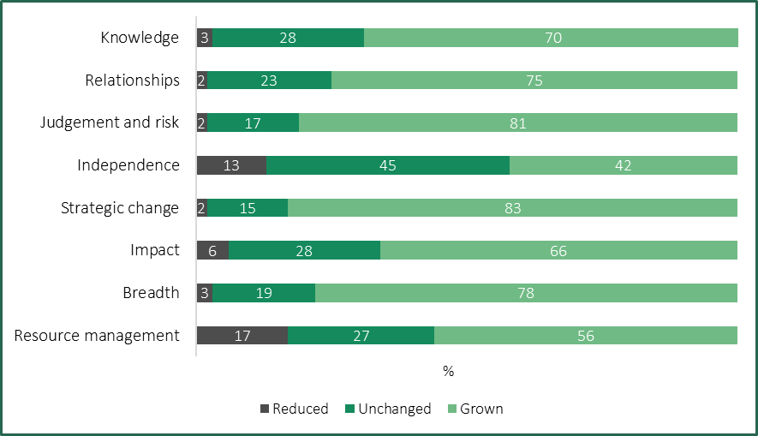
Note: The question asked was ‘Over the past four years, how have the following components of your role changed? If you have worked in more than one executive role in the last four years, please respond based on your longest role’, which received 279 responses.
Source: Tribunal analysis of data from executive questionnaire.
Of these factors, only ‘Independence’ was cited by a majority of respondents as having either reduced or remained unchanged. This suggests that some executives may feel constrained in their ability to make decisions and exercise independent judgement. According to one executive:
The last five years have seen … lower thresholds for centralised oversight … and reduced reliance on judgement as a feature of executive decision-making.
The results were broadly similar for both CEOs and other executives. However, other executives were more likely to report that their ‘independence’ had grown (49 per cent) than CEOs (25 per cent). Some CEOs specifically commented on the relationship between their entity and portfolio department, suggesting that department oversight was seen as inhibiting their entity’s independence and/or influence (Box 3.1).
Box 3.1: Extracts from the executive questionnaire — role of portfolio department
‘Direction from department is unclear, takes a long time and lacks depth (management by memo without understanding of impact). Only news from them is bad news (problems and criticism). Direction creates and amplifies clashes between its participants rather than bringing together.’

‘Often the reach in from the portfolio department does not advance the freedom to plan or promote public value outcomes, but rather inhibits through … red tape. The relationship between entity and department is inhibited by a focus … [on] oversight as opposed to collaboration, facilitation and advancing the business at hand.’

‘Our influence as an agency is progressively eroded by our lead department.’
Source: Free-text responses from CEOs to the Tribunal’s executive questionnaire.
The results also closely mirror those of the Tribunal’s earlier questionnaire sent to VPS executives, which it used to inform the 2024 VPS Determination. Indeed, VPS executives similarly reported that most components of their roles had grown over the past four years, with the exception of ‘independence’.
The remainder of this section examines two themes regarding the nature of the changes to executive roles over the past four years. These relate to resource pressures and complexity.

Budget and resource pressures appear to be increasing executive workloads
The savings and efficiency measures introduced in recent budgets have included initiatives across public entities. Depending on the entity, these can take the form of efficiency dividends, capital repatriations, grants or reduced funding.
The impact of these measures on particular public entities is difficult to quantify. However, responses to the Tribunal’s executive questionnaire indicate that some entities and/or business units are experiencing budget and resource pressures (Box 3.2). These may also reflect the lingering effects of the COVID-19 pandemic, particularly on entities that lost revenue due to pandemic-related restrictions.
Box 3.2: Extracts from the executive questionnaire — budget and resourcing pressures
CEOs
‘Financial constraint means more expected by less within own business.’

‘Challenging macro-economic environment has placed significant financial pressure on the organisation and sector, resulting in substantially lower revenue requiring large expenditure reductions, including an [organisation] restructure and across the board executive cuts and staff redundancies.’

‘Lack of government funding/ proposed budget cuts require augmentation of revenue from other sources …’
Other executives
‘Victoria’s economic climate has driven efficiency savings which can only be realised by [full-time equivalent] reduction while demand for services is increasing.’

‘There is the need to do more with less …’

‘… resourcing and budgets have shrunk in real terms …’

‘… not replacing roles lost in natural attrition as well as actively restructuring to downsize staffing costs.’

‘Budgets and resources across the board have reduced in the last 4 years.’

Source: Free-text responses to the Tribunal’s executive questionnaire.
At the same time, the expectations placed on public entities by both government and the public to perform their functions effectively and deliver high quality services may not have changed, and in some cases appear to have increased. In this respect, the submission from VicWater noted that its member organisations are required to fund and deliver major capital works programs to support a growing population, while providing ‘additional financial contributions to government through efficiency dividends’.
In some cases, budget and resource pressures were reported to be contributing to increased workloads among executives. For example, one executive who responded to the Tribunal’s questionnaire commented:
The lack of resources has meant that I have had to carry alot of tasks which I should have delegated to my team, and this has kept me away from doing more valuable work for the organisation.
Similarly, another executive said that:
The components of the role have grown … with no growth to resources or budget. In fact we’ve experienced reductions to budget …. The impact quite often is felt in work life balance i.e executives are working longer hours to keep up.

Executives reported that their roles are more complex than four years ago
Many executives who responded to the Tribunal’s questionnaire reported that their roles have increased in complexity and scope over the last four years (Box 3.3). Factors commonly cited by executives included:
- increased regulatory and compliance obligations
- an evolving and generally heightened risk environment
- legislative changes and government policies/priorities
- increased complexity of stakeholder relationships.
These factors may also be a trigger for broader organisational changes that can increase the complexity of executive roles. This is because, as the organisation’s most senior leaders, executives are expected to drive and manage such changes. For example, VicWater observed that executives in water corporations are required to manage significant organisational change programs in addition to their business-as-usual activities.
Box 3.3: Extracts from the executive questionnaire — complexity of executive roles
CEOs
‘The water sector is seeing a convergence of increasing uncertainty and complexity, coupled with an ever increasing focus on compliance, ratcheting up of regulations, and ever increasing compliance related reporting to regulators and government.’

‘The role of public entity executive[s] is expanding rapidly. Expectations to effectively manage … a wider range of risks (for example, climate change, cyber security) … requires a greater degree of innovation, strategic planning and capacity to deal with ambiguity and complexity.’

‘Changing government policy has [increased] strategic complexity and uncertainty with respect to coastal Crown land management. The impact of climate changes is already increasing public risks and complexity of risk management. Public expectations combined with policy changes have increased the complexity of relationships.’

‘The need to be across more strategic issues, changes in regulation, legislation, digitisation, societal and govt expectations, sustainability etc all contribute to an increasing complexity and changing nature of role.’
Other executives
‘The changing legislative environment increases the level of accountability of the role. I have taken on additional functions not part of my original [position description]. Risk environment continues to evolve and high level of cyber security risk.’

‘The role is becoming increasingly difficult to deliver [due] to increases in scope (new funding programs, constant [information technology] and cybersecurity changes) whilst red tape increases …’
Source: Free-text responses to the Tribunal’s executive questionnaire.
Other factors that may impact the complexity of executive roles include broader changes to working practices — particularly flexible and hybrid working arrangements.
According to the VPSC’s 2023 People matter survey, almost a third of public sector employees are choosing to work remotely at least some of the time. This increases to over 40 per cent for staff working in ‘water and land management’ and ‘TAFE and other education’, and falls to below 20 per cent for staff in ‘police and emergency services’ and ‘public health care’. This variance likely reflects the fact that it is not possible or practical for frontline staff in certain entities, particularly emergency services and health entities, to perform their roles remotely, including due to operational requirements.
Individual entities have adopted their own policies and approaches towards flexible working, in some cases as part of a broader EVP. For example, ‘flexible working’ is one of the objectives of Melbourne Water’s Diversity and Inclusion Strategy 2020-25, while the VFMC states that it has embedded hybrid and flexible working by ‘empowering teams to develop and implement Balanced Lives Team Agreements’.
While the suitability and feasibility of hybrid work will vary between entities and sectors, some challenges for executives in navigating a hybrid workplace include:
- building digital skills, which are essential to enabling leaders to share and collaborate with their employees regardless of time, place or setting
- managing performance, including having difficult conversations virtually
- accounting for the lack of incidental interaction between leaders and staff, which requires a more proactive approach to coordinating and delegating tasks
- adapting the physical workplace for the needs of hybrid work, such as increased use of collaborative spaces.

3.6 Summary
Public entity executives are senior leaders responsible for delivering their entity’s objectives.
Public entity CEOs are responsible for managing the day-to-day operations of their entity, and are accountable to the governing body for the entity’s performance. CEOs also employ entity staff, including other executives.
Executive roles vary from entity to entity and across industries. Common responsibilities of executives include managing teams of staff, delivering services and programs, developing policy, implementing compliance and enforcement programs, and providing technical or specialist advice in their areas of expertise.
The operating environment for public entities and their executives has changed since the Tribunal made its 2020 PE Determination. Executives reported that their roles have increased in scale and complexity due to increased compliance obligations, budget and resource pressures, and government priorities.
- Existing employment and remuneration arrangements

In making this Determination, the Tribunal comprehensively reviewed the existing employment arrangements and remuneration provided to executives employed in prescribed public entities.

4.1 Several whole of government policies guide executive employment
The PAA sets, or gives legal force to, several standards and policies that public entities must comply with.
These include the PEER Policy, which supports consistent and transparent executive employment and remuneration arrangements in prescribed public entities. The PEER Policy has been updated on several occasions, most recently on 4 July 2024.
Prescribed public entities are required to comply with the PEER Policy, which sets overarching requirements relating to the classification of executive roles and the remuneration of executives. It also sets mandatory contractual terms and conditions for public entity executives, which are discussed further below.
Some public entities employ some, or all, of their executives under Part 3 of the PAA, which generally applies to the employment of executives in public service bodies. While the rules that apply to executives employed under Part 3 of the PAA (SES executives) are broadly the same as for other public entity executives (PESES executives), there are several differences, which are discussed below.
The VPSC has published the Public Entity Executive Handbook (PE Handbook) to support public entities with understanding applicable executive employment policies and procedures. The VPSC’s VPS Executive Employment Handbook (VPS Handbook) provides guidance on the employment of SES executives.

The PEER Policy explains who is considered an executive
The PEER Policy defines who is considered an executive for the purpose of that policy and the Tribunal’s Determinations.
Generally, an entity’s executives include its CEO (or equivalent) and staff in roles that have been classified under the PEECF with a work value score of at least 21. If a role is yet to be classified, it is considered an executive role in the meantime if the total remuneration package (TRP) is equal to or higher than the base of the SES-1 remuneration band, which — as of 1 July 2024 — is $225,000 per annum.
Despite the above, the following staff are not considered to be executives:
- staff whose remuneration rates are specified by an award or enterprise agreement
- technical specialists who meet one of the criteria outlined above, but do not have a people management function
- statutory or prerogative office holders appointed to public entities.
The PEER Policy and the Tribunal’s Determinations also apply to SES executives employed in public entities.

Executive roles are classified using government frameworks
The PEER Policy requires public entities to facilitate the classification of all executive positions, using classification frameworks issued by the VPSC. The PEECF applies to PESES executives and the VPSECF applies to SES executives.
As explained in Chapter 3, the PEECF comprises eight work value factors that are used to determine work value scores. Each role is scored on a scale of one to seven for each factor, providing an overall work value score of up to 56. The final score determines the appropriate classification to the PESES-1, PESES-2 or PESES-3 band. The VPSECF also uses eight factors, scores each factor on a scale of one to seven to provide a work value score of up to 56, and classifies roles into three SES levels. While the PEECF aligns closely with the VPSECF, it was modified to better reflect the accountabilities and responsibilities of public entity CEOs and other executives.
The description of the work value factors in the PEECF differ from those in the VPSECF, reflecting differences between public entities and public service bodies. For example, to achieve a score of at least five for the ‘relationship’ factor, the:
- VPSECF requires the role to provide highly influential, strategic advice to Secretaries, Deputy Secretaries and Ministers
- PEECF requires the role to provide highly influential, strategic advice to the organisation Chair, departments and Ministers.
The Tribunal provided an overview of the VPSECF and the SES classification bands in its 2024 VPS Determination.
A current work value assessment must be undertaken, and the role classified, where:
- a new executive role is created
- an expiring contract is renewed
- an executive’s remuneration is adjusted, other than as a result of a whole-of-government annual adjustment process.
Prior to the introduction of the PEECF in 2020, there was no whole-of-government policy for classifying PESES executive roles. The VPSC was initially responsible for undertaking and moderating the classification of executive positions, but each public entity assumed responsibility for classifying its executive roles from July 2024. A public entity is required to consult with its portfolio department before finalising a work value assessment for a new position, or if a change to a classification for an existing position is proposed. Table 4.1 shows the distribution of executives in public entities in each classification.
Table 4.1: Distribution of executive roles by classification, as at 30 June 2023
Classification | Number of executives | Per cent of all executives
PESES-1/SES-1 | 549 | 52
PESES-2/SES-2 | 427 | 41
PESES-3/SES-3 | 73 | 7
Source: Tribunal analysis of VPSC data.

Executive contracts must include mandatory terms
The PEER Policy outlines mandatory terms which prescribed public entities must include in each executive’s employment contract (Table 4.2).
Table 4.2: Summary of mandatory employment conditions
Provision | Conditions
Contract term | Maximum contract term is up to five years.
Total remuneration package | TRP includes base salary, superannuation contributions, employment benefits (i.e. non-salary) and the annual cost to the employer of providing the non-monetary benefits, including any fringe benefits tax payable.
Termination | Employer may terminate a contract by providing the executive with four months’ notice in writing.
No compensation for termination | No compensation for termination of a contract beyond payment in lieu of notice and accrued leave. An unexpired portion of a contract may only be paid out in exceptional circumstances, with the written consent of the relevant department Secretary.
Bonus opportunities | Subject to limited exceptions, all new or renewed executive contracts entered into from 4 February 2020 must not include a bonus opportunity. The maximum bonus opportunity available to public entity executives employed before 4 February 2020 is either 17 per cent or 20 per cent.
Source: State Government of Victoria (2024c), clauses 7-8.
To support public entities, the VPSC has developed a standard contract for employing PESES executives, which incorporates the mandatory employment conditions. While use of the standard contract is not mandatory, it is strongly encouraged and the VPSC data indicates that, as at 30 June 2023, the vast majority (close to 90 per cent) of PESES executives are employed using the standard contract.
The VPSC has also developed a standard contract for VPS executives. Use of that contract is mandatory for SES executives.
As the PESES standard contract is not mandatory, employers have greater discretion in setting employment terms and conditions for individual executives, for example, in relation to leave entitlements.
In a 2018 review, the VPSC found little evidence linking bonuses to higher performance and recommended phasing them out. This recommendation was accepted by the Victorian Government and implemented in 2020 via the PEER Policy. An exemption was provided for a limited number of investment-related roles in the VFMC and TCV, which continue to be eligible for bonuses.
Public entities were required to offer to buy-out bonus opportunities from existing executive contracts. From 4 February 2020, public entities are prohibited from including bonuses in new executive contracts. As executive contracts may be no longer than five years in duration, bonus opportunities should be fully phased out by 5 February 2025. As at 30 June 2023, 30 executive roles outside of the VFMC and TCV still have a bonus opportunity.

SES executives have a right of return
Under the PAA, SES executives are entitled to a ‘right of return’ in certain circumstances. If the ‘right of return’ provision is exercised, the executive is entitled to be employed in the highest classification of a non-executive role, currently the VPS Grade 7 Senior Technical Specialist classification.
The right of return is available where an executive’s contract is terminated for reasons other than misconduct, or the contract has expired, provided that:
- the executive was employed as a non-executive VPS employee immediately prior to becoming an executive
- the executive has been continuously employed as an executive ever since.
There is no equivalent legislative provision for PESES executives.

4.2 The Tribunal sets the value of the executive remuneration bands
The PEER Policy states that public entities must ensure that the remuneration of each executive is within the relevant remuneration band set by the Tribunal. The remuneration of an executive may exceed the maximum of the relevant remuneration band only if the employer has obtained and considered the Tribunal’s advice on the proposed remuneration. The employer is not bound to accept the Tribunal’s advice.

The remuneration bands are expressed in terms of a TRP
The PEER Policy and VPS Handbook explain that for both PESES and SES executives, TRP consists of:
- base salary
- superannuation contributions
- employment benefits (i.e. non-salary)
- the annual cost to the employer of providing the non-monetary benefits, including any fringe benefits tax payable.
Each of these TRP components must be taken into account for the purpose of determining whether an executive’s remuneration falls within the relevant band set by the Tribunal.
The PE Handbook and VPS Handbook explain that executives may choose to include non-salary benefits in their TRP as part of a salary sacrifice arrangement, such as the executive vehicle scheme, a novated leasing arrangement or their employer’s health insurance scheme.
Public entities are required to make superannuation contributions for executives in line with the Superannuation Guarantee (Administration) Act 1992 (Cth). Public entities may pay higher superannuation contributions than required under Commonwealth law, for example as part of a salary sacrifice arrangement requested by an executive, under the terms of the executive’s employment contract or as part of the entity’s remuneration policy.
Some executives are members of public sector defined benefit superannuation schemes. Most of these schemes are closed to new members — the exception is the Emergency Services Superannuation Scheme, which is only open to operational emergency services workers. These schemes are established by legislation and have prescribed levels of employer and employee contributions.

Most executives are paid within the relevant band
The 2020 PE Determination established a single, unified remuneration framework for all PESES executives. The Tribunal created three distinct and contiguous remuneration bands aligned with the executive classification structure under the PEECF.
The Tribunal decided to broadly align the values of the remuneration bands for PESES executives with the values of the SES remuneration bands for executives employed in public service bodies. The key exception was that the PESES-1 band was split into two portions, with the lower portion reserved for CEOs of some small public entities and the higher portion aligned to the SES-1 band. That provided smaller public entities, in particular entities that employed a single executive, with an appropriate degree of flexibility to set their CEO’s remuneration. According to the VPSC’s data, as of 30 June 2023, four CEOs were paid in the lower portion of the band.
The 2020 PE Determination also set the remuneration bands for SES executives employed in public entities. The Tribunal noted that, as a matter of convention, that group of executives had been remunerated in accordance with the remuneration bands that applied to executives employed in public service bodies. The Tribunal chose to retain that practice when it made its 2020 PE Determination. It specified that the relevant remuneration band for an SES executive in a public entity corresponded to that for an SES executive in the latest VPS Determination.
In accordance with legislative requirements, the Tribunal made Determinations in 2021, 2022 and 2023 providing for annual adjustments to the values of the remuneration bands set in the 2020 PE Determination. The Tribunal’s annual adjustment Determinations have maintained the broad alignment of the PESES and SES remuneration bands. However, the bands have not been aligned since 1 July 2024, as a result of changes to the SES bands made by the Tribunal in its 2024 VPS Determination. The values of the PESES and SES bands before making the 2024 PE Determination are shown in Figure 4.1.
Figure 4.1: Values of the PESES and SES executive remuneration bands, from 1 July 2024
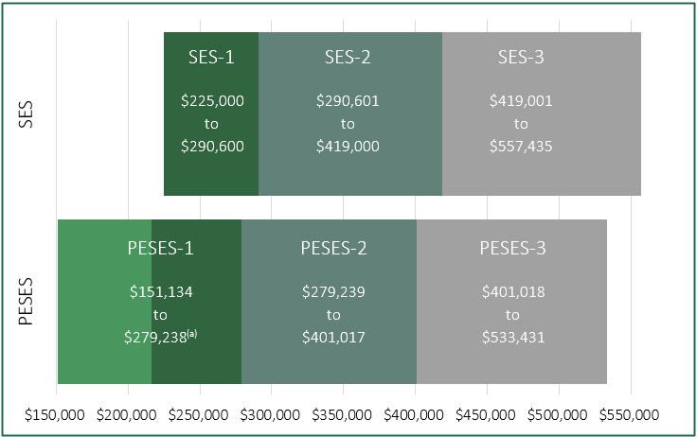
Note: (a) The lighter portion of the PESES-1 band ($151,134 to $216,375) is reserved for CEOs with a work value under 21.
Sources: Tribunal (2023), (2024).

Executives may be paid above the relevant remuneration band
Under the PEER Policy and VIRTIPS Act, a public entity may only pay an executive above the relevant remuneration band if they request and consider the Tribunal’s advice on the proposal. Advice must be sought in the case of mid-contract remuneration adjustments, reappointments, new appointments and temporary appointments.
Since the 2020 PE Determination first set the remuneration bands for executives in public entities, the Tribunal has received approximately 70 requests for advice. Around a third of the requests have come from the VFMC (Figure 4.2).
Figure 4.2: Requests for Tribunal advice, public entity executives, 2020-21 to 2024-25
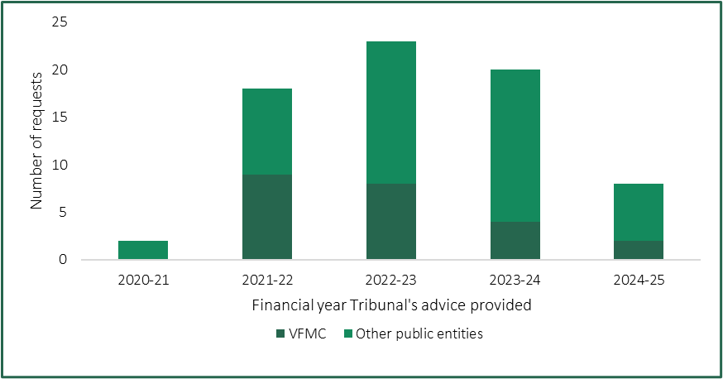
Notes: Data for 2024-25 included up to 30 November 2024. Includes requests for advice for new appointments, re-appointments and mid-contract adjustments. The Suburban Rail Loop Authority became a public entity in December 2021 and is included in the data for part of 2021-22 and subsequent financial years.
Source: Tribunal data.
Table 4.3 shows the percentage of executives paid above the band in public entities as at 30 June 2023, based on the VPSC’s executive workforce data. The Tribunal’s analysis indicates that a greater proportion of PESES-1/SES-1 and PESES-3/SES-3 executives in public entities are paid above the band than in public service bodies.
Table 4.3: Public entity executives paid above the band, as at 30 June 2023
Classification | Number | Per cent of all executives in band
PESES-1/SES-1 | 44 | 8.0
PESES-2/SES-2 | 21 | 4.9
PESES-3/SES-3 | 10 | 13.7
Source: Tribunal analysis of VPSC data.

4.3 Bespoke remuneration frameworks apply to some public entities
While the PEER Policy and remuneration bands set by the Tribunal apply to all public entities, in some cases these are supplemented by policies that are specific to a particular sector or entity. Two examples are summarised below.
The Minister for Training and Skills has issued a Ministerial Direction, which requires TAFE institutes to apply additional criteria when setting executive remuneration. The Direction sets thresholds within the remuneration bands and requires each TAFE to substantiate to the Department of Jobs, Skills, Industry and Regions that it has complied with applicable rules if setting an executive’s remuneration above the relevant threshold (Table 4.4).
Table 4.4: TAFE salary substantiation thresholds set by Ministerial Direction
Work value score | Classification (position within classification band) | Salary substantiation threshold  (% above base of remuneration band)
21 to 25 | PESES-1 (low) | 50
26 to 30 | PESES-1 (medium) | 60
31 to 35 | PESES-1 (high) | 65
36 to 39 | PESES-2 (low) | 5
40 to 43 | PESES-2 (medium) | 15
44 to 47 | PESES-2 (high) | 20
48 to 50 | PESES-3 (low) | 5
51 to 53 | PESES-3 (medium) | 15
54 to 56 | PESES-3 (high) | 20
Source: Education and Training Reform Act 2006 Ministerial Direction TAFE Institute Executive Remuneration (No. 2).
The CFA explained in its submission that it has chosen to adapt the PEECF and remuneration bands to develop its own bespoke framework. It has created sub-bands by splitting the PESES-2 and PESES-3 remuneration bands in half, in order to accommodate its executive structure and work streams (Table 4.5).
Table 4.5: CFA executive levels and remuneration ranges
Org level | Position | Benchmarked classification | Remuneration range  ($ per annum)
Corporate Services 1 | CEO | PESES-3b | 467,225 to 533,431
Chief Officer 1 | Chief Officer | PESES-3a | 401,018 to 467,225
Corporate Services 2 | Group General Manager | PESES-2b | 340,128 to 401,017
Chief Officer 2 | Deputy Chief Officer | PESES-2a | 279,239 to 340,128
Corporate Services 3 | General Manager | PESES-2a | 279,239 to 340,128
Chief Officer 3 | Head of … | PESES-1 | 216,376 to 279,238
Corporate Services 4 | Head of … | PESES-1 | 216,376 to 279,238
Source: CFA submission, p. 2.

4.4 Employers set the remuneration of individual executives
Subject to the requirements of the PEER Policy and VIRTIPS Act explained above, employers have discretion in setting an individual executive’s remuneration. For example, an employer may choose to position executive TRPs towards the base, or top of the remuneration band.
In practice, the remuneration of public entity executives tends to be distributed relatively evenly across each band, while executive remuneration in public service bodies tends to be clustered towards the bottom of each band.
Data published by the VPSC show that, between 2021 and 2023, the average TRP of public entity executives grew faster than that of public service executives.
The Tribunal compared the average and median TRP of executives in public entities and public service bodies, as at 30 June 2023 (Table 4.6). At each classification level, the average and median TRP was higher in public entities than in public service bodies. The difference was most pronounced at the PESES-3/SES-3 classification, and least pronounced at the PESES-2/SES-2 classification.
Table 4.6: Average and median TRP of executives by classification as at 30 June 2023
Classification | Public entities ($ p.a.) | Public service ($ p.a.) | Difference^{(a)} ($ p.a.)
PESES-1/SES-1 | 240/235 | 226/221 | 14/14
PESES-2/SES-2 | 316/303 | 309/300 | 6/3
PESES-3/SES-3 | 462/444 | 432/410 | 30/34
Note: (a) Discrepancies reflect the impact of rounding.
Source: Tribunal analysis of VPSC data.
The Tribunal has issued guidelines with respect to the placement of executives employed in prescribed public entities within the remuneration bands. The PE Guidelines complement this Determination by assisting employers to identify and consider relevant factors when setting and reviewing an executive’s remuneration. Stakeholder feedback on the Guidelines and the Tribunal’s changes to them are discussed in Chapter 8.
More generally, the PAA requires public sector body Heads, including public entity CEOs, to establish employment processes that ensure:
- employment decisions are based on merit
- employees are treated fairly and reasonably
- equal employment opportunity is provided
- human rights as set out in the Charter of Human Rights and Responsibilities are upheld
- public sector employees have a reasonable avenue of redress against unfair or unreasonable treatment.
The VPSC encourages public entities to establish an executive remuneration committee, to ensure that a consistent and rigorous approach is taken to setting and adjusting executive remuneration. It notes that for smaller public entities, it may be appropriate for this role to be undertaken by the entity’s board.

Executive remuneration is reviewed annually
The standard contract issued by the VPSC provides that the employer will review an executive’s remuneration on an annual basis, subject to Government policy.
Each year, the Premier sets an ‘annual adjustment guideline rate’, which is a salary increase that employers may pass on to executives and senior office holders. Employers have a general discretion to increase executive salaries by up to the guideline rate, although it is not mandatory. The guideline rate for 2024-25, which applied from 1 July 2024, is 3 per cent.
The standard contract also states that the employer may agree to undertake a remuneration review at any time, if requested by the executive. However, a review does not guarantee an increase to remuneration.
Under Commonwealth law, the minimum superannuation entitlements that employers must pay in respect of their employees periodically increase. Increases typically take effect at the start of a financial year. As explained in Box 4.2, prescribed public entities may be required to separately adjust the remuneration of their executives to take those increases into account.
Box 4.2: Increases to minimum employer superannuation contributions for executives who are members of an accumulation scheme
The superannuation guarantee (SG) and maximum superannuation contribution base (MSCB) apply to executives who are members of an accumulation scheme.
The SG is the minimum amount of employer superannuation contributions to which an employee is entitled, expressed as a percentage of the employee’s ‘ordinary time earnings’. The MSCB serves to limit the ‘ordinary time earnings’ that are used to calculate an employee’s superannuation entitlements – that is, earnings over the MSCB are not counted for the purpose of calculating entitlements.
The superannuation entitlements of executives in an accumulation scheme may change from year to year due to the indexation of the MSCB or changes to the SG rate.
On 1 July 2024:
- the SG rate increased from 11 per cent to 11.5 per cent
- the MSCB increased from $249,080 per annum to $260,280 per annum.
The SG rate is scheduled to increase to 12 per cent on 1 July 2025. The value of the MSCB from that date is not known at the time of this Determination.
The PE Handbook explains that public entities that employ executives using the standard contract must bear the cost of increases to both the SG and MSCB. This means that the salary and other components of TRP cannot be reduced to offset changes to Commonwealth superannuation obligations.
Sources: PE Handbook, p. 43; Superannuation Guarantee (Administration) Act 1992 (Cth).

4.5 Summary
The PAA and PEER Policy set the overarching framework for the employment of executives in prescribed public entities. While most executives employed in prescribed public entities are PESES executives, some are employed under SES arrangements. While the rules that apply to PESES and SES executives are broadly the same, there are several key differences. For example, while SES executives must be employed using a standard contract, a mandatory contract does not apply to PESES executives. That means employers have greater discretion in setting employment terms and conditions for PESES executives. In addition, SES executives are entitled to a ‘right of return’ in certain circumstances.
The Tribunal is responsible for determining the values of the remuneration bands for public entity executives. A remuneration band structure consisting of three distinct and contiguous bands for PESES executives, aligned to the PEECF, has been in place since 2020.
Employers retain the power to set the remuneration of individual executives and must seek the Tribunal’s advice if they propose to pay an executive above the relevant remuneration band. Whole-of-government processes and policies are in place to guide the periodic review and adjustment of executive remuneration.
- Labour market considerations

In making its Determination, the Tribunal examined the key characteristics of the market for public entity executives.
Stated simply, labour markets match the supply of labour from employees with the demand for that labour from employers. In the public entity context, this means the supply of individuals with the necessary skills, experience and willingness to take on an executive role, and the demand for their services from public entity employers and market competitors.
The various data, observations and analyses set out in this chapter, as well as the economic and financial analysis in Chapter 6, will be brought together in Chapter 7 to explain the Tribunal’s decision on the values of the remuneration bands.

5.1 Broader labour market conditions are tight, with some signs of easing
The ‘market’ for public entity executives is influenced by conditions in the broader labour market. This is because, to a certain extent, public entities compete for executive talent with firms in the for-profit and not-for-profit sectors looking to employ executives with similar skills, knowledge and experience, as well as public sectors in other Australian jurisdictions.
Conditions in the broader Australian labour market have recently been tight by historical standards.
Table 5.1 shows that Australian labour market conditions are tighter across a range of indicators than they were before the Tribunal made its 2020 Determination, though several indicators point to easing conditions in recent times. For example, the seasonally adjusted national unemployment rate fell from an average of 5.6 per cent in 2019-20 to an average of 3.9 per cent in 2023-24.

Table 5.1: Changes in selected indicators of spare capacity in the Australian labour market, 2019 to 2024
Indicator^{(a)} | Average value in 2019-20 | Average value in 2023-24 | Current value
Unemployment rate (%)^{(b)} | 5.6 | 3.9 | 3.9^{(e)}
Underemployment rate (%)^{(b)} | 9.5 | 6.5 | 6.1^{(e)}
Unemployed persons per job vacancy^{(b)} | 4.1^{(d)} | 1.5^{(d)} | 1.9^{(f)}
Job vacancies as share of total employment (%)^{(c)} | 1.6^{(d)} | 2.6^{(d)} | 2.3^{(f)}
Job advertisements as share of labour force (%)^{(c)} | 1.1 | 1.7 | 1.5^{(e)}
Notes: (a) All data are seasonally adjusted. (b) Lower value indicates a tighter labour market. (c) Higher value indicates a tighter labour market. (d) Financial year data is from the September quarter to the June quarter. (e) Value at November 2024. (f) Value at August 2024.
Sources: ABS (2024e); ABS (2024d); JSA (2024b).
The Reserve Bank of Australia (RBA) published a Statement on Monetary Policy – November 2024 which noted that labour market conditions remained tight relative to full employment, although the easing in some key indicators had recently stalled or modestly reversed.
In October 2024, Jobs and Skills Australia (JSA) reported ‘resilience’ in the Australian labour market, albeit with emerging signs of softening. JSA noted that employers are filling vacancies more easily, and that partial forward indicators of labour demand — such as its Internet Vacancy Index — are pointing to easing conditions in the near future.
At the time of making the Determination, the Victorian seasonally adjusted unemployment rate of 4.2 per cent was higher than the national rate, although annual employment growth of 3.5 per cent was above the Australian rate of 2.4 per cent, indicating a strong overall labour market.

5.2 The demand for public entity executives can vary over time
As discussed in Chapters 2 and 3 respectively, there is considerable diversity and complexity in the scope and design of public entities and in the nature of executive roles in these entities. This means that depending on the sector in which they operate, individual public entities will experience different demand for executives, depending on the priorities of the government of the day and external factors (e.g. the need to invest in ICT expertise to strengthen cybersecurity systems).
In addition, the number of public entities, and by extension, their executive numbers, have varied over time. For example, in 2020, there were 139 public entities employing approximately 800 executives, whereas, as discussed in Chapter 2, there were 143 public entities employing 1,050 executives at 30 June 2023.
This increase reflects a number of factors discussed in Chapter 2, including changes to the definition of a public entity as well as the creation of new entities (e.g. Breakthrough Victoria) and mergers and consolidations of entities (e.g. the abolition of waste and resource recovery groups and the transfer of their functions to Recycling Victoria).
There have also been increases in the number of executives employed in some entities as the scale and scope of their activities change. For example, while noting that the Suburban Rail Loop Authority was recategorised from an AO to a public entity in 2021, the number of executives it employed increased from 22 to 78 between 2020 and 2023.

5.3 There are some challenges in sourcing executives
Public entities need to source appropriately skilled executives to perform their functions and meet their objectives. Executives may be sourced internally (e.g. via promotion or lateral movement) or externally (e.g. from other public sector bodies or the for-profit sector). In some cases public entities are in direct competition with the private sector for executives with specialist skills and experience.
Responses to the Tribunal’s questionnaire indicated that public entity executives are recruited from a variety of sources. For example, around 23 per cent of all respondents reported that, immediately prior to their current role, they were employed in their current entity. Of the 23 per cent, 17 per cent were in non-executive roles and 6 per cent were in a different executive role.
Around 20 per cent of respondents stated that their prior role was in the for-profit sector, while just over 15 per cent had been employed in a different public entity as either an executive (11 per cent) or non-executive (4 per cent).
Consistent with conditions in the broader economy outlined above, participants in the Tribunal’s roundtables indicated that labour market pressures for public entity executives had slightly eased. This included the construction sector — as some projects have progressed from construction to operation — but there remains a significant infrastructure pipeline which is having spillover effects on other sectors.
Some stakeholders also noted a degree of labour market segmentation for public entities in terms of geography, sector and talent, including that:
- Attracting executives to regional areas is a consistent challenge, where challenges include having to ‘recruit the whole family’ (including partners who may also have to change jobs), although once employed executives may be inclined to stay for a longer period for lifestyle reasons.
- There can be thin labour markets for executives with bespoke skills and experience required for some public entity roles.
- While long-standing market pressures remained for construction, engineering and project delivery skills, there were also pressures for specific skillsets in intellectual property law, risk management and ICT (particularly for information security given the prevalence of legacy systems in the public sector).
Several written submissions also noted challenges in sourcing appropriately skilled executives, reflecting tight conditions in the broader labour market. For example, VicWater noted recruitment difficulties associated with a strong labour market and competition from other public sector employers, including for ‘in-demand’ roles in ICT/cyber, finance and commercial disciplines, capital project delivery and management, and specialised services in relation to water and wastewater management.
VicWater also noted additional challenges for water corporations in regional areas, citing factors such as a smaller and less diverse labour market, competition with other regional employers and unwillingness of high calibre candidates to relocate to regional areas.
The CFA submission noted current market conditions and pressures are affecting the ability of public entities to attract and retain executives:
Executives with specialised skills and experience in high demand, such as those involved in ICT and project management, tend to command higher compensation in the private sector, making it harder for public entities to compete. Furthermore, location and relocation challenges arise as private sector organisations may sometimes allow fully remote working conditions, whereas public sector roles typically require Victorian residency.
These submissions align with JSA’s research into occupational shortages across Australia, which found that the ‘Professionals’ group of occupations comprised 48 per cent of occupations in shortage in 2023 and 2024. This group includes the fields of engineering and ICT.

5.4 Remuneration is a factor in the attraction and retention of executives
In general, remuneration plays a role in attracting and retaining the talent required by a public entity to achieve its objectives. While the Tribunal does not set individual executive remuneration, it seeks to ensure that remuneration bands are sufficiently competitive with the private sector and other public sector jurisdictions with which Victoria competes for talent.
Participants in the Tribunal’s roundtables generally agreed that public sector remuneration is set at the lower end of the market — and significantly below market rates in some cases — but acknowledged that the public sector does not target the top range of the market. In some sectors, participants noted that remuneration for comparable VPS roles was higher than they were able to offer.
Some participants noted they are generally (but not always) able to fill executive roles within the existing remuneration bands, but would not necessarily be able to attract the most suitable person. As a consequence, employers may then incur additional costs due to extended vacancies (with associated impacts on other staff) and for professional development or coaching.
The Tribunal’s questionnaire also identified challenges for public entities in recruiting executives in specialist areas including digital and technology, finance and insurance, legal and engineering. Respondents involved in executive recruitment were asked to identify the factors affecting the willingness of potential candidates to apply for executive positions or accept an employment offer. Respondents were able to choose more than one factor. ‘Total remuneration package is too low’ was chosen by around 95 per cent of respondents and was by far the most common response (Figure 5.1).
Figure 5.1: Executive questionnaire — factors affecting potential candidates’ interest in applying for, or accepting, executive employment in a public entity
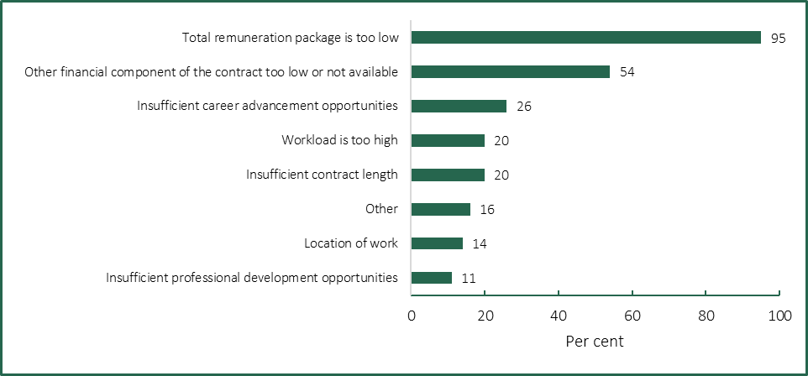
Note: The figure shows responses to the question ‘What factors do you think are affecting potential candidates' interest in applying for, or accepting employment offers? Please select all that apply.’ 80 responses were received.
Source: Tribunal analysis of responses to executive questionnaire.
Inadequate levels of remuneration were also cited as a key factor by:
- around 75 per cent of respondents who reported an increase in the rate at which executives were voluntarily departing their organisation
- around half of executives who indicated an intention to leave their role within the next year.
However, the relationship between recruitment difficulties and remuneration is not straightforward. For example, JSA reported that at the national level, employers rarely adjust wages to fill vacancies, preferring other strategies such as continuing to advertise, restructuring the organisation or giving up on filling the position.

5.5 Remuneration relativities between executive and non-executive staff have narrowed
In its 2020 PE Determination, the Tribunal examined the relativities between public entity executive and non-executive remuneration. It found that many (although not all) non-executive employees in public entities are remunerated based on rates set in enterprise agreements.
The Tribunal considered that the value ranges of the executive remuneration bands should enable public entities to offer their executives higher remuneration than that provided under their respective enterprise agreements, as this would:
- recognise executive roles generally have a higher work value
- reflect that executive roles carry greater risk, and may come with lower security of employment
- provide non-executive employees with an incentive to apply for executive roles.
In this Determination, the Tribunal sought stakeholder views about the appropriateness of the relativities between non-executive and executive remuneration. Stakeholders agreed that maintaining remuneration relativities is necessary to attract executive talent and ensure fair compensation. For example, one de-identified submission noted:
Executives are expected to meet higher obligations and expectations, including strategic decision-making, leadership responsibilities, and accountability for the overall performance of the entity. Non-executives, while important, do not carry the same level of responsibility and accountability.
Some stakeholders commented that the gap between non-executive and executive remuneration has narrowed. For example, another de-identified submission noted that:
As the government wages policy is applied through Enterprise Agreement negotiations, the relativity between executives and non-executives has shrunk over the past few years, particularly when there was no guideline rate increase approved by the Premier, or, when executive increases were lower than the government wages policy.
Roundtable participants cited narrow relativities — in terms of remuneration and other terms and conditions, such as job security — as a constraint on the pool of internal candidates for promotion for some public entities. This was of particular concern to some entities where non-executives were entitled to specific allowances under enterprise agreements.
The Tribunal’s questionnaire asked current executives if they consider the difference in remuneration between executives and non-executives to be appropriate. Respondents expressed mixed views, with around 42 per cent of respondents indicating the gap is ‘about right’, around 40 per cent indicating it is ‘too small’ and 11 per cent selecting ‘too large’, while around 7 per cent did not know. Several respondents commented that the gap between executive and non-executive roles had narrowed, including due to enterprise agreement outcomes resulting in relatively higher salary adjustments for non-executives. Other respondents questioned whether executive remuneration levels adequately reflected the breadth of responsibilities and risk carried at the executive level (Box 5.1).
Box 5.1: Public entity executive views about the differences in remuneration between non-executives and executives in their organisation – selected views
‘There is very minimal gap for much larger risk’.
‘The gap has clearly narrowed over the recent medium term such that it is now too small’.
‘Gap is getting smaller and smaller with VPS Enterprise Agreements typically affording far greater percentage wage growth than at the executive levels’.
‘There is a significant gap between the highest paid non-executive role and the executive roles. Higher remunerated non-executive roles would … attract higher skilled managers.’
‘The breadth and consequence of the responsibilities borne by a CEO are so much more significant than those carried out by non-executives, but without the commensurate compensation for that additional burden. [It’s] just not worth it’.

Sources: Responses to the executive questionnaire.

5.6 The remuneration bands are positioned towards the lower end of the market
As discussed in Chapter 4, the Tribunal’s 2020 PE Determination set the values of the remuneration bands to broadly align with the remuneration bands set for executives employed in VPS bodies. At that time, the Tribunal observed that broad alignment of the VPS and public entity remuneration bands would further promote mobility between the VPS and public entities, retention of executives and fairness in remuneration outcomes across the public sector. Subsequent annual adjustments to the values of the remuneration bands have maintained this broad alignment.
For its 2024 VPS Determination, the Tribunal commissioned Mercer Consulting to undertake work value assessments and remuneration benchmarking for VPS executive roles and provide advice on market positioning. Mercer found that compared to 2020, VPS remuneration — particularly for senior executives — had fallen below the 15th percentile of the Australian General Market. The Tribunal considered this advice in its decision to increase the values of the remuneration bands for VPS executives by between 4.0 and 4.5 per cent.
The Tribunal invited stakeholders to comment on whether the values of the existing remuneration bands are competitive in terms of attracting and retaining executive talent, noting that an employer must seek and consider the Tribunal’s advice if they propose to pay an executive above the band.
The VSB submission commented that:
The executive remuneration bands are sufficiently flexible for the vast majority of [public entities] … Competitive pressures from the private sector have been and continue to be a reality when seeking to recruit or retain an employee in the public sector. VSB considers this is one of a multitude of factors an employer must consider, and that this is also a consideration for many VPS employers.
The VSB submission also supported maintaining alignment of the VPS and public entity executive remuneration bands, citing similarities across executive roles:
VSB’s view is the remuneration framework should remain consistent across the VPS and [public entities], unless there are compelling reasons otherwise. As the [public entity] executive role remains broadly comparable with their VPS counterparts, the VPS and [public entity] executive remuneration bands should also remain consistent.
Most participants in the Tribunal’s roundtables expressed the view that the current structure and values of the remuneration bands were broadly appropriate, while noting challenges in setting a single remuneration framework for a diverse public entity cohort. Participants also generally agreed that the VPS and public entity remuneration bands should continue to be aligned, with this arrangement contributing to a common overarching ‘public purpose’ and reinforcing that the public sector values apply regardless of organisation form.
Some submitters noted difficulties in attracting and retaining public entity executives within the remuneration bands set by the Tribunal (Box 5.2). Submitters commented that, as the lower end of the bands were not considered competitive, particularly for PESES-1 or SES-1 roles, market positioning was often chosen at the middle to higher end of the bands.
The VicWater submission also drew attention to base salary being supplemented by bonuses in competitor sectors. Under the PEER policy, bonuses are not available to public entity executives, other than for a small number of specialist finance-related roles.
Box 5.2: Public entity views about the competitiveness of the remuneration bands – selected views
‘VMIA has been able to attract and retain Executives within the PESES bands. However, in all instances we have had to recruit at the higher end of the bands. For attraction and retention purposes, the lower end of the bands does not meet candidate and market demands.’ (VMIA submission)
‘One notable trend is the increasing difficulty in appointing suitable candidates for highly specialised or skilled roles classified within the PESES 1 band … This disparity between candidate expectations and the current remuneration bands has resulted in several promising candidates either withdrawing from the process or accepting more lucrative offers elsewhere.’ (CFA submission).
‘GHCMA does not believe the existing bands are competitive, particularly in attracting high quality people in regional areas.’ (GHCMA submission).
‘Advice from the search firm is that the middle of the market is realistic positioning, noting the competition for excellent executive candidates with comparable sectors such as private sector utilities, construction and consulting. This still drives interest from candidates seeking purpose or values alignment in their work, but allows a reasonably competitive position.’ (VicWater submission)
Sources: Submissions to the Determination.
A majority (55 per cent) of respondents to the Tribunal’s questionnaire did not consider the existing remuneration bands to be competitive for the type of work they do. Many respondents commented that higher levels of remuneration, including bonuses, are available for comparable roles in the private sector. However, some respondents also acknowledged that the attraction of public sector employment lay in making a difference to the community (Box 5.3).
Particular concerns were expressed regarding the competitiveness of the PESES-1 and SES-1 remuneration bands, along with challenges in attracting specialist skills such as legal, finance and technology. Some respondents commented that remuneration for non-uniformed operational executive roles in the emergency services sector relative to non-executive roles was also considered uncompetitive, given expectations to attend out of business hours emergencies and differences in superannuation entitlements.
Box 5.3: Public entity executive views about the competitiveness of the existing remuneration bands – selected views
‘Speaking with multiple recruiters, remuneration in the not-for-profit sector is equivalent while the for-profit sector is 10-50% higher.’
‘The infrastructure pipeline across Australia combined with the big build has created a significant gap between private and public sectors.’
‘Due to the nature of our business, we have to recruit from the for-profit financial services sector, and we typically find that the remuneration bands are not competitive for comparable levels of expertise and responsibility.’
‘For the combination of legal and strategic judgement required it is not competitive compared to private market.’
‘SES banding is conservative and lack of bonus scheme or equity scheme makes it challenging to compete with private practice.’
‘… I do not work in the VPS for remuneration (it is my choice to do so). I would say VPS is 25-40% under what you can get paid in the private sector. For the workload and pressure within VPS currently and the foreseeable future (resource reductions – already past tipping point), there should [be] a review of remuneration bands for SES-1/2.’
‘I have governance skills in both the private and public sector which is unusual. The bands are not competitive for people who have private sector experience. They would need to want to work for the Government for other reasons.’
Source: Responses to the executive questionnaire.
Finally, the questionnaire asked executives how satisfied or unsatisfied they were with their current remuneration, considering the work they do. Results were mixed, with a similar percentage of respondents, around 30 per cent, selecting either ‘satisfied’ or ‘dissatisfied’. Some respondents commented on remuneration not necessarily reflecting the growing scope and complexity of executive roles, while others highlighted that remuneration was not a key driver of their choice of employment (Box 5.4).
Notwithstanding these responses, over 85 per cent of executives who responded to the questionnaire indicated an intention to remain as a public entity executive for at least the next year, including around 45 per cent who intend to stay for over three years. Notably, among executives who indicated an intention to stay for one year or more, the factors most influencing their decision included belief in the purpose of their organisation or role (64 per cent), the type/nature of the work (59 per cent) and remuneration (44 per cent).
Box 5.4: Public entity executive views about the level of satisfaction with their own remuneration – selected views
‘The remuneration does not account for the hours worked or the expectations of the knowledge, skills and experience.’
‘Considering the scope and size of the role, I don’t think that the salary reflects that. It is an arduous process to apply for salary review and the process does not seem to result in a market salary.’
‘I came into the role taking a pay cut and since then my role and responsibility has expanded without increased compensation.’
‘I enjoy working for the organisation that I do. However, it should be noted that the remuneration is not at all competitive with what is easily and readily available in similar roles elsewhere.’
‘Wouldn’t be working here if remuneration was the key driver – however the treatment of executives remuneration is poor and bears no relativity to actual performance and the market.’

Note: The question asked was ‘How satisfied or unsatisfied are you with your current remuneration considering the type of work you do’?
Sources: Responses to the executive questionnaire.

5.7 The public sector employee value proposition is changing
The EVP can be defined as the set of benefits — both monetary and non-monetary — that employers provide to their employees in exchange for their contribution and commitment. Traditionally, the public sector EVP has included provision of a broader range of career pathways and development opportunities, greater security of employment and access to flexible working arrangements, relative to the private sector.
Roundtable participants noted that the EVP remains an attraction factor for many public entities, based on:
- delivery of public value and service to the community, including a more direct ability to deliver outcomes or specific projects (compared to VPS bodies)
- executives sharing the purpose and values of the organisation
- the value of public sector experience for future employment
- work/life balance, flexible working arrangements and lifestyle choices for individual executives
- for smaller public entities, the opportunity for a new CEO to significantly reform the organisation.
On the other hand, the Tribunal also heard that the public sector EVP for executives has diminished over recent years. One example given was commercial lawyers hired from the private sector who were motivated to improve community outcomes, but returned to the private sector after finding their work/life balance comparable to their private sector counterparts but with lower remuneration.
Participants also noted that the private sector may offer more flexible work arrangements, while in terms of job security, the PEER Policy provides for termination without notice and that an unexpired portion of a contract may only be paid out in exceptional circumstances.
The submission from VicWater highlighted the changing nature of the public sector EVP relative to the private sector following the COVID-19 pandemic:
Post-pandemic, the majority of both public and private sector employers now offer flexible and hybrid working as a standard condition of employment. There are very few options for non-financial benefits to be offered, apart from car and parking arrangements and salary continuance insurance. Moreover, public entity executives are subject to stringent accountability measures which mean that their access to gifts, benefits and hospitality is more constrained than their private sector counterparts.
In our members’ experience, their ‘employee value proposition’, as compared to the private sector, is the opportunity to work in a purpose-driven organisation and the ability to have a positive impact in the community. While a candidate may be prepared to accept a lower salary to have a role that aligns with their purpose and values, it is not reasonable to expect a candidate to accept a significantly lower salary than they could expect to earn in a similar role in the private sector.

5.8 Summary
Conditions in the Australian labour market have tightened since the Tribunal made the 2020 PE Determination, though there are signs of easing. Within the broad market for public entity executive roles, the supply of executives is generally matching demand, although recruitment difficulties are reported for some specialist roles.
The Tribunal has traditionally broadly aligned the values of the remuneration bands for public entity executives with those for VPS executives, which are positioned at the lower end of the market. In setting these bands, the Tribunal has taken into account that an employer can pay an executive above the relevant bands, after seeking and considering advice from the Tribunal. Most stakeholders supported continued alignment of the bands.
Some stakeholders commented that the lower end of the bands were not competitive, particularly for PESES-1/SES-1 roles, while others drew attention to the lack of bonus or incentive structures as negatively affecting competitiveness. However, some stakeholders also highlighted that remuneration is not necessarily the key driver in employment decisions, with a key attraction of public sector employment continuing to be in making a difference to the community.
- Economic and financial considerations

The Tribunal is required to consider the following factors when making this Determination:
- current and projected economic conditions and trends
- the financial position and fiscal strategy of the State of Victoria
- any statement or policy issued by the Government of Victoria which is in force with respect to its wages policy (or equivalent).
The following discussion of economic conditions and Victoria’s financial position is informed by the Tribunal’s analysis for its 2024 VPS Determination, plus the latest information and data from a range of sources up to 13 December 2024.

6.1 Current economic conditions
The Tribunal’s understanding of current economic conditions draws on the latest data on key economic indicators published by the Australian Bureau of Statistics (ABS), along with statements from the RBA and the 2024-25 Victorian Budget Update (2024-25 Budget Update).
A high-level overview of the latest economic conditions in Australia and Victoria is provided in Figure 6.1 and described in further detail below.
Figure 6.1: Overview of Australian and Victorian economic conditions, December 2024
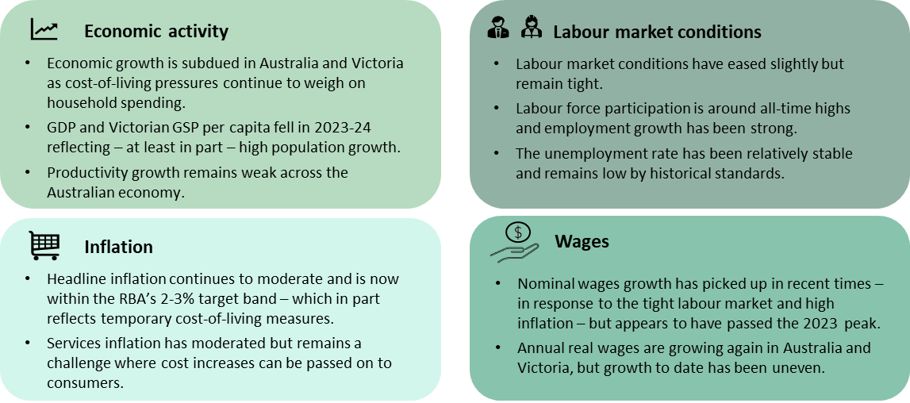

Economic growth has continued to slow as cost-of-living pressures and interest rates weigh on consumption
Economic growth has continued to slow in both Australia and Victoria after the post COVID-19 peak in 2021-22.
Annual growth in real Gross Domestic Product (GDP) was 1.4 per cent in 2023-24, less than half the growth rate in the previous year (Figure 6.2). According to the ABS, while there have now been twelve consecutive quarters of economic growth, GDP growth through the year to September 2024 (0.8 per cent) was the lowest since the December quarter 2020, which was affected by the pandemic.
Growth in Victoria’s real Gross State Product (GSP) was 1.5 per cent in 2023-24, slightly above GDP growth, but down from 3.4 per cent in 2022-23 and below the long-run average growth rate of 3.0 per cent prior to the COVID-19 pandemic.
Figure 6.2: Annual growth in real GDP and real Victorian GSP, June quarter 2019 to June quarter 2024
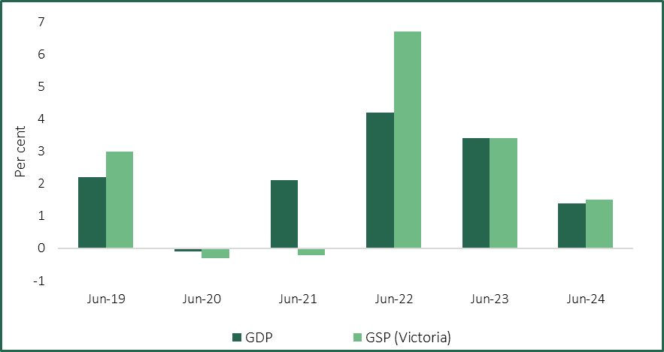
Source: ABS (2024b).
The RBA noted that growth in the year to June 2024 was underpinned by strong public demand, reflecting the provision of Commonwealth disability and aged care benefits to households. Conversely, private demand was weak, with lower than expected growth in household consumption owing to the impact of previous falls in real disposable incomes and tight financial conditions. Business investment, while still contributing to GDP growth, also slowed compared to 2022-23, due in part to persistent construction cost pressures.
According to the 2024-25 Budget Update, growth in the Victorian economy in 2023-24 was underpinned by public demand and business investment, while household consumption was subdued.
Population growth has rebounded significantly since Australia’s international borders were re-opened in early 2022, and has exceeded economic growth in recent times. This is reflected in declining real GDP per capita and real GSP per capita, which fell 1.0 per cent and 1.2 per cent respectively in 2023-24.
Productivity growth, which is a key driver of long-term economic growth and higher living standards, has continued to be weak. ABS data show that labour productivity — measured by GDP per hour worked — fell by 0.8 per cent through the year to September 2024. The RBA noted that productivity growth has been weak in both the market and non-market sectors and that this is weighing on economic growth.

Inflation has continued to moderate
Headline inflation has continued to moderate in both Australia and Victoria.
The Australian All Groups Consumer Price Index (CPI) increased by 0.2 percent in the September quarter 2024 and 2.8 per cent through the year. Higher prices in the September quarter for some goods and services, including ‘recreation and culture’ (+1.3 per cent) and ‘food and non-alcoholic beverages’ (+0.6 per cent), were mostly offset by falls in ‘electricity’ (-17.3 per cent) and ‘automotive fuel’ (-6.7 per cent).
However, the fall in electricity prices reflected temporary bill rebates for households from the Commonwealth and some state governments. Excluding these policy measures, the ABS estimated that electricity prices would have increased by 0.7 per cent in the quarter.
While headline inflation is currently within the RBA’s 2-3 per cent target band, trimmed mean inflation — the RBA’s preferred measure of underlying inflation — remains above the band. Annual trimmed mean inflation was 3.5 per cent in the September quarter 2024, down from a peak of 6.8 per cent in the December quarter 2022.
Recent movements in the All Groups CPI for Melbourne (Melbourne CPI) have broadly reflected national outcomes, with an increase of 0.7 per cent in the September quarter 2024 and an increase of 3.0 per cent through the year (Figure 6.3). While annual CPI growth in Melbourne is currently the third highest of the capital cities (after Perth and Adelaide), it is well below the peak of 8.0 per cent in the December quarter 2022.
Figure 6.3: Quarterly and annual growth in the Melbourne CPI, September quarter 2018 to September quarter 2024
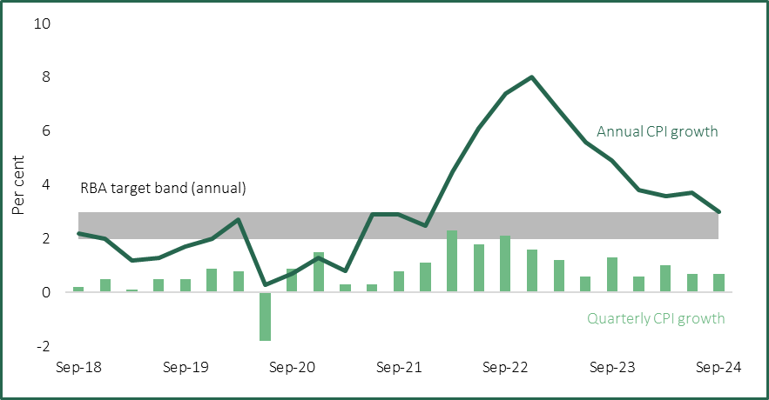
Source: ABS (2024c).
In its latest Statement on Monetary Policy (November 2024 Statement), the RBA observed that inflation outcomes are underpinned by continued easing in the prices of goods, while services inflation has also moderated — albeit from a high level.
The decline in goods inflation reflects lower prices for imported goods and some easing of shipping costs, as well as weaker demand conditions. In Victoria, the latest ABS data showed annual goods inflation at 1.8 per cent in the September quarter 2024, down from 4.6 per cent a year earlier and 9.8 per cent in the December quarter 2022.
The RBA noted that, while services inflation remains above its historical average, the recent easing was ‘broadly based across most market services’. Drivers of services inflation include growth in labour and non-labour costs, which businesses appear to be able to pass on to consumers. Services inflation in Victoria remains elevated at 4.5 per cent in the year to the September quarter 2024, which was higher than the annual rate of 4.2 per cent reported in the preceding three quarters.

Labour market conditions appear to have eased slightly, but remain tight
As discussed in further detail in Chapter 5, conditions in the Australian and Victorian labour markets have been ‘tight’ in recent years but with signs of a gradual easing.
In its November 2024 Statement — released prior to the latest unemployment data — the RBA noted that:
The labour market has continued to ease this year through a gradual increase in the unemployment rate, as strong growth in employment has only partially absorbed higher labour force participation.
In seasonally adjusted terms, total employment in Australia increased by 2.4 per cent from November 2023 to November 2024, while the national participation rate was 67.0 per cent in November 2024 and remains near record levels. The unemployment rate has been relatively stable over the past year, but decreased to 3.9 per cent in November 2024.
The Victorian labour market is broadly similar, with total employment increasing strongly (+3.5 per cent) over the year to November 2024, which was well above the long-term average growth rate. The labour force participation rate has recently been at record highs, but fell slightly to 68.2 per cent in November 2024. The unemployment rate in Victoria decreased to 4.2 per cent in November 2024 and, despite being the highest of the states and territories, remains low by historical standards.

Wages growth has continued to moderate
Tight labour market conditions and high inflation have meant that nominal wages growth has recently been above its long-term average, although growth has moderated over the past year.
The seasonally adjusted Australian Wage Price Index (WPI) rose 0.8 per cent in the September quarter 2024 and 3.5 per cent through the year. However, the RBA noted that wages growth has passed its 2023 peak and that the subsequent easing has been broadly based. The RBA further indicated that, given the recent weakness in productivity outcomes, it would be difficult to sustain the current pace of wages growth without putting upward pressure on inflation.
Award wages and the National Minimum Wage (NMW) have also grown in recent years. Following a 5.75 per cent increase from 1 July 2023, the Fair Work Commission (FWC) increased the NMW and all modern award minimum wages by 3.75 per cent from 1 July 2024. A key consideration for the FWC was to balance cost-of-living pressures for employees on modern awards with macroeconomic factors, including flat labour productivity.
More broadly, the ABS has noted that the FWC decision directly influences:
… enterprise agreements linked to the Commission’s annual wage review decision. It can also indirectly influence the size and timing of increases paid to jobs under individual arrangement as employers undertake wage and salary review decisions.
In Victoria, the WPI rose 1.4 per cent in the September quarter 2024 and 3.2 per cent through the year. This was the equal second lowest annual growth among the states and territories alongside South Australia. More broadly, the Victorian WPI has grown more slowly than the national WPI since mid-2023 (Figure 6.4).
Figure 6.4: Annual WPI growth (all sectors), Victoria and Australia, September quarter 2018 to September quarter 2024
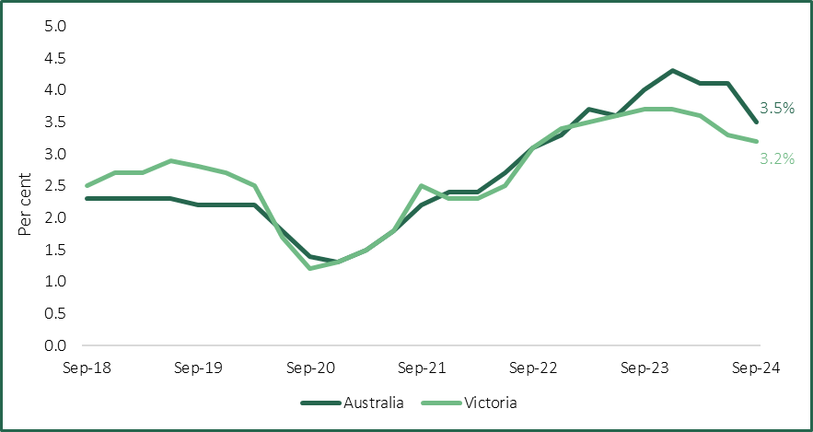
Source: ABS (2024f).
The public sector in Victoria (comprising the Victorian Government, local governments and Australian Government agencies operating in Victoria) has experienced lower wages growth than the private sector in recent years. Over the year to the September quarter 2024, public sector wages grew by 2.4 per cent, compared with 3.4 per cent in the private sector. The Victorian Government has noted that a relevant factor in this regard is the influence of the prevalent pay setting method in each sector (enterprise agreements in the public sector, individual arrangements in the private sector). Recent and forthcoming public sector enterprise agreements in Victoria may impact future public sector wages growth.

Real wages growth has been uneven
Although nominal wages have continued to grow, real wages have declined considerably since the onset of the current inflationary period and recent growth has been uneven.
The Australian headline inflation rate consistently exceeded annual WPI growth from mid-2021 to mid-2023, signifying falling real wages. However, more recently, declining inflation and relatively strong nominal wages growth has led to some, albeit uneven, growth in real wages.
At the national level, real wages grew by 0.7 per cent over the year to the September quarter 2024. In Victoria, real wages growth over the same period was 0.2 per cent, and has been lower than in Australia as a whole since the December quarter 2023 (Figure 6.5).
Figure 6.5: Difference between annual CPI and WPI growth rates, Australia and Victoria, September quarter 2018 to September quarter 2024
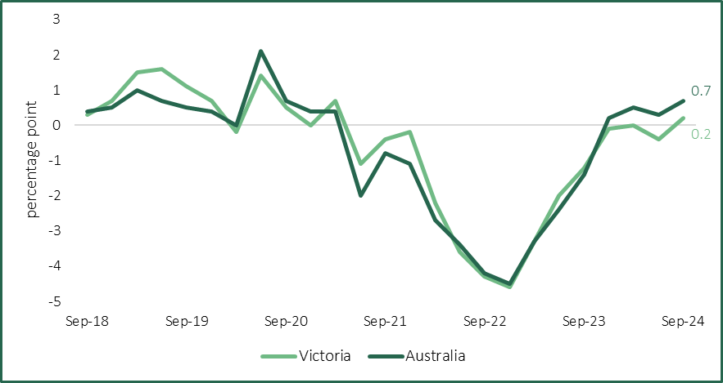
Sources: ABS (2024c); ABS (2024f).

6.2 Economic outlook
The following discussion of the outlook for the Australian and Victorian economies has been informed by the latest forecasts and analysis from the RBA and the 2024-25 Budget Update. Key forecasts are reproduced in Tables 6.1 and 6.2, followed by more detailed analysis.
Table 6.1: Selected RBA forecasts for the Australian economy, November 2024
Indicator | Dec 2024 | June 2025 | Dec 2025 | June 2026 | Dec 2026
Real GDP^{(a)} | 1.5 | 2.3 | 2.3 | 2.3 | 2.2
Population^{(a)} | 1.9 | 1.6 | 1.2 | 1.1 | 1.3
CPI^{(a)} | 2.6 | 2.5 | 3.7 | 3.1 | 2.5
Trimmed mean^{(a)} | 3.4 | 3.0 | 2.8 | 2.7 | 2.5
Employment^{(a)} | 2.6 | 2.2 | 1.4 | 1.3 | 1.3
Unemployment rate^{(b)} | 4.3 | 4.4 | 4.5 | 4.5 | 4.5
WPI^{(a)} | 3.4 | 3.4 | 3.2 | 3.2 | 3.1
Labour productivity^{(a)} | -1.0 | 0.5 | 1.1 | 1.1 | 1.1
Notes: (a) Percentage change through the year. (b) Percentage rate in the quarter.
Source: RBA (2024c), p. 55.
Table 6.2: 2024-25 Budget Update forecasts for the Victorian economy
Indicator | 2024-25 | 2025-26 | 2026-27 | 2027-28
Real GSP^{(a)} | 2.50 | 2.50 | 2.75 | 2.75
Population^{(b)} | 1.80 | 1.70 | 1.70 | 1.70
Melbourne CPI^{(a)} | 2.50 | 3.00 | 2.50 | 2.50
Employment^{(a)} | 2.50 | 0.75 | 1.75 | 1.75
Unemployment rate^{(c)} | 4.50 | 4.75 | 4.75 | 4.75
Victorian WPI^{(a)} | 3.50 | 3.25 | 3.25 | 3.25
Notes: (a) Percentage change in year-average terms compared with the previous year. (b) Percentage change over the year to 30 June. (c) Year average.
Source: DTF (2024d), p. 8.

Economic growth is forecast to pick up in coming years
The RBA has slightly moderated its earlier forecasts for economic growth due to a slower than expected recovery in household consumption. Higher real household incomes (due to the effect of tax cuts and moderating inflation) are expected to see spending pick up through 2025, although recent data suggests that households may be saving more of their income than previously assumed.
Private and public investment is expected to stabilise in the short term due to a combination of construction cost pressures and the completion or reprofiling of some major projects. The RBA expects growth in public spending on services for households to continue supporting economic growth.
Annual growth in real GDP is therefore forecast to be 1.5 per cent in December 2024 before increasing to 2.3 per cent in June 2025.
The 2024-25 Budget Update forecast Victoria’s real GSP to grow by 2.50 per cent in each of the next two financial years, before picking up to 2.75 per cent in 2026-27. Similar to the national outlook, household consumption is expected to pick up due to higher real disposable income. Public demand — which includes spending and capital expenditure by national, state and local governments — is again expected to contribute to growth in 2024-25. This is principally due to Commonwealth assistance to households and infrastructure spending, with Victorian Government public demand expected to be subdued.
The RBA is forecasting population growth to moderate further over the forecast period, principally due to downwards revisions for growth in net overseas migration following changes to international education policies. This is expected to weigh on both household consumption and the supply capacity of the Australian economy.
As noted earlier, Australia’s productivity outcomes have been weak, which has constrained economic growth. While the RBA is assuming that trend productivity will return towards its average in the decade prior to the COVID-19 pandemic, it also noted that lower productivity growth would weigh on the economy and add to inflationary pressures.

Underlying inflation is forecast to continue easing, but headline inflation could be more volatile
The latest inflation forecasts published by the RBA show trimmed mean inflation easing through to December 2026, with services inflation expected to gradually ease. Headline inflation is forecast to increase in the short term as household electricity rebates unwind, but then ‘return sustainably to the mid-point of the [2-3 per cent] target range by the end of 2026’, albeit later than in previous forecasts.
The 2024-25 Budget Update forecast annual growth in the Melbourne CPI to average 2.50 per cent in 2024-25, before temporarily increasing to 3.00 per cent in 2025-26 as Commonwealth electricity bill rebates end.

Labour market conditions should continue to ease
Employment growth is forecast by the RBA to remain strong in the near term before easing in 2025, while labour force participation is expected to increase gradually. Accordingly, the unemployment rate is expected to increase gradually before stabilising at 4.5 per cent from the December quarter 2025 — which is consistent with the RBA’s estimates for full employment.
In relation to the Victorian labour market, the 2024-25 Budget Update similarly forecast employment growth to slow from an average of 2.50 per cent in 2024-25 to 0.75 per cent in 2025-26. The unemployment rate is expected to average 4.50 per cent in 2024-25, before increasing to 4.75 per cent from 2025-26.

Wages growth is expected to moderate as the labour market eases
The RBA observed that nominal wages growth has peaked, with growth forecast to moderate over the coming years. Annual growth in the Australian WPI is forecast to be 3.4 per cent in December 2024, before declining gradually to 3.1 per cent in December 2026.
The 2024-25 Budget Update forecast annual growth in the Victorian WPI to average 3.50 per cent in 2024-25, before easing to 3.25 per cent from 2025-26. The Department of Treasury and Finance (DTF) expects private sector wages growth to ease, but noted that overall wages growth would be supported by the progressive finalisation of public sector enterprise agreements.
The Tribunal notes that, while the Victorian Government finalised the VPS enterprise agreement earlier in 2024, at the time of making this Determination it was negotiating several other major public sector enterprise agreements. The commencement of those agreements is likely to boost public sector wages growth, which has been relatively subdued compared with the private sector.
Real wages are expected to continue growing, although the end of temporary electricity bill rebates will likely see inflation briefly exceed nominal wages growth. By December 2026, the RBA expects annual real wage growth of 0.6 per cent.

There are risks to the economic outlook, particularly around inflation
In its November 2024 Statement, the RBA considered that the overall risks to the Australian economy remained ‘broadly balanced’, although the International Monetary Fund considered that the balance of risks is ‘tilted to the downside’.
Inflation could ease more gradually than expected if productivity growth does not return to its long-run growth rate, which would reduce the supply capacity of the Australian economy and likely see cost pressures passed on to consumers.
The outlook for private sector consumption and investment could be more subdued than expected if, for example, households choose to save a higher proportion of their expected growth in income or business investment is deferred. Conversely, the significant increase in accumulated household wealth since the beginning of the pandemic could see the savings rate fall and consumption increase faster than expected.
Australia also faces an uncertain external environment with downside and upside risks. Broader geopolitical tensions and intensifying regional conflicts could disrupt supply chains and increase shipping costs, which would add to domestic inflationary pressures. While the International Monetary Fund pointed to ‘geoeconomic fragmentation’ from increased trade barriers and weaknesses in major trading partners that could reduce demand for Australian exports, the RBA also noted the potential upside from additional fiscal stimulus in the global economy (particularly in China).
DTF noted similar risks to the Victorian economic outlook, including the potential for subdued consumption if, for example, households moderated spending and increased precautionary savings.

6.3 Financial position and fiscal strategy of the State of Victoria
The following discussion of the financial position and fiscal strategy of the State of Victoria has been informed by the 2024-25 Budget, the 2024-25 Budget Update and the latest Auditor General’s Report on the Annual Financial Report of the State of Victoria (November 2024).

Savings and efficiency measures have been introduced in successive budgets
As noted in Chapter 3, the Victorian Government has adopted a range of strategies to improve the State’s financial position. These include the introduction of a temporary COVID-19 Debt Levy to offset the cost of measures introduced by the Victorian Government in response to the COVID 19 pandemic. The Victorian Budget 2023-24 also included a range of savings and efficiency measures to be implemented across the public sector, including targeted reductions in the number of VPS staff.
According to the Victorian Government, the 2024-25 Budget builds on this strategy by:
… recalibrating the Government’s service delivery, departmental expenditure and capital program to take account of the increasing cost of labour and materials as well as supply constraints in the economy, including workforce availability and capacity.
In particular, the Victorian Government announced that it will ‘progressively return its capital program towards pre-pandemic levels’ by the end of 2027-28. The 2024-25 Budget Update noted that government infrastructure investment is expected to have peaked in 2023-24 and to progressively decline to $15.6 billion in 2027-28 (Figure 6.6). Overall, however, government infrastructure investment is forecast to average $19.9 billion per annum over the forward estimates, which is slightly higher than the forecasts published in the 2024-25 Budget.
Figure 6.6: 2024-25 Budget Update forecasts^{(a)} for government infrastructure investment
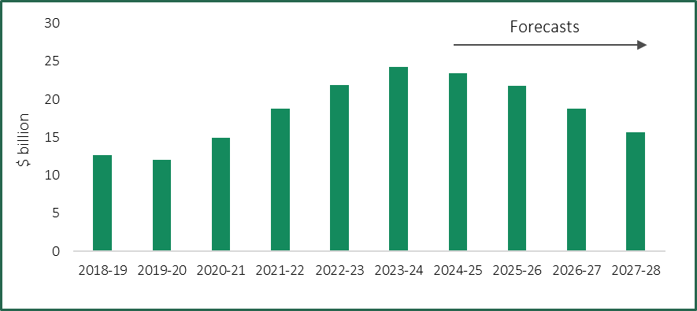
Note: (a) Actual values are shown for 2018-19 to 2023-24 (inclusive).
Sources: DTF (2024b); DTF (2024d), p. 27.
The 2024-25 Budget also added a new step to the Victorian Government’s fiscal strategy, which was first outlined in the Victorian Budget 2020-21 in response to the COVID-19 pandemic:
- Step 1 – Creating jobs, reducing unemployment and restoring economic growth
- Step 2 – Returning to an operating cash surplus
- Step 3 – Returning to operating surpluses
- Step 4 – Stabilising debt levels
- Step 5 – Reducing net debt as a proportion of GSP (new).

A return to an operating surplus is expected in 2025-26, but net debt is forecast to continue rising
The Victorian Government reported achieving step 2 of its fiscal strategy in 2022-23, with the general government sector (GGS) recording an operating cash surplus of $4.3 billion. A smaller surplus of $2.6 billion was achieved in 2023-24, although this was $2.2 billion higher than forecast in the 2024-25 Budget, largely due to the timing of certain payments and receipts. Larger surpluses are forecast in future years (Figure 6.7).
Figure 6.7: 2024-25 Budget Update^{(a)} forecast operating result and operating cash result
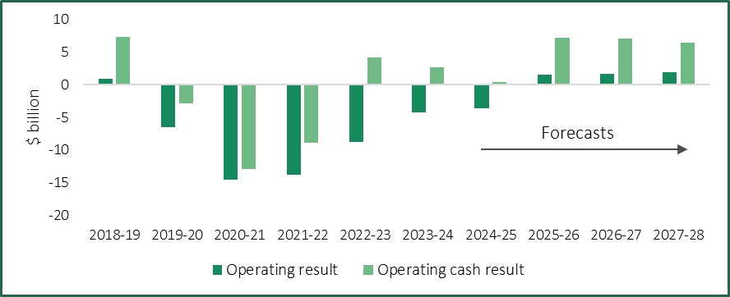
Note: (a) Actual values are shown for 2018-19 to 2023-24 (inclusive).
Sources: DTF (2024b); DTF (2024d), p. 19.
The operating deficit for the GGS is forecast to be $3.6 billion in 2024-25, compared to a forecast deficit of $2.2 billion in the 2024-25 Budget. This principally reflects additional spending on health services, partially offset by additional revenue and budget contingencies.
The 2024-25 Budget Update forecast a return to surplus in 2025-26, which would be the first surplus since 2018-19, with larger surpluses forecast for 2026-27 and 2027-28. The 2024-25 Budget noted that future surpluses would fund an increasing share of the Victorian Government’s capital program, reducing the amount of new borrowing required and helping to stabilise and reduce net debt.
Net debt for the GGS was $133.2 billion at 30 June 2024, which reflected the improved operating cash surplus. Net debt is expected to stabilise as a proportion of GSP at around 25 per cent from June 2026, consistent with achieving steps 4 and 5 of the fiscal strategy. Debt is forecast to continue rising in nominal terms, with net debt expected to be around $187 billion by 30 June 2028, which is slightly lower than the 2024-25 Budget forecast (Figure 6.8).
Figure 6.8: 2024-25 Budget Update forecasts^{(a)} for net debt and net debt to GSP
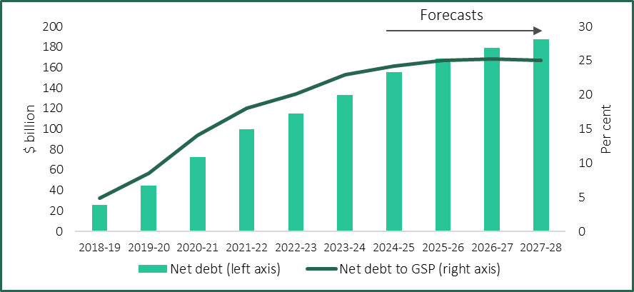
Note: (a) Actual values are shown for 2018-19 to 2023-24 (inclusive).
Sources: ABS (2024b); DTF (2024b); DTF (2024d), p. 19.

The Auditor-General has identified risks to Victoria’s fiscal outlook
Each year, VAGO issues a report on the Annual Financial Report of the State of Victoria. The November 2024 report examined Victoria’s 2023-24 Financial Report, and was released prior to the 2024-25 Budget Update.
VAGO recommended that the Victorian Government supplement its current fiscal strategy with a long-term plan for fiscal sustainability to address current challenges and future risks. Three emerging risks to the GGS identified by VAGO — interest expenses, employee expenses and infrastructure spending — are discussed in Box 6.1.
Box 6.1: Emerging risks to Victoria’s fiscal outlook identified by VAGO
Interest expenses
- GGS gross debt is forecast to be 30.5 per cent of GSP at 30 June 2028 and VAGO noted that the annual growth rate from 2023-24 to 2027-28 is forecast to be well above growth in GSP and GGS operating revenue.
- Over $52 billion of existing debt is projected to be refinanced over the four years to 30 June 2028, which is likely to be at higher interest rates.
- VAGO noted that higher debt servicing costs as a proportion of revenue can pose challenges for funding other activities and place pressure on the operating result.
- Annual interest expenses are expected to increase from $5.6 billion in 2023-24 to $9.4 billion by 2027-28 (or from 6.1 per cent to 8.8 per cent of GGS operating revenue).

Employee expenses
- Employee costs are the State’s single largest operating expense, accounting for around 37 per cent of GGS operating expenditure in 2023-24.
- Annual growth in employee expenses was 7.6 per cent over the last eight years, but is forecast to be 2.6 per cent over the next four years.
- VAGO noted that there could be pressure on forecast employee expenses if planned staff reductions are not realised or if enterprise agreements are renegotiated at higher rates than expiring agreements.
- Other challenges include increased demand for public services due to population growth.

Infrastructure spending
- The 2024-25 Budget included a forward capital program of $208 billion, which was a net increase of $7.9 billion compared to the same time last year.
- VAGO regularly reviews the performance of major capital projects and has observed cost escalation on specific projects. This can occur for different reasons, including changes to the scope of projects and volatility in the construction sector and supply chains.
- VAGO noted that further cost pressures in current or new major projects could affect the State’s fiscal sustainability.
Source: VAGO (2024), pp. 25-35.
VAGO also identified emerging risks that impact the broader public sector, in particular, the continued growth in the State’s insurance liabilities. Collectively, the State’s three insurance entities — WorkSafe Victoria, the Transport Accident Commission and VMIA — had $53.1 billion in liabilities (including $50.1 billion in outstanding insurance claims) at 30 June 2024, against total assets of $53.3 billion. VAGO noted that the financial sustainability of public financial corporations, including the aforementioned entities, is critical for the State’s overall fiscal sustainability.

6.4 Victorian Public Sector Wages Policy
The Wages Policy and the Enterprise Bargaining Framework (Wages Policy) sets out the parameters within which Victorian public sector employers, including public service bodies, are required to bargain and make enterprise agreements.
Box 6.2 outlines the key features of the current Wages Policy, which was introduced by the Victorian Government in April 2023. In particular:
- increases in wages and conditions will be funded at a rate of growth of 3 per cent per annum over the life of an agreement (compared to 1.5 per cent under the previous policy)
- in addition to annual wage increases, a separate lump sum cash payment will be available, equivalent to 0.5 per cent of overall agreement costs.
In 2024, the Victorian Government finalised a new enterprise agreement for non-executive VPS employees with the following remuneration provisions:
- annual salary increases of 3 per cent over the life of the agreement, effective from 1 May each year
- a once-off lump sum payment of $5,600 (pro-rated for part-time and eligible casual employees) for all non-executive employees, regardless of classification, who are employed on 28 June 2024
- an additional once-off payment of $1,000 (also calculated on a pro rata basis) will also be payable to eligible shift workers employed on 1 October 2024
- an increase to the lump sum payment (from 1 per cent to 1.5 per cent of base salary) paid to employees at the top of their grade or value range who are assessed as having met their progression criteria.
VPS staff continue to have access to annual progression payments and the mobility payment, while there were other changes to leave arrangements and to support flexible working arrangements.
Box 6.2: Victorian Public Sector Wages Policy — key features
Primary Pathway
Pillar 1: Wages
- Increases in wages and conditions will be funded at a rate of growth of 3.0 per cent per annum over the life of the agreement. In practice, this means that employee wages and conditions will be allowed to grow at this rate.
- In addition to annual wage increases, a separate lump sum, cash payment will be available equivalent to an additional 0.5 per cent of overall agreement costs which for the purposes of this policy means a per annum amount calculated on wages and wage related conditions.
Pillar 2: Best Practice Employment Commitment
- Public sector agencies may make a Best Practice Employment Commitment which outlines measures to operationalise elements of the Government’s Public Sector Priorities^{(a)} that reflect good practice within Government and can be implemented operationally or without significant costs.
Pillar 3: Additional strategic changes
- Additional changes to allowances and other conditions (not general wages) will only be allowed if Government agrees that the changes will address key operational or strategic priorities for the agency, and/or one or more of the Public Sector Priorities and provided the associated costs are funded through appropriate cash offsets or a government approved funding strategy.
Secondary Pathway
This pathway was available where an enterprise agreement expired before 1 January 2024 and the bargaining parties wished to reach a new agreement without changing previously agreed terms and conditions.
Relevant terms were:
- wage increases were funded at a rate of growth of 3.5 per cent per annum (pro-rated)
- the nominal expiry date for a new agreement was between 12 to 18 months from the expiry of the previous agreement
- there were no changes to existing terms and conditions, except in specific circumstances (for example to resolve legal issues).
Note: (a) The Public Sector Priorities are: ‘deliver exceptional services and value for Victorians’, ‘a professional and responsive public sector’ and ‘government as a fair and best practice employer’.
Source: Industrial Relations Victoria (2023), pp. 3-4.
Public entities have also concluded new enterprise agreements under the Wages Policy, including:
- several water corporations negotiated annual wage increases of 3 per cent plus lump sum payments (either a larger one-off sum or a smaller amount over multiple years)
- several TAFEs negotiated agreements under the ‘secondary pathway’ that provided for wage increases of 3.5 per cent from 1 July 2023 and 1.75 per cent from 1 July 2024.
- Tribunal’s considerations

The Tribunal now turns to a discussion of the matters it considered, and the weight it gave to various factors, to reach a decision about the value of remuneration bands for executives employed in public entities.
The overall analytical framework is set by the VIRTIPS Act which requires that, in making its Determinations, the Tribunal must consider the following:
- the existing remuneration provided to executives
- any statement or policy issued by the Government of Victoria which is in force with respect to its wages policy
- the financial position and fiscal strategy of the State
- current and projected economic conditions and trends
- submissions received in relation to the proposed Determination
- a comprehensive review of the roles of executives employed in public entities.
Chapter 2 provides an overview of the Victorian public sector and the public entities covered by the Determination, which informed the Tribunal’s consideration of the roles of the executives employed by these entities in Chapter 3. The current employment and remuneration arrangements for public entity executives are summarised in Chapter 4.
Chapter 5 sets out the Tribunal’s understanding of the labour market for public entity executives drawing upon an analysis by Mercer in respect of the 2024 VPS Determination. Chapter 6 presents the Tribunal’s analysis of the economic, financial and policy factors that it is required to consider. Submissions received by the Tribunal, and responses to the Tribunal’s executive questionnaire, are cited throughout the Statement of Reasons.
The first part of the analysis identifies a number of factors which, taken together, support a significant increase to the remuneration bands for public entity executives. The second part sets these considerations in a broader context, including the government’s current Wages Policy and the financial position and fiscal strategy of the State. This is followed by a discussion of the case for an alignment of the public entity bands with the current VPS bands which came into effect on 1 July 2024.

7.1 Factors supporting higher remuneration bands
In support of an increase in the bands, there is compelling evidence of a significant change in the role of public entity executives since the Tribunal’s first Determination four years ago. While core responsibilities of executives have more or less remained constant, the operating environment for, and complexity of, their roles have all changed significantly. Each of these is discussed below.

Operating environment
As evidenced by responses to the Tribunal’s questionnaire and submissions discussed in earlier chapters, changes to the public sector operating environment over the past four years have significantly impacted the role of public entity executives. Foremost amongst these are the implementation of savings and efficiency measures across government — at a time of increasing demand — and a greater focus on integrity and adherence to public sector values.
Consistent with other Australian jurisdictions and most countries throughout the world, over the period 2019-20 to 2022-23 the Victorian Government incurred significant one-off expenditures responding to the economic and health impacts of COVID-19. The subsequent introduction of debt repayment and other measures has, and will continue to, impact public entity executives at all levels, who will find it more challenging to perform their functions at the same standard and deliver the high quality services expected of them.
The savings and efficiency measures introduced in recent budgets have included initiatives across public entities. Depending on the entity, these can take the form of efficiency dividends, capital repatriations, grants or reduced funding. As discussed in Chapter 3, the impact of these measures on particular public entities is difficult to quantify. However, responses to the Tribunal’s executive questionnaire indicate that some entities and/or business units are experiencing budget and resource pressures.
Since the 2020 PE Determination, there has been an increased focus on integrity and public sector values driven by several recent inquiries and reports which scrutinised the actions of the Australian and Victorian public sectors. While widely accepted as necessary and beneficial, the actions required to build upon and sustain a system of public integrity, embracing leadership and cultural change across all levels of an organisation, add a significant additional dimension to the executive role.
The third change in the operating environment arises from an increasing level of scrutiny of the actions of public sector executives. A high level of scrutiny, including by the integrity agencies is, and has always been, appropriate and critical to the maintenance of public trust in public bodies. The point made here is that the breadth and frequency of such scrutiny has increased significantly adding a further degree of difficulty to the daily challenges faced by executives in the course of performing their roles.
At the same time, the expectations placed on public entities by both government and the public to perform their functions effectively and deliver high quality services may not have changed, and in some cases appear to have increased. While in many respects similar to the expectations on VPS executives, the Tribunal also noted some important differences for public entity executives. Examples include the potential for direct feedback from the community on the goods and services they receive from public entities and greater department oversight of entity performance.

Complexity of executive roles
The Tribunal heard from stakeholders that executive roles have increased in complexity and scope over the last four years. Factors commonly cited by executives included: increased regulatory and compliance obligations, an evolving and generally heightened risk environment, legislative changes and increased complexity of stakeholder relationships.
As one CEO so cogently put it in responding to the Tribunal’s questionnaire, managing a wide range of risks (including climate change and cyber-security) requires a greater degree of innovation, strategic planning and capacity to deal with ambiguity and complexity.
Other factors impacting the complexity of executive roles include broader changes to working practices — particularly flexible and hybrid working arrangements. Some challenges for executives in managing a hybrid workplace include:
- building digital skills that enable executives to lead their teams regardless of the time, place or setting
- managing team performance, including having difficult conversations virtually
- adapting the physical workplace for the needs of hybrid work, such as increased use of collaborative spaces.
At the same time, there have also been specific factors that have affected particular public entities or the sectors in which they operate that have added a further level of complexity to executive roles. For example, the implementation of significant government reforms can prompt broader structural and cultural changes that amplify the impact of the factors noted above on executives.
These factors are reflected in the detailed feedback provided through the Tribunal’s executive questionnaire, which asked respondents to indicate whether elements of their roles had reduced, increased or remained unchanged over the past four years. The responses, which are discussed in Chapter 3, can be viewed as strong evidence of a substantial change in the role of public entity executives over the past four years.
A majority of executives reported that of the eight factors that reflect the core competencies and accountabilities of their role, seven had increased over the past four years — some by a significant margin. For example, over 80 per cent responded that the components of their role relating to ‘strategic change’ and ‘judgment and risk’ had increased. Similar responses were received for ‘relationships’ and the ‘breadth’ of executive roles.

Market positioning and competitiveness
We turn now to a discussion of the competitiveness of the Victorian public sector compared to the private sector and other public sector jurisdictions with which Victoria competes for talent.
As part of its 2024 VPS determination, the Tribunal engaged Mercer Consulting to undertake a detailed analysis of the market for VPS executives. Of particular relevance to the analysis is the positioning of the VPS in the AGM (which refers to Mercer’s remuneration database for positions within Australia comprising over 700,000 remuneration records covering the private, public and not-for-profit sectors).
Remuneration arrangements for public service executives in most Australian jurisdictions are generally positioned around the 15th percentile of the AGM, while pay practices in the private sector tend to be closer to the 50th percentile (or median) of the AGM. This approach to public service remuneration reflects, in part, the value attached to non-salary benefits, for example, the satisfaction that comes from the opportunity to serve the community and make a difference.
The critical part of Mercer’s analysis is that, compared to four years ago, current executive remuneration in Victoria — particularly for senior executives — has fallen further below the 15th percentile of the AGM.
The insights from Mercer’s analysis for the VPS provide important insights for the Tribunal’s consideration of the remuneration for public entity executives. While there are many similarities in the public sector operating environment and the nature of executive roles in the VPS and public entities, the Tribunal is also mindful of important differences. These include the specialised functions undertaken by some public entities and the commercial focus of others, which requires them to more directly compete with the private sector for executive talent.
This decline in market positioning is not simply a statistical derivation. As part of the Tribunal’s questionnaire, public entity executives who are involved in the recruitment of other executives were asked to identify the factors affecting the willingness of potential candidates to apply for executive positions or accept an employment offer. Of those that reported recruitment challenges, 95 per cent listed ‘total remuneration package is too low’. These are the people who have first-hand experience of executive recruitment and are more likely to have real knowledge of contemporary market realities.
Moreover, the Tribunal heard during its roundtable consultations that adhering to the current bands has sometimes led to compromise in recruitment decision-making. Given the importance of a high-performing public sector to the economic performance of the State, this decline in positioning and its impact on the State’s ability to compete for talent should be viewed with some concern and provides further evidence supporting an uplift in the bands.

7.2 Factors supporting restraint
An increase in the complexity of executive roles and a changing operating environment along with a decline in market positioning for the public sector, taken together, provide compelling evidence for an increase in the remuneration bands for public entity executives.
We turn now to a discussion of the broader context that must be considered before a well-rounded and informed decision can be made.
The first point to note is that, notwithstanding difficulties in recruitment and retention for some roles discussed above, data from responses to the Tribunal’s questionnaire and submissions did not identify any uniform push for a significant increase in the remuneration bands.
Part of the reasoning can be found in the payment above the band provision in the VIRTIPS Act. Under this provision, an employer may pay an executive above the maximum of the relevant band but first must seek and consider the advice of the Tribunal. The employer is not bound to accept the advice. The fact that relatively few executives are paid above the band (around seven per cent as at 30 June 2023) suggests that the bands are generally fair, equitable and competitive for the vast majority of public entity executives.
The availability of this mechanism, together with the flexibility provided by the width of the bands (up to $132,413 for the current PESES-3 band), should equip employers to offer competitive remuneration in most cases.

Economic conditions and the financial position and fiscal strategy of the State
Economic growth has been subdued in recent years as cost of living pressures weigh on household spending. While growth is expected to pick up in the coming years, it is likely to be weaker than previously expected.
Inflation has continued to moderate — although recent easing reflects the effect of temporary policy measures to assist households. Headline inflation is expected to increase in the near term, but to be around the mid-point of the RBA’s target range by late 2026.
Labour market conditions have eased slightly but remain tight, with strong employment growth and high rates of labour force participation. The unemployment rate has recently been stable, but is expected to increase. Reflecting these conditions, nominal wages growth has increased in recent years but has passed its peak, while real wage growth has been uneven.
The Victorian Government’s fiscal strategy was developed in response to the COVID-19 pandemic and involved four steps to support Victorians through the pandemic and restore the budget over the medium-term. Actions taken by the government include a commitment to rebalancing the public service and bringing staffing levels back to pre-pandemic levels. A fifth step — to reduce net debt as a proportion of GSP — was introduced in the 2024-25 Budget.
Consistent with its strategy, the Victorian Government achieved an operating cash surplus in 2022-23 and is forecasting a return to an operating surplus in 2025-26. Net debt is forecast to increase in nominal terms through to 2027-28, but stabilise as a share of the economy from mid-2026.

Wages Policy
Although the Victorian Government’s current Wages Policy is one of many factors the Tribunal is required to consider in making its decisions, in light of the current financial circumstances of the State and its strategies for dealing with net debt, the Tribunal felt it appropriate that the policy be given considerable weight in the decision-making process.
The Wages Policy provides that:
- Increases in wages and conditions will be funded at a rate of growth of 3 per cent per annum over the life of the agreement. In practice this means that employee wages and conditions will be allowed to grow at this rate.
- In addition to annual wage increases, a separate lump sum cash payment will be available equivalent to an additional 0.5 per cent of overall agreement costs.
The Tribunal’s rationale for giving some weight to Wages Policy is not related to the financial impact of any increase in the executive remuneration bands. Given the relatively small size of the public entity executive cohort compared to total public sector employment, any increase in the public entity executive remuneration bands will not have a significant impact on the budget’s bottom line or on individual entities (although it may have an impact in some of the smaller entities).
Rather, the challenges facing the State are considerable and a degree of discipline and a high level of adherence to policy objectives will be required to overcome them. If any group is seen to be given ‘special treatment’ it will inevitably weaken the collective effort.

The Social Compact
In making this decision — and indeed all decisions — the Tribunal did so having weighed the impact that its decision may have on the level of trust between the community and the Victorian public sector, if increases in remuneration for executives are perceived as out of step with community standards and expectations and prevailing economic conditions.

7.3 The Tribunal’s decision
As indicated, the Tribunal is of the view that an increase in the remuneration bands for public entity executives is justified by the evidence and particularly if the significant changes to the operating environment and the role of executives is taken into account.
The fact that the public sector has fallen behind movements in the AGM compared to where it was four years ago — for example, based on Mercer’s 2024 analysis of market remuneration data, the top of the PESES-3 band is now 8.4 per cent below where it would have been if it had been adjusted in line with market movements — also supports an increase.
However, the Tribunal also acknowledges that economic and fiscal conditions are challenging and, in that context, has given some weight to the Government’s Wages Policy and its own assessment of community expectations.

Consistency with the VPS
Having determined that an increase in the public entity bands is justified, we now turn to a consideration of the values of the new remuneration bands.
A particular consideration is whether there should be consistency with the recently determined VPS bands. The Tribunal heard that although there are many similarities between the two groups, there are some important differences including governance arrangements, a more commercial operating environment for many entities and a degree of flexibility not enjoyed by the VPS.
The distinctive operating environment and governance arrangements (relative to the VPS and private sector organisations) require executives to possess a range of skills and competencies. In addition to possessing technical or specialist skills, executives may also be required to navigate the public sector context, including relationships with portfolio departments and Ministers, and engage with the entity’s board.
On the other hand, there are a number of factors that lean towards consistency as the preferred outcome. The most important of these are as follows:
- Notwithstanding the differences referred to above, public entities are part of the one public sector with common values including a service ethos, the same professional standards, and ultimately are accountable in equal measure to the government of the day. As part of the broader executive employment framework, a common remuneration framework will further encourage entities — including those with a commercial focus — to view themselves as part of a single cohesive public sector.
- Common remuneration bands will support mobility across the public sector, resulting in an exchange in experience, skills and technical expertise to the benefit of the public sector as a whole.
- As discussed above, there is strong evidence that the real competitive pressures experienced by some entities compared to the VPS can be accommodated by the existing payment above the band system rather than adding another band on top of the existing structure — which inevitably would result in migration into this band irrespective of competitive pressures.
- Finally, there is the question of equity. It would be unseemly to be seen to value the work of executives in one group over the other through different remuneration arrangements. A risk in such an arrangement would be that it would result in additional recruitment and retention pressures as executives in the lower paid group sought greener pastures elsewhere.
Having weighed all of the factors discussed above, and in particular current economic circumstances and the financial position of the State, and the likely public reaction to significant increases in public entity executive pay at this time, the Tribunal has decided to exercise restraint consistent with its 2024 VPS Determination earlier this year.
The effect of the Tribunal’s decision for most executives employed in public entities is shown in Table 7.1. Overall, the remuneration bands set by the Tribunal result in an increase to the current bands of between 4 and 4.5 per cent.
Table 7.1: Tribunal’s decision compared to the current public entity remuneration bands
Band | Description | Bottom of band | Top of band
PESES-1 / SES-1^{(a)} | Current band ($ p.a.) | 216,376 | 279,238
PESES-1 / SES-1^{(a)} | Tribunal’s decision ($ p.a.) | 225,000 | 290,600
PESES-1 / SES-1^{(a)} | Change (%) | +4.0 | +4.1
PESES-2 / SES-2 | Current band ($ p.a.) | 279,239 | 401,017
PESES-2 / SES-2 | Tribunal’s decision ($ p.a.) | 290,601 | 419,000
PESES-2 / SES-2 | Change (%) | +4.1 | +4.5
PESES-3 / SES-3 | Current band ($ p.a.) | 401,018 | 533,431
PESES-3 / SES-3 | Tribunal’s decision ($ p.a.) | 419,001 | 557,435
PESES-3 / SES-3 | Change (%) | +4.5 | +4.5
Note: (a) The bottom of the PESES-1 / SES-1 band shown applies to an executive with a work value score of at least 21 under the PEECF or VPSECF.
It is important to note that the increases in the remuneration bands are inclusive of Commonwealth Government-legislated changes to statutory superannuation entitlements that took effect from 1 July 2024. In particular, the SG rate increased from 11 per cent to 11.5 per cent and the MSCB (which caps the salary to which the SG applies) increased from $249,080 to $260,280. Victorian Government policy is that employers must bear the cost of such changes, which is reflected in an increase in each executive’s TRP. Once the impact of the superannuation changes are accounted for, the effective increase in the remuneration bands is between 3.5 per cent and 4.0 per cent.
It should also be noted that an increase in the remuneration bands does not automatically result in an increase in remuneration for all public entity executives. The task of the Tribunal is to determine the values of the remuneration bands. While the remuneration for public entity executives at the bottom of each band will need to be adjusted to remain within the relevant band, responsibility for what executives are paid resides with employers taking account of the Premier’s annual adjustment guideline rate.
The Premier has determined an annual guideline rate of 3 per cent applicable from 1 July 2024. Accounting for the effect of the guideline rate and changes to statutory superannuation, the actual impact of this Determination on executives at the bottom of the band will be reduced. For example, for an executive paid at the bottom of the PESES-1 or PESES-2 band as at 30 June 2024 and who received the guideline rate increase and the superannuation adjustment, the increase in their TRP will be 0.5 per cent. For executives paid at the base of the PESES-3 band the equivalent increase will be 1 per cent.

Backdating
A further consideration is the date on which this Determination should take effect. Under the VIRTIPS Act, a comprehensive Determination cannot be made within four years of an earlier comprehensive Determination. As the original VPS Determination in 2020 was made six months before the public entity Determination, this Determination will be backdated to 1 July 2024 to ensure that public entity executives are not disadvantaged by the lag. In future, the Tribunal proposes to examine options for making a comprehensive Determination on the same date for both groups to avoid the necessity for backdating in the future.

A single band structure for PESES and SES executives
As discussed in Chapter 4, some public entities employ some or all of their executives under Part 3 of the PAA, and these executives have historically been covered by VPS employment policies, such as the standard VPS executive contract.
However, the VIRTIPS Act requires that the remuneration bands for this executive cohort be set in a public entity Determination. In its 2020 PE Determination, the Tribunal decided that:
The relevant remuneration band for an executive employed under Part 3 of the PAA corresponds to that which applies to an executive with the same SES or Executive Officer classification, under the VPS Determination in effect at the time.
This approach was consistent with the arrangements in place at that time and meant that executives employed under Part 3 of the PAA in public entities and in the VPS were treated in the same way.
The Tribunal now considers that, consistent with the VIRTIPS Act, there should be a single remuneration framework for all executives employed in public entities. This means that, for example, the remuneration band for an SES-1 executive employed in a public entity under Part 3 of the PAA is the PESES-1 / SES-1 band in Table 7.1.
This change has no substantive impact on the remuneration of executives employed in public entities under Part 3 of the PAA due to the alignment of the PESES and SES remuneration bands. Provided that an executive’s remuneration has already been adjusted to reflect the SES remuneration bands applying from 1 July 2024, no further adjustments are required to comply with the 2024 PE Determination.

CEOs of small public entities
In its 2020 PE Determination, the Tribunal decided to provide flexibility for smaller public entities to set the remuneration for CEO positions that reflected their circumstances. As discussed in Chapter 4, this was achieved by reserving the lower portion of the PESES-1 band for the CEOs of small public entities.
The number of CEO positions covered by the provision has decreased since 2020, with just four CEOs paid in the lower portion of the PESES-1 band at 30 June 2023.
The Tribunal has therefore decided to simplify the remuneration arrangements for this cohort, while retaining the current flexibility for smaller public entities.
A separate remuneration band has been established which only applies to CEOs (or similar positions) with a work value score of less than 21 points under the PEECF. The bottom of this band ($157,158) represents a 4 per cent increase in the equivalent value under the previous band, while the top of the band ($290,600) continues to be aligned with the top of the new PESES-1 band.
- Public Entity Executive Remuneration Guidelines

This chapter discusses the Tribunal’s considerations in updating its guidelines with respect to the placement of executives within the remuneration bands. The updated Guidelines are available on the Tribunal’s website.
The existing Guidelines were first published in 2020, and aim to assist employers by outlining:
- ‘guiding principles’ for executive remuneration, drawn from matters considered by the Tribunal when making its Determinations
- ‘specific factors’ that employers should consider when setting the remuneration of individual executives within the relevant band.
The notice of intention invited feedback on whether changes could be made to the existing Guidelines to better support employers in setting remuneration for executives within the remuneration bands. In addition to feedback received via stakeholder submissions, the Tribunal consulted on the Guidelines at roundtables with public entity representatives, as well as via the executive questionnaire.
Stakeholders generally considered that the existing Guidelines were clear and easy to apply, with suggested changes echoing those made by the Tribunal to the equivalent guidelines for VPS executives in July 2024.
Specific suggestions from stakeholders included:
- clarifying the role of work value scores in setting remuneration, and specifically to note that there is not a direct relationship between a position’s work value score and positioning within the remuneration band
- noting that there is scope for remuneration to be adjusted as individual executives develop their capabilities and increase their ‘value-add’ in a role
- considering the importance of specific executive roles to an organisation.
A further suggestion was for the Tribunal to promote awareness of the Guidelines among public entities to assist them in considering remuneration policies and practices.
Most executives who responded to the questionnaire reported that they were familiar with the existing Guidelines, including almost 90 per cent of CEO respondents. A handful of executives indicated that their entity has a practice of remunerating executives at the bottom of the relevant remuneration band, although this appeared to be less widespread than in the VPS.
The Tribunal has made several changes to the Guidelines in response to this feedback and, where appropriate, to align the Guidelines with the equivalent guidelines for VPS executives, which were updated in July 2024. Key changes are summarised below.
Firstly, the ‘guiding principles’ have been amended. In particular, Principle 3.3 — ‘Executive remuneration should be robust’ — has been amended to include a ‘transparency’ consideration, and to state that the basis for decisions should be clearly understood (e.g. through reference to an entity’s executive remuneration framework or strategy). Two additional guiding principles have also been added:
- Principle 3.4 — ‘Executive remuneration should take into account Government policies’ (e.g. to improve gender equality and promote diversity and inclusion)
- Principle 3.5 — ‘Executive remuneration should be regularly reviewed’ both at an individual and workforce level, including consideration of relativities and performance.
The ‘specific factors’ have been updated to emphasise the importance of carefully assessing the specific functions and responsibilities of an executive position (e.g. contributing to or leading a major reform initiative or emergency response) when setting remuneration. Two new clauses have also been added, which note that:
- where a position is deemed critical to an entity’s operations, remuneration above the middle of the band may be appropriate
- executives may undertake additional work beyond the specific functions and responsibilities of a position (e.g. a First Nations’ executive may provide broader cultural leadership within an organisation), which should be considered in setting remuneration.
The updated Guidelines include two illustrative case studies to assist employers in applying the ‘guiding principles’ and ‘specific factors’ when setting executive remuneration. The case studies highlight the importance of employers regularly reviewing executive remuneration arrangements to ensure that they support the recruitment and retention of executives with the requisite skills, capability and experience, and that they are fair and equitable over time.
The introductory section on ‘How and when to use these Guidelines’ has been updated to:
- clarify that the Guidelines do not require employers to remunerate an executive at the bottom of the remuneration band
- note that a public entity employer may — in limited circumstances — consider it appropriate to pay an executive above the relevant band, recognising that ‘payment above the band’ is a legitimate part of the remuneration framework.
Finally, the Tribunal simplified the Guidelines, including removing sections relating to transitional measures.

Appendix A — summary of executive questionnaire responses

The Tribunal invited public entity executives to make a submission via an anonymous questionnaire that was distributed by public entity employers on behalf of the Tribunal.
The questionnaire was open to respondents from Thursday 22 August to Friday 13 September 2024 (23 days).
The responses to the questionnaire helped the Tribunal to better understand executives’ views on:
- their roles and responsibilities (and how these had changed since the Tribunal’s 2020 PE Determination)
- their career intentions
- recruitment and retention issues for the executive cohort
- the level and structure of the remuneration bands.
The questionnaire contained 39 questions, 18 of which were mandatory. The questions were grouped into sections, including on:
- pathway to a public entity executive role
- intention to stay
- roles and responsibilities of public entity executives
- attracting and retaining public entity executives
- levels and structure of the public entity executive remuneration bands
- the executive’s current position
- demographic information.
No single person could have answered all 39 questions as some questions contained branching logic.
The questionnaire received 293 responses, with 264 executives completing the questionnaire. This means that an estimated 28 per cent of all public entity executives answered at least one question, while an estimated 25 per cent completed the questionnaire.
The estimated response rate is based on the number of executives employed in public entities at 30 June 2023 (Chapter 2).
The margin of error for the questionnaire, based on an estimated population size of 1,050 and a 99 per cent confidence level, is between 6 and 7 per cent.

A.1 Questionnaire responses
A compilation of questions asked, and responses received is provided below. All feedback has been considered and some responses have been included verbatim where relevant in this Statement of Reasons.

Profile of executives
Table A.1 shows that almost half of all respondents were employed in either the PESES-1 or SES-1 band, followed by the PESES-2 or SES-2, and PESES-3 or SES-3 bands. This distribution broadly aligns with the public entity executive workforce data shown in Chapter 4.
Table A.1: What is your classification?
Answer choices | Number of responses | % of responses^{(a)}
PESES-1 or SES-1 | 123 | 46
PESES-2 or SES-2 | 90 | 34
PESES-3 or SES-3 | 33 | 12
Other^{(b)} | 19 | 7
Total | 265
Notes: (a) The sum of the percentages in this table exceeds 100 per cent due to the rounding of individual percentages to the nearest whole number. (b) Most respondents who selected ‘Other’ indicated that they did not know or were unsure of their classification.
Most respondents were employed in the water and land management, regulator, finance and insurance and transport sectors (Table A.2). This distribution is broadly consistent with the number of executives in each sector at 30 June 2023 (Chapter 2).
Table A.2: Which industry or sub-sector does your organisation belong to? If you are not sure please refer to the VPSC’s list of public sector employers.
Answer choices | Number of responses | % of responses^{(a)}
Water and land management | 59 | 22
Regulator | 42 | 16
Finance and insurance | 31 | 12
Transport | 27 | 10
Other | 20 | 8
Emergency services | 18 | 7
Arts | 13 | 5
TAFE and other education | 12 | 5
Health care | 11 | 4
Sport and recreation | 11 | 4
Cemetery | 8 | 3
Community service | 7 | 3
Facilities management | 5 | 2
Commercialisation | 1 | <1
Total | 265
Note: (a) The sum of the percentages in this table exceeds 100 per cent due to the rounding of individual percentages to the nearest whole number.
Respondents were asked if they undertook a specialist role. A total of 36 per cent nominated one of the roles specified in the questionnaire (Table A.3). For the 25 per cent of respondents answering ‘other’, the most common free text responses were ‘human resources’ and ‘operations’, whilst several respondents identified their role as having multiple specialities.
Table A.3: Do you specialise in any of the following areas in your current role?
Answer choices | Number of responses | % of responses
Finance and insurance | 32 | 12
Legal | 24 | 9
Digital and technology (including software engineering) | 21 | 8
Engineering (excluding software engineering) | 18 | 7
Other | 66 | 25
None of the above | 104 | 39
Total | 265
Respondents were evenly split between men and women, and less than one per cent described their gender as non-binary (Table A.4).
Table A.4: How do you describe your gender?
Answer choices | Number of responses | % of responses
Man | 130 | 49
Woman | 125 | 47
Prefer not to say | 8 | 3
Non-binary | 1 | <1
I use a different term | 0 | 0
Total | 264
All respondents were aged 25 years and older, with nearly half aged between 45 and 54 years old (Table A.5).
Table A.5: What is your age?
Answer choices | Number of responses | % of responses^{(a)}
25-34 years | 1 | <1
35-44 years | 52 | 20
45-54 years | 124 | 47
55-64 years | 73 | 28
65+ years | 8 | 3
Prefer not to say | 6 | 2
Total | 264
Note: (a) The sum of the percentages in this table exceeds 100 per cent due to the rounding of individual percentages to the nearest whole number.
Only 28 per cent of respondents lived in either regional or rural Victoria, while 68 per cent lived in greater Melbourne (Figure A.1).
Figure A.1: Where do you live?
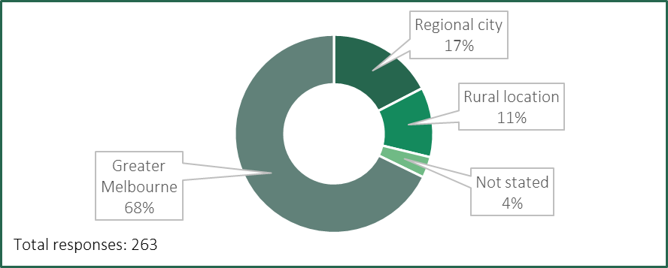
While nearly all respondents worked full-time, a small percentage reported they only worked full-time because they felt they are unable to work part-time (Table A.6).
Table A.6: Do you work full-time or part-time?
Answer choices | Number of responses | % of responses
Full-time | 253 | 95
Full-time, but I would like to work part-time | 7 | 3
Part-time | 5 | 2
Part-time, but I would like to work full-time | 0 | 0
Total | 265
Respondents were also asked why they would prefer to work part-time. Respondents indicated that the demands of their role prevent them from working part-time. For example:
Upon return from parental leave intention was to attempt part time work. Whilst my manager and the business were supportive, the nature of the role and work activity/workload and business requirements made this near impossible for me to feel this was workable. I now work a compressed week (5 in 4).
Am approaching retirement and would like to transition into retirement but the workload is so heavy that it is almost impossible to reduce hours. It would just mean that I would be working more hours in my own time.
I don’t think we are yet very open to executives working part time or in a job share arrangement.

Pathway to a public entity executive role
Three-quarters of respondents were in their first executive role within a Victorian public entity.
Respondents were asked to identify the type of position they held immediately prior to becoming a public entity executive for the first time (Table A.7).
Nearly half (44 per cent) of respondents were employed in the Victorian public sector — either with their current public entity employer, a different public entity or the Victorian Public Service (VPS) — prior to their first public entity executive role. This indicates some degree of mobility between different public entities and within the broader Victorian public sector.
Around one-quarter (23 per cent) of respondents were employed in the private sector prior to their first public entity executive role.
Table A.7: Which of the following best describes the position you held before your first Victorian public entity executive role?
Answer choices | Number of responses | % of responses
For-profit sector | 66 | 23
Current organisation | 53 | 18
Non-executive role | 53 | 18
Victorian public service | 44 | 15
Executive role | 31 | 11
Non-executive role | 13 | 4
Different Victorian public entity | 31 | 11
Non-executive role | 31 | 11
Public sector in another Australian jurisdiction | 29 | 10
Executive role | 24 | 8
Non-executive role | 5 | 2
Not-for-profit sector | 24 | 8
Victorian local government | 14 | 5
Executive role | 11 | 4
Non-executive role | 3 | 1
Other | 30 | 10
Total | 291
Respondents were asked about the position they held before their current role, with almost half having already worked elsewhere in the Victorian public sector (Table A.8).
Table A.8: Where did you work before your current role?
Answer choices | Number of responses | % of responses^{(a)}
Current organisation | 67 | 23
Executive role | 17 | 6
Non-executive role | 50 | 17
For-profit sector | 57 | 20
Different Victorian public entity | 45 | 15
Executive role | 32 | 11
Non-executive role | 13 | 4
Victorian public service | 33 | 11
Executive role | 23 | 8
Non-executive role | 10 | 3
Not-for-profit sector | 24 | 8
Public sector in another Australian jurisdiction | 23 | 8
Executive role | 19 | 7
Non-executive role | 4 | 1
Victorian local government | 15 | 5
Executive role | 13 | 4
Non-executive role | 2 | <1
Other | 27 | 9
Total | 291
Note: (a) The sum of the percentages in this table is lower than 100 per cent due to the rounding of individual percentages to the nearest whole number.
More than half of respondents were relatively new to the public entity executive workforce, having worked as a public entity executive for less than five years (Table A.9). Respondents were asked to exclude any time spent working as an executive for other Victorian public sector employers, such as departments.
Table A.9: How many years in total have you been an executive at a Victorian public entity?
Answer choices | Number of responses | % of responses^{(a)}
Less than 1 year | 41 | 14
1-2 years | 59 | 20
3-4 years | 59 | 20
5-9 years | 82 | 28
10-14 years | 29 | 10
15-19 years | 13 | 4
20 years or more | 10 | 3
Total | 293
Note: (a) The sum of the percentages in this table is lower than 100 per cent due to the rounding of individual percentages to the nearest whole number.

Intention to stay
Nearly half of respondents planned to work for their current organisation at executive level for three years or more (Table A.10). Given the PEER Policy requires executive contracts to have a maximum term of up to five years (with reappointment possible), this indicates most respondents were committed to working for their current employer for an extended period.
Conversely, 14 per cent of respondents planned to leave the public entity executive workforce by September 2025 (one year after the questionnaire was conducted).
Table A.10: I plan to work as an executive in my current organisation for …
Answer choices | Branching logic | Number of responses | % of responses
Over 5 years | Go to Table A.13 | 43 | 15
Over 3 years and up to 5 years | Go to Table A.13 | 90 | 31
Over 1 year and up to 3 years | Go to Table A.13 | 116 | 40
Over 6 months and up to 1 year | Go to Table A.11 | 28 | 10
6 months or less | Go to Table A.11 | 12 | 4
Total |  | 289
Of those executives indicating that they planned to leave their current employer within 12 months of completing the questionnaire, over half stated that their TRP being too low was a factor (Table A.11).
Table A.11: Which factors most influence you to consider leaving your current organisation?^{(a)} Please select up to three.
Answer choices | Number of responses | % of responses^{(b)}
Total remuneration package is too low | 20 | 51
Other financial components of my contract are too low or not available (e.g. bonuses) | 10 | 26
Insufficient career advancement opportunities | 10 | 26
Insufficient length of contract | 6 | 15
Workload is too high | 6 | 15
Retirement | 6 | 15
Poor leadership | 5 | 13
Type/nature of work (e.g. insufficient intellectual challenge, not enough autonomy) | 4 | 10
Insufficient professional development opportunities | 4 | 10
Location of work | 3 | 8
Work environment is not inclusive | 3 | 8
Lack of belief in the purpose and objectives of my organisation or my role | 3 | 8
Insufficient opportunity to contribute to community | 2 | 5
Workplace relationships with colleagues | 2 | 5
Non-monetary employment conditions are unsatisfactory (e.g. leave, flexible work arrangements, etc.) | 0 | 0
Total respondents | 39
Notes: (a) This question was only asked to respondents who answered ‘6 months or less’ or ‘Over 6 months and up to 1 year’ in Table A.10. (b) The sum of the percentages in this table exceeds 100 per cent as respondents were asked to select multiple options if applicable.
The preferred employer for those executives intending to leave their current employers within 12 months of completing the questionnaire was outside the public sector — either the ‘for-profit’ or the ‘not-for-profit’ sectors (Table A.12).
Table A.12: If you were to leave your current organisation, which of the following levels of employment (executive or non-executive), and sectors would be your preference?^{(a)} Please select all that apply.
Answer choices | Number of responses | % of responses^{(b)}
For-profit sector (executive or otherwise) | 19 | 49
Not-for-profit sector (executive or otherwise) | 19 | 49
Executive role – different Victorian public entity | 14 | 36
Other | 8 | 21
Executive role – public sector in another Australian jurisdiction | 6 | 15
Executive role – Victorian local government | 4 | 10
Executive role – VPS | 4 | 10
Non-executive role – different Victorian public entity | 3 | 8
Non-executive role – public sector in another Australian jurisdiction | 1 | 3
Non-executive role – Victorian local government | 0 | 0
Non-executive role – VPS | 0 | 0
Total respondents | 39
Notes: (a) This question was only asked to respondents who answered ‘6 months or less’ or ‘Over 6 months and up to 1 year’ in Table A.10. (b) The sum of the percentages in this table exceeds 100 per cent as respondents were asked to select multiple options if applicable.
Of those indicating they planned to stay with their current employer for at least one year or more, 64 per cent said this was due to belief in the purpose and objective of their organisation or role (Table A.13). TRP was cited as a factor influencing their decision to remain with their current employer by 44 per cent of respondents.
Table A.13: Which factors most influence your intention to stay working in your current organisation?^{(a)} Please select up to three.
Answer choices | Number of responses | % of responses^{(b)}
Belief in the purpose and objective of my organisation or my role | 156 | 64
Type/nature of work (e.g. interesting, challenging, specialised, autonomous) | 145 | 59
Total remuneration package | 108 | 44
Quality of leadership | 94 | 38
Service to the Victorian public (or opportunity to contribute to the community) | 92 | 38
Workplace relationships with colleagues | 70 | 29
Location of work | 51 | 21
Professional development opportunities | 48 | 20
Inclusive work environment | 44 | 18
Non-monetary employment conditions (e.g. leave, flexible work arrangements, other benefits) | 40 | 16
Contract length | 40 | 16
Level of workload | 24 | 10
Career prestige or advancement | 22 | 9
Lack of suitable alternative job prospects | 12 | 5
Other | 8 | 3
Total respondents | 245
Notes: (a) This question was only asked to respondents who answered ‘Over 1 year and up to 3 years’, ‘Over 3 years and up to 5 years’ or ‘Over 5 years’ in Table A.10. (b) The sum of the percentages in this table exceeds 100 per cent as respondents were asked to select multiple options if applicable.

Attracting and retaining public entity executives
Respondents were asked if they were involved specifically in recruiting public entity executives (Table A.14). Those that answered ‘no’ skipped the seven questions in Tables A.15 to A.21.
Table A.14: Are you involved in recruiting public entity executives?
Answer choices | Branching logic | Number of responses | % of responses
Yes | Go to Table A.15 | 142 | 50
No | Go to Table A.22 | 143 | 50
Total |  | 285
Of those respondents involved in executive recruitment, more than half indicated they were experiencing significant challenges attracting candidates (Table A.15).
Table A.15: Are you experiencing any significant challenges attracting executives?^{(a)}
Answer choices | Branching logic | Number of responses | % of responses
Yes | Go to Table A.16 | 81 | 57
No | Go to Table A.18 | 50 | 35
I don’t know | Go to Table A.18 | 12 | 8
Total |  | 143
Note: (a) This question was only asked to respondents who answered ‘Yes’ in Table A.14.
A follow up question found that this group were mostly experiencing significant challenges in attracting executives to digital and technology, and finance and insurance roles (Table A.16).
Table A.16: Are you experiencing significant challenges in attracting public entity executives to any specialist areas?^{(a)} Select all that apply.
Answer choices | Branching logic | Number of responses^{(b)}
Digital and technology (including software engineering) | 34 | 43
Finance and insurance | 34 | 43
Legal | 26 | 33
Other | 26 | 33
Engineering (excluding software engineering) | 16 | 20
None of the above | 7 | 9
Total respondents | 80
Notes: (a) This question was only asked to respondents who answered ‘Yes’ in Table A.14 and ‘Yes’ in Table A.15. (b) The sum of the percentages in this table exceeds 100 per cent as respondents were asked to select multiple options if applicable.
Respondents considered that the principal reason deterring potential candidates from accepting an executive position was the level of the TRP, followed by other financial components of the contract being either too low or not available (Table A.17).
Table A.17: What factors do you think are affecting potential candidates’ interest in applying for, or accepting employment offers?^{(a)} Please select all that apply.
Answer choices | Number of responses | % of responses^{(b)}
Total remuneration package is too low | 76 | 95
Other financial component of the contract too low or not available (e.g. bonuses) | 43 | 54
Insufficient career advancement opportunities | 21 | 26
Insufficient contract length | 16 | 20
Workload is too high | 16 | 20
Other | 13 | 16
Location of work | 11 | 14
Insufficient professional development opportunities | 9 | 11
Non-monetary employment conditions are unsatisfactory (e.g. leave, flexible work arrangements, etc) | 7 | 9
Insufficient termination notice period | 5 | 6
Poor leadership | 4 | 5
Type/nature of work (e.g. insufficient intellectual challenge, not enough autonomy) | 3 | 4
Insufficient opportunity to contribute to the community | 1 | 1
Work environment is not inclusive | 0 | 0
Workplace relationships with colleagues | 0 | 0
Total respondents | 80
Notes: (a) This question was only asked to respondents who answered ‘Yes’ in Table A.14 and ‘Yes’ in Table A.15. (b) The sum of the percentages in this table exceeds 100 per cent as respondents were asked to select multiple options if applicable.
Several respondents identified that limited understanding of the opportunities and value of working in public entities was impacting potential candidates’ interest in roles. For example, one respondent considered that:
…there is a lack of understanding from possible corporate candidates about how interesting, exciting, challenging and rewarding executive careers can be in Government. ... Not enough external candidates have any idea about how great and challenging and diverse [government] work can be, therefore they don't apply for roles in [government] … we have to change the stereotypical narrative about what it's like to work for a [government] agency.
Respondents involved in executive recruitment were also asked if they have noticed an increase in the rate of executives voluntarily leaving (Table A.18). They were asked to disregard redundancies, voluntary or otherwise.
Table A.18: Are you experiencing an increase in the rate of executives voluntarily leaving your organisation?^{(a)}
Answer choices | Branching logic | Number of responses | % of responses
Yes | Go to Table A.19 | 45 | 32
No | Go to Table A.22 | 88 | 63
I don’t know | Go to Table A.22 | 7 | 5
Total |  | 140
Note: (a) This question was only asked to respondents who answered ‘Yes’ in Table A.14.
A follow up question asked those respondents who have experienced an increase in executives leaving their organisation what factors they thought influenced those decisions (Table A.19). The main factor cited — by over three-quarters of respondents — was that the level of the TRP was too low.
Table A.19: What factors do you think are influencing these executives to voluntarily leave?^{(a)} Please select up to three.
Answer choices | Number of responses | % of responses^{(b)}
Total remuneration package is too low | 34 | 76
Workload is too high | 17 | 38
Retirement | 11 | 24
Other financial components of their contract too low or not available (e.g. bonuses) | 10 | 22
Insufficient career advancement opportunities | 8 | 18
Poor leadership | 6 | 13
Insufficient length of contract | 6 | 13
Other | 6 | 13
Type/nature of work (e.g. insufficient intellectual challenge, not enough autonomy) | 5 | 11
Work environment not inclusive | 2 | 4
Insufficient opportunity to contribute to the community | 2 | 4
Insufficient professional development opportunities | 2 | 4
Location of work | 1 | 2
Workplace relationships with colleagues | 1 | 2
Total respondents | 45
Notes: (a) This question was only asked to respondents who answered ‘Yes’ in Table A.14 and ‘Yes’ in Table A.18. (b) The sum of the percentages in this table exceeds 100 per cent as respondents were asked to select multiple options if applicable.
Another follow up question highlighted the specialist areas where retaining executives was perceived to be a challenge (Table A.20).

Table A.20: Are you experiencing significant challenges in retaining executives within any specialist areas?^{(a)} Select all that apply.
Answer choices | Number of responses | % of responses^{(b)}
Digital and technology (including software engineering) | 22 | 52
Finance and insurance | 14 | 33
Legal | 13 | 31
Other | 13 | 31
Engineering (excluding software engineering) | 9 | 21
None of the above | 7 | 17
Total respondents | 42
Notes: (a) This question was only asked to respondents who answered ‘Yes’ in Table A.14 and ‘Yes’ in Table A.18. (b) The sum of the percentages in this table exceeds 100 per cent as respondents were asked to select multiple options if applicable.
Of those that indicated there was an increase in executives leaving their organisation, more than half said executives were leaving to take up roles in the for-profit sector (Table A.21). The answers also suggested some level of mobility within the public entity sector and between public entities and the VPS.
Table A.21: What types of roles are your executives taking up?^{(a)} Please select all that apply.
Answer choices | Number of responses | % of responses^{(b)}
For-profit sector (executive or otherwise) | 25 | 56
Executive roles – other Victorian public entities | 17 | 38
Executive roles – VPS | 9 | 20
I don’t know | 9 | 20
Not-for-profit sector (executive or otherwise) | 5 | 11
Other | 5 | 11
Executive roles – public sector in other Australian jurisdictions | 3 | 7
Executive roles – Victorian local government | 2 | 4
Non-executive roles – other Victorian public entities | 1 | 2
Non-executive roles – VPS | 1 | 2
Non-executive roles – public sector in other Australian jurisdictions | 1 | 2
Non-executive roles – Victorian local government | 0 | 0
Total respondents | 45
Notes: (a) This question was only asked to respondents who answered ‘Yes’ in Table A.14 and ‘Yes’ in Table A.18. (b) The sum of the percentages in this table exceeds 100 per cent as respondents were asked to select multiple options if applicable.

Roles and responsibilities of public entity executives
All executives were asked to consider the eight core competencies from the Public Entity Executive Classification Framework (Table A.22).
- For most competencies, over half of the respondents reported an increase in their responsibilities, except for ‘independence.’
- A small number of respondents indicated a reduction in their responsibilities across each of the competencies.
Table A.22: Over the past four years, how have the following components of your role changed? If you have worked in more than one executive role in the last four years, please respond based on your longest role.
Competency | Responses^{(a)}
Knowledge:  - level of required knowledge, skills and expertise  - proficiency in your specialised discipline  - level of authority  - depth of understanding of the work environment  - whether a source of advice, and to whom. | 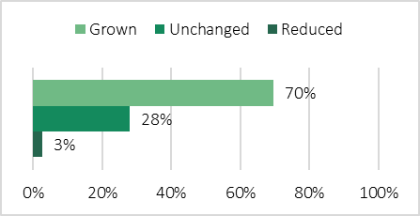
Relationships:  - requirement to influence and negotiate  - level, frequency and quantity of interaction with internal and external stakeholders  - assessment of the sensitivity and complexity of issues and interactions. | 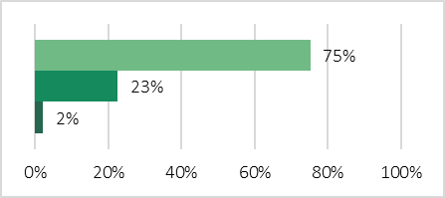
Judgement and risk:  - the complexity of decision-making and risk assessment and mitigation associated with your position  - degree of uncertainty and ambiguity  - criticality of judgements and risks  - the level at which the risk/judgement applies e.g. organisational/state/ nationwide. | 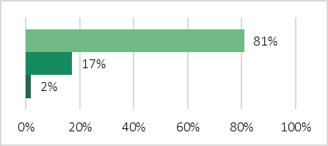
Independence:  - the requirement to make decisions without support  - authority and freedom to plan objectives  - requirement to contribute to or lead strategic direction of the entity. | 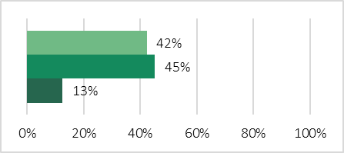
Strategic change:  - delivering change  - measured by your position’s extent of responsibility for and level of complexity of significant strategic change management  - contribution to business improvement. | 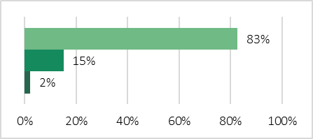
Impact:  - developing the policy frameworks and the strategic direction of the entity  - measured by the scope of your position’s impact internally, into the sector, across the state or nationally and internationally. | 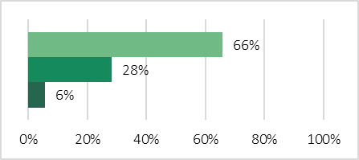
Breadth:  - diversity of activities and functions managed by your position  - geographical breadth of responsibility  - range of programs, products and services managed by your position. | 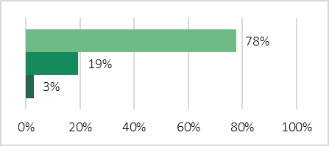
Resource management:  - number of staff and size of resources and budget. | 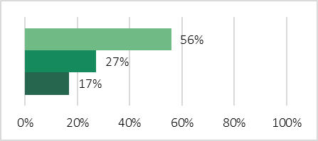
Note: (a) The sum of the percentages may not add to 100 per cent due to the rounding of individual percentages to the nearest whole number.

Levels and structure of the executive remuneration bands
More than half of respondents did not consider the executive remuneration bands to be competitive for the type of work that they do (Table A.23).
Table A.23: Do you consider the executive remuneration bands to be competitive for the type of work that you do?^{(a)}
Answer choices | Number of responses | % of responses^{(b)}
Yes | 97 | 35
No | 152 | 55
I don’t know | 26 | 9
Total | 275
Notes: (a) The remuneration of most executives is governed by the PESES executive remuneration bands, but some executives are governed by the SES executive remuneration bands. (b) The sum of the percentages in this table is lower than 100 per cent due to the rounding of individual percentages to the nearest whole number.
Respondents were asked to consider whether the difference in remuneration between executive and non-executive positions was appropriate, with a similar number of respondents considering that the ‘gap’ was ‘too small or ‘about right’ (Table A.24).
Table A.24: Do you consider the difference in remuneration between non-executives and executives in your organisation to be too small, too large or about right?
Answer choices | Number of responses | % of responses
The gap is too small | 110 | 40
The gap is about right | 116 | 42
The gap is too large | 29 | 11
I don’t know | 20 | 7
Total | 275
Respondents were evenly split in their views about their current remuneration with 40 per cent either very satisfied or satisfied compared to 38 per cent who were very dissatisfied or dissatisfied (Figure A.2).
Figure A.2: How satisfied or unsatisfied are you with your current remuneration considering the type or work you do?
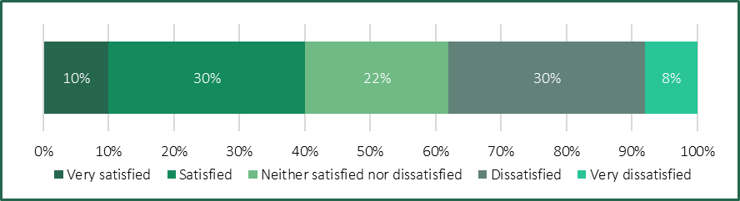

A.2 Segment analysis
The questionnaire responses have been further analysed to consider differences between Chief Executive Officers (CEOs) and other executives.
Several results are highlighted as being ‘significantly’ different. This wording is only used where there is a statistically significant difference between how certain response groups answered those questions. Statistical significance means that the numbers are reliably different using a standard 95 per cent confidence level. This means the difference between the two groups has less than a 5 per cent probability of occurring by chance or sampling error alone.

CEOs and other executives
Respondents were asked to identify if they are the CEO or equivalent for their organisation (Figure A.3).
Figure A.3: Are you the Chief Executive Officer (or equivalent) for your organisation?
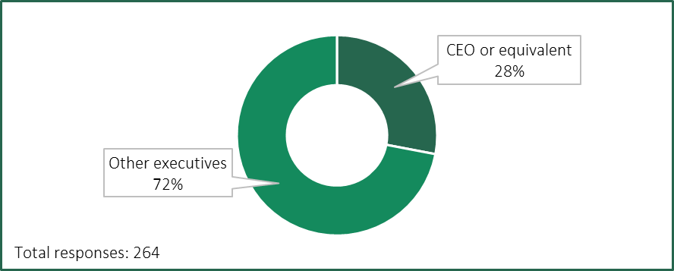
Of the respondents to the questionnaire, CEOs were significantly more likely to report being very satisfied with their current remuneration. Over half (52 per cent) of CEOs reported being either satisfied or very satisfied with their current remuneration, compared with only 34 per cent of other executives (Figure A.4).
Figure A.4: Satisfaction level with current remuneration, CEOs and other executives.^{(a)}
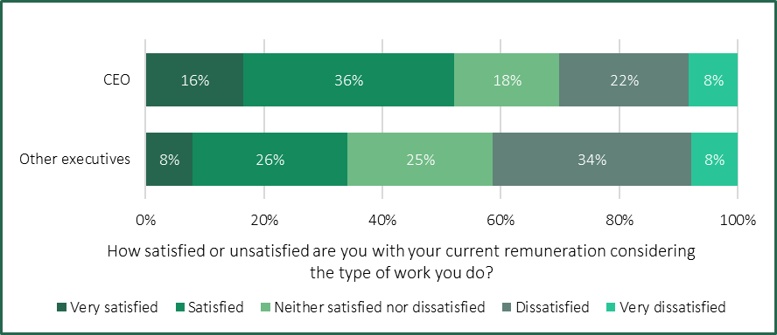
Note: (a) The sum of the percentages in this figure exceeds 100 per cent due to the rounding of individual percentages to the nearest whole number.
CEOs were more likely to consider the executive remuneration bands to be competitive (Figure A.5).
Figure A.5: Do you consider the executive remuneration bands to be competitive for the type of work you do, CEOs and other executives.
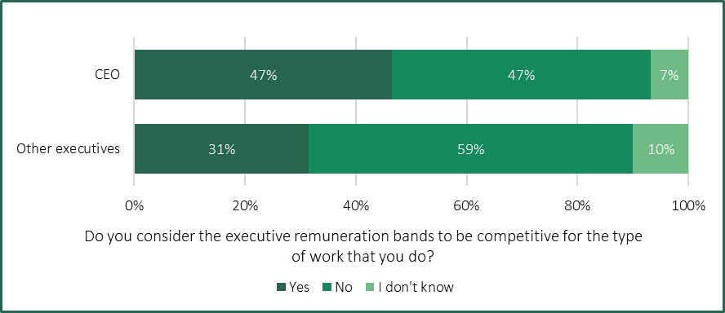
Note: (a) The sum of the percentages in this figure exceeds 100 per cent due to the rounding of individual percentages to the nearest whole number.
CEOs were significantly more likely to consider the difference in remuneration between non-executives and executives to be about right, while other executives were significantly more likely to consider the difference to be too small (Figure A.6).
Figure A.6: Do you consider the difference in remuneration between non-executives and executives in your organisation to be too small, too large or about right, CEOs and other executives.
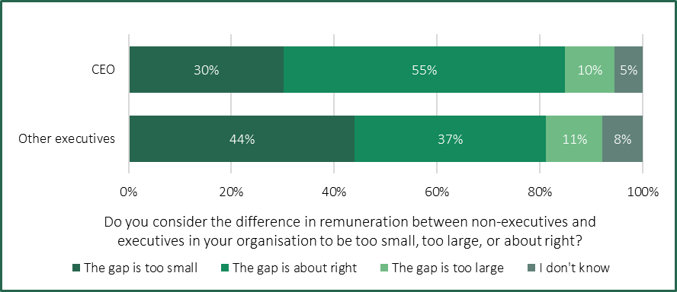
In considering changes to their roles since the 2020 PE Determination, CEOs and other executives had similar views across most dimensions of the core competencies in the PEECF.
However, CEOs were more likely to report that the degree of ‘independence’ in their role had not changed over the past four years, while other executives were more likely to report that their level of ‘independence’ had increased (Figure A.7).
Figure A.7: How has independence^{(a)} within your roles changed over the past four years, CEOs and other executives.^{(b)}
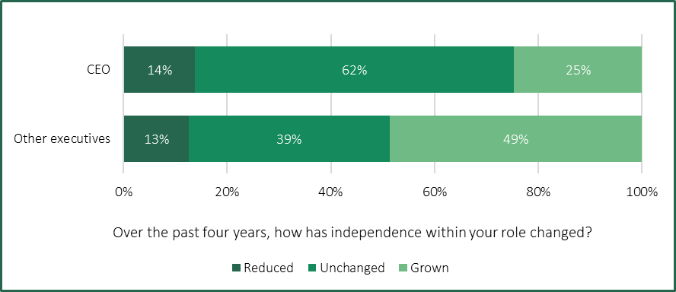
Notes: (a) Independence is ‘the requirement to make decisions without support; authority and freedom to plan objectives; requirement to contribute to or lead strategic direction of the entity’. (b) The sum of the percentages in this figure exceeds 100 per cent due to the rounding of individual percentages to the nearest whole number.

References

ABS (Australian Bureau of Statistics) (2015), Australian System of Government Finance Statistics: Concepts, Sources and Methods, https://www.abs.gov.au/statistics/detailed-methodology-information/concepts-sources-methods/australian-system-government-finance-statistics-concepts-sources-and-methods/2015, accessed 14 December 2024.
——— (2024a), Australian National Accounts: National Income, Expenditure and Product, September 2024.
——— (2024b), Australian National Accounts: State Accounts, 2023-24 financial year.
——— (2024c), Consumer Price Index, Australia, September quarter 2024.
——— (2024d), Job Vacancies, Australia, August 2024.
——— (2024e), Labour Force, Australia, November 2024.
——— (2024f), Wage Price Index, Australia, September 2024.
Agriculture Victoria Services (2024), About us, https://agvicservices.com.au/, accessed 2 December 2024.
Alpine Resorts Victoria (2023), Alpine Resorts (Management) Act 1997, https://www.alpineresorts.vic.gov.au/about-arv/alpine-resorts-management-act-1997, accessed on 5 December 2024.
AMES Australia (2024), Annual Report 2023-2024.
Arts Centre Melbourne (2024), About us, https://www.artscentremelbourne.com.au/about-us, accessed 5 December 2024.
Australian Grand Prix Corporation (2024), 2024 Annual Report.
Australian Institute of Company Directors (2020), Role of chief executive officer (CEO) or managing director (MD), https://www.aicd.com.au/board-of-directors/roles/executive/role-of-chief-executive-officer-ceo-or-managing-director-md.html, accessed 14 December 2024.
Better Regulation Victoria (2024), 2024 Victorian Guide to Regulation.
Breakthrough Victoria (2024), Investing in innovation for impact, https://breakthroughvictoria.com/, accessed on 5 December 2024.
CFA (Country Fire Authority) (2024), What we do, https://www.cfa.vic.gov.au/about-us/what-we-do, accessed 5 December 2024.
Commonwealth of Australia (2019), Our Public Service, Our Future – Independent review of the Australian Public Service.
——— (2023), Royal Commission into the Robodebt Scheme – Report.
COVID-19 Hotel Quarantine Inquiry (2020), Final Report and Recommendations.
Deloitte (2022), Hybrid hiccups: Moving to distributed working in the public sector, https://www2.deloitte.com/us/en/insights/industry/public-sector/hybrid-work-challenges.html, accessed 14 December 2024.
Department of Energy, Environment and Climate Action (2023), Catchment governance, https://www.water.vic.gov.au/catchments/catchment-governance, accessed 5 December 2024.
——— (2024), Forestry in Victoria, https://www.deeca.vic.gov.au/forestry/forestry-in-victoria, accessed 5 December 2024.
Department of Families, Fairness and Housing (2023), Our equal state: Victoria’s gender equality strategy and action plan 2023-2027.
Department of Transport (2021), Annual Report 2020-21.
Development Victoria (2024), What we do, https://www.development.vic.gov.au/about/what-we-do, accessed 5 December 2024.
Docklands Studios Melbourne (n.d.), Homepage, https://www.dsmelbourne.com/, accessed 5 December 2024.
DTF (Department of Treasury and Finance) (2023), Victorian Budget 2023-24 – COVID Debt Repayment Plan.
——— (2024a), 2023-24 Financial Report (inc. Quarterly Financial Report No. 4).
——— (2024b), Aggregate financial statements, https://www.dtf.vic.gov.au/aggregate-financial-statements, accessed 13 December 2024.
——— (2024c), Statement of Expectations for Regulators.
——— (2024d), Victorian Budget 2024-25 — 2024-25 Budget Update.
——— (2024e), Victorian Budget 2024-25 — Budget Paper No. 2: Strategy and Outlook.
——— (2024f), Victorian Budget 2024-25 — Budget Paper No. 3: Service Delivery.
——— (2024g),Victorian Budget 2024-25 — Budget Paper No. 4: State Capital Program.
——— (2024h), Victorian Government submission to the Annual Wage Review 2023-24.
Engage Victoria (n.d.) Public Entity Executive Classification Framework, https://engage.vic.gov.au/public-entity-executive-classification-framework, accessed 2 December 2024.
Essential Services Commission (2024), Annual Report 2023-24.
FWC (Fair Work Commission) (2024a), Decision — Annual Wage Review 2023-24.
——— (2024b), Decision — Victorian Public Service Enterprise Agreement 2024.
——— (2024c), Find an enterprise agreement, https://www.fwc.gov.au/work-conditions/enterprise-agreements/find-enterprise-agreement, accessed 13 November 2024.
Greater Melbourne Cemeteries Trust (n.d.), Locations, https://www.gmct.com.au/our-locations, accessed 5 December 2024.
IBAC (Independent Broad-based Anti-corruption Commission) and Victorian Ombudsman (2022), Operation Watts – Investigation into allegations of misuse of electorate office and ministerial office staff and resources for branch stacking and other party-related activities.
Industrial Relations Victoria (2023), Wages Policy and the Enterprise Bargaining Framework.
Infrastructure Victoria (n.d.), Homepage, https://www.infrastructurevictoria.com.au/, accessed 5 December 2024.
International Monetary Fund (2024), Australia: Staff Concluding Statement of the 2024 Article IV Mission, https://www.imf.org/en/News/Articles/
2024/10/02/mcs-australia-staff-concluding-statement-of-the-2024-article-iv-mission, accessed 14 December 2024.
JSA (Jobs and Skills Australia) (2024a), 2024 Occupational Shortage List.
——— (2024b), Internet Vacancy Index, November 2024.
Language Loop (2024), About Us, https://languageloop.com.au/about-us/about-us/, accessed 5 December 2024.
Melbourne Market (n.d.), Overview, https://melbournemarkets.com.au/about-the-market/overview/, accessed 5 December 2024.
Melbourne Water Corporation (2020), Diversity and Inclusion Strategy 2020-25.
Mercer Consulting (2024), Executive Remuneration Benchmarking and Advice – Secretary and Senior Executive Service, report to the Victorian Independent Remuneration Tribunal.
North East Link State Tolling Corporation (2024), North East Link State Tolling Corporation, https://www.vic.gov.au/north-east-link-state-tolling-corporation, accessed 5 December 2024.
Parliament of Victoria (n.d.a), Inquiry into the 2022 Flood Event in Victoria, https://www.parliament.vic.gov.au/floodinquiry, accessed 14 December 2024.
——— (n.d.b), Inquiry into the 2023-24 financial and performance outcomes, https://www.parliament.vic.gov.au/get-involved/inquiries/inquiry-into-the-2023-24-financial-and-performance-outcomes, accessed 14 December 2024.
——— (n.d.c), Inquiry into Victoria's recreational native bird hunting arrangements, https://www.parliament.vic.gov.au/nativebirdhunting, accessed 14 December 2024.
Phillip Island Nature Parks (n.d.), Conservation Meets Ecotourism, https://www.penguins.org.au/about/, accessed 5 December 2024.
Ports Victoria (n.d.), About us, https://ports.vic.gov.au/about-us/, accessed 5 December 2024.
Premier of Victoria (2023), New Legislation to Reform Victoria’s Triple Zero Service, https://www.premier.vic.gov.au/site-4/new-legislation-reform-victorias-triple-zero-service, accessed 5 December 2024.
Primesafe (2024), Homepage, https://www.primesafe.vic.gov.au/, accessed 5 December 2024.
RBA (Reserve Bank of Australia) (2024a), Statement on Monetary Policy — May 2024.
——— (2024b), Statement on Monetary Policy — August 2024.
——— (2024c), Statement on Monetary Policy — November 2024.
Recycling Victoria (2022), Establishing Recycling Victoria, https://www.vic.gov.au/establishment-recycling-victoria, accessed 5 December 2024.
Shrine Melbourne (2024), About the Shrine, https://www.shrine.org.au/about-shrine-remembrance, accessed 5 December 2024.
Social Services Regulator (2024a), About the Social Services Regulator, https://www.vic.gov.au/about-social-services-regulator, accessed 5 December 2024.
——— (2024b), Changes to the regulation of social services, https://www.vic.gov.au/changes-regulation-social-services, accessed 5 December 2024.
State Government of Victoria (2024a), Bonus Removal Offer, https://www.vic.gov.au/bonus-removal-offer-0, accessed 5 December 2024.
——— (2024b), Executive and senior office holders annual remuneration changes, https://www.vic.gov.au/executive-and-senior-office-holders-annual-remuneration-changes, accessed 18 September 2024.
——— (2024c), Public entity executive remuneration policy, https://www.vic.gov.au/public-entity-executive-remuneration-policy, accessed 5 December 2024.
State Trustees (n.d.), Homepage, https://www.statetrustees.com.au/, accessed 5 December 2024.
Suburban Rail Loop Authority (2023), Annual Report 2022-2023.
SurveyMonkey (n.d.), Statistical Significance, https://help.surveymonkey.com/en/surveymonkey/analyze/significant-differences/, accessed 22 November 2024.
TCV (Treasury Corporation of Victoria) (2024), About TCV, https://www.tcv.vic.gov.au/about-tcv, accessed 5 December 2024.
The Age (2019), Big merger: VicRoads and PTV to become one mega-agency, https://www.theage.com.au/national/victoria/big-merger-vicroads-and-ptv-to-become-one-mega-agency-20190404-p51arj.html, accessed 24 October 2024.
The Australia and New Zealand School of Government (2021), Senior Executive Service Case Study – Victoria.
——— (2023), ANZSOG insights into how leaders can support hybrid work in the public sector, https://anzsog.edu.au/news/anzsog-insights-into-how-leaders-can-support-hybrid-work-in-the-public-sector/, accessed 5 December 2024. The Wheeler Centre (2024), About the Wheeler Centre, https://www.wheelercentre.com/about-us, accessed 5 December 2024.
Tribunal (Victorian Independent Remuneration Tribunal) (2020), Remuneration bands for executives employed in prescribed public entities (Victoria) Determination No. 01/2020.
——— (2023), Remuneration bands for executives employed in prescribed public entities (Victoria) Annual Adjustment Determination 2023.
——— (2024), Remuneration bands for executives employed in public service bodies (Victoria) Determination No. 01/2024.
Triple Zero Victoria (2024), About Triple Zero Victoria, https://www.triplezero.vic.gov.au/about-triple-zero-victoria, accessed 5 December 2024.
Trust for Nature (2017), What we do, https://trustfornature.org.au/what-we-do, accessed 5 December 2024.
VAGO (Victorian Auditor-General’s Office) (2023), Reducing the Illegal Disposal of Asbestos.
——— (2024), Auditor-General's Report on the Annual Financial Report of the State of Victoria: 2023-24.
VFMC (Victorian Funds Management Corporation) (n.d.), Balanced Lives, https://www.vfmc.vic.gov.au/why-join-vfmc/balanced-lives/, accessed 14 December 2024.
VicHealth (n.d.), Homepage, https://www.vichealth.vic.gov.au/, accessed 5 December 2024.
Victoria Law Foundation (2024), Annual Report 2023-24.
Victorian Institute of Sport (2024), 2023/2024 Annual Review.
Victorian Ombudsman (2023), Alleged politicisation of the public sector – Investigation of a matter referred from the Legislative Council on 9 February 2022 – Part 2.
Victorian Responsible Gambling Foundation (2024), Changing the way we talk about gambling harm, https://responsiblegambling.vic.gov.au/about-us/news-and-media/changing-the-way-we-talk-about-gambling-harm/, accessed 5 December 2024.
Victoria’s Big Build (2024), About the Suburban Rail Loop Authority, https://bigbuild.vic.gov.au/about/about-the-suburban-rail-loop-authority, accessed 2 December 2024.
VicTrack (n.d.), Our role, https://www.victrack.com.au/about/our-role, accessed 5 December 2024.
V/Line Corporation (2024), Annual Report 2023-24.
VPSC (Victorian Public Sector Commission) (2018), Executive Workforce Reform, Industry Segment Reviews: final report for public release.
——— (2022a), Employment arrangements for public entities.
——— (2022b), Flexible work policy.
——— (2022c), Legal form and governance arrangements for public entities.
——— (2022d), Public entity executive classification framework, https://vpsc.vic.gov.au/executive-employment/victorian-public-entity-executive-employment/public-entity-executive-classification-framework/, accessed 14 December 2024.
——— (2022e), Public entity executive handbook.
——— (2022f), Serving Victoria: A guide for public sector CEOs.
——— (2022g), Victorian Public Service (VPS) executive classification framework, https://vpsc.vic.gov.au/executive-employment/victorian-public-service-executive-employment/vps-executive-classification-framework/, accessed 14 December 2024.
——— (2024a), Executive pay and gender pay 2023, https://vpsc.vic.gov.au/workforce-data-state-of-the-public-sector/employee-and-executive-pay-leave-and-work-arrangements-2023/executive-pay-and-gender-pay-2023/, accessed 2 December 2024.
——— (2024b), Flexible work 2023, https://vpsc.vic.gov.au/workforce-data-state-of-the-public-sector/employee-experiences-in-the-workplace-2023/flexible-work-2023/, accessed 14 December 2024.
——— (2024c), Functions and features of public entities, https://vpsc.vic.gov.au/governance/public-entity-types-features-and-functions/functions-and-features-of-public-entities/, accessed 5 December 2024.
——— (2024d), List of public sector employers, https://vpsc.vic.gov.au/about-public-sector/employer-public-sector-bodies/, accessed 5 December 2024.
——— (2024e), Public sector integrity framework, https://vpsc.vic.gov.au/ethics-behaviours-culture/public-sector-integrity-framework/, accessed 14 December2024.
——— (2024f), VPS Executive Employment Handbook.
——— (n.d.), Standard contract.
Williamson S, Taylor H, Lundy J and Jogulu U (2024), Hybrid Working: From ‘the new normal’ to ‘business as usual’.
Workplace Injury Commission (2024), Homepage, https://www.wic.vic.gov.au/, accessed 5 December 2024.

VIRTIPS Act, s. 5.
VIRTIPS Act, s. 19(2).
VIRTIPS Act, s. 25.
Victorian Independent Remuneration Tribunal and Improving Parliamentary Standards (Prescribed Public Entities) Regulations 2021, s. 5.
State Government of Victoria (2024c), clause 1.1.
State Government of Victoria (2024c), clause 4.1.
State Government of Victoria (2024c), clause 5.1.
State Government of Victoria (2024c), clause 5.2; VIRTIPS Act, s. 37(1)(a).
VIRTIPS Act, s. 36(6).
VIRTIPS Act, s. 19(3) and ss. 24(2)(a)-(d).
VIRTIPS Act, s. 24(1).
VIRTIPS Act, s. 24(3).
VPSC (2022c), section 2.
The Age (2019); The Australia and New Zealand School of Government (2021), p. 17.
VPSC (2022c), section 2.2.1.
PAA, s. 13.
PAA, ss. 13-13A.
PAA, s. 13A.
VPSC (2022c), section 2.2.2.
VPSC (2022c), section 2.2.2.
PAA, s. 14.
PAA, s. 5; VPSC (2022c), section 3.1.
VPSC (2022c), section 3.
VPSC (2022c).
VPSC (2022c), section 3.3.
Phillip Island Nature Parks (n.d.).
Better Regulation Victoria (2024), p. 1.
Essential Services Commission (2024), p. 8.
Victoria Law Foundation (2024), pp. 8-9.
VPSC (2024c).
PAA, s. 85.
DTF (2024c), p. 1.
VPSC (2022c), section 4.
VPSC (2022c), section 4.2.
Royal Botanic Gardens Act 1991 (Vic), Part 2.
Catchment and Land Protection Act 1994 (Vic), Part 2.
State-Owned Enterprises Act 1992 (Vic).
VPSC (2022c), section 5.2.
State Government of Victoria (2024c), clause 4.2.
Victorian Independent Remuneration Tribunal and Improving Parliamentary Standards (Prescribed Public Entities) Regulations 2021, s. 5. Conversely, the regulations in place at the time of the 2020 PE Determination — the Victorian Independent Remuneration Tribunal and Improving Parliamentary Standards (Prescribed Public Entities) Regulations 2019 — listed the specific entities that were covered by the Determination.
Victorian Independent Remuneration Tribunal and Improving Parliamentary Standards (Prescribed Public Entities) Regulations 2021, s. 5.
VPSC (2024d).
VPSC (2024d).
Tribunal (2024), pp. 30, 32.
VAGO (2024), pp. D1-D3.
Victoria’s Big Build (2024).
North East Link State Tolling Corporation (2024).
Circular Economy (Waste Reduction and Recycling) Act 2021 (Vic), ss. 184-190; Recycling Victoria (2022).
Alpine Resorts Victoria (2023).
Premier of Victoria (2023).
Social Services Regulator (2024a), (2024b).
Department of Energy, Environment and Climate Action (2024); Victorian Responsible Gambling Foundation (2024).
Arts Centre Melbourne (2024); The Wheeler Centre (2024).
Department of Energy, Environment and Climate Action (2023).
Greater Melbourne Cemeteries Trust (n.d.).
Agriculture Victoria Services (2024); Breakthrough Victoria (2024).
Language Loop (2024); Victoria Law Foundation (2024), pp. 8-9.
CFA (2024); Triple Zero Victoria (2024).
Docklands Studios Melbourne (n.d.); Melbourne Market (n.d.); Shrine Melbourne (2024).
State Trustees (n.d.); TCV (2024).
VicHealth (n.d.).
Trust for Nature (2017).
Development Victoria (2024); Infrastructure Victoria (n.d.).
Primesafe (2024); Workplace Injury Commission (2024).
Australian Grand Prix Corporation (2024); Victorian Institute of Sport (2024).
AMES Australia (2024), pp. 1-11.
Ports Victoria (n.d.); VicTrack (n.d.).
VIRTIPS Act, s. 19.
Tribunal (2020), p. 33.
At June 2023, around 200 executives in public entities (approximately 20 per cent) were employed under Part 3 of the PAA.
State Government of Victoria (2024c), clause 6.
Tribunal (2024), p. 34.
VPSC (2022d).
VPSC (2022d); VPSC (2022g).
VPSC (2022d); VPSC (2022g).
The Tribunal’s analysis of VPSC data shows that CEOs and equivalent positions represented around 10 per cent of all executives employed in prescribed public entities at June 2023.
VPSC (2022f), p. 16.
Transport Integration Act 2010 (Vic), s. 151A; V/Line Corporation (2024), p. 32.
VPSC (2022f), p. 28; Australian Institute of Company Directors (2020), p. 2.
VPSC (2022f), p. 3.
Australian Institute of Company Directors (2020), p. 2.
VPSC (2022f), p. 17.
VPSC (2022f), pp. 17-18.
VPSC (2022f), pp. 7, 19; PAA, s. 13A(2).
PAA, s. 13(3).
VAGO (2024), p. 37.
DTF (2024g), pp. 20, 182.
VPSC (2022f), p. 32.
According to the Parliament of Victoria’s website, these inquiries assist ‘Parliament and the community to gauge what the Government achieved in the last financial year(s) compared to what the Government planned to achieve’, and aim to improve accountability and transparency. Parliament of Victoria (n.d.b).
Parliament of Victoria (n.d.b).
Parliament of Victoria (n.d.a).
Parliament of Victoria (n.d.c).
Audit Act 1994 (Vic), s. 14.
VAGO (2023), pp. 1-2.
Tribunal (2020), p. 38.
VPSC (2022d).
De-identified submission 4.
Tribunal (2024), pp. 38-42.
DTF (2023), p. 14.
DTF (2023), p. 19.
DTF (2024f), p. 92.
Tribunal (2024), p. 39.
VPSC (2022b), pp. 5, 11-12.
Gender Equality Act 2020 (Vic), ss. 10, 19.
Department of Families, Fairness and Housing (2023), p. 75.
Tribunal (2024), p. 41.
COVID-19 Hotel Quarantine Inquiry (2020); Commonwealth of Australia (2019); Commonwealth of Australia (2023); IBAC and Victorian Ombudsman (2022); Victorian Ombudsman (2023).
VPSC (2024e).
VicWater is the peak body representing Victoria’s 18 water corporations and other water sector bodies.
Tribunal (2024), pp. 45-48.
DTF (2024e), p. 73.
Thirty-two per cent of public sector employees who took part in the 2023 People matter survey selected ‘working from an alternative location’ as one of their flexible work arrangements. VPSC (2024b).
Melbourne Water Corporation (2020), p. 17; VFMC (n.d.).
The Australia and New Zealand School of Government (2023).
Williamson, Taylor et al. (2024), pp. 25, 28
Williamson, Taylor et al. (2024), pp. 25, 28
Deloitte (2022).
VIRTIPS Act, s. 19(3).
PAA, s. 92.
State Government of Victoria (2024c), clause 4.1.
State Government of Victoria (2024c), clause 4.1.
State Government of Victoria (2024c), clause 4.2.
State Government of Victoria (2024c), clause 6.
Engage Victoria (n.d.).
Tribunal (2024), pp. 33-34, 54-55.
State Government of Victoria (2024c), clause 6.2.
State Government of Victoria (2024c), clause 6.
VPSC (2022e), p. 20; Tribunal analysis of VPSC data.
VPSC (2024f), p. 20.
VPSC (2018), p. 12.
State Government of Victoria (2024a); State Government of Victoria (2024c), clause 8.
State Government of Victoria (2024c), clause 8.
Tribunal analysis of VPSC data.
PAA, s. 27.
PAA, s. 27(2).
State Government of Victoria (2024c), clause 5; VIRTIPS Act, s. 37.
State Government of Victoria (2024c), clause 7.1; VPSC (2024f), p. 25.
VPSC (2022e), p. 34; VPSC (2024f), p. 42.
VPSC (2022e), p. 39.
VPSC (2022e), pp. 40-41.
Tribunal (2020), pp. 5, 85.
State Government of Victoria (2024c), clause 5; VIRTIPS Act, s. 37.
For information on executives in public service bodies paid above the band, see Tribunal (2024), p. 62.
Education and Training Reform Act 2006 Ministerial Direction TAFE Institute Executive Remuneration (No. 2).
VPSC (2024a).
PAA, s. 8.
VPSC (2022e), p. 28.
VPSC (n.d.), p. 4.
State Government of Victoria (2024b).
VPSC (n.d.), p. 4.
RBA (2024c), p. 23.
JSA (2024a), p. 5.
ABS (2024e).
Tribunal (2020), p. 16; Tribunal analysis of VPSC data.
Department of Transport (2021), p. 228; Suburban Rail Loop Authority (2023), p. 17.
According to JSA, ‘An occupation is in shortage when employers are unable to fill or have considerable difficulty filling vacancies for an occupation or cannot meet specialised skill needs within that occupation, at current levels of remuneration and conditions of employment and in reasonably accessible locations’. JSA (2024a), p. 4.
JSA (2024a), p. 10.
JSA (2024a), p. 22.
Tribunal (2020), p. 96.
Tribunal (2020), p. 98.
Tribunal (2020), p. 98.
Mercer Consulting (2024), p. 25
Tribunal (2024), p. 10.
VIRTIPS Act, s. 24(2).
ABS (2024b).
ABS (2024a).
ABS (2024b). Unless referring to a comment by the ABS or RBA the long-run pre-pandemic average refers to the average from June 1999 to June 2019 calculated by the Tribunal.
RBA (2024c), pp. 29-30.
RBA (2024c), pp. 29-31.
DTF (2024d), p. 9.
ABS (2024b).
ABS (2024a).
RBA (2024c), p. 34.
ABS (2024c).
ABS (2024c).
While the RBA targets headline inflation, it has noted that it is necessary to ‘look through’ temporary volatility in prices to assess whether inflation will sustainably return to the midpoint of the target band. Measures of underlying inflation help to inform this assessment. RBA (2024b), pp. 59-61.
ABS (2024c).
ABS (2024c).
RBA (2024c), pp. 38-39.
RBA (2024c), p. 39.
ABS (2024c).
RBA (2024c), p. 38.
ABS (2024c).
RBA (2024c), p. 33.
ABS (2024e).
ABS (2024e).
ABS (2024f).
RBA (2024c), p. 35.
FWC (2024a), p. 8.
ABS (2024f).
ABS (2024f).
ABS (2024f).
DTF (2024h), p. 8.
ABS (2024c); ABS (2024f).
RBA (2024c), p. 48.
RBA (2024c), pp. 48-49.
RBA (2024c), p. 55.
DTF (2024d), p. 8.
DTF (2024d), p. 10.
RBA (2024c), p. 49.
RBA (2024c), pp. 49, 53-54.
RBA (2024c), pp. 51-52.
RBA (2024a), pp. 45-46; RBA (2024c), p 3.
DTF (2024d), p. 12.
RBA (2024c), pp. 50, 55.
RBA (2024c), p. 50.
DTF (2024d), p. 11.
RBA (2024c), p. 50, 55.
DTF (2024d), p. 13.
RBA (2024c), p. 55.
RBA (2024c), pp. 53-54; International Monetary Fund (2024).
RBA (2024c), pp. 53-54.
RBA (2024c), p. 53.
RBA (2024c), p. 54; International Monetary Fund (2024).
DTF (2024d), p. 15.
DTF (2024e), p. 4.
DTF (2023), p. 20.
DTF (2024e), p. 4.
DTF (2024e), p. 6.
DTF (2024d), p. 19.
DTF (2024d), p. 19.
DTF (2024a), p. 6. The general government sector comprises ‘all government units and non-profit institutions controlled by government’, where a government unit provides goods or services free of charge or at ‘prices that are not economically significant’ or redistributes income and wealth, and a non-profit institution provides goods or services but does not generate profit or financial gain for its owner. ABS (2015).
DTF (2024a), p. 7.
DTF (2024d), p. 24.
DTF (2024d), pp. 24, 69-70, 138.
DTF (2024b); DTF (2024d), p. 19.
DTF (2024e), p. 4.
DTF (2024a), p. 5.
VAGO (2024), p. 18.
VAGO (2024), p. 36.
FWC (2024b).
Tribunal analysis of selected public sector enterprise agreements which commenced since April 2023. FWC (2024c).
Tribunal (2024), pp. 125-126.
Tribunal (2024), p.129.
Tribunal (2020), p. 100.
Branching logic is the term used when respondents are directed through different paths in the questionnaire based on their answers.
‘Completed’ means the respondent answered all mandatory questions at a minimum.
The margin of error indicates how much the questionnaire results can be expected to reflect the views of the whole cohort of public entity executives. The margin of error is a range of values above and below the actual results from the questionnaire. For example, a 60 per cent ‘yes’ response with a margin of error of 6 per cent means that between 54 and 66 per cent of the whole cohort think that the answer is ‘yes’.
State Government of Victoria (2024c), clause 7.1.
SurveyMonkey (n.d.).

